Part IV: Advanced Features
Chapter 11 Layer 3 Switching
Chapter 12 VLAN Trunking Protocol
Chapter 13 Multicast and Broadcast Services

Chapter 11. Layer 3 Switching
This chapter covers the following key topics:
- Layer 3 Switching Terminology—
Examines the confusing subject of Layer 3 switching terminology and jargon.
- The Importance of Routing—
Discusses how routing, and therefore Layer 3 switching, is the key to building large-scale networks that are stable and easy to manage.
- Router-on-a-Stick—
This section explores the use of traditional router platforms for inter-VLAN routing. As the earliest form of Layer 3 switching, this approach can use either multiple interfaces or a single interface configured for a trunking protocol such as ISL or 802.1Q.
- The RSM—
Cisco's route-switch module was a natural evolution of the router-on-a-stick approach by bringing the routing function into the Catalyst 5000 chassis. This section discusses issues such as RSM configuration and the advantages of their use.
- Routing Switches—
Explores the use of the NetFlow Feature Cards (NFFCs) to provide high-performance, ASIC-based Layer 3 switching. After a detailed examination of the theory behind MLS, this section also considers configuration and the appropriate use of MLS technology.
- Switching Routers—
Discusses an alternate approach to Layer 3 switching represented by devices such as the Catalyst 8500. Resembling traditional router platforms from a design and configuration standpoint, the technology and configuration behind this approach is explained.
- Routing Switches versus Switching Routers—
Although both styles of Layer 3 switching offer high-performance routing, they are very different from a design and implementation standpoint. This section takes a detailed look at these differences.
- Catalyst 6000 Layer 3 Switching—
Examines how the Catalyst 6000 both evolves and blends the various Layer 3 switching technologies introduced before it.
- HSRP—
This section discusses the use of Cisco's Hot Standby Router Protocol for both resiliency and performance.
- Integration between Routing and Bridging—
Looks at several technologies that are available for blending Layer 2 and Layer 3 technologies.
Layer 3 switching is one of the most important but over-hyped technologies of recent memory. On one hand, vendors have created a labyrinth of names, architectures, and options that have done little but confuse people. On the other hand, Layer 3 switching (routing) is one of the most important ingredients in a successful campus design. While providing the bandwidth necessary to build modern campus backbones, it also provides the scalability necessary for growth and ease of maintenance.
The goal of this chapter is to clear up any confusion created by competing marchitectures (marketing architectures). By digging into the details behind Cisco's approach to Layer 3 switching, myth and fact can be separated. The chapter takes a chronological look at inter-VLAN (VLAN) routing. It begins with a brief discussion of switching terminology and the importance of routing. It then dives into the first technique commonly used to connect virtual LANs (VLANs) in a switched environment: the router-on-a-stick design. The chapter then looks at more integrated approaches such as the Catalyst Route Switch Module (RSM), followed by a discussion of two hardware-based approaches to Layer 3 switching. The chapter concludes with coverage of Cisco's Hot Standby Router Protocol (HSRP) and bridging between VLANs.

Layer 3 Switching Terminology
Several factors have created significant confusion surrounding the subject of Layer 3 switching. Some of this bewilderment arises from the recent merging of several technologies. In the past, switches and routers have been separate and distinct devices. The term switch was reserved for hardware-based platforms that generally functioned at Layer 2. For example, ATM switches perform hardware-based forwarding of fixed-length cells, whereas Ethernet switches use MAC addresses to make forwarding decisions. Conversely, the term router has been used to refer to a device that runs routing protocols to discover the Layer 3 topology and makes forwarding decisions based on hierarchical Layer 3 addresses. Because of the complexity of these tasks, routers have traditionally been software-based devices. Routers have also performed a wide variety of "high touch" and value added features such as tunneling, data-link switching (DLSw), protocol translation, access lists, and Dynamic Host Configuration Protocol (DHCP) relay.
Layer 3 switching is a term that encompasses a wide variety of techniques that seek to merge the benefits of these previously separate technologies. The goal is to capture the speed of switching and the scalability of routing. In general, Layer 3 switching techniques can be grouped into two categories:
- Routing switches
- Switching routers
As a broad category, routing switches uses hardware to create shortcut paths through the middle of the network, bypassing the traditional software-based router. Some routing switch devices have been referred to as router accelerators. Routing switches do not run routing protocols such as Open Shortest Path First (OSPF) or Enhanced Interior Gateway Routing Protocol (EIGRP). Instead, they utilize various techniques to discover, create, or cache shortcut information. For example, Multiprotocol over ATM was discussed in Chapter 10, "Trunking with Multiprotocol over ATM." This is a standards-based technique that allows ATM-attached devices to build a virtual circuit that avoids routers for sustained flows of information. Although Cisco obviously supports MPOA, it has developed another shortcut technique that does not require an ATM backbone. This feature is called Multilayer Switching (MLS), although many people (and Cisco documents) still refer to it by an earlier name, NetFlow LAN Switching (NFLS). MLS is discussed in detail during this chapter.
Warning
Do not confuse MLS with other shortcut Layer 3 switching techniques that are not standards-compliant (many of these use the term cut-through switching). Many of these other techniques quickly switch the packets through the network without making the necessary modifications to the packet (such as decrementing the TTL field and rewriting the source and destination MAC addresses). MLS makes all of same modifications as a normal router and is therefore completely standards-compliant.

Unlike routing switches, switching routers do run routing protocols such as OSPF. These operations are typically run on a general-purpose CPU as with a traditional router platform. However, unlike traditional routers that utilize general-purpose CPUs for both control-plane and data-plane functions, Layer 3 switches use high-speed application specific integrated circuits (ASICs) in the data plane. By removing CPUs from the data-forwarding path, wire-speed performance can be obtained. This results in a much faster version of the traditional router. Switching routers such as the Catalyst 8500 are discussed in more detail later in this chapter.
Although the terms routing switch and switching router seem arbitrarily close, the terms are actually very descriptive of the sometimes subtle difference between these types of devices. For example, in the case of routing switch, switch is the noun and routing is the adjective (you didn't know you were in for a grammar lesson in this chapter, did you?). In other words, it is primarily a switch (a Layer 2 device) that has been enhanced or taught some routing (Layer 3) capabilities. In the case of a switching router, it is primarily a router (Layer 3 device) that uses switching technology (high-speed ASICs) for speed and performance (as well as also supporting Layer 2 bridging functions).
Tip
Routing switches are Layer 2-oriented devices that have been enhanced to provide Layer 3 (and 4) functionality. On the other hand, switching routers are primarily Layer 3 devices that can also do Layer 2 processing (like any Cisco router).

Of the variety of other switching devices and terminology released by vendors, Layer 4 and Layer 7 switching have received considerable attention. In general, these approaches refer to the capability of a switch to act on Layer 4 (transport layer) information contained in packets. For example, Transmission Control Protocol (TCP) and User Datagram Protocol (UDP) port numbers can be used to make decisions affecting issues such as security and Quality of Service (QoS). However, rather than being viewed as a third type of campus switching devices, these should be seen as a logical extension and enhancement to the two types of switches already discussed. In fact, both routing switches and switching routers can perform these upper-layer functions.

The Importance of Routing
Although Chapter 14, "Campus Design Models," discusses the advantages of routing from a design perspective, it is also useful to consider the importance of routing when discussing Layer 3 switching—after all, Layer 3 switching is routing. This section is designed to serve only as a brief reminder of routing's benefits in a large network (campus or WAN). For a more thorough discussion of this subject, please see the section "Advantages of Routing" in Chapter 14.
Probably the most important benefit of routing is its proven history of facilitating large networks. Although the Internet serves as the obvious example here, this point is true of any type of network, such as a large campus backbone. Because routers prevent broadcast propagation and use more intelligent forwarding algorithms than bridges, routers provide much more efficient use of bandwidth. This simultaneously results in flexible and optimal path selection. For example, it is very easy to implement load balancing across multiple paths in most networks when using routing. On the other hand, as Chapter 7, "Advanced Spanning Tree," discussed, Layer 2 load balancing can be very difficult to design, implement, and maintain. The data forwarding benefits of routers are especially important when multicast traffic is in use. As multicast traffic becomes increasingly common in campus networks, routers play an increasingly important role.
Routers provide additional benefits that reach beyond the area of data forwarding. Because Layer 3 addresses are hierarchical, routers can be used to implement summarized designs. By reducing routing protocol overhead, increasing table lookup performance, and improving network stability, this can further facilitate networks of almost unlimited size. Most routers provide extensive access list capabilities that can be used to provide important policy controls. Finally, routers can also provide important features such as DHCP relay, proxy Address Resolution Protocol (ARP), and Get Nearest Server (GNS) functions in IPX networks.
Tip
You should build routing (Layer 3 switching) into all but the smallest campus networks. See Chapters 14, "Campus Design Models," and 15,"Campus Design Implementation," for more information.

Router-on-a-Stick
Early VLAN designs relied on routers connected to VLAN-capable switches in the manner shown in Figure 11-1.

Figure 11-1 Router-on-a-Stick Design
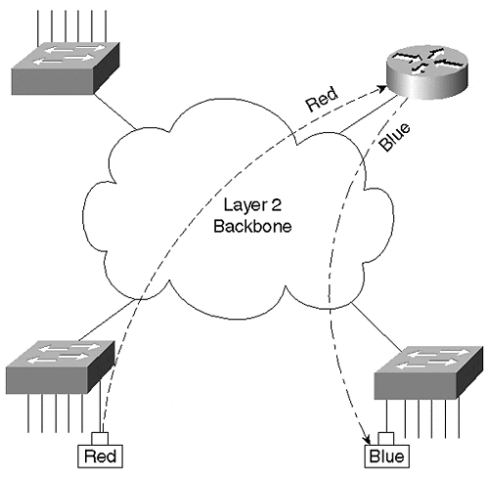
In this approach, traditional routers are connected via one or more links to a switched network. Figure 11-1 shows a single link, the stick, connecting the router to the rest of the campus network. Inter-VLAN traffic must cross the Layer 2 backbone to reach the router where it can move between VLANs. It then travels back to the desired end station using normal Layer 2 forwarding. This "out to the router and back" flow is characteristic of all router-on-a stick designs.
Figure 11-1 portrays the router connection in a general sense. When discussing specific options for linking a router to a switched network, two alternatives are available:
- One-link-per-VLAN
- Trunk-connected router

One-Link-per-VLAN
One of the earliest techniques for connecting a switched network to a router was the use of one-link-per-VLAN as shown in Figure 11-2.

Figure 11-2 One-Link-per-VLAN
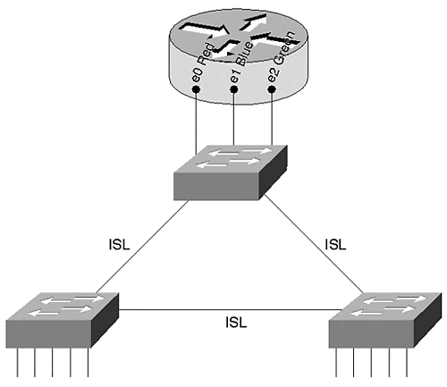
In this case, the switched network carries three VLANs: Red, Blue, and Green. Inter-Switch Link (ISL) trunks are used to connect the three switches together, allowing a single link to carry all three VLANs. However, connections to the router use a separate link for every VLAN. Figure 11-2 illustrates the use of 10 Mbps router ports; however, Fast Ethernet, Gigabit Ethernet, or even other media such as Asynchronous Transfer Mode (ATM) or Fiber Distributed Data Interface (FDDI) can be used.
There are several advantages to using the one-link-per-VLAN approach:
- It allows existing equipment to be redeployed in a switched infrastructure, consequently saving money.
- It is simple to understand and implement. Network administrators do not have to learn any new concepts or configuration commands to roll out the one-link-per-VLAN approach.
- Because it relies of multiple interfaces, it can provide high performance.
Furthermore, notice that every router interface is unaware of the VLAN infrastructure (they are access ports). This allows the router to utilize normal processing to move packets between VLANs. In other words, there is no additional processing or overhead.
Although there are advantages to the one-link-per-VLAN design, it suffers from several critical flaws:
- It can require more interfaces than is practical. In effect, this limits the one-link-per-VLAN approach to networks carrying less than 10 VLANs. Trying to use this model with networks that carry 15 or more VLANs is generally not feasible because of port-density and cost limitations.
- Although it can initially save money because it allows the reuse of existing equipment, it can become very expensive as the number of VLANs grows over time. Keep in mind that every VLAN requires an additional port on both the router and the switch.
- It can become difficult to maintain the network over time. Although the one-link-per-VLAN design can be simple to initially configure, it can become very cumbersome as the number of VLANs (and therefore cables) grows.
In short, the downside of the one-link-per-VLAN approach can be summarized as a lack of scalability. Therefore, you should only consider this to be a viable option in networks that contain a small number of VLANs.
Tip
The one-link-per-VLAN model can be appropriate in networks with a limited number of VLANs.

Example 11-1 presents a possible configuration for the router in Figure 11-2.

Example 11-1 One-Link-Per-VLAN Router Configuration
interface Ethernet0 ip address 10.1.1.1 255.255.255.0 ! interface Ethernet1 ip address 10.1.2.1 255.255.255.0 ipx network 2 ! interface Ethernet2 ip address 10.1.3.1 255.255.255.0 appletalk cable-range 300-310 304.101 appletalk zone ZonedOut ipx network 3
The configuration in Example 11-1 provides inter-VLAN routing services for three VLANs:
- VLAN 1 is connected to the Ethernet0 interface and is only using the IP protocol.
- VLAN 2 is linked the Ethernet1 interface and uses the IP and IPX protocols.
- VLAN 3 is linked to the Ethernet2 interface and supports three network layer protocols: IP, IPX, and AppleTalk.
Notice that the router is unaware of VLANs directly—it sees the network as three normal segments.

Trunk-Connected Routers
As technologies such as ISL became more common, network designers began to use trunk links to connect routers to a campus backbone. Figure 11-3 illustrates an example of this approach.

Figure 11-3 Trunk-Connected Router
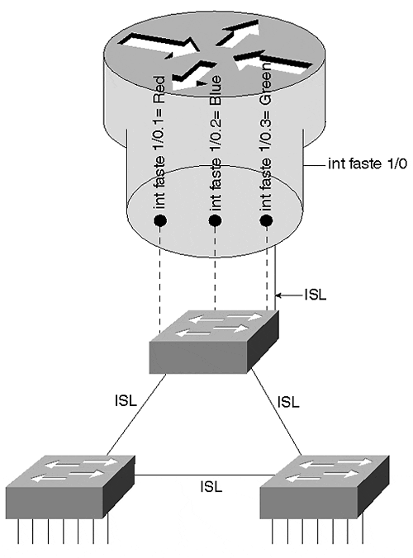
Although any trunking technology such as ISL, 802.1Q, 802.10, LAN Emulation (LANE), or MPOA can be used, Ethernet-based approaches are most common (ISL and 802.1Q). Figure 11-3 uses ISL running over Fast Ethernet. The solid lines refer to the single physical link running between the top Catalyst and the router. The dashed lines refer to the multiple logical links running over this physical link.
The primary advantage of using a trunk link is a reduction in router and switch ports. Not only can this save money, it can reduce configuration complexity. Consequently, the trunk-connected router approach can scale to a much larger number of VLANs than the one-link-per-VLAN design.
However, there are disadvantages to the trunk-connected router configuration, including the following:
- Inadequate bandwidth for each VLAN
- Additional overhead on the router
- Older versions of the IOS only support a limited set of features on ISL interfaces
With regard to inadequate bandwidth for each VLAN, consider, for example, the use of a Fast Ethernet link where all VLANs must share 100 Mbps of bandwidth. A single VLAN could easily consume the entire capacity of the router or the link (especially if there is a broadcast storm or Spanning Tree problem).
With regard to the additional overhead on the router caused by using a trunk-connected router, not only must the router perform normal routing and data forwarding duties, it must handle the additional encapsulation used by the trunking protocol. Take ISL running on a 7500 router as an example. Cisco's software-based routers have a number of different switching modes, a term that Cisco uses to generically refer to the process of data forwarding in a router.
Note
Don't confuse the term switching here with how it normally gets used throughout this book. These software-based routers use the term switching to refer to the process of forwarding frames through the box, regardless of whether the frames are routed or bridged.

Every Cisco router supports multiple forwarding techniques. Although a full discussion of these is not appropriate for a campus-oriented book, it is easiest to think of them as gears in an automobile transmission. For example, just as every car has a first gear, every Cisco router (including low-end routers such as the 2500) supports something called Process Switching. Process Switching relies on the CPU to perform brute-force routing on each and every packet. Just as first gear is useful in all situations (uphill, flat roads, rain, snow, dry, and so on), Process Switching can route all packets and protocols. However, just as first gear is the slowest in a car, Process Switching is slowest forwarding technique for a router.
Every Cisco router also has a second gear—this is referred to as Fast Switching. By taking advantage of software-based caching techniques, it provides faster data forwarding. However, just as second gear is not useful in all situations (going up a steep hill, starting away from a traffic signal, and so on), Fast Switching cannot handle all types of traffic (for example, many types of SNA traffic).
Finally, just as high-end automobiles offer fancy six-speed transmissions, high-end Cisco routers offer a variety of other switching modes. These switching modes go by names such as Autonomous Switching, Silicon Switching, Optimum Switching, and Distributed Switching. Think of these as gears three, four, five, and six (respectively) in a Ferrari's transmission—they can allow you to move very quickly, but can be useful only in ideal conditions and very limited situations (that is, dry pavement, a long country road, and no police!).
Getting back to the example of an ISL interface on a 7500 router, 7500 routers normally use techniques such as Optimum Switching and Distributed Switching to achieve data forwarding rates from 300,000 to over 1,000,000 packets per second (pps).
Note
Several performance figures are included in this chapter to allow you to develop a general sense of the throughput you can expect from the various Layer 3 switching options. Any sort of throughput numbers are obviously highly dependent on many factors such as configuration options, software version, and hardware revision. You should not treat them as an absolute indication of performance (in other words, "your mileage may vary").

However, when running ISL, that interface becomes limited to second gear Fast Switching. Because of this restriction, ISL routing is limited to approximately 50,000 to 100,000 pps on a 7500 (and considerably less on many other platforms).
Some of this limitation is due to the overhead of processing the additional 30-byte ISL encapsulation. With older interfaces such as the Fast Ethernet Interface Processor (FEIP), this can be especially noticeable because the second CRC (cyclic redundancy check) contained in the ISL trailer must be performed in software. In the case of newer interfaces such as the PA-FE (Fast Ethernet port adapter for 7200 and VIP interfaces) or the FEIP2, hardware assistance has been provided for tasks such as the ISL CRC. However, even in the case of the PA-FE and the FEIP2, the Fast Switching limitation remains.
Tip
The RSM Versatile Interface Processor (VIP) (the card into which you put port adapters) is not the same as a 7500 VIP. It is port adapters themselves that are the same in both platforms.

Note that switching routers such as the Catalyst 8500s use ASICs to handle ISL and 802.1Q encapsulations, effectively removing the overhead penalty of trunk links. However, devices such as the 8500 are rarely deployed in router-on-a-stick configurations. See the section on 8500-style switching routers later in this chapter.
Tip
Software-based routers containing Fast Ethernet interfaces, such as the 7500, 7200, 4000, and 3600, are limited to Fast Switching speeds for ISL operations. ASIC-based routers such as the Catalyst 8500 do not have this limitation and can perform ISL routing at wire speed.

The third disadvantage of the trunk-connected router design is that older versions of the IOS only support a limited set of features on ISL interfaces. Although most limitations were removed in 11.3 and some later 11.2 images, networks using older images need to carefully plan the inter-VLAN routing in their network. Some of the more significant limitations prior to 11.3 include the following:
- Support for only IP and IPX. All other protocols (including AppleTalk and DECnet) must be bridged. Inter-VLAN bridging is almost always a bad idea and is discussed later in the section "Integration between Routing and Bridging."
- IPX only supports the novell_ether encapsulation (Novell refers to this as Ethernet_802.3).
- HSRP is not supported. This can make it very difficult or impossible to provide default gateway redundancy.
- Secondary IP addresses are not supported.
Tip
ISL interfaces prior to 11.3 (and some later versions of 11.2) only support a limited set of protocols and features. 11.3+ code addresses all four of the issues mentioned in the preceding list.

As discussed in Chapter 9, "Trunking with LAN Emulation," subinterfaces allow Cisco routers to create multiple logical partitions on a single physical interface. Just as subinterfaces allow each ELAN on a single ATM interface to belong to its own logical grouping, subinterfaces on Fast Ethernet (or other media) interfaces allow a logical partition for each VLAN. If the physical interface is Fast Ethernet1/0 (this is also called the major interface), subinterfaces can use designations such as Fast Ethernet1/0.1, Fast Ethernet1/0.2, and Fast Ethernet1/0.3. For example, the configuration in Example 11-2 configures a Fast Ethernet port to perform ISL routing for three VLANs.

Example 11-2 ISL Router-on-a-Stick Configuration
interface FastEthernet1/0 no ip address ! interface FastEthernet1/0.1 encapsulation isl 1 ip address 10.1.1.1 255.255.255.0 ! interface FastEthernet1/0.2 encapsulation isl 2 ip address 10.1.2.1 255.255.255.0 ipx network 2 ! interface FastEthernet1/0.3 encapsulation isl 3 ip address 10.1.3.1 255.255.255.0 appletalk cable-range 300-310 304.101 appletalk zone ZonedOut ipx network 3
The major interface contains no configuration statements (the no ip address command appears by default). One subinterface is created per VLAN. Each subinterface must receive the encapsulation isl vlan command to specify the VLAN to associate with that subinterface. (This must be done before the IP and AppleTalk parameters are configured, otherwise the router generates an error message.) Commands specific to each VLAN are also placed on the subinterface. For example, the first subinterface (Fast Ethernet1/0.1) is configured to handle VLAN 1. Because only an IP address is specified on this subinterface, the router does not perform services for other protocols that might be present in VLAN 1. On the other hand, subinterface 1/0.3 is used to handle traffic for IP, IPX, and AppleTalk.
Notice that this router must be running 11.3+ code to support the AppleTalk protocol. Also notice that this configuration is functionally identical to the example presented in the "One-Link-per-VLAN" section.
Tip
Although the router allows the subinterface numbers and VLAN numbers to differ, using the same numbers provides easier maintenance. For example, configure VLAN 2 on subinterface X.2 (where X equals the major interface designation).

When to Use the Router-On-A-Stick Design
In general, the router-on-a-stick approach to inter-VLAN routing is most appropriate when other options are not available. This is not to say that the router-on-a-stick design is a poor choice, it is only a reflection that other options tend to provide higher throughput and functionality. Also, because the router-on-a-stick technique functions as if the router were sitting on the edge of the network (at least as far as the Layer 2 network is concerned), it tends to be less tightly integrated with the rest of the campus network. Newer approaches, such as MLS and the 8500s, seek to place routing in the middle of the network where it can have a greater influence on the overall scalability and stability of the network. However, before looking into MLS and 8500 technology, the next section looks at Cisco's first attempt to provide a more integrated approach to inter-VLAN routing—the Catalyst 5000 Catalyst Route Switch Module (RSM).

The RSM
In the case of the router-on-a-stick design, traffic flows to the router within the source VLAN where it is routed into the destination VLAN. This created an out and back flow to the router. Technically, the Catalyst 5000 RSM uses a very similar flow, but with one important difference: the stick becomes the Catalyst 5000 backplane (the high-speed switching path used inside the Catalyst chassis). This difference provides two key benefits:
- Speed
- Integration
Because the RSM directly connects to the Catalyst 5000 backplane, it allows the router to be much more tightly integrated into the Catalyst switching mechanics. Not only can this ease configuration tasks, it can provide intelligent communication between the Layer 2 and Layer 3 portions of the network (several examples are discussed later in the chapter). Also, because it provides a faster link than a single Fast Ethernet ISL interface, the performance can be greater. In general, the RSM provides 125,000–175,000 pps for IP and approximately 100,000 pps for other protocols.
Tip
If necessary, more than one RSM can be used in a single Catalyst chassis for additional throughput.

RSM Configuration
One of the appealing benefits of the RSM is its familiarity. From a hardware perspective, it is almost identical to an RSP2 (the second version of the Route Switch Processor) from a Cisco 7500. It has the same CPU and contains the same console and auxiliary ports for out-of-band configuration. It has its own flash, dynamic random-access memory (DRAM), and nonvolatile random-access memory (NVRAM). And, because it runs the full IOS, RSM is configured almost exactly like any Cisco router.
Tip
Although the IOS is identical from a configuration standpoint, do not try to use a 7500 router image on an RSM—the RSM uses its own image sets. Under Cisco's current naming convention, RSM images begin with the characters c5rsm.

The most obvious modification is a set of dual direct memory access (DMA) connections to the Catalyst 5000 backplane. (The backplane connection remains 1.2 Gbps even in 3.6 Gbps devices such as the Catalyst 5500.) The status of these two connections is indicated by the Channel 0 and Channel 1 LEDs on the front panel. Each channel provides 200 Mbps of throughput for a total of 400 Mbps.
Because the RSM runs the full IOS and contains its own image and memory, it shares some of the same configuration aspects as the LANE module discussed in Chapter 9. To configure the RSM, you need to enter the session slot command. For example, to configure an RSM located in slot 3, you enter session 3. This instantly transports you from the Catalyst world of set and show commands to the router world of config t. The full range of IOS help and command-line editing features are available. The RSM also requires you to save your configuration changes to NVRAM using the copy run start command.
Tip
Don't forget to save your RSM configurations with copy run start or write mem. Unlike the Catalyst Supervisor, the RSM does not automatically save configuration changes.

Although the session command is the most common way to configure an RSM, the console and auxiliary ports can be useful in certain situations. Many organizations use the auxiliary port to connect a modem to the Catalyst. This is especially useful for Supervisors that do not contain an Aux port (or, in the case of the Catalyst 5000 Supervisor III, where the Aux port is not enabled).
Tip
The session command opens a Telnet session across the Catalyst's backplane. The destination address is 127.0.0.slot_number + 1. For example, slot 3 uses 127.0.0.4. Some versions (but unfortunately not all) of the RSM code allow you to enter telnet 127.0.0.2 to Telnet from the RSM to the Supervisor in slot 1 (or 127.0.0.3 for slot 2). This can very useful when accessing the box from a modem connected to the RSM's auxiliary port. If the code on your RSM does not permit the use of the 127.0.0.X addresses, use normal IP addresses assigned to both SC0 and an RSM interface. However, this obviously requires a valid configuration on the Supervisor before you remotely dial into the RSM.

Just as the auxiliary port is useful for connecting a modem to the Catalyst, the RSM's console port is useful for password recovery operations.
Tip
RSM password recovery is identical to normal Cisco router password recovery. See the IOS "System Management" documentation for more details.

RSM Interfaces
The RSM uses interfaces just as any Cisco router does. However, instead of using the usual Ethernet0 and Fast Ethernet1/0, the RSM uses virtual interfaces that correspond to VLANs. For example, interface vlan 1 and interface vlan 2 can be used to create interfaces for VLANs 1 and 2, respectively. These virtual interfaces are automatically linked to all ports configured in that VLAN on the Catalyst Supervisor. This creates a very flexible and intuitive routing platform. Simply use the set vlanvlan_number port_list command on the Supervisor to make VLAN assignments at will, and the RSM automatically reflects these changes.
Tip
RSMs do not use subinterfaces for VLAN configuration. Instead, the RSM uses virtual VLAN interfaces (that function as major interfaces). In fact, these VLAN interfaces currently do not support subinterfaces.

Except for the earliest versions of RSM code, RSM virtual interfaces only become active if the Supervisor detects active ports that have been assigned to that VLAN. For example, if VLAN 3 has no ports currently active, a show interface vlan 3 command on the RSM shows in the interface in the down state. If a device in VLAN 3 boots, the RSM's VLAN 3 interface enters the up state. This value-added feature further reflects the tight integration between the Supervisor and RSM and is useful for avoiding black hole routing situations.
Tip
You cannot activate an RSM interface until the corresponding VLAN has one or more active ports.

This black hole prevention feature can be controlled through the use of the set rsmautostate [ enable| disable ] Supervisor command. In modern Catalyst images, this feature is enabled by default.
The RSM contains no VLANs by default. The VLAN virtual interfaces are created as interface vlan commands are first entered. Each VLAN interface can then be configured with the addressing and other parameters associated with that VLAN. For example, the code sample in Example 11-3 creates three interfaces that correspond to three VLANs.

Example 11-3 RSM Configuration
interface Vlan1 ip address 10.1.1.1 255.255.255.0 ! interface Vlan2 ip address 10.1.2.1 255.255.255.0 ipx network 2 ! interface Vlan3 ip address 10.1.3.1 255.255.255.0 appletalk cable-range 300-310 304.101 appletalk zone ZonedOut ipx network 3
As with the earlier examples, Vlan1 is only used for IP traffic. Vlan2 adds support for IPX routing, and Vlan3 is running IP, IPX, and AppleTalk services.
Tip
RSM interfaces are in a shutdown state when they are first created. Don't forget to use the no shutdown command to enable them.

Troubleshooting with the RSM
The usefulness of an RSM can go way beyond being a tightly integrated router—it can be a very powerful troubleshooting tool. Because the RSM uses the full IOS, you have access to all of the debug and show commands normally present on any Cisco router. Extended ping and trace can be very useful when the more limited capabilities of the Supervisor's tools have failed to reveal the problem. For example, Example 11-4 shows some of the extended ping options.

Example 11-4 Using the RSM for Extended pings
RSM# ping Protocol [ip]: Target IP address: 10.1.1.55 Repeat count [5]: 100000 Datagram size [100]: 1024 Timeout in seconds [2]: Extended commands [n]: y Source address or interface: Type of service [0]: Set DF bit in IP header? [no]: y Validate reply data? [no]: y Data pattern [0xABCD]: 0000 Loose, Strict, Record, Timestamp, Verbose[none]: Sweep range of sizes [n]: Type escape sequence to abort. Sending 100000, 1024-byte ICMP Echos to 10.1.6.100, timeout is 2 seconds: Packet has data pattern 0x0000 !!!!!!!!!!!!!!!!!!!!!!!!!!!!!!!!!!!!!!!!!!!!!!!!!!!!!!!!!!!!!!!
Example 11-4 illustrates the use of the repeat count, datagram size, and data pattern options. Respectively, these can be useful when trying to create a sustained stream of rapid-fire pings, to probe for maximum transmission unit (MTU) problems, and to detect ones-density problems on serial links.
However, the most powerful troubleshooting advantage to the RSM is debug. For example, debug ip icmp or debug ip packet[access-list-number] can be extremely useful when trying to track down the reason why some ping operation mysteriously fails.
The usual caveats about debug output volumes apply, though. Be very careful, especially when using commands such as debug ip packet in production networks. It is almost always advisable to use the access-list-number parameter to very specifically limit the amount of output. Also, because the RSM automatically sends debug output to a connection made via the session command, the terminal monitor command is not necessary.
Tip
To make it easier to enter commands while the router is generating debug or informational output, use the logging synchronous line command. For the RSM, it is most useful to enter this under line vty 0 4. However, this command can be useful on all of Cisco's router platforms running 10.2+ code (in which case it should also be applied to line con 0 and line aux 0).

When to Use the RSM
Using an RSM in conjunction with a Catalyst 5000 can be a very effective combination for medium-sized networks with moderate Layer 3 bandwidth requirements. Although it is faster than most router-on-a-stick implementations, its speed is not enough for many larger campus backbone applications. Instead, it is the RSMs integration into the Catalyst 5000 architecture that makes it most appealing. Features such as ease of configuration, an intuitive interface, a wide range of supported capabilities, and troubleshooting capabilities are its strengths.
The RSM can also be extremely useful for organizations deploying switched infrastructures in remote offices. This requirement can be met by utilizing the Versatile Interface Processor (VIP) option for the RSM. This is a separate card that literally bolts on top of the RSM to become a two-slot card in the Catalyst. The RSM and the VIP do not communicate over the Catalyst backplane. Instead, a pair of ribbon cables are used to create miniature CyBuses as are used in a 7500-style router. The VIP then accepts a wide variety of 7200-style Port Adapters. This can allow wide-area serial and ATM links to be directly connected to the Catalyst chassis. Therefore, the RSM can not only provide inter-VLAN routing, it can also perform WAN routing duties.
Tip
Be careful when using the HSSI port adapter (typically used for T3 connections) with the RSM VIP because it can overload the power supplies on some models. Check the current release notes for the latest list of models that are affected by this.

As discussed earlier, the RSM is a software-based routing device that cannot provide enough Layer 3 performance for larger campus networks on its own. However, another appealing benefit to the RSM is that it can be easily upgraded to provide hardware-based forwarding via MLS, the subject of the next section.

MLS
Multilayer Switching (MLS) is Cisco's Ethernet-based routing switch technology. MLS is currently supported in two platforms: the Catalyst 5000 and the Catalyst 6000. The Catalyst 5000 makes use of the NetFlow Feature Card (NFFC) I or II to provide hardware-assisted routing. The Catalyst 6000 performs the same operations using the Multilayer Switch Feature Card (MSFC) in conjunction with the Policy Feature Card (PFC). In keeping with the chronological presentation of this chapter, this section focuses on the Catalyst 5000's implementation of MLS. The Catalyst 6000's Layer 3 capabilities are discussed in the "Catalyst 6000 Layer 3 Switching" section later in the chapter and in Chapter 18, "Layer 3 Switching and the Catalyst 6000/6500s." Also, although MLS supports both IP and IPX traffic, this section focuses on IP.
Note
IPX MLS is supported on all Catalyst 6000s using a Multilayer Switch Feature Card (MSFC, discussed later in the chapter). IPX MLS is supported on Catalyst 5000s using a NFFC II and 5.1+ software.

In its most basic sense, the NFFC is a pattern-matching engine. This allows the Catalyst to recognize a wide variety of different packets. By matching on various combinations of addresses and port numbers, the routing switch form of Layer 3 switching can be performed. However, a host of other features are also possible. By matching on Layer 3 protocol type, a feature called Protocol Filtering can be implemented. By matching on Internet Group Management Protocol (IGMP) packets, the Catalyst can perform IGMP Snooping to dynamically build efficient multicast forwarding tables. Finally, by matching on Layer 2 and Layer 3 QoS and COS information, traffic classification and differentiation can be performed.
This section initially only considers the Layer 3 switching aspects of the NFFC. The other capabilities are addressed at the end of the section (as well as in other chapters such as Chapter 13, "Multicast and Broadcast Services" ).
One of the important things to keep in mind when discussing MLS is that, like all shortcut switching mechanisms, it is a caching technique. The NFFC does not run any routingprotocols such as OSPF, EIGRP, or BGP.
It is also important to realize that MLS, formerly known as NetFlow LAN Switching, is a completely different mechanism than the NetFlow switching on Cisco's software-based routers. In its current implementation, NetFlow on the routers is targeted as a powerful data collection tool via NetFlow Data Export (although it can also be used to reduce the overhead associated with things like complex access lists). Although MLS also supports NetFlow Data Export (NDE), its primary mission is something very different—Layer 3 switching.
Because the NFFC does not run any routing protocols, it must rely on its pattern-matching capabilities to discover packets that have been sent to a router (notice this is the device running protocols such as OSPF) and then sent back to the same Catalyst. It then allows the NFFC to shortcut future packets in a manner that bypasses the router. In effect, the NFFC notices that it sent a particular packet to the router, only to have the router send it right back. It then says to itself, "Boy, that was a waste of time!" and starts shortcutting all remaining packets following this same path (or flow).
Note
NetFlow defines a flow as being unidirectional. Therefore, when two nodes communicate via a bi-directional protocol such as Telnet, two flows are created.

Although MLS is fundamentally a very simple technique, there are many details involved. The following section presents an in-depth account of the entire MLS mechanism. Later sections examine how to configure and use MLS.

Detailed MLS Theory of Operations
MLS makes use of three components:
- MLS Route Processor (MLS-RP)
- MLS Switching Engine (MLS-SE)
- Multilayer Switching Protocol (MLSP)
The MLS-RP acts as the router in the network (note that more than one can be used). This device handles the first packet in every flow, allowing the MLS-SE to build shortcut entries in a Layer 3 CAM table. The MLSP is a lightweight protocol used by the MLS-RP to initialize the MLS-SE and notify it of changes in the Layer 3 topology or security requirements. For simplicity, this chapter usually refers to the MLS-RP as the router and the MLS-SE as the NFFC.
MLS uses a four-step process:
Step 1. MLSP hello packets are sent by the router
Step 2. The NFFC identifies candidate packets
Step 3. The NFFC identifies enable packets
Step 4. The NFFC shortcuts future packets
The following sections describe each of these steps using the sample network shown in Figure 11-4.

Figure 11-4 Sample MLS Network
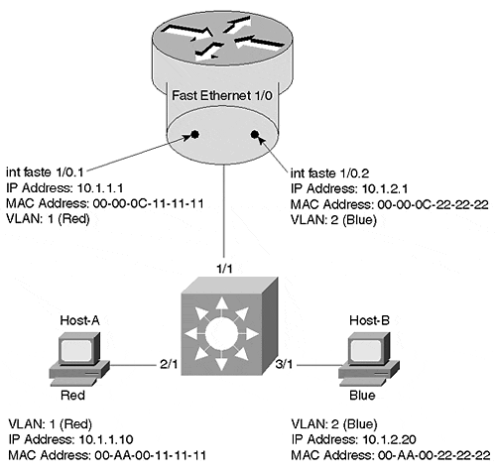
This network consists of two VLANs, VLAN 1 (Red) and VLAN 2 (Blue). Two end stations have been shown. Host-A has been assigned to the Red VLAN, and Host-B has been assigned to the Blue VLAN. An ISL-attached router has also been included. Its single Fast Ethernet interface (Fast Ethernet1/0) has been logically partitioned into two subinterfaces, one per VLAN. The IP and MAC addresses for all devices and subinterfaces are shown.
Figure 11-4 portrays the router as an ISL-attached external device using the router-on-a-stick configuration. Other possibilities include an RSM or a one-interface-per-VLAN attached router.

Step 1: MLSP Hello Packets Are Sent by the Router
When the router first boots, it begins sending MLSP hello packets every 15 seconds. These packets contain information on the VLANs and MAC addresses in use on the router. By listening for these hello packets, the NFFC can learn the attributes of any MLS-capable routers in the Layer 2 network. The NFFC associates a single XTAG value with every MLS router that it identifies. Because the MLSP hellos are periodic in nature, they allow routers and Catalysts to boot at random times while also serving as a router keepalive mechanism for the NFFC (if a router goes offline, its cache entries are purged).
Tip
There is one XTAG per MLS-capable router. The XTAG serves as a single handle for a router's multiple MAC addresses (each interface/VLAN could be using a different MAC address). XTAGs are locally significant (different NFFCs can refer to the same router with different XTAGs).

Figure 11-5 illustrates the MLS hello process.

Figure 11-5 MLS Hello Process
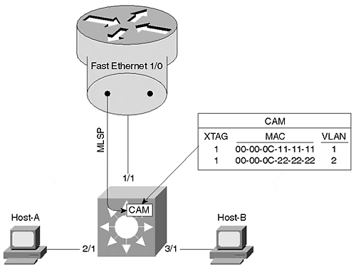
As shown in Figure 11-5, the MLSP packets are sourced from subinterface Fast Ethernet1/0.1 on the router (this is a configurable option; the router commands are presented later). These packets are then used to populate the Layer 2 CAM table (a form of bridging table commonly used in modern switches) with special entries that are used to identify packets going to or coming from a router interface (the show cam Catalyst command places an R next to these entries). Each router is also assigned a unique XTAG value. If a second router were present in Figure 11-5, it would receive a different XTAG number than the value of 1 assigned to the first router. However, notice that all MAC addresses and VLANs for a single router are associated with a single XTAG value.
Although it is not illustrated in Figure 11-5, the MLSP hello packets flow throughout the Layer 2 network. Because they are sent using a multicast address (01-00-0C-DD-DD-DD, the same address used by CGMP), non-MLS-aware switches simply flood the hello packets to every segment in VLAN 1. In this way, all MLS switches learn about all MLS-capable routers.

Step 2: The NFFC Identifies Candidate Packets
After Step 1 has allowed the NFFC to acquire the addresses of the MLS-capable routers, the NFFC starts using its pattern-matching capabilities to look for packets that are destined to these addresses. If a packet is headed to the router and does not have an existing shortcut entry (if it did have a shortcut entry, it would skip this step and be shortcut switched), it is classified as a candidate packet. The packet uses the normal Catalyst Layer 2 forwarding process and gets forwarded out the port connected to the router.
Note
Candidate packets must meet the following criteria:
- They have a destination address equal to one of the router MAC addresses learned via MLSP.
- They do not have an existing shortcut entry.

For example, refer to Figure 11-6 and assume that Host-A Telnets to Host-B. Recognizing that Host-B is in a different subnet, Host-A sends the packets to its default gateway, subinterface 1/0.1 on the router.

Figure 11-6 A Candidate Packet
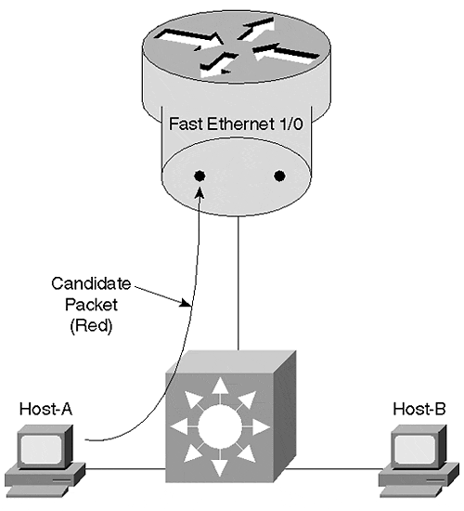
Figure 11-7 illustrates the relevant fields in this packet as it traverses the ISL link to the router.

Figure 11-7 Candidate Packet Fields
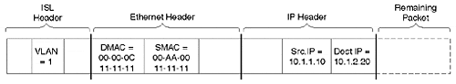
The ISL header contains a VLAN ID of 1. The Ethernet header contains a source MAC address equal to Host-A and a destination MAC address equal to 00-00-0C-11-11-11, the MAC address of subinterface 1/0.1 on the router. The source and destination IP addresses belong to Host-A and Host-B, respectively. The switch uses the destination MAC address to perform two actions:
- It forwards the packet out Port 1/1 toward the router using Layer 2 switching.
- It recognizes the MAC address destination address as one of the router's addresses learned in Step 1. This triggers a lookup for an existing Layer 3 shortcut entry based on the destination IP address (other options are available, but these are discussed later). Assuming that a shortcut does not exist (it is a new flow), the packet is flagged as a candidate packet and a partial shortcut entry is created.

Step 3: The NFFC Identifies Enable Packets
The router receives and routes the packet as normal. Recognizing the destination address as being directly connected on subinterface Fast Ethernet1/0.2, the router sends the packet back across the ISL link encapsulated in VLAN 2 as illustrated in Figure 11-8.

Figure 11-8 An Enable Packet
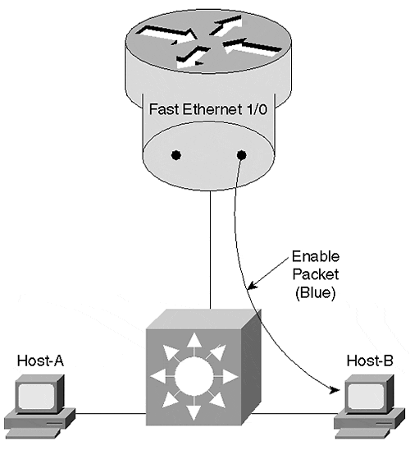
Figure 11-9 shows the relevant fields contained in the packet as it crosses the ISL link between the router and switch.

Figure 11-9 Enable Packet Fields
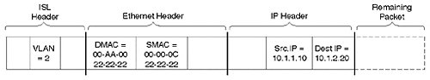
The router has rewritten the Layer 2 header. Not only has it changed the VLAN number in the ISL header, it has modified both MAC addresses. The source MAC address is now equal to 00-00-0C-22-22-22, the MAC address used on the router's Fast Ethernet1/0.2 subinterface, and the destination address is set to Host-B. Although the IP addresses have not been changed, the router must modify the IP header by decrementing the Time To Live (TTL) field and update the IP checksum.
As the packet traverses the Catalyst on its way from the router to Host-B, five functions are performed:
- The destination MAC address is used to Layer 2 switch the packet out Port 3/1.
- The NFFC recognizes the source MAC address as one of the entries created in Step 1 via the hello process.
- The NFFC uses the destination IP address to look up the existing partial shortcut entry created in Step 2.
- The NFFC compares the XTAG values associated with the source MAC address of this packet and the partial shortcut entry. Because they match, the NFFC knows that this is the enable packet coming from the same router targeted by the candidate packet.
- The NFFC completes the shortcut entry. This entry will contain all of the information necessary to rewrite the header of future packets (in other words, the fields shown in Figure 11-9).

Step 4: The NFFC Shortcuts Future Packets
As future packets are sent by Host-A, the NFFC uses the destination IP address to look up the completed shortcut entry created in Step 3. Finding a match, it uses a rewrite engine to modify the necessary header information and then sends the packet directly to Host-B (the packet is not forwarded to the router). The rewrite operation modifies all of the same fields initially modified by the router for the first packet. From Host-B's perspective, it has no idea that the NFFC has intercepted the packet. Figure 11-10 illustrates this operation.

Figure 11-10 A Shortcut Packet
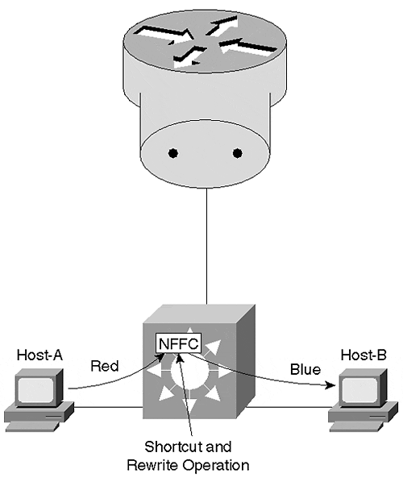
The rewrite mechanism can modify the following fields:
- Source and Destination MAC address
- VLAN ID
- TTL
- Encapsulation (for example, ARPA to SNAP)
- Checksums
- ToS/COS
Note
It is important to understand that, although MLS is a Cisco-specific feature, it is entirely standards compliant. Unlike some other shortcut and cut-through mechanisms, MLS makes all of the modifications that a normal router makes to an IP and IPX packet. In fact, if you were to use a protocol analyzer to capture traffic going through MLS and a normal router, you would not be able to tell the difference.

There are two options that MLS can use to rewrite the packet. In the first option, the NFFC card itself is used to rewrite the packet. The NFFC actually contains three rewrite engines, one per Catalyst 5500 bus. These rewrite engines are referred to as central rewrite engines. The downside of using a central rewrite engine is that it requires the packet to traverse the bus twice. For example, in Figure 11-10, the packet first arrives through Port 2/1 and is flooded across the backplane as a VLAN 1 frame. The NFFC is treated as the destination output port. After the NFFC has completed the shortcut lookup operation, it uses the rewrite information contained in the Layer 3 CAM table to update the packet appropriately. It then sends the rewritten packet back across the bus as a VLAN 2 frame, where the Layer 2 CAM table is used to forward it out Port 3/1. In other words, it crosses the bus first as a packet in the Red VLAN and again as a packet in the Blue VLAN. As a result, performance is limited to approximately 750,000 pps (on Catalyst 5000s).
The second rewrite option uses a feature called inline rewrite to optimize this flow. When using Catalyst modules that support this feature, the rewrite operation can be performed on the output module itself, allowing the packet to cross the bus a single time. Figure 11-11 illustrates the inline rewrite operation.

Figure 11-11 Inline Rewrite
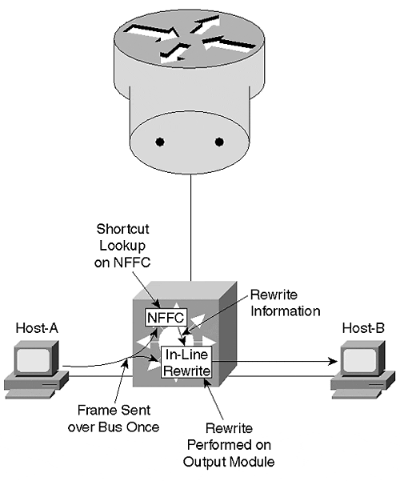
When the packet comes in from Host-A, it is flooded across the bus. All ports make a copy of the frame, including the destination Port 3/1 and the NFFC. The NFFC looks up the existing shortcut entry and sends just the rewrite information to Module 3 (this occurs on a separate bus from the data bus). Module 3 uses its local rewrite engine to modify the packet and immediately forwards it out Port 3/1. Because the frame only traversed the bus once, throughput is doubled to approximately 1,500,000 pps.
Note
The central rewrite versus inline rewrite issue is not a problem on the Calayst 6000 because all of its Ethernet line cards support inline rewrite.

Cache Aging
To prevent the MLS cache from overflowing, an aging process must be run. This is a software-controlled operation that runs in the background. Although the architecture of current NFFCs can theoretically hold 128,000 entries, it is recommended to keep the total number of entries below 32,000 on current versions of the card. MLS supports three separate aging times:
- Quick
- Normal
- Fast
Quick aging is utilized to age out partial shortcut entries that never get completed by an enable packet. The aging period for these entries is fixed at five seconds.
Normal aging is used for the typical sort of data transfer flow. This is a user-configurable interval that can range from 64 to 1,920 seconds with the set mls agingtime [agingtime] command. The default is 256 seconds. When changing the default value, it is rounded to the nearest multiple of 64 seconds.
Fast aging is used to age short-term data flows such as DNS, ping, and TFTP. The Fast aging time can be adjusted with the set mls agingtime fast [fastagingtime] [pkt_threshold] command. If the entry does not have more than pkt_thresholdpackets within fastagingtimeseconds, the entry is removed. By default, Fast aging is not enabled because the fastagingtimeme parameter is set to 0. The possible fastagingtime values are 0, 32, 64, 96, and 128 seconds (it uses the nearest value if you enter a different value). The pkt_threshold parameter can be set to 0, 1, 3, 7, 15, 31, or 63 (again, you can enter other values and it uses the closest possible value).

Access Lists and Flow Masks
One of the best features of MLS is that it supports access lists. Both standard and extended output IP access lists are available. This support relies on three mechanisms:
- The assumption that if a candidate packet fails an access list, the router never sends an enable packet to complete the shortcut
- The MLSP protocol to notify the NFFC to flush all shortcut entries if the access list is modified
- A flow mask
The first mechanism handles the case where a packet is forwarded to the router and never returned to any Catalyst because it failed an access list. As a result, MLS can be a safe and effective technique.
The MLSP flush mechanism provides important integration between the router and the NFFC. If the router is configured with an access list, the MLSP protocol can be used to cause all cache entries to be flushed (forcing new entries to be processed by the access list). The flush mechanism is also used to remove cache entries after a routing table change.
The flow mask is used to set the granularity with which the NFFC determines what constitutes a flow. In all, three flow masks are possible:
- Destination flow mask.
- Destination-source flow mask
- Full flow mask
A destination flow mask enables flows based on Layer 3 destination addresses only. A single shortcut is created and used for all packets headed to a specific destination IP (or IPX) address, regardless of the source node or application. This flow mask is used if no access lists are configured on the router.
A destination-source flow mask uses both the source and destination Layer 3 addresses. As a result, each pair of communicating nodes uses a unique shortcut entry. However, all of the applications flowing between each pair of nodes uses the same shortcut entry. This flow mask is used if a standard access list or a simple extended access list without port numbers is in use on the router.
A full flow mask uses Layer 4 port numbers in addition to source and destination Layer 3 addresses. This creates a separate shortcut for every application flowing between every pair of nodes. By doing so, a full flow mask provides the highest level of control and allows the NFFC to perform Layer 4 switching. Because it tracks flows at the application level, it can also be used to provide very detailed traffic statistics via NetFlow Data Export (NDE), a feature that is discussed in more detail later. The full flow mask is applied if extended access lists referencing port numbers are in use.
For example, consider the network shown in Figure 11-12.

Figure 11-12 A Sample MLS Network
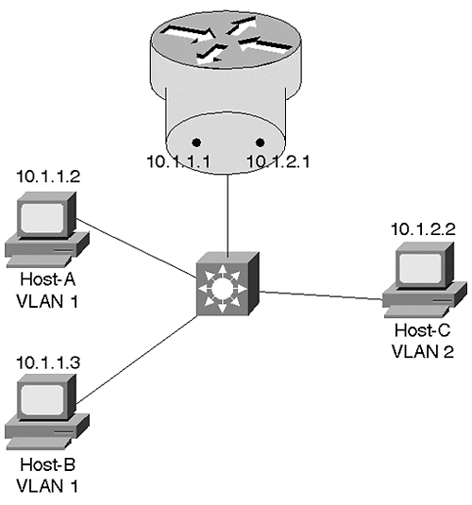
Host-A and Host-B are assigned to VLAN 1, whereas Host-C is in VLAN 2. The Catalyst and the router have been correctly configured for MLS. Example 11-5 shows the output of the show mls entry command when using a destination flow mask.

Example 11-5 Sample show mls entry Output When Using a Destination Flow Mask
Cat-A> (enable) show mls entry Last Used Last Used Destination IP Source IP Prot DstPrt SrcPrt Destination Mac Vlan Port --------------- --------------- ---- ------ ------ ----------------- ---- ----- MLS-RP 10.1.1.1: 10.1.1.2 10.1.2.2 TCP 11000 Telnet 00-00-0c-7c-3c-90 1 2/16 10.1.1.3 10.1.2.2 ICMP - - 00-60-3e-26-96-00 1 2/15 10.1.2.2 10.1.1.3 ICMP - - 00-00-0c-5d-0b-f4 2 2/17
Because only three destination IP addresses exist between the two VLANs in this network, only three lines are displayed with a destination flow mask. Notice that all of the traffic flowing to a single destination address uses a single shortcut entry. Therefore, each line in the output only shows information on the most recent packet going to each destination. This fact is reflected in the column headers that use names such as Last Used Source IP.
Example 11-6 shows the same output after a destination-source flow mask has been configured.

Example 11-6 Sample show mls entry Output When Using a Destination-Source Flow Mask
Cat-A> (enable) show mls entry Last Used Destination IP Source IP Prot DstPrt SrcPrt Destination Mac Vlan Port --------------- --------------- ---- ------ ------ ----------------- ---- ----- MLS-RP 10.1.1.1: 10.1.1.3 10.1.2.2 ICMP - - 00-60-3e-26-96-00 1 2/15 10.1.2.2 10.1.1.3 ICMP - - 00-00-0c-5d-0b-f4 2 2/17 10.1.1.2 10.1.2.2 TCP 61954 Telnet 00-00-0c-7c-3c-90 1 2/16 10.1.2.2 10.1.1.2 TCP Telnet 61954 00-00-0c-5d-0b-f4 2 2/17
Example 11-6 displays two lines of output for every pair of nodes that communicate through the router (one for each direction). For example, the first two lines indicate that the last packets to travel between 10.1.1.3 and 10.1.2.2 was a ping (the first line shows the flow from 10.1.1.3 to 10.1.2.2, and the second line shows the flow in the opposite direction). The last two lines show the two sides of a Telnet session between 10.1.1.2 and 10.1.2.2 (notice how the source and destination port number numbers are swapped). Notice that traffic between 10.1.1.2 and 10.1.1.3 do not show up (this information is Layer 2 switched and does not use MLS). Also notice that the "Last Used" header only applies to the Prot (protocol), DstPrt (destination port), and SrcPrt (source port) fields. It no longer applies to the Source IP field because every new source addresses creates a new shortcut entry.
Finally, Example 11-7 displays sample output after configuring a full flow mask.

Example 11-7 Sample show mls entry Output When Using a Full Flow Mask
Cat-A> (enable) show mls entry Destination IP Source IP Prot DstPrt SrcPrt Destination Mac Vlan Port --------------- --------------- ---- ------ ------ ----------------- ---- ----- MLS-RP 10.0.1.1: 10.0.1.2 10.0.2.2 TCP 11778 69 00-00-0c-7c-3c-90 1 2/16 10.0.2.2 10.0.1.3 TCP 110 11004 00-00-0c-5d-0b-f4 2 2/17 10.0.2.2 10.0.1.2 TCP 69 11778 00-00-0c-5d-0b-f4 2 2/17 10.0.1.2 10.0.2.2 TCP 65026 SMTP 00-00-0c-7c-3c-90 1 2/16 10.0.1.3 10.0.2.2 TCP 11002 Telnet 00-60-3e-26-96-00 1 2/15 10.0.1.2 10.0.2.2 TCP 12290 110 00-00-0c-7c-3c-90 1 2/16 10.0.1.2 10.0.2.2 TCP 11266 WWW 00-00-0c-7c-3c-90 1 2/16 10.0.1.2 10.0.2.2 TCP 64514 FTP 00-00-0c-7c-3c-90 1 2/16 10.0.2.2 10.0.1.2 TCP FTP 64514 00-00-0c-5d-0b-f4 2 2/17 10.0.2.2 10.0.1.3 TCP 69 11005 00-00-0c-5d-0b-f4 2 2/17 10.0.2.2 10.0.1.2 TCP WWW 63490 00-00-0c-5d-0b-f4 2 2/17 10.0.2.2 10.0.1.3 TCP 9 11001 00-00-0c-5d-0b-f4 2 2/17 10.0.2.2 10.0.1.3 ICMP - - 00-00-0c-5d-0b-f4 2 2/17 10.0.1.2 10.0.2.2 TCP 62978 9 00-00-0c-7c-3c-90 1 2/16 10.0.1.2 10.0.2.2 TCP 64002 20 00-00-0c-7c-3c-90 1 2/16 10.0.2.2 10.0.1.2 TCP Telnet 62466 00-00-0c-5d-0b-f4 2 2/17 10.0.1.2 10.0.2.2 TCP 63490 WWW 00-00-0c-7c-3c-90 1 2/16 10.0.1.2 10.0.2.2 TCP 62466 Telnet 00-00-0c-7c-3c-90 1 2/16 10.0.2.2 10.0.1.3 TCP Telnet 11002 00-00-0c-5d-0b-f4 2 2/17 10.0.2.2 10.0.1.2 TCP WWW 11266 00-00-0c-5d-0b-f4 2 2/17 10.0.1.3 10.0.2.2 TCP 11004 110 00-60-3e-26-96-00 1 2/15 10.0.2.2 10.0.1.2 TCP SMTP 65026 00-00-0c-5d-0b-f4 2 2/17 10.0.1.3 10.0.2.2 TCP 11005 69 00-60-3e-26-96-00 1 2/15 10.0.2.2 10.0.1.2 TCP 110 12290 00-00-0c-5d-0b-f4 2 2/17 10.0.2.2 10.0.1.3 TCP WWW 11003 00-00-0c-5d-0b-f4 2 2/17 10.0.1.3 10.0.2.2 TCP 11003 WWW 00-60-3e-26-96-00 1 2/15 10.0.2.2 10.0.1.2 TCP 20 64002 00-00-0c-5d-0b-f4 2 2/17 10.0.1.3 10.0.2.2 ICMP - - 00-60-3e-26-96-00 1 2/15 10.0.1.3 10.0.2.2 TCP 11001 9 00-60-3e-26-96-00 1 2/15 10.0.2.2 10.0.1.2 TCP 9 62978 00-00-0c-5d-0b-f4 2 2/17
Notice that Example 11-7 includes every pair of communicating applications (both IP addresses and port numbers are considered). Also notice that none of the fields include a Last Used header because all of the individual flows are fully accounted for.
The multiple flow masks allow the NFFC to track information at a sufficient level of granularity to ensure that denied packets do not slip through using a pre-existing shortcut entry. However, to be truly secure, input access lists need to process every packet. As a result, configuring an input access on the router disables MLS on that interface. However, an optional parameter was introduced in 12.0 IOS images to allow input access lists at the expense of some security risk. To enable this feature, specify the input-acl parameter on the end of the mls rp ip global router command (Step 1 in the five-step router configuration process discussed later).
Tip
The mls rp ip input-acl command can be used to enable input access lists at the expense of some fairly minor security risks.

If multiple routers are in use with different flow masks, all MLS-capable Catalysts use the most granular (longest) flow mask. In other words, if there are two routers without access lists and a third router with a standard access list, the destination-source flow mask is used.
If you are not using access lists but you want to use a source-destination or full flow mask, you can use the set mls {flow destination | destination-source | full } command to set a minimum flow mask. For example, by forcing the flow mask to full, you can collect detailed traffic statistics (see the "Using MLS" section).

Configuring MLS
Although the theory behind MLS is somewhat involved, it is fairly easy to configure. To fully implement MLS, you must separately configure the router and the Catalyst Supervisor.

MLS Router Configuration
To configure a Cisco router for MLS, use the following five-step process:
Step 1. Globally enable MLS on the router. To do this, use the mls rp ip command. This command must be entered from the global configuration mode (in other words, not on a particular interface or subinterface).
Step 2. Configure a VLAN Trunking Protocol (VTP) domain for each interface using the mls rp vtp-domain domain_name command. This is an interface configuration command. For ISL interfaces, it can only be entered on the major interface (all of the subinterfaces inherit the same VTP domain name). The vtp-domain command should be entered prior to completing the remaining steps. However, if no VTP domain has been assigned to the switches in your network, this step can be skipped.
Step 3. If a non-trunk interface is used on an external router, the mls rp vlan-id vlan_number command must be used to tell the router about VLAN assignments. This command must be entered before the remaining steps can be completed. On an ISL interface, this command is not required because the encap isl vlan_number command performs the same function. In the case of an RSM, this command is also not required because the RSM automatically receives VLAN information.
Step 4. Enable each MLS interface using the mls rp ip command. This is an interface or subinterface configuration command.
Step 5. Select one or more router interfaces to send MLSP packets using the mls rp management-interface command. Again, this is an interface or subinterface command. In general, you only enter it on a single interface. Choose an interface connected to a VLAN that reaches all of the MLS-capable Catalysts in your network. If the command is not entered at all, no MLSP packets are sent, preventing MLS from functioning.
Tip
If no VTP domain has been specified on the Catalysts (check this with show vtp domain), you do not need to set one on the router (in other words, the Null domain is used). If you use the mls rp ip or mls rp management-interface commands before specifying a VTP domain, the interface is automatically assigned to the Null domain. To change the domain name to something else, you need to remove all mls rp commands from that interface and start reconfiguring it from scratch (current versions automatically remove the mls rp commands when you enter no mls rp vtp-domain domain_name).

Example 11-8 illustrates a router MLS configuration that is appropriate for the example presented in Figures 11-4 through Figure 11-11.

Example 11-8 External Router MLS Configuration
mls rp ip ! interface FastEthernet1/0 mls rp vtp-domain Skinner ! interface FastEthernet1/0.1 ip address 10.1.1.1 255.255.255.0 mls rp management-interface mls rp ip ! interface FastEthernet1/0.2 ip address 10.1.2.1 255.255.255.0 mls rp ip
The corresponding RSM configuration appears as in Example 11-9.

Example 11-9 RSM Router MLS Configuration
mls rp ip ! interface Vlan1 ip address 10.1.1.1 255.255.255.0 mls rp vtp-domain Skinner mls rp management-interface mls rp ip ! interface Vlan2 ip address 10.1.2.1 255.255.255.0 mls rp vtp-domain Skinner mls rp ip
And finally, the same configuration running on a router using two Ethernet ports looks like Example 11-10.

Example 11-10 External Router MLS Configuration for Multiple Ethernet Ports
mls rp ip ! interface Ethernet0 ip address 10.1.1.1 255.255.255.0 mls rp vtp-domain Skinner mls rp vlan-id 1 mls rp management-interface mls rp ip ! interface Ethernet1 ip address 10.1.2.1 255.255.255.0 mls rp vtp-domain Skinner mls rp vlan-id 2 mls rp ip

MLS Switch Configuration
The switch configuration is considerably more straightforward. In fact, if you are using MLS in conjunction with an RSM that is located in the same chassis, no configuration is necessary on the Catalyst Supervisor. However, you must specify each MLS-capable router when using external routers. To do this, use the set mls include {route_processor_ip | route_processor_name} command. For example, to include an external router using the IP address 10.1.1.1, you should enter set mls include 10.1.1.1. Only include the IP address associated with the first MLS interface on the router.
Tip
The address to include is displayed on the mls ip address field of the show mls rp router command. Be sure to enter show mls rp on the router, not the Catalyst Supervisor.

The switch supports a set mls [enable | disable]. However, because MLS is enabled by default (given that you have the proper hardware and software), this command is not necessary.

Using MLS
Because the routing switch form of Layer 3 switching is a fairly new technique to most network administrators, this section takes a look at some of the more important MLS commands.

The show mls Command
One of the most important commands is the show mls Catalyst command. Several options are available for this command. In its basic form, show mls displays output similar to that included in Example 11-11.

Example 11-11 Output of show mls on the Catalyst Supervisor
Cat-A> (enable) show mls Multilayer switching enabled Multilayer switching aging time = 256 seconds Multilayer switching fast aging time = 0 seconds, packet threshold = 0 Current flow mask is Destination flow Configured flow mask is Destination flow Total packets switched = 0 Active shortcuts = 0 Netflow Data Export disabled Netflow Data Export port/host is not configured. Total packets exported = 0 MLS-RP IP MLS-RP ID XTAG MLS-RP MAC-Vlans ---------------- ------------ ---- --------------------------------- 10.1.1.1 00000c111111 2 00-00-0c-11-11-11 1 00-00-0c-22-22-22 2
The first three lines after the initial prompt tell you if MLS is enabled on this Catalyst and the configured aging timers. The next two lines indicate the flow mask currently in use and if a minimum flow mask has been configured. The Total packets switched and Active shortcuts lines can be very useful for keeping track of the amount of shortcut switching being performed and the size of your shortcut cache (as mentioned earlier, it is best to keep this value below 32,000 entries or current versions of the NFFC). The next three lines report the status of NetFlow Data Export, a feature that is discussed later. The bottom section lists all of the known routers, their XTAG values, and a list of the MAC addresses and VLANs.

The show mls entry Command
The show mls entry command is very useful when you want to examine the shortcut cache entries. Example 11-12 shows some sample output for the show mls entry command.

Example 11-12 Output of show mls entry
Cat-A> (enable) sh mls entry Last Used Last Used Destination IP Source IP Prot DstPrt SrcPrt Destination Mac Vlan Port --------------- --------------- ---- ------ ------ ----------------- ---- ----- MLS-RP 10.1.1.1: 10.1.1.9 10.1.2.99 TCP 1293 5001 00-60-08-b6-49-84 1 3/9 10.1.1.7 10.1.2.99 ICMP - - 00-60-08-b6-4a-49 1 3/13 10.1.2.99 10.1.1.7 ICMP - - 00-10-7b-3a-7b-97 2 3/18
Because the flow mask is set to destination, the cache only creates a single entry per destination address. Each cache entry is shown on a separate line. The Last Used Source IP, Protocol, Destination Port, and Source Port Fields show the characteristics of the packet that most recently used this shortcut entry. Because a single entry exists for all source nodes, protocols, and applications targeted to the destination address listed in the first column, it cannot list every type of packet individually (use a full flow mask for that level of detail).
If your cache is large, you probably want to use one of the options to filter the output. The full syntax for the show mls entry command is:

show mls entry {[destination ip_addr_spec] [source ip_addr_spec] | [flow protocol
[ccc] src_port dst_port]} [rp ip_addr]

For example, show mls entry rp 10.1.1.1 lists all of the cache entries created from router 10.1.1.1. show mls entry destination 10.1.2.20lists the entries created for packets containing a destination IP address of 10.1.2.20.

The show mls statistics entry Command
Packet and byte counts for each entry can be listed with show mls statistics entry. The output is similar to that of show mls entry except it includes two new fields at the end of each line as shown in Example 11-13.

Example 11-13 Output of show mls statistics entry
Cat-A> (enable) show mls statistics entry Destination IP Source IP Prot DstPrt SrcPrt Stat-Pkts Stat-Bytes --------------- --------------- ---- ------ ------ ---------- --------------- MLS-RP 10.1.1.1: 10.1.2.99 10.1.1.7 ICMP - - 6 456 10.1.1.9 10.1.2.99 ICMP - - 8 824 10.1.1.7 10.1.2.99 TCP 1037 Telnet 11 802

The show mls statistics protocol Command
If you are using a full flow mask, the show mls statistics protocol command can provide extremely useful application layer information such as that displayed in Example 11-14.

Example 11-14 Output of show mls statistics protocol
Cat-A> (enable) show mls statistics protocol Protocol TotalFlows TotalPackets TotalBytes ---------- ---------- ------------ -------------- Telnet 6 24 1641 FTP 2 6 390 WWW 8 30 5219 SMTP 2 6 390 X 0 0 0 DNS 2 6 390 Others 12 11543 9093664 Total 32 11615 9101694
This information is very similar to the output of the show ip cache flow router command. By listing traffic volumes by both packet and byte counts, it can be very useful for profiling your network.

The debug mls rp Command
On the router, debug mls rp commands can be used to troubleshoot various issues. Example 11-15 displays the available options.

Example 11-15 Available Options for the debug mls rp Command
Router# debug mls rp ? all mls all error mls errors events mls events ip mls ip events locator mls locator packets mls packets verbose packets mls verbose packets
As always, you should be very careful when using debug on production networks.

MLS Design Considerations
As discussed earlier, MLS can be characterized as a mechanism that caches "to the router and back" flows. Although this is a simple concept, it can be tricky to achieve in certain topologies and networks.
Tip
Note in advance that almost all of the issues discussed in this section can be avoided by simply making sure that every NFFC is paired with its own "internal router" such as the RSM (or RSFC). Because this automatically creates a "to the router and back" set of flows (across the blackplane of the Catalyst), it can dramatically simply your overall design considerations.

WAN Links
For example, MLS currently cannot be used on WAN links. Consider the network illustrated in Figure 11-13.

Figure 11-13 WAN Flows Defeat MLS
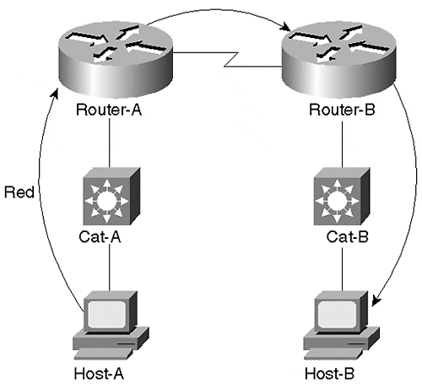
As with the earlier examples, Host-A is sending packets to Host-B. Recognizing that Host-B is on a different subnet, Host-A forwards all of the traffic to its default gateway, Router-A. The NFFC in Cat-A recognizes the first packet as a candidate packet and creates a partial shortcut entry. However, an enable packet is never received by Cat-A because the traffic is forwarded directly out the router's serial interface. The to the router and back flow necessary for MLS is not present. Because the shortcut entry is never completed, it ages out using the five-second quick aging scheme.

Using Multiple Router Ports
Although it is fairly obvious why MLS is not suitable for situations such as Figure 11-13, other situations can be far more subtle. The rule to remember is that the same NFFC must see the flow traveling to and from the router. For this to happen, the Catalyst performing MLS needs to participate in both VLANs/subnets. For example, the Catalysts shown in Figure 11-14 only contain a single VLAN.

Figure 11-14 Each Catalyst Contains Only a Single VLAN
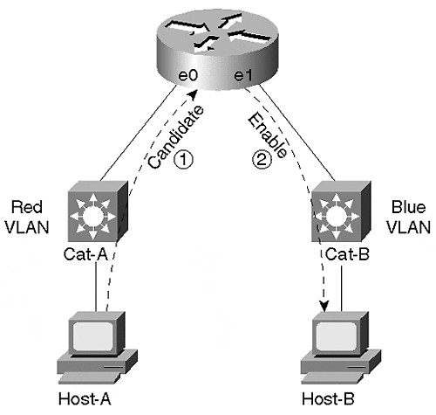
The results in Figure 11-14 are very similar to those in Figure 11-13. Cat-A sees the candidate packet, but only Cat-B sees the enable packet. Shortcut switching is not possible.
Tip
MLS requires that the same NFFC or MSFC/PFC must see the flow traveling to and from the router. This can require careful planning and design work in certain situations.

However, simply placing both VLANs on both switches does not necessarily solve the problem. In Figure 11-15, both Cat-A and Cat-B contain the Red and Blue VLANs. An ISL trunk has even been provided to create a contiguous set of Layer 2 bridge domains.

Figure 11-15 Although Both Switches Contain Both VLANs, MLS Is Not Possible
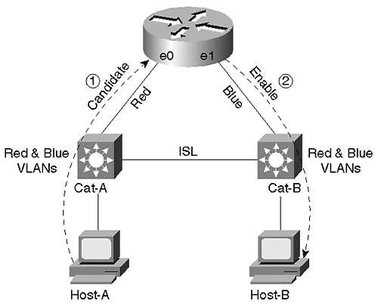
However, because non-trunk links are used to connect the router, the router only sends and receives traffic for the Red VLAN to/from Cat-A, whereas all Blue traffic flows to/from Cat-B. The effect of this is the same as in the previous two examples: Cat-A only sees the candidate packet because the enable packet is sent to Cat-B.

A Solution for Using Multiple Router Ports
Although several alternatives are available to fix this configuration, the simplest option involves connecting the router to a single Catalyst. At this point, the one-link-per-VLAN or the trunk-connected router designs are appropriate. For example, Figure 11-16 simply swings the interface Ethernet1 router link from Cat-B to Cat-A to employ the one-link-per-VLAN design.

Figure 11-16 Connecting the Router to a Single Catalyst Permits MLS
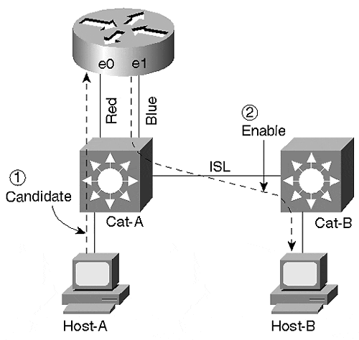
As shown in Figure 11-16, this forces all inter-VLAN traffic to flow through Cat-A and, therefore, makes shortcut switching possible.

The Spanning-Tree Protocol and MLS
But what if additional switches are added so that additional Layer 2 loops are introduced? For example, consider the network shown in Figure 11-17 (assume all three Catalysts are MLS-capable and the router is connected via an ISL link).

Figure 11-17 A More Complex Network Using MLS
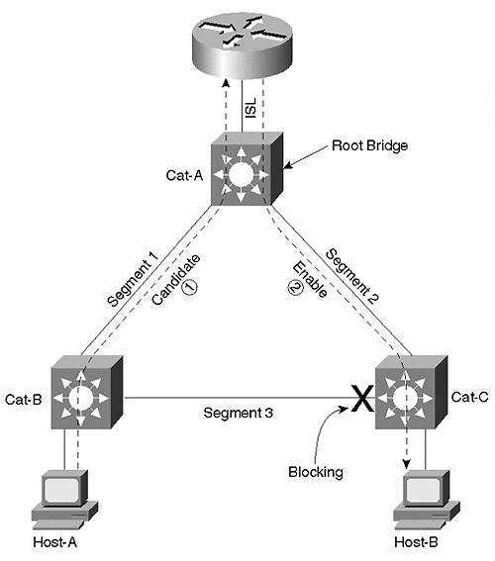
Because this is a redundant (that is, looped) Layer 2 topology, the Spanning-Tree Protocol becomes involved. Figure 11-17 assumes that Cat-A is functioning as the Root Bridge for all VLANs. This places one of the ports on Segment 3 in the Spanning Tree Blocking state. As a result, traffic flowing in the Red VLAN from Host-A to the router uses Segment 1. Both Cat-B and Cat-A recognize this as a candidate packet and create a partial shortcut entry. However, because traffic flowing from the router to Host-B uses Segment 2, only Cat-A sees the enable packet and creates a full shortcut entry. Cat-B's partial shortcut entry ages out in five seconds.
Consider what happens if Cat-B becomes the Spanning Tree Root Bridge. Figure 11-18 provides a diagram for this situation.

Figure 11-18 Cat-B Is the Spanning Tree Root Bridge
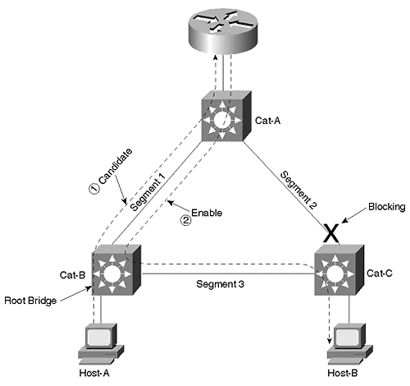
This causes Spanning Tree to reconverge to a logical topology where one of the ports on Segment 2 is Blocking. This allows the traffic from Host-A to the router to follow the same path as in Figure 11-17. Both Cat-A and Cat-B recognize the first packet as a candidate packet and create a partial shortcut entry. However, the traffic flowing from the router to Host-B cannot use Segment 2 because it is blocked. Instead, the traffic flows back through Cat-B and uses Segment 1 and Segment 3. Notice that this causes both Cat-A and Cat-B to see the Enable Packet and complete the shortcut entry.
When the second packet is sent from Host-A to Host-B, Cat-B uses its shortcut entry to Layer 3 switch the packet directly onto Segment 3, bypassing the router. Because Cat-A does not see any traffic for the shortcut entry it created, the entry ages out in 256 seconds by default. Although this allows MLS to function (in fact, it creates a more efficient flow in this case), it can be disconcerting to see the shortcut switching operation move from Cat-A to Cat-B only because of Spanning Tree. Obviously, the interaction between MLS and Spanning Tree can get very complex in large and very flat campus networks (yet one more reason to avoid the flat earth approach to campus design; see Chapters 14 and 15 for more information).

Using MLS on a Subset of Your Switches
Figures 11-17 and 11-18 assumed that all three Catalysts supported MLS. Subtleties can also arise if this is not the case. For example, what if Cat-A did not support MLS? In Figure 11-17, MLS would not be possible. Because Cat-A was the only switch to see both sides of the flow, it is the only device capable of performing MLS in this topology. However, MLS is possible in Figure 11-18, even if Cat-A is not MLS-capable. Because of the Spanning Tree reconvergence performed in Figure 11-18, Cat-B now sees both sides of the flow and can perform shortcut switching in the same manner as already explained.

Using Stacks of MLS Devices
This section considers the case where stacks of MLS-capable devices connect multiple end stations and Catalysts as shown in Figure 11-19.

Figure 11-19 Host-A Communicating with Host-B via MLS
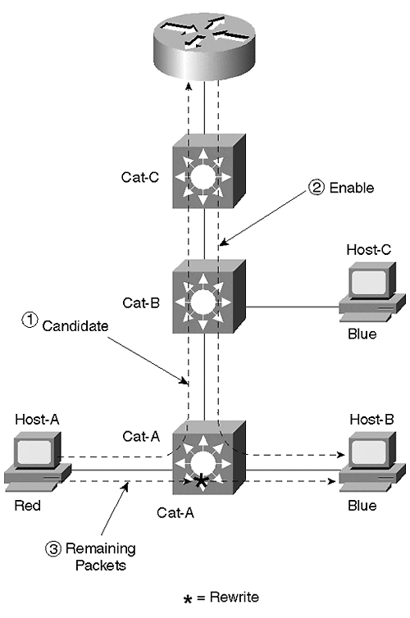
First, look at the case of Host-A sending traffic to Host-B. The traffic from Host-A to the router travels up the ISL links connecting the Catalysts and the router to each other. As the first packet hits the NFFC in each Catalyst, it is recognized as a candidate packet and three partial shortcut entries are created (one per Catalyst). As the packet travels back down from the router to reach Host-B, all three NFFC cards see the enable packet and complete the shortcut entries. However, as additional packets travel from Host-A to Host-B, Cat-A shortcut switches them directly to Host-B. The shortcut entries in Cat-B and Cat-C simply age out in 256 seconds (by default).
Now consider the flow from Host-A to Host-C. Again, all three NFFCs see the initial packet as a candidate packet. However, the return packet only passes through Cat-C and Cat-B. The partial shortcut entry in Cat-A ages out in five seconds. As Host-A sends additional packets, Cat-A uses normal Layer 2 switching to send the packets towards the MAC address of the router. When Cat-B receives the packets, it recognizes that it has a completed shortcut for this flow and shortcut switches the packets directly to Host-C. Cat-C's shortcut entry is not used and therefore ages out in 256 seconds. Figure 11-20 illustrates this sequence.

Figure 11-20 Host-A Communicating with Host-C via MLS
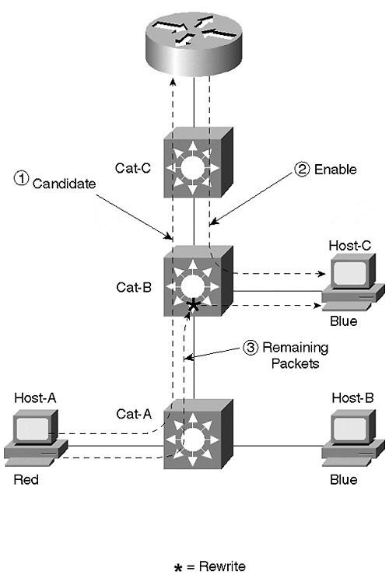

Using Multiple Routers with a Single MLS-Capable Catalyst
Finally, consider the case of multiple MLS-capable routers and a single MLS switch shown in Figure 11-21.

Figure 11-21 Two MLS Routers and One MLS Switch
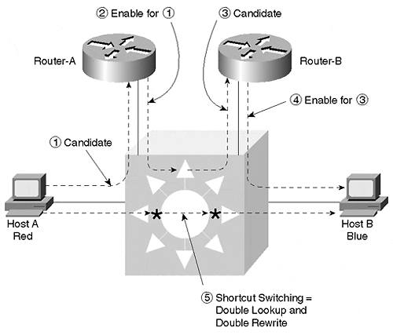
Here, Host-A is still located in the Red VLAN and Host-B is still located in the Blue VLAN. However, a new VLAN has been created between the two routers (call it the Purple VLAN). Host-A still sends traffic destined to Host-B to its default gateway using the Red VLAN. As the first packet passes through the Catalyst, the NFFC recognizes it as a candidate packet and creates a partial shortcut entry (labeled Step 1 in Figure 11-21). Router-A then forwards the traffic over the Purple VLAN to Router-B. As the packet passes back through the Catalyst, the NFFC recognizes the packet as an enable packet and completes the shortcut entry (Step 2 in Figure 11-21). However, it also recognizes the destination MAC address as that of Router-B and therefore sees this packet as another candidate packet (Step 3 in Figure 11-21). Router-B then routes the packet normally and forwards it to Host-B over the Blue VLAN. As the packet passes back through the Catalyst for the third time, it is identified as an enable packet for the partial entry created in Step 3. A second shortcut entry is created (Step 4 Figure 11-21).
When additional traffic flows from Host-A to Host-B (Step 5 in Figure 11-21), two sets of shortcut lookups and rewrite operations are performed. As a result, the additional packets are not sent to either router. Neat!

Other MLS Capabilities
One of the nicest things about using the NFFC for MLS is that it enables many other applications that extend beyond accelerated Layer 3 routing. Because the NFFC is at its most basic level a pattern-matching engine, these pattern-matching capabilities can be used to provide many interesting and powerful features as detailed in the following sections.

Protocol Filtering
Protocol Filtering is the capability of the NFFC to limit broadcast and multicast traffic on a per-port and per-protocol basis. As discussed in Chapter 5, "VLANs," it allows a group of nodes to be placed in a single VLAN and only receive traffic associated with the protocols they are actually running. Four groupings of protocols exist: IP, IPX, a combined group of AppleTalk and DECnet (some platforms also include VINES here), and a final group that contains all other protocols. By pattern matching on the protocol type information contained in the Layer 2 header, the NFFC can, for example, filter IPX SAPs on ports that are only using IP.
Protocol Filtering is disabled by default. To enable this feature, use the set protocolfilter enable command. To configure Protocol Filtering, use the set port protocol command:

set port protocol mod_num/port_num {ip|ipx|group} {on|off|auto}

The group parameter corresponds to AppleTalk and DECnet (and, in some cases, VINES). The on state forces that port to send broadcasts of the specified type. The off state forces that port to not send broadcasts of the specified type. The auto state only send broadcasts for the specified protocol if that protocol is detected coming in that port. This creates a dynamic configuration where the Catalyst is detecting the protocols being run on each port and only sending the appropriate broadcasts in response. IP defaults to the on state, and the other protocol categories (IPX and "group") default to auto.
The show protocolfilter command can be used to determine if Protocol Filtering is running on a device. The show port protocol command can be used to view the configuration on a per-port basis (including the number of nodes detected on a per port and per protocol basis). For ports and protocols in the auto state, auto-on and auto-off are used to indicate the dynamically selected setting currently in use. Trunk ports are excluded from Protocol Filtering.

Multicast Switching and IGMP Snooping
Traditional transparent bridges (and, therefore, most Layer 2 switches) do not have a mechanism to learn multicast MAC address. As a result, these Layer 2 bridging and switching devices treat multicast frames as if they were broadcast frames. Although this does allow multicast applications to function, it has the highly undesirable side effect of wasting lots of bandwidth (it can also waste CPU cycles on end stations).
One solution to this problem is the use of static CAM entries. However, given the growing popularity of multicast usage, this can rapidly become a huge management problem. For example, every time a user wants to join or leave a multicast group, it requires manual intervention by the network administrators. In a large network, this can easily amount to hundreds of entries and adjustments per day.
Clearly some sort of dynamic process is required. Three options are available for dynamically building multicast forwarding tables: CGMP, GMRP, and IGMP Snooping. This section briefly discusses these three options, especially as they pertain to the NFFC. For a more thorough discussion, please see Chapter 13.
Of these techniques, Cisco developed the Cisco Group Management Protocol (CGMP) first. This allows routers running the Internet Group Management Protocol (IGMP) to update the Catalyst Layer 2 CAM table. IGMP is a protocol that allows end stations to request that routers send them a copy of certain multicast streams. However, because it is a Layer 3 protocol, it is difficult for a Layer 2 switch to speak this protocol. Therefore, Cisco developed CGMP. Think of it as a mechanism that allows a Layer 3 router to tell a Layer 2 Catalyst about multicast group membership. As a result, the Layer 2 Catalyst forwards IP multicast traffic only to end-station ports that are actually interested.
Configuring CGMP on a Catalyst is simple. It runs by default on most Catalysts, requiring no configuration whatsoever. Other Catalysts, such as the 5000, require the set cgmp enable command. The show multicast group cgmp command can be used to display the multicast MAC address to port mappings created via the CGMP protocol. To configure CGMP on the router, the ip cgmp command must be configured on the interfaces where CGMP support is desired. In addition, some sort of multicast routing protocol must be configured (PIM dense-mode is the simplest option).
In the future, the GARP Multicast Registration Protocol (GMRP) might become a commonly used approach. GMRP uses the Generic Attributed Registration Protocol (GARP) specified in 802.1p to provide registration services for multicast MAC addresses. However, because work is still ongoing in the development of GMRP, this is not a suitable option today.
The third option, IGMP Snooping, is a standards-based alternative to the Cisco Group Management Protocol (CGMP). This relies on the pattern-matching capabilities of the NFFC to listen for IGMP packets as they flow between the router and the end stations. By inspecting these packets, the Catalyst can learn which ports have end stations interested in which multicast groups.
Some vendors have implemented IGMP Snooping using general-purpose CPUs. However, without some sort of hardware-based support, this approach suffers from extreme scaling problems. This situation arises because IGMP messages are intermixed with data in literally every multicast flow in the network. In short, vendors cannot simply point a single IGMP multicast MAC address at the CPU. Instead, the switch must sort through every packet of every multicast stream looking for and processing IGMP packets. Do not try this on a general-purpose CPU!
Note
This also suggests that IGMP is not a replacement for CGMP. IGMP is suitable for high-end devices that contain ASIC-based pattern-matching capabilities. However, low-end devices without this support still require the services of CGMP. In fact, many multicast networks require both.

The good news is that IGMP Snooping is extremely easy to configure. Because IGMP Snooping is a passive listening process much like routed running in quiet mode on a UNIX box, no configuration is required on the router (although it still needs to be running a multicast routing protocol). On the Catalyst, simply enter the set igmp enable command. Use the show multicast group igmp command to display the list of multicast MAC address to port mappings created via the IGMP Snooping process.

Quality of Service
Although the initial version of the NFFC (NFFC I) did not support Quality of Service (QoS) and Class of Service (COS), more recent versions (NFFC II and MSFC/PFC) have included this feature. This capability is targeted at being able to reclassify traffic in the wiring closet at the edge of the network. This can allow mission critical traffic to be flagged as such using Layer 3 IP Type of Service (ToS) bits or Layer 2 capabilities such as 802.1p and ISL (the ISL header contains 3 bits for COS). Devices that support sophisticated queuing and scheduling algorithms such as the Catalyst 8500 can then act on these QoS/COS fields to provide differentiated service levels. Because these capabilities are still evolving at the time this book goes to press, they are not discussed here.

NetFlow Data Export
Just as MLS show commands such as show mls entry and show mls statistics protocol provide incredibly detailed information on protocol flows in the network, this information can be captured on an ongoing basis with NetFlow Data Export (NDE). NDE ships information on each flow to a NetFlow collection device (such as Cisco's NetFlow FlowCollector). These collection stations then massage the data to eliminate duplicate information (a single flow could have traversed and therefore been reported by several devices) and output information such as reports and billing information. First enable NDE with set mls nde enable. Then specify the IP address and port number of the collector station with set mls nde {collector_address | collector_name} port_number.
Tip
The set mls nde flow command can be used to filter the amount of information collected by NDE. For example, set mls nde flow destination 10.1.1.1/32 source 10.1.1.2/32 collects information flowing only from 10.1.1.2 to 10.1.1.1.

When to Use MLS
MLS's hardware-assisted approach to routing can be very useful when the RSM and router-on-a-stick techniques do not have enough capacity. In fact, one of the most appealing benefits to MLS is that it can be easily added to an existing network to turbocharge the routing performance. Therefore, the most common argument for using MLS is throughput. The additional capabilities of the NFFC to handle tasks such as Protocol Filtering, IGMP Snooping, NetFlow data collection, and QoS can make MLS an even more attractive option than simply using it for go fast routing. However, to fully discuss the pros and cons of MLS, 8500-style routing must be considered.

Switching Routers
Whereas MLS relies on hardware-based caching to perform shortcut switching, the Catalyst 8500 relies on hardware to perform the same tasks as a traditional router, only faster. To accomplish the extremely high throughput required in modern campus backbones, the 8500s split routing tasks into two functional groups. The job of running routing protocols such as OSPF and EIGRP for purposes of topology discovery and path determination are handled by a general-purpose, RISC-based CPU (these are often referred to as "control plane" activities). The job of doing routing table lookups and data forwarding is handled by high-speed ASICs (this if often called the "data plane"). Combined, these create a very fast but feature-rich and flexible platform.
Note
The "Native IOS Mode" of the Catalyst 6000 can also be used to implement the "switching router" style of Layer 3 switching. This will be discussed later in this chapter, as well as in Chapter 18.

In the case of the Catalyst 8510, Cisco's first switching router targeted at the campus market, the routing functions are performed by a Switch Route Processor (SRP). From a hardware perspective, the SRP is essentially the same as the ATM Switch Processor (ASP) from a Lightstream 1010 ATM switch. However, rather than running ATM routing protocols such as PNNI, the SRP is used to run datagram routing protocols such as RIP and OSPF.
After the routing protocol has been used to build a routing table, the CPU uses this information to create what is called a Cisco Express Forwarding (CEF) table. Just as the routing table lists all of the possible locations this router can deliver packets to, the CEF table contains an entry indicating how to reach every known location in the network. However, unlike a routing table, which is limited to very basic information such as destination route, next hop, and routing metric, the CEF table can be used to store a variety of information that pertains to features such as Queuing and QoS/COS. Furthermore, because it is stored in a format that provides extremely efficient longest-match lookups, it is very fast. CEF fulfills the competing goals of speed and functionality and represents an important step forward in routing technology. Cisco has been using CEF with great success in their high-end, Internet-oriented routing platforms since 1997 and has introduced it to the entire line of routers starting in IOS 12.0.
Although the basic concept of CEF is available throughout Cisco's product line, the 8510 introduced a new use of this technology. The CPU located on the SRP is used to create the CEF table, but it is not used to make forwarding decisions. Instead, the CPU downloads a copy of the CEF table to every line card. The line cards then contain ASICs that perform the actual CEF lookups at wire-rate speeds. From the point of view of the ingress port on the 8510, it has a bunch of ATM-like virtual circuits that connect it to every other port in the box (there are multiple virtual circuits [VCs] between all of the ports to facilitate QoS). You can think of these VCs as tubes that the input port can use to send data to each output port. If you then think of the incoming data as marbles, each input port simply uses the CEF to determine which marble gets dropped in which tube.The result is a mechanism that builds an efficient and flexible forwarding table centrally using a general-purpose CPU, but uses a distributed set of high-speed ASICs to handle the resource intensive process of determining how to move frames through the box. When this is combined with the fact that 8500 switches are based on ATM technology internally and therefore support sophisticated QoS mechanisms, the benefits of CEF become extremely compelling.
The 8540, Cisco's next switching router, uses the same technique but with different hardware. The primary differences are a new set of control and line cards and a larger chassis that supports more interfaces and a higher-speed backplane/fabric (because the 8500s use ATM technology internally, they have more of a fabric than a backplane). In the 8540, the single SRP of the 8510 has been split into the Route Processor (RP) and the Switch Processor (SP). The RP handles functions such as running routing protocols and building the CEF tables (control plane). The line cards still contain ASICs that use a local copy of the CEF table to make forwarding decisions (data plane). However, to move data across the backplane/fabric, the line cards must use the services of the SP.
In most respects, another advantage to the 8500's approach to Layer 3 switching is that the CPU runs the full IOS. Not only does this result in a more mature implementation of routing protocols and other features, it makes configuration a breeze for anyone familiar with Cisco's traditional router platform. Simply perform the normal conf t, int fa X/X/X, and router ospf 1 sequence of commands and you are ready to roll in most situations. For example, consider the network illustrated in Figure 11-22.

Figure 11-22 A Sample Catalyst 8500 Network
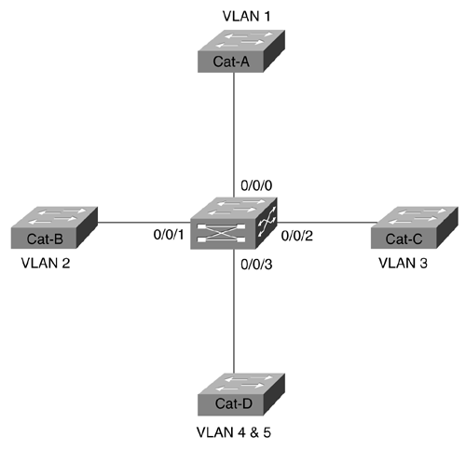
Cat-A, Cat-B, Cat-C, and Cat-D are Catalyst 5000 devices performing the usual Layer 2 switching. Each of these has a single VLAN except Cat-D which has two VLANs. All of the Catalyst 5000s are connected to a central 8500 for Layer 3 routing services. Example 11-16 shows a possible configuration for the 8500.

Example 11-16 Sample Catalyst 8500 Series Configuration
ipx routing 0000.0000.1001 ! interface FastEthernet0/0/0 description VLAN 1 ip address 10.1.1.1 255.255.255.0 ! interface FastEthernet0/0/1 description VLAN 2 ip address 10.1.2.1 255.255.255.0 ipx network 2 ! interface FastEthernet0/0/2 description VLAN 3 ip address 10.1.3.1 255.255.255.0 ipx encapsulation ARPA ipx network 3 ! interface FastEthernet0/0/3 no ip address ! interface FastEthernet0/0/3.4 description VLAN 4 encapsulation isl 4 ip address 10.1.4.1 255.255.255.0 ipx network 4 ! interface FastEthernet0/0/3.5 description VLAN 5 encapsulation isl 5 ip address 10.1.5.1 255.255.255.0 ipx network 5 ! router eigrp 1 network 10.0.0.0
All VLANs are configured for both IP and IPX traffic except VLAN 1 which is only using IP. All of the IPX interfaces are using the default Ethernet encapsulation of novell_ether except Fast Ethernet0/0/2 which is using ARPA (DIX V2). Also, because Cat-D is using two VLANs, Fast Ethernet0/0/3 is configured for ISL. As with the ISL router-on-a-stick examples earlier, each VLAN is configured on a separate subinterface.
Tip
The show vlan command on the 8500 can be very useful for getting a quick overview of which VLANs have been configured on which ports.

EtherChannel
One feature that deserves special mention is EtherChannel. The 8500s support both Fast and Gigabit EtherChannel. When configuring EtherChannel on any Cisco router (including the 8500s), the configuration centers around a virtual interface known as the Port-Channel interface. Your IP and IPX configurations are placed on this interface. The real Ethernet interfaces are then included in the channel by using the channel-group command. For example, the partial configuration in Example 11-17 converts Cat-D in Figure 11-22 to use EtherChannel on Ports 0/0/3 and 0/0/4.

Example 11-17 Configuring EtherChannel on the Catalyst 8500 and Cisco Routers
interface Port-Channel1 description To Cat-D no ip address ! interface Port-Channel1.4 description VLAN 4 encapsulation isl 4 ip address 10.1.4.1 255.255.255.0 ipx network 4 ! interface Port-Channel1.5 description VLAN 5 encapsulation isl 5 ip address 10.1.5.1 255.255.255.0 ipx network 5 ! interface FastEthernet0/0/3 no ip address channel-group 1 ! interface FastEthernet0/0/4 no ip address channel-group 1
Notice that the ISL subinterfaces are created under the Port-Channel interface, not under the real Fast Ethernet interfaces.

MLS versus 8500s
Which method of Layer 3 switching is better, switching routers (8500s) or routing switches (MLS)? Well, as you can imagine, the real answer is, it depends. Neither option is technically superior to the other. Neither option is newer. In fact, both were released in the same month (June, 1998). Neither option is inherently faster than the other option (although in the first several revisions of both products, the 8500s have had higher throughput). Many people have therefore come to the conclusion that MLS and 8500s are interchangeable options. However, the opposite view is much closer to the truth.
From a design perspective, MLS and 8500s approach the same problem (Layer 3 switching) from completely different angles. On one hand, MLS is a technique that adds Layer 3 capabilities into predominately Layer 2 Catalysts. Think of MLS as enabling Layer 2 Catalyst Supervisors to move up into Layer 3 processing. On the other hand, the 8500s function as a pure router that, like all Cisco routers, happens to also support bridging functionality. It is not an issue of which device can or cannot do Layer 3 processing—after all, both devices can do both Layer 2 and Layer 3. Instead, the issue is what layer a device is most comfortable with (or what the device does by default).
Tip
Routing switches and switching routers both support Layer 3 switching, but they approach it from opposite directions. Routing switches are predominately Layer 2 devices that have moved up into the Layer 3 arena. Conversely, switching routers are predominately Layer 3 devices that also happen to support Layer 2 bridging.

Routing Switch Applications
From the perspective discussed in the previous paragraphs, it becomes clear that MLS is most comfortable in a more Layer 2-oriented world. Although its Layer 3 performance is very respectable, this is not what sets MLS apart from the 8500s. What does differentiate MLS is its capability to very tightly integrate Layer 2 and Layer 3 processing.
For example, designs utilizing campus-wide VLANs can benefit greatly from MLS support. Although Chapter 14 argues that campus-wide VLANs are not the best approach for most networks, they can be very effective in certain situations (for example, when specific user mobility and security issues exist). Given the router-oriented nature of the 8500s, it can be tedious to mix Layer 2 and Layer 3 processing in more than the simplest configurations (this point is discussed in more detail in the section on Integrated Routing and Bridging [IRB] at the end of the chapter).
Designs utilizing a more hierarchical approach (such as the "multilayer model" discussed in Chapter 14) can also benefit from MLS. Not only can it be used to implement the Layer 3 switching component required by this design, it can do it with considerable flexibility. One case where this flexibility can be advantageous is where the user requirements are such that you would like to have VLANs (in other words, IP subnets and IPX networks) that traverse multiple MDF switches in order to reach multiple IDF switches. For example, both a user connected to IDF-1 and another user connected to IDF-2 could be placed in the "Marketing" VLAN and have IP addresses on the same subnet.
Note
As will be discussed later in this section, it turns out that the 8500s make it fairly difficult to implement VLANs that span multiple IDF switches. Under the 8500 approach, the recommendation is to use different VLANs on every IDF. This design looks at things from the point of view "Why do they need to be in the same VLAN/subnet?" Simply put both users in different VLANs/subnets and let the wire-speed Layer 3 performance of the 8500 route all packets between these two nodes (after all, it essentially routes and bridges at the same speed). Also, DHCP can be used to handle user-mobility problems, further minimizing the need to place these two devices in the same subnet.

Another case where MLS' strengths shine is in the wiring closet where port densities and cost are very important issues. Placing a switching router in the wiring closet is usually cost prohibitive. Instead, high-density and cost-effective Catalyst 5000s and 6000s can be used. Where local traffic can be shortcut switched, MLS can offload processing from the backbone routers. Furthermore, the NFFC's additional capabilities such as Protocol Filtering, IGMP Snooping, and QoS classification can be extremely useful in wiring-closet applications (in fact, this is where they are most useful).
Tip
The primary advantage of a routing switch (MLS) is its unique capability to blend Layer 2 and Layer 3 technology.

On the other hand, MLS requires that you take specific actions to fully realize the scalability benefits of Layer 3 processing. For example, Chapter 7 discussed the importance of using Layer 3 processing to break large campus networks into smaller Spanning Tree domains. However, just blindly installing MLS-capable switches does not do this. Figure 11-23 illustrates a large network containing 50 MLS-capable switches with RSMs (for simplicity, not all are shown) and 50 VLANs.

Figure 11-23 A Large MLS Network
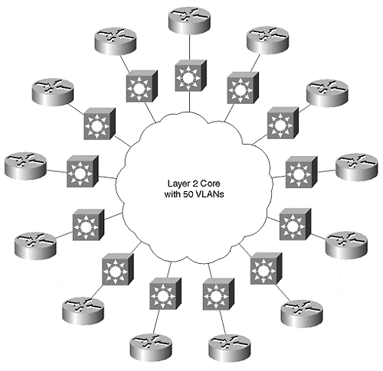
As you can see, the net effect is a huge, flat network with lots of routers sitting on the perimeter. The RSM and the MLS processing are not creating any Layer 3 barriers. The VLAN Trunking Protocol (VTP) discussed in Chapter 12, "VLAN Trunking Protocol," automatically puts all 50 VLANs on all 50 switches by default (even if every switch only uses two or three VLANs). Every switch then starts running 50 instances of the Spanning-Tree Protocol. If a problem de velops in a single VLAN on a single switch, the entire network can quickly collapse.
Creating Layer 3 partitions when using the MLS-style of Layer 3 switching requires careful design and planning of VLANs and trunk links. Figure 11-24 illustrates one approach.

Figure 11-24 Using MLS to Create Layer 3 Partitions
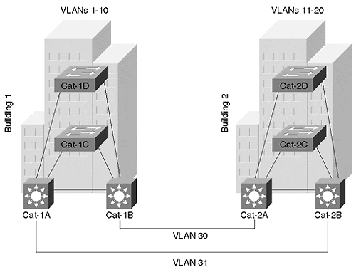
In this case, VLANs have not been allowed to spread throughout the campus. Assume that that the campus represents two buildings. VLANs 1–10 have been contained with Building 1. VLANs 11–20 have been placed in Building 2. A pair of links connects the two buildings. Rather than simply creating ISL links that trunk all VLANs across to the other building, non-trunk links have been used. By placing each of these links in a unique VLAN, you are forcing the traffic to utilize Layer 3 switching before it can exit a building. Also, because VTP advertisements are sent only on trunk links, this prevents VTP's default tendency of spreading every VLAN to every switch.
Tip
Another strategy that helps create Layer 3 barriers in an MLS network is assigning a unique VTP domain to each building. VTP advertisements are only shared between Catalysts that have matching VTP domain names. If each building has a different VTP domain name, the VLANs are contained.

Switching Router Applications
Although it is certainly possible to create Layer 3 partitions using MLS technology with techniques like that shown in Figure 11-24, it is not the default behavior, and it can get tricky in certain topologies. This is where the switching router approach of the 8500s excels. Because 8500s are simply a faster version of the traditional Cisco router, they automatically create Layer 3 barriers that are the key to network stability and scalability. For example, 8500s do not run the Spanning-Tree Protocol unless bridging is specifically enabled. Similarly, the 8500s do not pass VLANs by default. Instead, they terminate VLANs and then route them into other VLANs. Therefore, you must take specific steps (such as enabling bridging) on an 8500 to not get the benefits of Layer 3 partitions. Figure 11-25 illustrates this point.

Figure 11-25 Using an 8500 to Link Layer 2 Catalysts
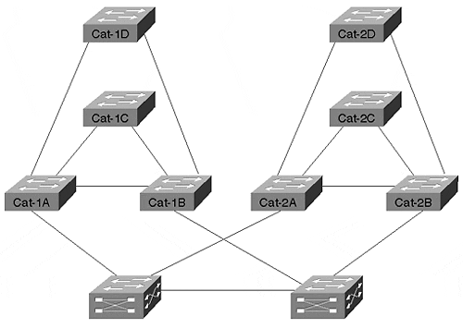
Without any special effort on the part of the Catalyst 5000s, the 8500s automatically isolate each building behind a Layer 3 barrier. This provides many benefits such as improved Spanning Tree stability and performance, easier configuration management, and improved multicast performance.
Tip
The primary advantage of switching routers (8500s) is simplicity. They allow a network to be as simple as the old router and hub design while also having the performance of modern-day switching.

Notice that the Catalyst 8500 is such a Layer 3-oriented box that it essentially has no concept of a VLAN. Yes, it does support bridge groups, an alternate means of creating multiple broadcast domains. However, it currently does not directly support VLANs and all of the VLAN-related features you find on more Layer 2-oriented platforms such as the Catalyst 5000 and 6000 (such as VTP and Dynamic VLANs). This essentially brings the discussion full circle to the opening point of this section: if you need a box with sophisticated Layer 2 features such as VLANs, VTP, and DISL/DTP, but you also need high-performance Layer 3 switching, go with MLS. If, on the other hand, you desire the simplicity of a traditional router-based network, 8500s are the solution of choice.
Tip
One implication of the discussion in this section is that 8500s virtually require a design that does not place the same VLAN/subnet on different IDF switches (it can be done through IRB, but, as discussed early, the use of IRB on a large scale should be avoided). On the other hand, the more Layer 2-oriented nature of MLS makes it fairly easy to have a single VLAN connect to multiple IDF switches.

Catalyst 6000 Layer 3 Switching
The Catalyst 6000 family of switches build on the existing technologies introduced by Cisco. From a Layer 3 switching perspective, two options are available:
- The Multilayer Switch Module (MSM)
- MLS using the Multilayer Switch Feature Card (MSFC)
Note
In a Catalyst 6000, the NFFC functionality is technically handled by an additional card known as the Policy Feature Card (PFC). However, because current implementations require an MSFC to allow a PFC to perform Layer 3 switching (alone, the PFC can provide QoS and access list features), this text will simply refer to the MSFC.

The MSM was the initial Layer 3 offering for the Catalyst 6000s. Based on the 8510 SRP, this card offers approximately 5 million pps for IP and IPX routing. From a configuration standpoint, it uses four Gigabit Ethernet connections to the backplane. Each of these ports can be used in a separate VLAN. Or, by enabling Gigabit EtherChannel on these ports, it can be used as a single interface supporting any number of VLANs. As with the router-on-a-stick approach discussed earlier, each VLAN can then be configured on a separate subinterface.
The second phase of Layer 3 switching for the Catalyst 6000s introduced the MSFC. This brings NFFC II functionality to the Catalyst 6000s, allowing full MLS support at 15 million pps for both IP and IPX. This also provides software-based routing services via technology derived from the 7200 router NPEs. By doing so, it completely eliminates the need for also having an MSM in the same chassis. The on-board router uses software routing to handle the first packet of every IP or IPX flow. The remaining packets are then handled in hardware by MLS. Finally, the on-board router can also be used to provide full software-based multiprotocol routing for protocols such as AppleTalk, DECnet, and VINEs at approximately 100,000 pps (Fast-Switched speeds).
One of the most interesting features of the MSFC, is that its configuration and management characteristics can be completely changed by using one of two different software images. Under the first option, the software-based router uses a traditional IOS image while the Supervisor uses the traditional XDI/CatOS image. This results in a user-interface and configuration process that is virtually identical to that discussed in the "MLS" section earlier in the chapter. This is referred to as the MSFC "Hybrid Mode." In the second option, the MSFC "Native IOS Mode" both the software-based router and the Supervisor run full IOS images. This creates an extremely integrated user interface. In short, by simply modifying the software on your Catalyst you can convert a very switch-like device into a full-blown router! For more information, see Chapter 18, "Layer 3 Switching and the Catalyst 6000/6500s."

HSRP
Cisco's Hot Standby Router Protocol (HSRP) plays an important role in most campus networks. The primary mission of HSRP is providing a redundant default gateway for end stations. However, it can also be used to provide load balancing. This section discusses both of these issues.
Many end stations allow only a single default gateway. Normally, this makes these hosts totally dependent on one router when communicating with all nodes off the local subnet. To avoid this limitation, HSRP provides a mechanism to allow this single IP address to be shared by two or more routers as illustrated in Figure 11-26.

Figure 11-26 HSRP Allows Multiple Routers to Share IP and MAC Addresses
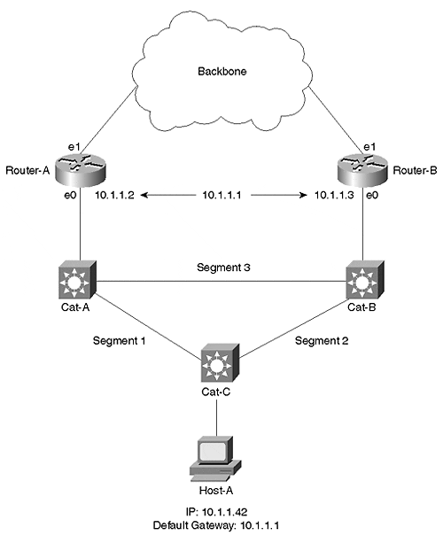
Although both routers are assigned unique IP addresses as normal (10.1.1.2 and 10.1.1.3), HSRP provides a third address that both routers share. The two routers exchange periodic hello messages (every three seconds by default) to monitor the status of each other. One router is elected the active HSRP peer and handles all router responsibilities for the shared address. The other node then acts as the standby HSRP peer. If the standby peer misses three HSRP hellos, it then assumes that the active peer has failed and takes over the role of the active peer.
One of the subtleties of HSRP is that the routers do not just share an IP address. To create a truly transparent failover mechanism, they must also share a MAC address. The routers therefore use an algorithm to create a shared virtual MAC address. As with the shared IP address, the active peer is the only node using the derived MAC address. However, if the active peer fails, the other device not only adopts the shared IP address, but also the shared MAC address. By doing so, the ARP cache located in every end station on the network does not require updating after a failover situation.
Tip
Although the shared MAC address prevents ARP cache problems during an HSRP failover scenario, it can be a problem when initially testing HSRP. For example, assume that you convert an existing router using the 10.1.1.1 address into an HSRP configuration where 10.1.1.1 becomes the shared IP address. At this point, the end stations still have the real MAC address associated with the original router, not the virtual MAC address created by HSRP. To solve this problem, reboot the end stations or clear their ARP caches.

Note that HSRP can be useful even in cases where the TCP/IP stack running on your clients supports multiple default gateways. In some cases, the mechanisms used by these stacks to failover to an alternate default gateway do not work reliably. In other cases, such as with current Microsoft stacks, the redundancy feature only works for certain protocols (such as TCP, but not UDP). In either case, most organizations do not want to leave default gateway reliability to chance and instead implement HSRP.
Tip
HSRP is useful even if your TCP/IP stack allows multiple default gateways.

Example 11-18 presents a sample HSRP configuration for the Router-A in Figure 11-26.

Example 11-18 HSRP Configuration for Router-A
interface Ethernet0 description Link to wiring closet Catalysts ip address 10.1.1.2 255.255.255.0 standby 1 priority 110 standby 1 preempt standby 1 ip 10.1.1.1 standby 1 track Ethernet1 15 ! interface Ethernet1 description Link to backbone ip address 10.1.2.2 255.255.255.0
The real IP address is assigned with the usual ip address command. HSRP parameters are then configured using various standby commands. The shared IP address is added with standby group_number ip ip_address command. This command needs to be entered on both routers.
Tip
The group_number parameters on both routers must match.

In most campus designs, some thought should be given as to the proper placement of the active peer. In general, the following guidelines should be used:
- The active HSRP peer should be located near or at the Spanning Tree Root Bridge.
- A router should relinquish its role as the active HSRP peer if it looses its connection to the backbone.
In networks that contain Layer 2 loops, the Spanning Tree Root Bridge acts as the center of the universe. Other bridges then look for the most efficient path to this device. By placing the active HSRP peer at or near the Root Bridge, the Spanning-Tree Protocol automatically helps end-user traffic follow the best path to the default gateway. For example, if Router-A is the active HSRP peer in Figure 11-26 but Cat-B is the Spanning Tree Root Bridge, Segment-1 has a port in the Blocking state. This forces all of the default gateway traffic to take an inefficient path through Cat-B (using Segment 2 and Segment 3). By co-locating the active HSRP peer and the Root Bridge at Cat-A and Router-A, this unnecessary bridge hop can be eliminated.
To force Cat-A to be the Root Bridge, the set spantree root or set spantree priority commands discussed in Chapter 6 can be used. To force Router-A to the active HSRP peer, the standby group_number priority priority_value command can be used. The peer with the highest priority_value becomes the active peer (the default is 100). In this case, Router-A has a configured priority of 110, making it win the active peer election. However, if Router-A boots after Router-B, it does not supercede Router-B by default (it waits for Router-B to fail first), creating the same inefficient pattern discussed earlier. This can be avoided by configuring the standby group_number preempt command. This causes a router to instantly take over as soon as it has the highest priority.
Tip
Unlike the Spanning-Tree Protocol where lower values are always preferred, HSRP prefers higher values.

The second guideline speaks to a situation where a router has the highest priority, but it has lost its connection to the rest of the network. For example, Router-A is the active HSRP peer but its Ethernet1 link goes down. Although this does not prevent traffic from reaching the backbone (Router-A can use its Ethernet0 interface to send traffic to the backbone through Router-B), it does lead to an inefficient flow. To prevent this situation, the standby track option can be used as shown in Example 11-18. The value indicated by the standby track command is the value that gets decremented from the node's priority if the specified interface goes down. Multiple standby track commands can be used to list multiple interfaces to track (if more than one interface goes down, the decrement values are cumulative). In this example, if Router-A loses interface Ethernet1, the priority is lowered to 95. Because this is lower than the default priority of 100 being used by Router-B, Router-B takes over as the active peer and provides a more optimal flow to the backbone.
Although the configuration discussed in this section does provide a redundant default gateway for the end stations connected to Cat-C, it does suffer from one limitation: Router-A is handling all of the traffic. To eliminate this problem, multiple VLANs should be created on Cat-C. Each VLAN uses a separate group_number on the standby command. Then, the VLANs should alternate active peers between the two routers. For example, Router-A could be the active peer for all odd-numbered VLANs, and Router-B could be the active peer for all even-numbered VLANs. Example 11-19 presents a sample configuration for Router-A (two VLANs and an ISL interface are used).

Example 11-19 ISL HSRP Configuration for Router-A
interface FastEthernet0/0/0 description Link to wiring closet Catalyst no ip address ! interface FastEthernet0/0/0.1 encapsulation isl 1 ip address 10.1.1.3 255.255.255.0 standby 1 priority 110 standby 1 preempt standby 1 ip 10.1.1.1 standby 1 track FastEthernet0/0/1 15 ! interface FastEthernet0/0/0.2 encapsulation isl 2 ip address 10.1.2.2 255.255.255.0 standby 2 priority 100 standby 2 preempt standby 2 ip 10.1.2.1 ! interface Ethernet0/0/1 description Link to backbone ip address 10.1.3.2 255.255.255.0
Example 11-20 shows the corresponding configuration for Router-B.

Example 11-20 ISL HSRP Configuration for Router-B
interface FastEthernet0/0/0 description Link to wiring closet Catalyst no ip address ! interface FastEthernet0/0/0.1 encapsulation isl 1 ip address 10.1.1.4 255.255.255.0 standby 1 ip 10.1.1.1 standby 1 priority 100 standby 1 preempt ! interface FastEthernet0/0/0.2 encapsulation isl 2 ip address 10.1.2.3 255.255.255.0 standby 2 ip 10.1.2.1 standby 2 priority 110 standby 2 track FastEthernet0/0/1 15 standby 2 preempt ! interface Ethernet0/0/1 description Link to backbone ip address 10.1.3.3 255.255.255.0
Tip
Alternate HSRP active peers for different VLANs between a pair of routers. This provides load balancing in addition to redundancy.

As discussed earlier, alternating HSRP active peer placements should obviously be coordinated with the Spanning Tree Root Bridge configuration. Cat-A should be the Root Bridge for the odd VLANs, and Cat-B should be the Root Bridge for the even VLANs.
Tip
The HSRP syntax allows a single standby group to be created without specifying the group_number parameter. However, I recommended that you always specify this parameter so that it is much easier to add other standby groups in the future. Also, using the default standby group can lead to very strange behavior if you accidentally use it in an attempt to configure HSRP for multiple VLANs.

Load Balancing with MHSRP
Using Spanning Tree and multiple VLANs can be effective if Layer 2 loops and multiple VLANs exist on Cat-C, the wiring closet switch. However, this is not always the case. Many network designers want to deploy networks similar to the one illustrated in Figure 11-27.

Figure 11-27 A Network Using a Single VLAN in the Wiring Closet
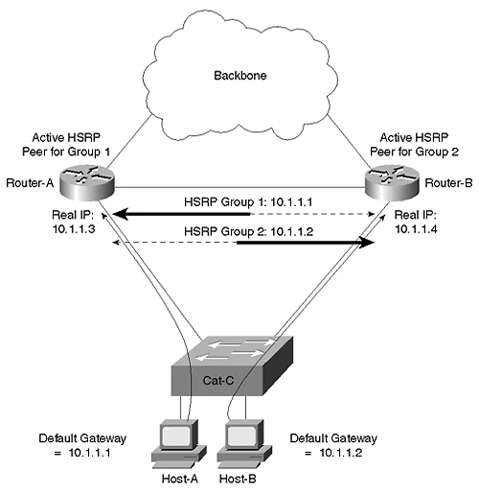
The design in Figure 11-27 has the wiring closet switch directly connected to a pair of switching routers such as the Catalyst 8500. This eliminates all Layer 2 loops and removes Spanning Tree from the equation (although there is a link between the two routers, it is a separate subnet). Furthermore, because a single VLAN is in use on Cat-C, the wiring closet switch, the alternating VLANs trick cannot be used.
In this case, the most effective solution is the use of Multigroup HSRP (MHSRP). This feature allows multiple HSRP group_numbers to be used on a single interface. For example, Example 11-21 shows a possible configuration for Router-A.

Example 11-21 MHSRP Configuration on a Catalyst 8500
interface FastEthernet0/0/0 description Link to wiring closet Catalyst ip address 10.1.1.3 255.255.255.0 standby 1 ip 10.1.1.1 standby 1 priority 110 standby 1 track FastEthernet0/0/1 15 standby 1 preempt standby 2 ip 10.1.1.2 standby 2 priority 100 standby 2 preempt
Note
Some of the low-end routers use a Lance Ethernet chipset that does not support MHSRP. However, all of the devices suitable for campus backbone use do support MHSRP.

The code in Example 11-21 creates two shared addresses between Router-A and Router-B for a single subnet. Load balancing can then be implemented by having half of the hosts on Cat-C use 10.1.1.1 as a default gateway and the other half use 10.1.1.2. The potential downside is that you have to come up with some way of configuring different hosts to use different default gateways. Fortunately, DHCP provides a simple and effective technique to accomplish this.
Because existing DHCP standards do not provide for server-to-server communication, organizations are forced to divide every scope (a scope can be loosely defined as a subnet's worth of DHCP addresses) of addresses into two blocks (assuming they want redundant DHCP servers). Each of two redundant DHCP servers receives one half of each scope. For example, a /24 subnet with 54 addresses reserved for fixed configuration leaves 200 addresses available for DHCP. 100 of these addresses can be placed on the first DHCP server and the other 100 are placed on the second DHCP server. If one of the DHCP servers fails, the other can provide addresses for clients on the network (assuming that no more than 100 new addresses are required). Because each server has its own block of globally unique addresses for every server, the lack of a server-to-server protocol is not a problem.
DHCP supports a variety of options that can be used to configure client stations. The DHCP Option 3 allows DHCP servers to provide a default gateway (or a list of default gateways) to clients. Simply configure one DHCP server with the first shared HSRP address (10.1.1.1 in Figure 11-26) and the other DHCP server with the second shared HSRP address (10.1.1.2).
For this technique to work, it requires a fairly random distribution of leases between the two DHCP servers. If one server ends up issuing 90 percent of the leases, one of the routers likely receives 90 percent of the traffic. To help ensure a random distribution, you should place the two DHCP servers close to each other (generally in the same server farm). You can also alternate the order of ip helper-address statements between the two routers. For example, assuming that the DHCP servers have the addresses 10.1.55.10 and 10.1.55.11, Router-A might use the ip helper-address configuration in Example 11-22.

Example 11-22 IP Helper Address Configuration for Router-A
interface FastEthernet0/0/0 ip helper-address 10.1.55.10 ip helper-address 10.1.55.11
Conversely, Router-B can then use the opposite order as demonstrated in Example 11-23.

Example 11-23 IP Helper Address Configuration for Router-B
interface FastEthernet0/0/0 ip helper-address 10.1.55.11 ip helper-address 10.1.55.10
This causes Router-A to give a slight advantage to the DHCP server located as 10.1.55.10, but Router-B gives an advantage to the other DHCP server. In general, both servers have an equal chance of responding first to the DHCP_DISCOVER packets that clients use to request a lease.
Tip
If this DHCP and MHSRP trick is not to your liking, consider placing a Layer 3 switch in the IDF wiring closet. Although this can be cost-prohibitive, it allows all devices connected to that IDF to use the IDF switch itself as a default gateway. The Layer 3 routing capabilities in the IDF switch can then choose the best path to use into the campus backbone and automatically balance the load over both uplinks. However, I should also point out that this can be difficult to implement with routing switch (MLS) devices. In general, it is much easier to accomplish with switching router designs such as the Catalyst 8500 and the native IOS router mode of the 6000.

Integration between Routing and Bridging
The section "MLS versus 8500s" discussed the advantages of having Layer 3 barriers or partitions in your network (this issue is also discussed extensively in Chapters 14, 15, and 17). However, for a variety of reasons, many people want to avoid the "hard barriers" formed by this approach. Instead, they seek "softer barriers" where some protocols or VLANs are terminated while others pass through. This requires a mixture of routing (that is, Layer 3 switching) and bridging (that is, Layer 2 switching). The next two sections look at the two most common forms of mixing routing and bridging.
Note
A third technique is possible using the Catalyst 6000 Native IOS Mode. This will be discussed in Chapter 18.

Bridging between VLANs
One of the simplest ways of avoiding the "hardness" of a Layer 3 barrier is bridging between multiple VLANs. Many network designers want to do this when they have two separate VLANs that need to share some non-routable protocol such as local-area transport (LAT) or NetBIOS/NetBEUI.
Tip
Other network designers cringe at this thought because it no longer keeps the VLANs separate.

This sort of bridging can be easily configured using the same bridge-group technology that Cisco routers have supported for many years. For example, the configuration in Example 11-24 enables bridging between VLANs 2 and 3 on an 8500.

Example 11-24 Using Bridge Groups to Bridge between VLANs
interface FastEthernet0/0/0 no ip address ! interface FastEthernet0/0/0.1 encapsulation isl 1 ip address 10.1.1.1 255.255.255.0 ! interface FastEthernet0/0/0.2 encapsulation isl 2 ip address 10.1.2.1 255.255.255.0 ipx network 2 bridge-group 1 ! interface FastEthernet0/0/0.3 encapsulation isl 3 ip address 10.1.3.1 255.255.255.0 ipx network 3 bridge-group 1 ! interface FastEthernet0/0/0.4 encapsulation isl 4 ip address 10.1.4.1 255.255.255.0 ipx network 4 ! bridge 1 protocol ieee
The configuration in Example 11-24 results in IP and IPX traffic being routed between subinterfaces Fast Ethernet1/0.2 and 1/0.3 while all other protocols are bridged. No bridging is performed on subinterfaces Fast Ethernet1/0.1 and 1/0.4. Notice that this requires IP users in VLANs 2 and 3 to use different IP subnets (and IPX networks) but the same AppleTalk cable range.
Tip
When using bridge-groups, remember that protocols configured with a Layer 3 address will be routed while all other protocols will be bridged. For example, if you only configure an IP address on a given interface, IP will be routed and all other protocols (IPX, AppleTalk, DECnet, and so on) will be bridged.

This technique is applicable as long as a particular protocol is either bridged or routed on a specific device. For instance, the previous example routed IP and IPX on every interface. Also, AppleTalk was only bridged on this device. Normal bridge-group processing does not allow you to bridge IP between two interfaces and route it between two other interfaces. To do so requires a feature called Integrated Routing and Bridging (IRB).

IRB
Integrated Routing and Bridging (IRB) is a technique Cisco introduced in IOS 11.2 to allow a single protocol to be both bridged and routed on the same box. IOS 11.1 introduced a precursor to IRB called Concurrent Routing and Bridging (CRB). This allowed a particular protocol such as IP to be both bridged and routed on the same device. It allowed all of the routed interfaces using this protocol to communicate and all of the bridged interfaces to communicate. However, CRB did not let routed interfaces communicate with the bridged interfaces. In other words, the routed and bridged worlds for the configured protocol were treated as two separate islands. Most people were not looking for this functionality.
IRB filled this gap by allowing communication between these two islands. This enabled configurations such as those shown in Figure 11-28.

Figure 11-28 A Sample IRB Configuration
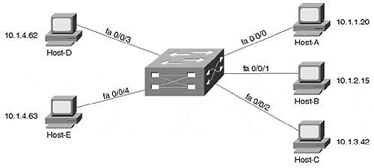
The interfaces on the right side of the router (fa0/0/0, fa0/0/1, and fa0/0/2) all use IP addresses on separate IP subnets. Conversely, the interfaces on the left (fa0/0/3 and fa0/0/4) both fall on the same subnet. And, because IRB is in use, 10.1.4.62 could ping 10.1.1.20 (this is not possible in CRB).
To create a link between the routed and bridged domains, Cisco created a special virtual interface known as a Bridged Virtual Interface (BVI). The BVI can be configured with Layer 3 addresses (it cannot be configured with bridging statements) and acts as a routed interface into the rest of the box. For example, the BVI in Figure 11-28 might use an IP address of 10.1.4.1, as illustrated in Figure 11-29.

Figure 11-29 A Logical Representation of a BVI
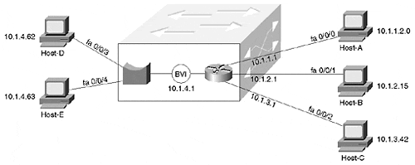
If interface fa0/0/4 receives a frame with Host-D's MAC address, it bridges it out interface fa0/0/3. However, if Host-D pings Host-A, Host-D sends the IP packet to its default gateway, address 10.1.4.1 (the BVI's address). If necessary, Host-D ARPs for 10.1.4.1 to learn the BVI's MAC address. When interface fa0/0/4 receives the traffic with a MAC address that belongs to the BVI, it knows to route, not bridge, the traffic. The normal routing process then sends the traffic out interface fa0/0/0.
The BVI essentially acts as a single routed interface on behalf of all of the bridged interfaces in a particular VLAN. In Figure 11-29, the BVI communicates with the right side of the box through routing, whereas the left side uses bridging.
Tip
You need one BVI interface for each VLAN that contains two or more interfaces on a single IOS-based router (except for the ports that make up an individual EtherChannel bundle).

Example 11-25 shows sample configuration for the network illustrated in Figures 11-28 and 11-29.

Example 11-25 IRB Configuration
interface FastEthernet0/0/0 ip address 10.1.1.1 255.255.255.0 ! interface FastEthernet0/0/1 ip address 10.1.2.1 255.255.255.0 ! interface FastEthernet0/0/2 ip address 10.1.3.1 255.255.255.0 ! interface FastEthernet0/0/3 no ip address bridge-group 1 ! interface FastEthernet0/0/4 no ip address brige-group 1 ! interface BVI 1 ip address 10.1.4.1 255.255.255.0 ! bridge 1 protocol ieee bridge 1 protocol ieee bridge 1 route ip
Tip
The BVI interface number must match the bridge group number.

IRB is an important feature on platforms such as the Catalyst 8500. For instance, consider the case where you want to directly connect 10 servers to an 8540 along with 20 trunks that lead to separate wiring closet switches. Assume the servers are going to all be placed in the same subnet (therefore bridging IP traffic), whereas each wiring closet switch uses a separate subnet (therefore routing IP). Without IRB, it is not possible to both route and bridge the IP traffic in one device. In other words, IRB allows you to route IP subnets while also extending the server farm VLAN through the router. Another advantage to IRB is that it is performed at nearly wire speed in the 8500 (IRB is Fast-Switched in software-based routers).
However, IRB does have its downsides. Most importantly, the extensive use of IRB can create configuration nightmares. For example, consider an 8540 with 100+ interfaces and 30 or 40 BVIs (one for every VLAN that needs to mix routing and bridging). Also, it can quickly deplete the number of available logical interfaces supported by the IOS. To avoid these issues, IRB should be used to solve specific and narrowly defined problems. Do not try to build your entire network on IRB.
Tip
A single BVI that contains many interfaces does not present configuration challenges. However, a design that uses many BVIs can lead to problems and confusion.

Issues and Caveats with Bridging between VLANs
Regardless of which approach is used, bridging between VLANs can create a wide variety of problems. One of the most common problems is that of throughput and switching speed. Many organizations have used software-based routers to rely on bridge groups and possibly BVIs to allow non-routable traffic to cross VLAN boundaries. However, software-based bridges perform these bridging functions at IOS Fast-Switching speeds. This creates a situation where traffic gets Layer 2 switched at millions of packets per second only to slam into a software-based bridging process often running at less than 100,000 pps. Talk about having the Autobahn suddenly turn into a dirt road!
Note
As discussed earlier, switching router platforms such as the 8500s do not suffer from this drawback because they perform both Layer 2 and Layer 3 forwarding at essentially the same speed.

However, even if the throughput problem is not an issue in your network, there is another problem that can surface. Assume that you link two Layer 2 domains with the configuration in Example 11-26.

Example 11-26 Routing IP and IPX While Bridging All Other Protocols
interface FastEthernet0/0/0 no ip address ! interface FastEthernet0/0/0.1 encapsulation isl 1 ip address 10.1.1.1 255.255.255.0 ipx network 1 bridge-group 1 ! interface FastEthernet0/0/0.2 encapsulation isl 2 ip address 10.1.2.1 255.255.255.0 ipx network 2 bridge-group 1 ! bridge 1 protocol ieee
The configuration in Example 11-26 routes IP and IPX between VLANs 1 and 2 but also allows non-routable traffic such as NetBIOS/NetBEUI to be bridged through the router. However, this also merges the Spanning Trees in VLAN 1 and 2. This introduces two significant problems:
- Scalability problems—
When two (or more) Spanning Trees are merged into a single tree, all of the Spanning Tree scalability benefits created by introducing routers disappear. A single Root Bridge is established between both VLANs. A single set of least-cost paths is found to this Root Bridge. Spanning Tree instability can easily and quickly spread throughout both VLANs and create network-wide outages.
- Defeats Spanning Tree load balancing—
Recall from Chapter 7 that Spanning Tree load balancing uses multiple VLANs to create different logical topologies between VLANs. For example, VLAN 1 can use Trunk-1 and VLAN 2 can use Trunk-2. However, if the Spanning Trees are merged because of inter-VLAN bridging, both VLANs are forced to use a single trunk. This cuts your available bandwidth in half!
Even if you find a way to avoid the issues previously discussed, you must plan very carefully to avoid a third problem that I refer to as the Broken Subnet Problem. Figure 11-30 illustrates this issue.

Figure 11-30 The Broken Subnet Problem
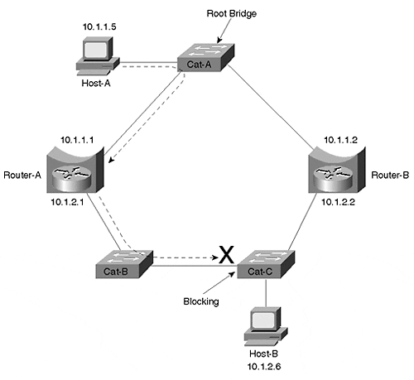
Three Layer 2 Catalysts and two routers have been used to form a ring. Router-A and Router-B have been configured to route IP and bridge all other protocols using a bridge-group 1 command on both Ethernet interfaces. As a result, IP sees the topology shown in Figure 11-31.

Figure 11-31 IP's View of the Network Shown in Figure 11-30
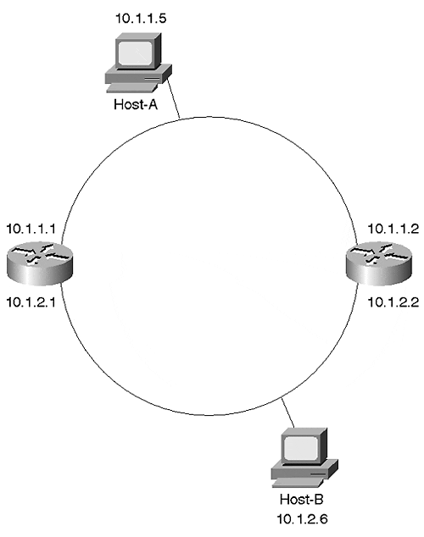
In other words, IP has divided the network into two subnets. However, the Spanning-Tree Protocol has a very different view of the world. Spanning Tree knows nothing about IP's interpretation. Instead, it sees only a ring of five Layer 2 devices. Assuming that Cat-A becomes the Root Bridge, Spanning Tree creates the topology shown in Figure 11-32 (see Chapter 6 for information on DP, RP, F, and B).

Figure 11-32 Spanning Tree's View of the Network Shown in Figure 11-29
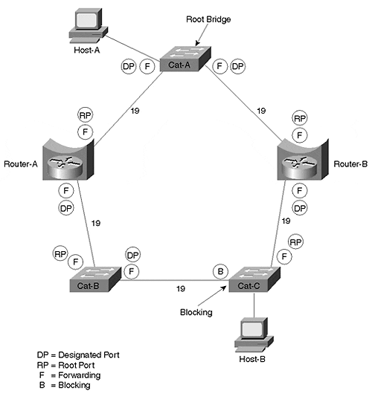
Unfortunately, this can create a very subtle problem. Consider what happens if Host-A tries to send IP data to Host-B. Host-A recognizes that Host-B is in a different subnet and forwards the traffic to Router-A, its default gateway. Router-A does the normal IP routing thing and forwards the traffic out its interface E1. However, the traffic cannot be delivered to Host-B because the Layer 2 switches have blocked the path (remember that Spanning Tree blocks all traffic on a Catalyst, not just non-routable traffic)! The dashed line in Figure 11-30 shows this path.
The Broken Subnet Problem can be extremely difficult to troubleshoot and diagnose. In many cases, only a very small number of nodes experience problems communicating with each other. For example, Host-A cannot reach Host-B, but it might be able to reach every other address in the network. If your network has Spanning Tree stability problems, the broken link is constantly shifting locations. Furthermore, the failure is protocol specific. If Host-A tries to reach Host-B using any protocol other than IP, it succeeds. All of these issues can lead to many extremely long days of troubleshooting before the actual problem is discovered.

How to Fix the Broken Subnet Problem
In general, there are three ways to fix the Broken Subnet Problem:
- Disable the inter-VLAN bridging on at least one bridge.
- Manipulate the Spanning Tree parameters to move the Blocking port to one of the router ports.
- Run a different version of the Spanning-Tree Protocol on the routers than on the Layer 2 switches.

Disable Inter-VLAN Bridging
The simplest and most effective solution to the Broken Subnet Problem is to disable inter-VLAN bridging on at least one of the routers (by removing the bridge-group commands from the interfaces). Because this creates a loop-free Layer 2 configuration, it prevents any of the ports in Figure 11-30 from Blocking. However, it also removes redundancy from the inter-VLAN bridging and, therefore, might not be appropriate for all networks.

Manipulating Spanning Tree Parameters
By tuning a variety of Spanning Tree parameters, the blocked port can be moved to one of the ports on the router. By doing so, the router can have full access to the network for routable protocols but also prevent Layer 2 loops within the non-routable protocols. In short, this allows the router to create a protocol-specific Blocking port. For routable protocols, the Spanning Tree Blocking port is ignored. However, for protocols the router does not route, the Blocking port is enforced. In general, there are three options for moving the Blocking port (see Table 11-1).

Table 11-1. Moving the Spanning Tree Blocking Port to a Router
Option | Description
Path Cost | Increases or decreases the STP path cost parameter to influence the election of Designated and non-Designated Ports.
Root Bridge placement | Moves the STP Root Bridge such that the Blocking port is forced to a router interface.
Multiple Spanning Trees | Uses IEEE STP on the Layer 2 Catalysts and DEC or VLAN-Bridge on the routers. See the section "Using Different Spanning-Tree Protocols."
Figure 11-33 shows how this can be done by increasing the cost of the link between Cat-A and Router-A to 1000 (the cost actually needs to be increased on the Router, not Cat-A, because Cat-A is the Root Bridge).

Figure 11-33 Moving the Blocking Port to a Router Interface
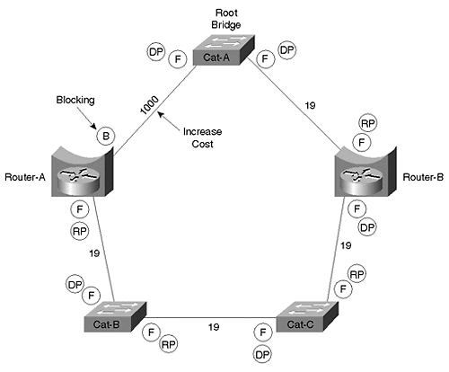
Another option is to move the Root Bridge to Router-B. When using this approach, Bridge Priorities or Path Costs might also have to be adjusted to force the Blocking port to the router-end of the link to Cat-B.

Using Different Spanning-Tree Protocols
The most complex and creative solution involves using a different version of the Spanning-Tree Protocol on the Layer 2 bridges than on the routers. Layer 2 Catalysts such as the Catalyst 6000 and Catalyst 5000 only use the IEEE version of the Spanning-Tree Protocol. Meanwhile, devices that run the full IOS, such as a 7500 router or a Catalyst 8500, can use one of three versions of the Spanning-Tree Protocol for transparent bridging (very early 8500 images only support IEEE, and VLAN-Bridge requires IOS 12.0+):
- IEEE
- DEC
- VLAN-Bridge
As discussed in Chapter 6, Radia Perlman created the DEC version of the Spanning-Tree Protocol, which was initially offered on DEC equipment. The IEEE version was the one standardized in 802.1D. VLAN-Bridge is a Cisco-specific extension to the IEEE protocol (it uses the same BPDU layout with a SNAP header). It was created to provide exactly the sort of feature being discussed in this section.
For example, in Figure 11-30, the Catalysts Cat-A, Cat-B, and Cat-C are using the IEEE Spanning-Tree Protocol, and Router-A and Router-B are using the DEC Spanning-Tree Protocol.
At first thought, this sounds like a dangerous proposition. After all, mixing the two protocols can lead to situations where one of the protocols does not detect a loop and the whole network collapses. However, because Layer 2 Catalysts process BPDUs slightly differently than IOS routers, the results can be both safe and effective. This is possible because of the following two characteristics:
- Layer 2 Catalysts flood DEC BPDUs
- IOS routers swallow IEEE BPDUs if they are only running the DEC variation of the Spanning-Tree Protocol
As a result, the IEEE BPDUs are blocked by the routers, creating a topology that resembles that shown in Figure 11-34.

Figure 11-34 IEEE Topology When Running Two Versions of the Spanning-Tree Protocol
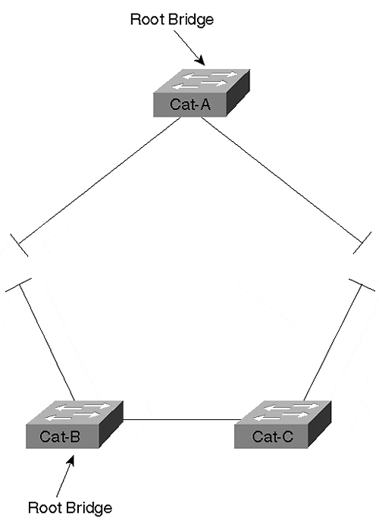
The IEEE Spanning-Tree Protocol views the network as being partitioned into two separate halves. Each half elects its own Root Bridge.
On the other hand, the DEC Spanning-Tree Protocol running on the routers sees a very different view of the network. From the DEC perspective, the Layer 2 Catalysts do not exist because DEC BPDUs are flooded without alteration by Cat-A, Cat-B, and Cat-C. This creates the logical topology diagrammed in Figure 11-35.

Figure 11-35 DEC Topology When Running Two Versions of the Spanning-Tree Protocol
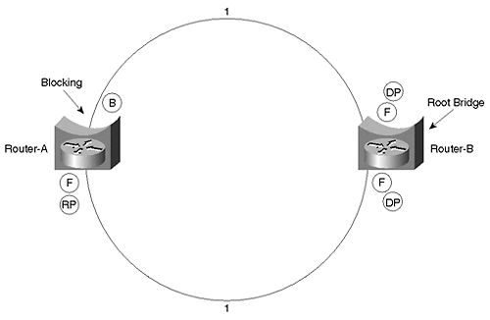
Note
Notice that the DEC Spanning-Tree Protocol uses a cost of 1 for Fast Ethernet links.

As a result, the two Spanning-Tree Protocols work together to provide connectivity throughout the network. The IEEE Spanning Trees are used to make sure that Layer 2 loops are not formed between the routers. Because each IEEE Spanning Tree provides full connectivity between all of the routers it touches, this avoids the Broken Subnet Problem. The DEC protocol is then used to detect if these pockets of IEEE Spanning Tree are interconnected in a looped topology. In the case of this example, it detects that a loop has been formed and blocks a port running the DEC Spanning-Tree Protocol. Assume that Router-B is acting as the Root Bridge of the DEC Spanning Tree in Figure 11-35. This causes the upper interface on Router-A to enter the Blocking state.
Note
As a minor detail, this assumes that the upper interface on Router-B has a lower Port ID. See the "Port/VLAN Priority Load Balancing" section of Chapter 7 for more detail.

Although this can hardly be called the most intuitive approach, it can be very useful in networks that need to mix routing and bridging technology.
Tip
Use multiple versions of the Spanning-Tree Protocol to avoid the Broken Subnet Problem where the simpler techniques discussed in the previous two sections are not an option.

Recommendations on Mixing Bridging and Routing
In general, the best advice is to avoid inter-VLAN bridging wherever possible. Not only does it create the obvious problem of potentially excessive broadcast radiation, it introduces a wide variety of scalability issues.
The simplest way to avoid inter-VLAN bridging is by putting all nodes that need to communicate via non-routable protocols in a single VLAN. If this VLAN needs to span multiple switching routers in the network's core, a single BVI interface can be created without significant problems. If more than one VLAN needs to be used for non-routable traffic, strive to limit them as much as possible. Also consider migrating to routable alternatives. For example, organizations using NetBIOS/NetBEUI for Microsoft's networking features can enable WINS and use NetBIOS over TCP/IP (NBT).
Finally, remember the unique benefits provided by the combination of MLS and Catalyst-based routers such as the RSM. The Catalyst's feature-rich Layer 2 architecture makes it very easy to group various combinations of ports into multiple VLANs. The RSM's unique design that treats all of the ports in a VLAN as a single router interface (interface Vlan X) also makes it very easy to route between these VLANs. This approach is considerably simpler and more scalable (at least from a configuration standpoint) than IRB. You can obtain similar benefits by using the Native IOS Mode routing feature of the Catalyts 6000 (see Chapter 18).

Review Questions
This section includes a variety of questions on the topic of this chapter—Layer 3 switching. By completing these, you can test your mastery of the material included in this chapter as well as help prepare yourself for the CCIE written and lab tests.
1: | What is the difference between routing and Layer 3 switching?
2: | Can the router-on-a-stick approach to inter-VLAN routing also support inter-VLAN bridging?
3: | How can the RSM be especially useful in remote office designs?
4: | What are the strengths of the RSM approach to Layer 3 switching?
5: | Does MLS eliminate the need for a router?
6: | Does MLS require a router that runs the router-based NetFlow mechanism?
7: | In MLS, does the router create the shortcut entry and download it to the Layer 3 CAM table located in the Catalyst's NFFC or MSFC/PFC?
8: | What is a flow mask?
9: | How does the Catalyst 8500 make routing decisions?
10: | What are the two routing options offered for the Catalyst 6000 family? From a conceptual standpoint, how do they differ?
11: | What is MHSRP? How is it useful?
12: | What is the difference between CRB and IRB?
13: | When is IRB useful?
14: | What are some of the dangers associated with mixing bridging and routing?
15: | What is the benefit of using the IEEE and DEC Spanning-Tree Protocols at the same time? Where should each be run?

