Part II: Spanning Tree
Chapter 6 Understanding Spanning Tree
Chapter 7 Advanced Spanning Tree

Chapter 6. Understanding Spanning Tree
The authors would like to thank Radia Perlman for graciously contributing her time to review the material in this chapter.
This chapter covers the following key topics:
- What Is Spanning Tree and Why Use Spanning Tree—
Briefly explains the purpose of the Spanning-Tree Protocol (STP). Explains why some form of loop-prevention protocol is required to prevent broadcast storms and bridge table corruption.
- Four-Step STP Decision Sequence—
Describes the process that the Spanning-Tree Protocol uses for all evaluations and calculations.
- Initial STP Convergence—
A detailed examination of the three steps that STP uses to initially converge on a loop-free active topology.
- STP States—
Explains the five STP states and how the algorithm progresses through each state.
- STP Timers—
Discusses the three configurable timers utilized by the Spanning-Tree Protocol.
- The show spantree Command—
Provides a detailed explanation of the fields contained in this powerful command. Several useful tips are discussed.
- BPDUs—
Provides a detailed discussion of the frames used by bridges and switches to convey STP information. Decodes of actual BPDUs are explained.
- Topology Change Process—
Explains how the Topology Change process allows the network to reconverge more quickly after changes in the physical network.
- Setting the Root Bridge—
Explains how to manually place Root Bridges in your network for improved stability and performance.
- Per VLAN Spanning Tree—
Explains how Cisco supports one instance of the Spanning-Tree Protocol per VLAN. This features allows for extremely flexible designs and is detailed in Chapter 7, "Advanced Spanning Tree."
Most network administrators and designers underestimate the importance of the Spanning-Tree Protocol (STP). As routers became popular in the early 1990s, STP faded into the background as a "less important protocol that just worked." However, with the recent rise of switching technology, Spanning Tree has once again become an important factor that can have a tremendous impact on your network's performance.
In fact, STP often accounts for more than 50 percent of the configuration, troubleshooting, and maintenance headaches in real-world campus networks (especially if they are poorly designed). When I first encountered switching technology, I had the typical "I'm a Layer 3 pro, how hard could this STP stuff be?" mentality. However, I soon learned that STP is a complex protocol that is generally very poorly understood. I found it difficult to locate good Spanning Tree information, especially information about modern implementations of STP. The goal of this chapter (and Chapter 7) is to make your STP journey smooth sailing.
This chapter covers the mechanics of the Spanning-Tree Protocol as it performs its basic loop-prevention duties. To build a baseline knowledge of STP, the chapter begins by answering the questions "What is Spanning Tree?" and "Why do I need Spanning Tree?" From there, the chapter walks through the Spanning Tree algorithm in detail. In short, this chapter sets the stage for Chapter 7, "Advanced Spanning Tree," where complex topics such as load balancing and minimizing convergence time are presented in detail.
This chapter uses the terms bridge, switch, and Layer 2 switch interchangeably. Although some argue that there are differences between these types of devices, these differences are irrelevant when discussing Spanning Tree. This is particularly true when discussing the STP standards that were written prior to the development of hardware-based switches. For example, you will learn about the Root Bridge concept (don't worry about what it means yet). Although the term Root Switch is becoming more common, I find it awkward when first learning how the Spanning-Tree Protocol functions. However, the term switch is used when discussing particular network designs and deployments because it is rare to deploy a traditional, software-based bridge today.
Caution
Please note that the examples used in this chapter (and Chapter 7) are designed to illustrate the operation of the Spanning-Tree Protocol, not necessarily good design practices. Design issues are addressed in Chapter 11, "Layer 3 Switching," Chapter 14, "Campus Design Models," Chapter 15, "Campus Design Implementation," and Chapter 17, "Case Studies: Implementing Switches."

What Is Spanning Tree and Why Use Spanning Tree?
In its most basic sense, the Spanning-Tree Protocol (STP) is a loop-prevention protocol. It is a technology that allows bridges to communicate with each other to discover physical loops in the network. The protocol then specifies an algorithm that bridges can use to create a loop-free logical topology. In other words, STP creates a tree structure of loop-free leaves and branches that spans the entire Layer 2 network. The actual mechanics of how the bridges communicate and how the STP algorithm works is the subject of the rest of the chapter.
Loops occur in networks for a variety of reasons. The most common reason you find loops in networks is the result of a deliberate attempt to provide redundancy—in case one link or switch fails, another link or switch can take over. However, loops can also occur by mistake (of course, that would never happen to you). Figure 6-1 shows a typical switch network and how loops can be intentionally used to provide redundancy.

Figure 6-1 Networks Often Include Bridging Loops to Provide Redundancy
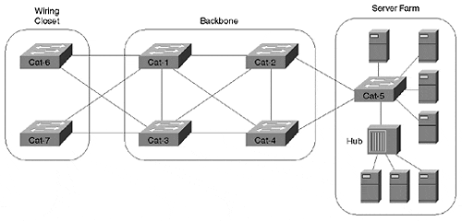
The catch is that loops are potentially disastrous in a bridged network for two primary reasons: broadcast loops and bridge table corruption.

Broadcast Loops
Broadcasts and Layer 2 loops can be a dangerous combination. Consider Figure 6-2.

Figure 6-2 Without STP, Broadcasts Create Feedback Loops
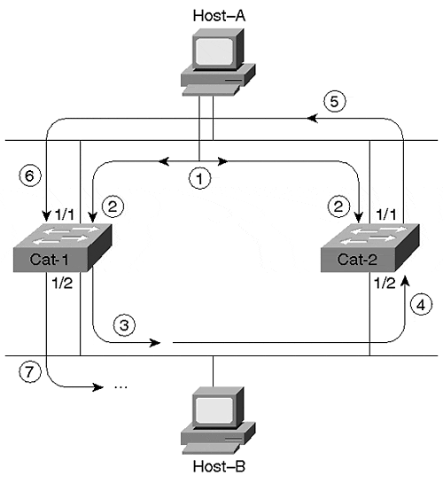
Assume that neither switch is running STP. Host-A begins by sending out a frame to the broadcast MAC address (FF-FF-FF-FF-FF-FF) in Step 1. Because Ethernet is a bus medium, this frame travels to both Cat-1 and Cat-2 (Step 2).
When the frame arrives at Cat-1:Port-1/1, Cat-1 will follow the standard bridging algorithm discussed in Chapter 3, "Bridging Technologies," and flood the frame out Port 1/2 (Step 3). Again, this frame will travel to all nodes on the lower Ethernet segment, including Cat-2:Port1/2 (Step 4). Cat-2 will flood the broadcast frame out Port 1/1 (Step 5) and, once again, the frame will show up at Cat-1:Port-1/1 (Step 6). Cat-1, being a good little switch, will follow orders and send the frame out Port 1/2 for the second time (Step 7). By now I think you can see the pattern—there is a pretty good loop going on here.
Additionally, notice that Figure 6-2 quietly ignored the broadcast that arrived at Cat-2:Port-1/1 back in Step 2. This frame would have also been flooded onto the bottom Ethernet segment and created a loop in the reverse direction. In other words, don't forget that this "feedback" loop would occur in both directions.
Notice an important conclusion that can be drawn from Figure 6-2—bridging loops are much more dangerous than routing loops. To understand this, refer back to the discussion of Ethernet frame formats in Chapter 1, "Desktop Technologies." For example, Figure 6-3 illustrates the layout of a DIX V2 Ethernet frame.

Figure 6-3 DIX Version 2 Ethernet Frame Format
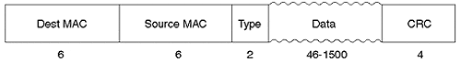
Notice that the DIX V2 Ethernet frame only contains two MAC addresses, a Type field, and a CRC (plus the next layer as Data). By way of contrast, an IP header contains a time to live (TTL) field that gets set by the original host and is then decremented at every router. By discarding packets that reach TTL=0, this allows routers to prevent "run-away" datagrams. Unlike IP, Ethernet (or, for that matter, any other common data link implementation) doesn't have a TTL field. Therefore, after a frame starts to loop in the network above, it continues forever until one of the following happens:
- Someone shuts off one of the bridges or breaks a link.
- The sun novas.
As if that is not frightening enough, networks that are more complex than the one illustrated in Figure 6-2 (such as Figure 6-1) can actually cause the feedback loop to grow at an exponential rate! As each frame is flooded out multiple switch ports, the total number of frames multiplies quickly. I have witnessed a single ARP filling two OC-12 ATM links for 45 minutes (for non-ATM wizards, each OC-12 sends 622 Mbps in each direction; this is a total of 2.4 Gbps of traffic)! For those who have a hard time recognizing the obvious, this is bad.
As a final note, consider the impact of this broadcast storm on the poor users of Host-A and Host-B in Figure 6-2. Not only can these users not play Doom (a popular game on campus networks) with each other, they can't do anything (other than go home for the day)! Recall in Chapter 2, "Segmenting LANs," that broadcasts must be processed by the CPU in all devices on the segment. In this case, both PCs lock up trying to process the broadcast storm that has been created. Even the mouse cursor freezes on most PCs that connect to this network. If you disconnect one of the hosts from the LAN, it generally returns to normal operation. However, as soon as you reconnect it to the LAN, the broadcasts again consume 100 percent of the CPU. If you have never witnessed this, some night when only your worst enemy is still using the network, feel free to create a physical loop in some VLAN (VLAN 2, for example) and then type set spantree 2 disable into your Catalyst 4000s, 5000s, and 6000s to test this theory. Of course, don't do this if your worst enemy is your boss!

Bridge Table Corruption
Many switch/bridge administrators are aware of the basic problem of broadcast storms as discussed in the previous section. However, fewer people are aware of the fact that even unicast frames can circulate forever in a network that contains loops. Figure 6-4 illustrates this point.

Figure 6-4 Without STP, Even Unicast Frames Can Loop and Corrupt Bridging Tables
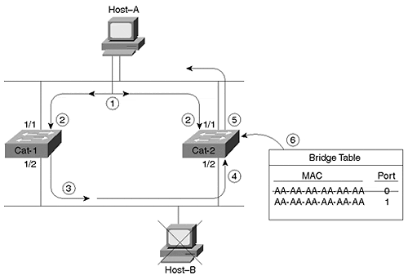
For example, suppose that Host-A, possessing a prior ARP entry for Host-B, wants to send a unicast Ping packet to Host-B. However, Host-B has been temporarily removed from the network, and the corresponding bridge-table entries in the switches have been flushed for Host-B. Assume that both switches are not running STP. As with the previous example, the frame travels to Port 1/1 on both switches (Step 2), but the text only considers things from Cat-1's point of view. Because Host-C is down, Cat-1 does not have an entry for the MAC address CC-CC-CC-CC-CC-CC in its bridging table, and it floods the frame (Step 3). In Step 4, Cat-2 receives the frame on Port 1/2. Two things (both bad) happen at this point:
- Cat-2 floods the frame because it has never learned MAC address CC-CC-CC-CC-CC-CC (Step 5). This creates a feedback loop and brings down the network.
- Cat-2 notices that it just received a frame on Port 1/2 with a source MAC of AA-AA-AA-AA-AA-AA. It changes its bridging entry for Host-A's MAC address to the wrong port!
As frames loop in the reverse direction (recall that the feedback loop exists in both directions), you actually see Host-A's MAC address flipping between Port 1/1 and Port 1/2.
In short, not only does this permanently saturate the network with the unicast ping packet, but it corrupts the bridging tables. Remember that it's not just broadcasts that can ruin your network.

Two Key Spanning-Tree Protocol Concepts
Spanning Tree calculations make extensive use of two key concepts when creating a loop-free logical topology:
- Bridge ID (BID)
- Path Cost

Bridge IDs
A Bridge ID (BID) is a single, 8-byte field that is composed of two subfields as illustrated in Figure 6-5.

Figure 6-5 The Bridge ID (BID) Is Composed of Bridge Priority and a MAC Address
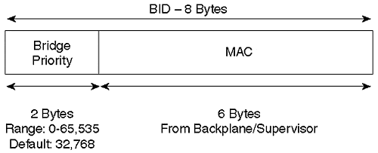
The low-order subfield consists of a 6-byte MAC address assigned to the switch. The Catalyst 5000 and 6000 use one of the MAC addresses from the pool of 1024 addresses assigned to every supervisor or backplane. This is a hard-coded number that is not designed to be changed by the user. The MAC address in the BID is expressed in the usual hexadecimal (base 16) format.
Note
Some Catalysts pull the MAC addresses from the supervisor module (for example, the Catalyst 5000), whereas others pull the addresses from the backplane (such as the Catalyst 5500 and 6000).

The high-order BID subfield is referred to as the Bridge Priority. Do not confuse Bridge Priority with the various versions of Port Priority that are discussed in Chapter 7, "Advanced Spanning Tree." The Bridge Priority field is a 2-byte (16-bit) value. The C programmers in the crowd might recall that an unsigned 16-bit integer can have 2¹⁶ possible values that range from 0–65,535. The default Bridge Priority is the mid-point value, 32,768. Bridge Priorities are typically expressed in a decimal (base 10) format.
Note
This book only covers the IEEE version of the Spanning-Tree Protocol. Although the basic mechanics of both are identical, there are some differences between IEEE STP and DEC STP (the original implementation of the Spanning-Tree Protocol). For example, DEC STP uses an 8-bit Bridge Priority. Layer 2 Catalysts (such as the 4000s, 5000s, and 6000s) only support IEEE STP. Cisco routers support both varieties. A third variety, the VLAN-Bridge Spanning Tree, is being introduced in 12.0 IOS code for the routers. This version can be useful in environments that mix routing and bridging and is discussed in Chapter 11.

Path Cost
Bridges use the concept of cost to evaluate how close they are to other bridges. 802.1D originally defined cost as 1000 Mbps divided by the bandwidth of the link in Mbps. For example, a 10BaseT link has a cost of 100 (1000/10), Fast Ethernet and FDDI use a cost of 10 (1000/100). This scheme has served the world well since Radia Perlman first began working on the protocol in 1983. However, with the rise of Gigabit Ethernet and OC-48 ATM (2.4 Gbps), a problem has come up because the cost is stored as an integer value that cannot carry fractional costs. For example, OC-48 ATM results in 1000 Mbps/2400 Mbps=.41667, an invalid cost value. One option is to use a cost of 1 for all links equal to or greater than 1 Gbps; however, this prevents STP from accurately choosing "the best path" in Gigabit networks.
As a solution to this dilemma, the IEEE has decided to modify cost to use a non-linear scale. Table 6-1 lists the new cost values.

Table 6-1. STP Cost Values for Network Bridges
Bandwidth | STP Cost
4 Mbps | 250
10 Mbps | 100
16 Mbps | 62
45 Mbps | 39
100 Mbps | 19
155 Mbps | 14
622 Mbps | 6
1 Gbps | 4
10 Gbps | 2
The values in Table 6-1 were carefully chosen so that the old and new schemes interoperate for the link speeds in common use today.
The key point to remember concerning STP cost values is that lower costs are better. Also keep in mind that Versions 1.X through 2.4 of the Catalyst 5000 NMP use the old, linear values, whereas version 3.1 and later use the newer values. All Catalyst 4000s and 6000s utilize the new values.

Four-Step STP Decision Sequence
When creating a loop-free logical topology, Spanning Tree always uses the same four-step decision sequence:
Step 1. Lowest Root BID
Step 2. Lowest Path Cost to Root Bridge
Step 3. Lowest Sender BID
Step 4. Lowest Port ID
Bridges pass Spanning Tree information between themselves using special frames known as bridge protocol data units (BPDUs). A bridge uses this four-step decision sequence to save a copy of the best BPDU seen on every port. When making this evaluation, it considers all of the BPDUs received on the port as well as the BPDU that would be sent on that port. As every BPDU arrives, it is checked against this four-step sequence to see if it is more attractive (that is, lower in value) than the existing BPDU saved for that port. If the new BPDU (or the locally generated BPDU) is more attractive, the old value is replaced.
Tip
Bridges send configuration BPDUs until a more attractive BPDU is received.

In addition, this "saving the best BPDU" process also controls the sending of BPDUs. When a bridge first becomes active, all of its ports are sending BPDUs every 2 seconds (when using the default timer values). However, if a port hears a BPDU from another bridge that is more attractive than the BPDU it has been sending, the local port stops sending BPDUs. If the more attractive BPDU stops arriving from a neighbor for a period of time (20 seconds by default), the local port can once again resume the sending of BPDUs.
Note
There are actually two types of BPDUs: Configuration BPDUs and Topology Change Notification (TCN) BPDUs. The first half of this chapter only discusses Configuration BPDUs. The second half discusses TCNs and the differences between the two.

Three Steps of Initial STP Convergence
This section considers the algorithm that the Spanning-Tree Protocol uses to initially converge on a loop-free logical topology. Although there are many facets to the Spanning-Tree Protocol, the initial convergence can be broken down into three simple steps:
Step 1. Elect one Root Bridge
Step 2. Elect Root Ports
Step 3. Elect Designated Ports
When the network first starts, all of the bridges are announcing a chaotic mix of BPDU information. However, the bridges immediately begin applying the four-step decision sequence discussed in the previous section. This allows the bridges to hone in on the set of BPDUs that form a single tree spanning the entire network. A single Root Bridge is elected to act as the "center of the universe" for this network (Step 1). All of the remaining bridges calculate a set of Root Ports (Step 2) and Designated Ports (Step 3) to build a loop-free topology. You can think of the resulting topology as a wheel—the Root Bridge is the hub with loop-free active paths (spokes) radiating outward. In a steady-state network, BPDUs flow from the Root Bridge outward along these loop-free spokes to every segment in the network.
After the network has converged on a loop-free active topology utilizing this three-step process, additional changes are handled using the Topology Change process. This subject is covered later in the "Topology Change Process" section.
For the discussion that follows in the rest of the chapter, refer to Figure 6-6 as the model layout of a three switches/bridges network.

Figure 6-6 Model Network Layout for Discussion of Basic STP Operations
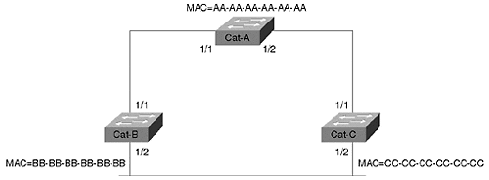
This network consists of three bridges connected in a looped configuration. Each bridge has been assigned a fictitious MAC address that corresponds to the device's name (for example, Cat-A uses MAC address AA-AA-AA-AA-AA-AA).

Step One: Elect One Root Bridge
The switches first need to elect a single Root Bridge by looking for the bridge with the lowest Bridge ID (BID). Remember, in "STP economics", the lowest BID wins! This process of selecting the bridge with the lowest BID often goes by the exciting title of a Root War.
Tip
Many texts use the term highest priority when discussing the results of the Root War. However, notice that the bridge with the highest priority actually has the lowest value. To avoid confusion, this text always refers to the values.

As discussed in the "Bridge ID" section earlier, a BID is an 8-byte identifier that is composed of two subfields: the Bridge Priority and a MAC address from the supervisor or backplane. Referring back to Figure 6-6, you can see that Cat-A has a default BID of 32,768.AA-AA-AA-AA-AA-AA. Note the mixing of a decimal Bridge Priority with a hexadecimal MAC address. Although this might look a little strange, this convention enables you to view each section of the BID in its most common format.
Tip
Remember, the lowest BID wins.

Continuing with the example, Cat-B assumes a default BID of 32,768.BB-BB-BB-BB-BB-BB, and Cat-C uses 32,768.CC-CC-CC-CC-CC-CC. Because all three bridges are using the default Bridge Priority of 32,768, the lowest MAC address (AA-AA-AA-AA-AA-AA) serves as the tie-breaker, and Cat-A becomes the Root Bridge. Figure 6-7 illustrates this process.

Figure 6-7 The Network Must Select a Single Root Bridge
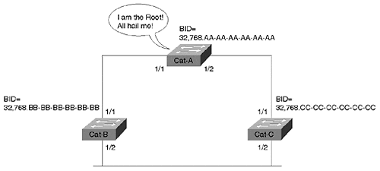
Okay, but how did the bridges learn that Cat-A had the lowest BID? This is accomplished through the exchange of BPDUs. As discussed earlier, BPDUs are special packets that bridges use to exchange topology and Spanning Tree information with each other. By default, BPDUs are sent out every two seconds. BPDUs are bridge-to-bridge traffic; they do not carry any end-user traffic (such as Doom or, if you are boring, e-mail traffic). Figure 6-8 illustrates the basic layout of a BPDU. (BPDU formats are covered in detail in the "Two Types of BPDUs" section.)

Figure 6-8 Basic BPDU Layout
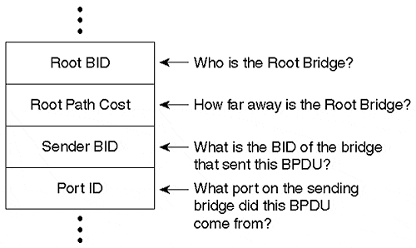
For the purposes of the Root War, the discussion is only concerned with the Root BID and Sender BID fields (again, the real names come later). When a bridge generates a BPDU every 2 seconds, it places who it thinks is the Root Bridge at that instant in time in the Root BID field. The bridge always places its own BID in the Sender BID field.
Tip
Remember that the Root BID is the bridge ID of the current Root Bridge, while the Sender BID is the bridge ID of the local bridge or switch.

It turns out that a bridge is a lot like a human in that it starts out assuming that the world revolves around itself. In other words, when a bridge first boots, it always places its BID in both the Root BID and the Sender BID fields. Suppose that Cat-B boots first and starts sending out BPDUs announcing itself as the Root Bridge every 2 seconds. A few minutes later, Cat-C boots and boldly announces itself as the Root Bridge. When Cat-C's BPDU arrives at Cat-B, Cat-B discards the BPDU because it has a lower BID saved on its ports (its own BID). As soon as Cat-B transmits a BPDU, Cat-C learns that it is not quite as important as it initially assumed. At this point, Cat-C starts sending BPDUs that list Cat-B as the Root BID and Cat-C as the Sender BID. The network is now in agreement that Cat-B is the Root Bridge.
Five minutes later Cat-A boots. As you saw with Cat-B earlier, Cat-A initially assumes that it is the Root Bridge and starts advertising this fact in BPDUs. As soon as these BPDUs arrive at Cat-B and Cat-C, these switches abdicate the Root Bridge position to Cat-A. All three switches are now sending out BPDUs that announce Cat-A as the Root Bridge and themselves as the Sender BID.

Step Two: Elect Root Ports
After the bloodshed of the Root War is behind them, the switches move on to selecting Root Ports. A bridge's Root Port is the port that is closest to the Root Bridge. Every non-RootBridge must select one Root Port.
Tip
Every non-Root Bridge will select one Root Port.

As discussed earlier, bridges use the concept of cost to judge closeness. Specifically, bridges track something called Root Path Cost, the cumulative cost of all links to the Root Bridge. Figure 6-9 illustrates how this value is calculated across multiple bridges and the resulting Root Port election process.

Figure 6-9 Every Non-Root Bridge Must Select One Root Port
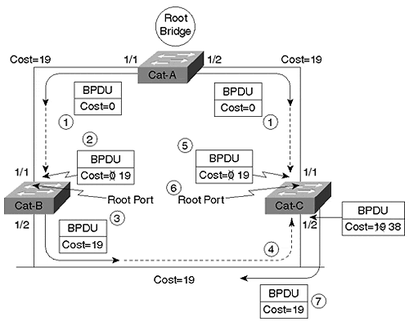
When Cat-A (the Root Bridge) sends out BPDUs, they contain a Root Path Cost of 0 (Step 1). When Cat-B receives these BPDUs, it adds the Path Cost of Port 1/1 to the Root Path Cost contained in the received BPDU. Assume the network is running Catalyst 5000 switch code greater than version 2.4 and that all three links in Figure 6-9 are Fast Ethernet. Cat-B receives a Root Path Cost of 0 and adds in Port 1/1's cost of 19 (Step 2). Cat-B then uses the value of 19 internally and sends BPDUs with a Root Path Cost of 19 out Port 1/2 (Step 3).
When Cat-C receives these BPDUs from Cat-B (Step 4), it increases the Root Path Cost to 38 (19+19). However, Cat-C is also receiving BPDUs from the Root Bridge on Port 1/1. These enter Cat-C:Port-1/1 with a cost of 0, and Cat-C increases the cost to 19 internally (Step 5). Cat-C has a decision to make: it must select a single Root Port, the port that is closest to the Root Bridge. Cat-C sees a Root Path Cost of 19 on Port 1/1 and 38 on Port 1/2—Cat-C:Port-1/1 becomes the Root Port (Step 6). Cat-C then begins advertising this Root Path Cost of 19 to downstream switches (Step 7).
Although not detailed in Figure 6-9, Cat-B goes through a similar set of calculations: Cat-B:Port-1/1 can reach the Root Bridge at a cost of 19, whereas Cat-B:Port-1/2 calculates a cost of 38…Port-1/1 becomes the Root Port for Cat-B. Notice that costs are incremented as BPDUs are received on a port.
Tip
Remember that STP costs are incremented as BPDUs are received on a port, not as they are sent out a port.

For example, BPDUs arrive on Cat-B:Port-1/1 with a cost of 0 and get increased to 19 "inside" Cat-B. This point is discussed in more detail in the section "Mastering the show spantree Command."
Tip
Remember the difference between Path Cost and Root Path Cost.
Path Cost is a value assigned to each port. It is added to BPDUs received on that port to calculate the Root Path Cost.
Root Path Cost is defined as the cumulative cost to the Root Bridge. In a BPDU, this is the value transmitted in the cost field. In a bridge, this value is calculated by adding the receiving port's Path Cost to the value contained in the BPDU.

Step Three: Elect Designated Ports
The loop prevention part of STP becomes obvious during the third step of initial STP convergence: electing Designated Ports. Each segment in a bridged network has oneDesignated Port. This port functions as the single bridge port that both sends and receives traffic to and from that segment and the Root Bridge. The idea is that if only one port handles traffic for each link, all of the loops have been broken! The bridge containing the Designated Port for a given segment is referred to as the Designated Bridge for that segment.
As with the Root Port selection, the Designated Ports are chosen based on cumulative Root Path Cost to the Root Bridge (see Figure 6-10).

Figure 6-10 Every Segment Elects One Designated Port Based on the Lowest Cost
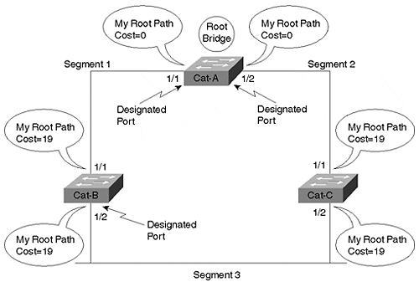
To locate the Designated Ports, take a look at each segment in turn. First look at Segment 1, the link between Cat-A and Cat-B. There are 2 bridge ports on the segment: Cat-A:Port-1/1 and Cat-B:Port-1/1. Cat-A:Port-1/1 has a Root Path Cost of 0 (after all, it is the Root Bridge), whereas Cat-B:Port-1/1 has a Root Path Cost of 19 (the value 0 received in BPDUs from Cat-A plus the Path Cost of 19 assigned to Cat-B:Port1/1). Because Cat-A:Port-1/1 has the lower Root Path Cost, it becomes the Designated Port for this link.
For Segment 2 (Cat-A to Cat-C link), a similar election takes place. Cat-A:Port-1/2 has a Root Path Cost of 0, whereas Cat-C:Port-1/1 has a Root Path Cost of 19. Cat-A:Port-1/2 has the lower cost and becomes the Designated Port. Notice that every active port on the Root Bridge becomes a Designated Port. The only exception to this rule is a Layer 1 physical loop to the Root Bridge (for example, you connected two ports on the Root Bridge to the same hub or you connected the two ports together with a crossover cable).
Now look at Segment 3 (Cat-B to Cat-C): both Cat-B:Port-1/2 and Cat-C:Port-1/2 have a Root Path Cost of 19. There is a tie! When faced with a tie (or any other determination), STP always uses the four-step decision sequence discussed earlier in the section "Four-Step STP Decision Sequence." Recall that the four steps are as follows:
Step 1. Lowest Root BID
Step 2. Lowest Path Cost to Root Bridge
Step 3. Lowest Sender BID
Step 4. Lowest Port ID
In the example shown in Figure 6-10, all three bridges are in agreement that Cat-A is the Root Bridge, causing Root Path Cost to be evaluated next. However, as pointed out in the previous paragraph, both Cat-B and Cat-C have a cost of 19. This causes BID, the third decision criteria, to be the deciding factor. Because Cat-B's BID (32,768.BB-BB-BB-BB-BB-BB) is lower than Cat-C's BID (32,768.CC-CC-CC-CC-CC-CC), Cat-B:Port-1/2 becomes the Designated Port for Segment 3. Cat-C:Port-1/2 therefore becomes a non-Designated Port.

Initial STP Convergence Review
Before continuing, this section recaps the points already discussed. Recall that switches go through three steps for their initial convergence:
Step 1. Elect one Root Bridge
Step 2. Elect one Root Port per non-Root Bridge
Step 3. Elect one Designated Port per segment
First, the bridged network elects a single Root Bridge. Second, every non-Root Bridge elects a single Root Port, the port that is the closest to the Root Bridge. Third, the bridges elect a single Designated Port for every segment.
For example, in a network that contains 15 switches and 146 segments (remember every switch port is a unique segment), the number of STP components that exist corresponds to the values documented in Table 6-2.

Table 6-2. STP Components in a 15 Switch and 146 Segment Network
STP Component | Number
Root Bridge | 1
Root Port | 14
Designated Ports | 146
Also, all STP decisions are based on a predetermined sequence as follows:
Step 1. Lowest Root BID
Step 2. Lowest Path Cost to Root Bridge
Step 3. Lowest Sender BID
Step 4. Lowest Port ID
Every BPDU received on a port is compared against the other BPDUs received (as well as the BPDU that is sent on that port). Only the best BPDU (or superior BPDU) is saved. Notice in all cases that "best" is determined by the lowest value (for example, the lowest BID becomes the Root Bridge, and the lowest cost is used to elect the Root and Designated Ports). A port stops transmitting BPDUs if it hears a better BPDU that it would transmit itself.

Five STP States
After the bridges have classified their ports as Root, Designated, or non-Designated, creating a loop-free topology is straightforward: Root and Designated Ports forward traffic, whereas non-Designated Ports block traffic. Although Forwarding and Blocking are the only two states commonly seen in a stable network, Table 6-3 illustrates that there are actually five STP states.

Table 6-3. STP States
State | Purpose
Forwarding | Sending/receiving user data
Learning | Building bridging table
Listening | Building "active" topology
Blocking | Receives BPDUs only
Disabled | Administratively down
You can view this list as a hierarchy in that bridge ports start at the bottom (Disabled or Blocking) and work their way up to Forwarding. The Disabled state allows network administrators to manually shut down a port. It is not part of the normal, dynamic port processing. After initialization, ports start in the Blocking state where they listen for BPDUs.
A variety of events (such as a bridge thinking it is the Root Bridge immediately after booting or an absence of BPDUs for certain period of time) can cause the bridge to transition into the Listening state. At this point, no user data is being passed—the port is sending and receiving BPDUs in an effort to determine the active topology. It is during the Listening state that the three initial convergence steps discussed in the previous section take place. Ports that lose the Designated Port election become non-Designated Ports and drop back to the Blocking state.
Ports that remain Designated or Root Ports after 15 seconds (the default timer value) progress into the Learning state. This is another 15-second period where the bridge is still not passing user data frames. Instead, the bridge is quietly building its bridging table as discussed in Chapter 3. As the bridge receives frames, it places the source MAC address and port into the bridging table. The Learning state reduces the amount of flooding required when data forwarding begins.
Note
In addition to storing source MAC address and port information, Catalysts learn information such as the source VLAN.

If a port is still a Designated or Root Port at the end of the Learning state period, the port transitions into the Forwarding state. At this stage, it finally starts sending and receiving user data frames. Figure 6-11 illustrates the port states and possible transitions.

Figure 6-11 Possible Port States and Transitions
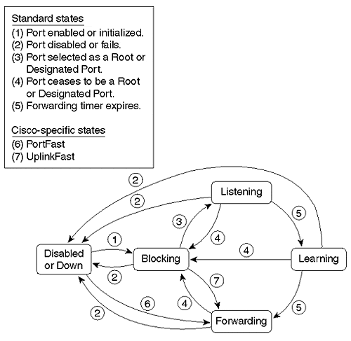
Figure 6-12 shows the sample network with the port classifications and states listed. Notice that all ports are forwarding except Cat-C:Port-1/2.

Figure 6-12 Sample Network with Port States Identified
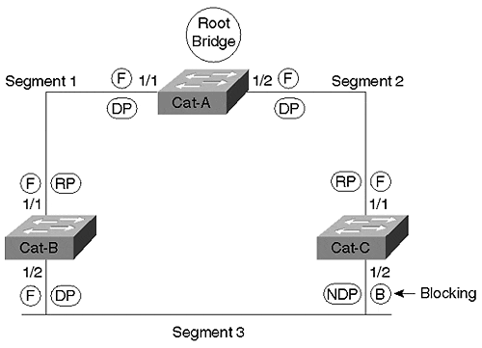
Table 6-4 documents the symbols used throughout the book to represent Spanning Tree states.

Table 6-4. STP State and Port Symbols
State/Port | Symbol
Blocking | B
Forwarding | F
Designated Port | DP
Root Port | RP
Non-Designated Port | NDP

Three STP Timers
The previous section mentioned that a bridge spends 15 seconds in each of the Listening and Learning states by default. In all, the Spanning-Tree Protocol is controlled by the three timers documented in Table 6-5.

Table 6-5. STP Timers
Timer | Primary Purpose | Default
Hello Time | Time between sending of Configuration BPDUs by the Root Bridge | 2 Secs
Forward Delay | Duration of Listening and Learning states | 15 Secs
Max Age | Time BPDU stored | 20 Secs
The Hello Time controls the time interval between the sending of Configuration BPDUs. 802.1D specifies a default value of two seconds. Note that this value really only controls Configuration BPDUs as they are generated at the Root Bridge—other bridges propagate BPDUs from the Root Bridge as they are received. In other words, if BPDUs stop arriving for 2–20 seconds because of a network disturbance, non-Root Bridges stop sending periodic BPDUs during this time. (If the outage lasts more than 20 seconds, the default Max Age time, the bridge invalidates the saved BPDUs and begins looking for a new Root Port.) However, as discussed in the "Topology Change Notification BPDUs" section later, all bridges use their locally configured Hello Time value as a TCN retransmit timer.
Forward Delay is the time that the bridge spends in the Listening and Learning states. This is a single value that controls both states. The default value of 15 seconds was originally derived assuming a maximum network size of seven bridge hops, a maximum of three lost BPDUs, and a Hello Time interval of two seconds (see the section "Tuning Forward Delay" in Chapter 7 for more detail on how Forward Delay is calculated). As discussed in the "Topology Change Notification BPDUs" section, the Forward Delay timer also controls the bridge table age-out period after a change in the active topology.
Max Age is the time that a bridge stores a BPDU before discarding it. Recall from the earlier discussions that each port saves a copy of the best BPDU it has seen. As long as the bridge receives a continuous stream of BPDUs every 2 seconds, the receiving bridge maintains a continuous copy of the BPDU's values. However, if the device sending this best BPDU fails, some mechanism must exist to allow other bridges to take over.
For example, assume that the Segment 3 link in Figure 6-12 uses a hub and Cat-B:Port-1/2's transceiver falls out. Cat-C has no immediate notification of the failure because it's still receiving Ethernet link from the hub. The only thing Cat-C notices is that BPDUs stop arriving. Twenty seconds (Max Age) after the failure, Cat-C:Port-1/2 ages out the stale BPDU information that lists Cat-B as having the best Designated Port for Segment 3. This causes Cat-C:Port-1/2 to transition into the Listening state in an effort to become the Designated Port. Because Cat-C:Port-1/2 now offers the most attractive access from the Root Bridge to this link, it eventually transitions all the way into Forwarding mode. In practice, it takes 50 seconds (20 Max Age + 15 Listening + 15 Learning) for Cat-C to take over after the failure of Port 1/2 on Cat-B.
In some situations, bridges can detect topology changes on directly connected links and immediately transition into the Listening state without waiting Max Age seconds. For example, consider Figure 6-13.

Figure 6-13 Failure of a Link Directly Connected to the Root Port of Cat-C
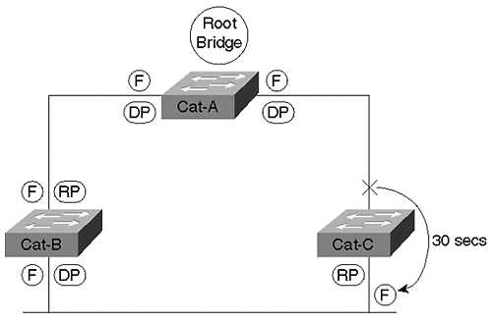
In this case, Cat-C:Port-1/1 failed. Because the failure results in a loss of link on the Root Port, there is no need to wait 20 seconds for the old information to age out. Instead, Cat-C:Port-1/2 immediately goes into Learning mode in an attempt to become the new Root Port. This has the effect of reducing the STP convergence time from 50 seconds to 30 seconds (15 Listening + 15 Learning).
Tip
The default STP convergence time is 30 to 50 seconds. The section "Fast STP Convergence" in Chapter 7 discusses ways to improve this.

There are two key points to remember about using the STP timers. First, don't change the default timer values without some careful consideration. This is discussed in more detail in Chapter 7. Second, assuming that you are brave enough to attempt timer tuning, you should only modify the STP timers from the Root Bridge. As you will see in the "Two Types of BPDUs" section, the BPDUs contain three fields where the timer values can be passed from the Root Bridge to all other bridges in the network. Consider the alternative: if every bridge was locally configured, some bridges could work their way up to the Forwarding state before other bridges ever leave the Listening state. This chaotic approach could obviously destabilize the entire network. By providing timer fields in the BPDUs, the single bridge acting as the Root Bridge can dictate the timing parameters for the entire bridged network.
Tip
You can only modify the timer values from the Root Bridge. Modifying the values on other bridges has no effect. However, don't forget to update any "backup" Root Bridges.

Mastering the show spantree Command
The most important Catalyst command for working with STP is the show spantree command. Although this command offers several useful parameters, this section only explains the basic syntax (see Chapter 7 for the full syntax). A sample of the show spantree output from Cat-B in the sample network from Figure 6-6 would contain the information shown in Example 6-1.

Figure 6-1 show spantree Output from Cat-B in the Network Shown in Figure 6-6
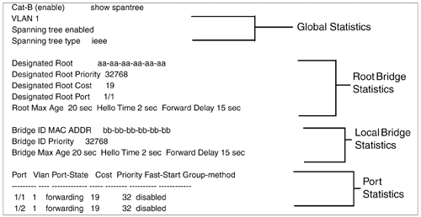
This show spantree output in Example 6-1 can be broken down into four sections as follows:
- Global statistics for the current switch/bridge (lines 2–4)
- Root Bridge statistics (lines 5–9)
- Local bridge statistics (lines 10–12)
- Port statistics (lines 13–16)
The global statistics appear at the top of the screen. The first line of this section (VLAN 1) indicates that the output only contains information for VLAN 1. The second line indicates that STP is enabled on this Catalyst for this VLAN. The final line of this section shows that the IEEE version of STP is being utilized (this cannot be changed on most Catalyst switches). Additional details about these values are discussed in the "All of This Per VLAN!" section at the end of the chapter.
The first two lines of the Root Bridge statistics display the BID of the current Root Bridge. The BID subfields are displayed separately—Designated Root shows the MAC address contained in the low-order six bytes, whereas Designated Root Priority holds the high-order two bytes. The cumulative Root Path Cost to the Root Bridge is displayed in the Designated Root Cost field. The fourth line of this section (Designated Root Port) shows the current Root Port of the local device. The last line of the Root Bridge statistics section shows the timer values currently set on the Root Bridge. As the previous section discussed, these values are used throughout the entire network (at least for VLAN 1) to provide consistency. The term designated is used here to signify that these values pertain to the bridge that this device currently believes is the Root Bridge. However, because of topology changes and propagation delays during network convergence, this information might not reflect the characteristics of the true Root Bridge.
The local bridge statistics section displays the BID of the current bridge in the first two lines. The locally configured timer values are shown in the third line of this section.
Tip
The timer values shown in the local bridge statistics section are not utilized unless the current bridge becomes the Root Bridge at some point.

The port statistics section is displayed at the bottom of the screen. Depending on the number of ports present in the Catalyst, this display can continue for many screens using the more prompt. This information displays the Path Cost value associated with each port. This value is the cost that is added to the Root Path Cost field contained in BPDUs received on this port. In other words, Cat-B receives BPDUs on Port 1/1 with a cost of 0 because they are sent by the Root Bridge. Port 1/1's cost of 19 is added to this zero-cost value to yield a Designated Root Cost of 19. In the outbound direction, Cat-B sends BPDUs downstream with a cost of 19—Port 1/2's Path Cost of 19 is not added to transmitted BPDUs.
Tip
The cost values displayed in the port statistics section show spantree are added to BPDUs that are received (not sent) on that port.

The information displayed by show spantree can be critical to learning how Spanning Tree is working in your network. For example, it can be extremely useful when you need to locate the Root Bridge. Consider the network shown in Figure 6-14.

Figure 6-14 Using show spantree to Locate the Root Bridge
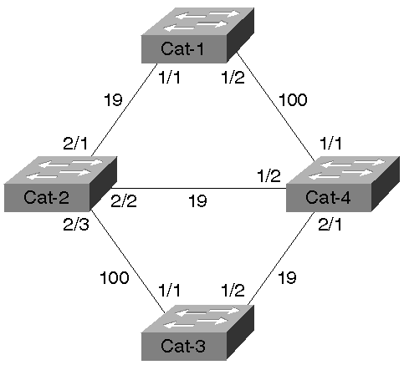
Example 6-2 shows the output of show spantree on Cat-1 for VLAN 1.

Example 6-2 Locating the Root Bridge with show spantree on Cat-1 for VLAN 1
Cat-1 (enable) show spantree VLAN 1 Spanning tree enabled Spanning tree type ieee Designated Root 00-e0-f9-16-28-00 Designated Root Priority 100 Designated Root Cost 57 Designated Root Port 1/1 Root Max Age 10 sec Hello Time 1 sec Forward Delay 10 sec Bridge ID MAC ADDR 00-e0-f9-af-5d-00 Bridge ID Priority 32768 Bridge Max Age 20 sec Hello Time 2 sec Forward Delay 15 sec Port Vlan Port-State Cost Priority Fast-Start Group-method --------- ---- ------------- ----- -------- ---------- ------------ 1/1 1 forwarding 19 32 disabled 1/2 1 blocking 100 32 disabled
Although this information indicates that the Root Bridge has a BID of 100.00-E0-F9-16-28-00, locating the specific MAC address 00-E0-F9-16-28-00 in a large network can be difficult. One approach is to maintain a list of all MAC addresses assigned to all Catalyst—a tedious and error-prone activity. A more effective approach is to simply use the output of show spantree to "walk" the network until you locate the Root Bridge. By looking at the Designated Root Port field, you can easily determine that the Root Bridge is located somewhere out Port 1/1. By consulting our topology diagram (or using the show cdp neighbor command), you can determine that Cat-2 is the next-hop switch on Port 1/1. Then, Telnet to Cat-2 and issue the show spantree command as in Example 6-3.

Example 6-3 Locating the Root Bridge with show spantree on Cat-2 for VLAN
Cat-2 (enable) show spantree VLAN 1 Spanning tree enabled Spanning tree type ieee Designated Root 00-e0-f9-16-28-00 Designated Root Priority 100 Designated Root Cost 38 Designated Root Port 2/2 Root Max Age 10 sec Hello Time 1 sec Forward Delay 10 sec Bridge ID MAC ADDR 00-e0-f9-1d-32-00 Bridge ID Priority 32768 Bridge Max Age 20 sec Hello Time 2 sec Forward Delay 15 sec Port Vlan Port-State Cost Priority Fast-Start Group-method --------- ---- ------------- ----- -------- ---------- ------------ 2/1 1 forwarding 19 32 disabled 2/2 1 forwarding 19 32 disabled 2/3 1 blocking 100 32 disabled
Cat-2's Root Port is Port 2/2. After determining Port 2/2's neighboring bridge (Cat-4), Telnet to Cat-4 and issue the show spantree command as in Example 6-4.

Example 6-4 Locating the Root Bridge with show spantree on Cat-4 for VLAN 1
Cat-4 (enable) show spantree VLAN 1 Spanning tree enabled Spanning tree type ieee Designated Root 00-e0-f9-16-28-00 Designated Root Priority 100 Designated Root Cost 19 Designated Root Port 2/1 Root Max Age 10 sec Hello Time 1 sec Forward Delay 10 sec Bridge ID MAC ADDR 00-e0-f9-52-ba-00 Bridge ID Priority 32768 Bridge Max Age 20 sec Hello Time 2 sec Forward Delay 15 sec Port Vlan Port-State Cost Priority Fast-Start Group-method --------- ---- ------------- ----- -------- ---------- ------------ 1/1 1 forwarding 19 32 disabled 1/2 1 forwarding 100 32 disabled 2/1 1 forwarding 19 32 disabled
Because Cat-4's Root Port is 2/1, you will next look at Cat-3 (see Example 6-5).

Example 6-5 Locating the Root Bridge with show spantree on Cat-3 for VLAN 1
Cat-3 (enable) show spantree VLAN 1 Spanning tree enabled Spanning tree type ieee Designated Root 00-e0-f9-16-28-00 Designated Root Priority 100 Designated Root Cost 0 Designated Root Port 1/0 Root Max Age 10 sec Hello Time 1 sec Forward Delay 10 sec Bridge ID MAC ADDR 00-e0-f9-16-28-00 Bridge ID Priority 100 Root Max Age 10 sec Hello Time 1 sec Forward Delay 10 sec Port Vlan Port-State Cost Priority Fast-Start Group-method --------- ---- ------------- ----- -------- ---------- ------------ 1/1 1 forwarding 100 32 disabled 1/2 1 forwarding 19 32 disabled
Several fields highlight the fact that Cat-3 is the Root Bridge:
- The Root Port is Port 1/0. Note that Catalyst 4000s, 5000s, and 6000s do not have a physical port labeled 1/0. Instead, the NPM software uses a reference to the logical console port, SC0, as a "logical Root Port."
- The local BID matches the Root Bridge BID.
- The Root Path Cost is zero.
- The timer values match.
- All ports are in the Forwarding state.
The search is over—you have found the Root Bridge located at Cat-3.

Two Types of BPDUs
To this point, the chapter has referred to all BPDUs as a single type. Actually, there are two types of BPDUs:
- Configuration BPDUs
- Topology Change Notification (TCN) BPDUs
Configuration BPDUs are originated by the Root Bridge and flow outward along the active paths that radiate away from the Root Bridge. Topology Change Notification BPDUs flow upstream (toward the Root Bridge) to alert the Root Bridge that the active topology has changed. The following sections discuss both of these BPDUs in detail.

Configuration BPDUs
All of the BPDUs discussed so far (and the vast majority of BPDUs on a healthy network) are Configuration BPDUs. Figure 6-15 illustrates a BPDU's protocol format.

Figure 6-15 Configuration BPDU Decode
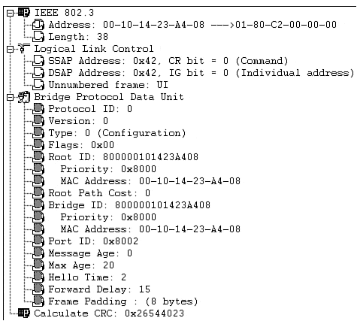
Note
For simplicity, the chapter has so far ignored the fact that there are two types of BPDUs and simply has used the term BPDU. However, recognize that all of these cases were referring to Configuration BPDUs. The second type of BPDU, the Topology Change BPDU, is discussed in the next section.

The decode in Figure 6-15 was captured and displayed by the NetXRay software from Network Associates (formerly Network General). Although considerably newer versions are available for sale, the version shown in Figure 6-15 is useful because it provides a very easy-to-read representation and decode of the Spanning-Tree Protocol. At the top of the screen you can observe the Ethernet 802.3 header. The source address is the MAC address of the individual port sending the BPDU. Every port on a Catalyst uses a unique Source MAC Address value for BPDUs sent out that port. Note the difference between this MAC address and the MAC address used to create the BID. The source MAC address is different on every Catalyst port. The BID is a global, box-wide value (within a single VLAN) that is formed from a MAC address located on the supervisor card or backplane. The source MAC is used to build the frame that carries the BPDU, whereas the BID's MAC is contained within the actual Configuration BPDU.
The Destination MAC Address uses the well-known STP multicast address of 01-80-C2-00-00-00. The Length field contains the length of the 802.2 LLC (Logical Link Control) header, BPDU, and pad that follows. Note that the CRC shown at the bottom of the screen is also part of the 802.3 encapsulation (specifically, the 802.3 trailer).
Below the 802.3 header lies the 802.2 LLC header. This 3-byte header consists of three fields that essentially identify the payload (in this case, a BPDU). The IEEE has reserved the DSAP (destination service access point) and SSAP (source service access point) value 0x42 hex to signify STP. This value has the unique advantage of being the same regardless of bit ordering (0×42 equals 0100 0010 in binary), avoiding confusion in environments that use translational bridging. Don't worry about the next byte, the control byte. It turns out that every non-SNA protocol you can name (including STP) always uses the value 0x03 to represent an Unnumbered Information (UI) frame.
The lower two-thirds of the output contains the actual BPDU. Configuration BPDUs consist of the following 12 fields (although many displays break the two BIDs out into separate subfields as shown in Figure 6-15):
- Protocol ID—
Always 0. Future enhancements to the protocol might cause the Protocol ID values to increase.
- Version—
Always 0. Future enhancements to the protocol might cause the Version value to increase.
- Type—
Determines which of the two BPDU formats this frame contains (Configuration BPDU or TCN BPDU). See the next section, "Topology Change Notification BPDUs," for more detail.
- Flags—
Used to handle changes in the active topology and is covered in the next section on Topology Change Notifications.
- Root BID (Root ID in Figure 6-15)—
Contains the Bridge ID of the Root Bridge. After convergence, all Configuration BPDUs in the bridged network should contain the same value for this field (for a single VLAN). NetXRay breaks out the two BID subfields: Bridge Priority and bridge MAC address. See the "Step One: Elect One Root Bridge" section for more detail.
- Root Path Cost—
The cumulative cost of all links leading to the Root Bridge. See the earlier "Path Cost" section for more detail.
- Sender BID (Bridge ID in Figure 6-15)—
The BID of the bridge that created the current BPDU. This field is the same for all BPDUs sent by a single switch (for a single VLAN), but it differs between switches. See the "Step Three: Elect Designated Ports" section for more detail.
- Port ID—
Contains a unique value for every port. Port 1/1 contains the value 0×8001, whereas Port 1/2 contains 0×8002 (although the numbers are grouped into blocks based on slot numbers and are not consecutive). See the "Load Balancing" section of Chapter 7 for more detail.
- Message Age—
Records the time since the Root Bridge originally generated the information that the current BPDU is derived from. If a bridge looses connectivity to the Root Bridge (and hence, stops receiving BPDU refreshes), it needs to increment this counter in any BPDUs it sends to signify that the data is old. Encoded in 256ths of a second.
- Max Age—
Maximum time that a BPDU is saved. Also influences the bridge table aging timer during the Topology Change Notification process (discussed later). See the "Three STP Timers" section for more detail. Encoded in 256ths of a second.
- Hello Time—
Time between periodic Configuration BPDUs. The Root Bridge sends a Configuration BPDU on every active port every Hello Time seconds. This causes the other bridges to propagate BPDUs throughout the bridged network. See the "Three STP Timers" section for more detail. Encoded in 256ths of a second.
- Forward Delay—
The time spent in the Listening and Learning states. Also influences timers during the Topology Change Notification process (discussed later). See the "Three STP Timers" section for more detail. Encoded in 256ths of a second.
Table 6-6 summarizes the Configuration BPDU fields.

Table 6-6. Configuration BPDU Fields
Field | Octets | Use
Protocol ID | 2 | Always 0
Version | 1 | Always 0
Type | 1 | Type of current BPDU  0 = Configuration BPDU
Flags | 1 | LSB = Topology Change (TC) flag  MSB = Topology Change Acknowledgment (TCA) flag
Root BID | 8 | Bridge ID of current Root Bridge
Root Path Cost | 4 | Cumulative cost to Root Bridge
Sender BID | 8 | Bridge ID of current bridge
Port ID | 2 | Unique ID for port that sent this BPDU
Message Age | 2 | Time since Root Bridge-created BPDU used to derive current BPDU
Max Age | 2 | Period to save BPDU information
Hello Time | 2 | Period between BPDUs
Forward Delay | 2 | Time spent in Listening and Learning states

Topology Change Notification BPDUs
Although the majority of BPDUs on a healthy network should be Configuration BPDUs, all bridged networks see at least a few of the second type of BPDU, the Topology Change Notification (TCN) BPDU. TCN BPDUs, as their name suggests, play a key role in handling changes in the active topology. Figure 6-16 illustrates a decode of a TCN BPDU.

Figure 6-16 Topology Change Notification BPDU Decode
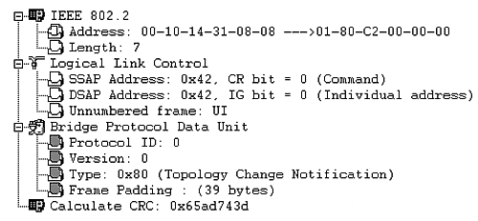
The TCN BPDU is much simpler than the Configuration BPDU illustrated in Figure 6-15 and consists of only three fields. TCN BPDUs are identical to the first three fields of a Configuration BPDU with the exception of a single bit in the Type field. After all, at least one bit is needed to say "this is a TCN BPDU, not a Configuration BPDU." Therefore, the Type field can contain one of two values:
- 0x00 (Binary: 0000 0000) Configuration BPDU
- 0x80 (Binary: 1000 0000) Topology Change Notification (TCN) BPDU
That's it. TCN BPDUs don't carry any additional information.

Topology Change Process
If TCN BPDUs are so simple, how then do they play such an important role? Before answering that question directly, consider a subtle side effect of topology changes. The discussion that follows refers to the scenario illustrated in Figure 6-17.

Figure 6-17 TCN BPDUs are Required to Update Bridge Tables More Quickly
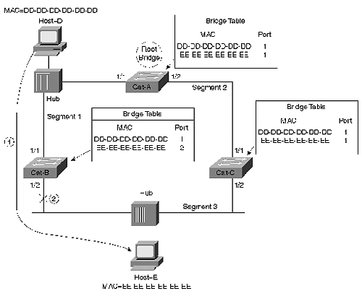
Suppose that Host-D is playing Doom with Host-E. As discussed earlier in Figure 6-12, the traffic from Host-D flows directly through Cat-B to reach Host-E (Step 1). Assume that the Ethernet transceiver on Cat-B:Port-1/2 falls out (Step 2). As discussed earlier, Cat-C: Port 1/2 takes over as the Designated Port in 50 seconds. However, without TCN BPDUs, the game continues to be interrupted for another 250 seconds (4 minutes, 10 seconds). Why is this the case? Prior to the failure, the bridging table entries for MAC address EE-EE-EE-EE-EE-EE on all three switches appeared as documented in Table 6-7.

Table 6-7. Bridge Table Values Before Topology Change
Bridge Table | Port Associated with EE-EE-EE-EE-EE-EE
Cat-A | Port 1/1
Cat-B | Port 1/2
Cat-C | Port 1/1
In other words, all frames destined for Host-E before the failure had to travel counterclockwise around the network because Cat-C:Port-1/2 was Blocking. When Cat-B:Port-1/2 fails, Cat-C:Port-1/2 takes over as the Designated Port. This allows traffic to start flowing in a clockwise direction and reach Host-E. However, the bridging tables in all three switches still point in the wrong direction. In other words, it appears to the network as if Host-E has moved and the bridging tables still require updating. One option is to wait for the natural timeout of entries in the bridging table. However, because the default address timeout is 300 seconds, this unfortunately results in the 5-minute outage calculated previously.
TCN BPDUs are a fairly simple way to improve this convergence time (and allow us to continue playing Doom sooner). TCN BPDUs work closely with Configuration BPDUs as follows:
- A bridge originates a TCN BPDU in two conditions:
  - It transitions a port into the Forwarding state and it has at least one Designated Port.
  - It transitions a port from either the Forwarding or Learning states to the Blocking state.
These situations construe a change in the active topology and require notification be sent to the Root Bridge. Assuming that the current bridge is not the Root Bridge, the current bridge begins this notification process by sending TCN BPDU out its Root Port. It continues sending the TCN BPDU every Hello Time interval seconds until the TCN message is acknowledged (note: this is the locally configured Hello Time, not the Hello Time distributed by the Root Bridge in Configuration BPDUs).
- The upstream bridge receives the TCN BPDU. Although several bridges might hear the TCN BPDU (because they are directly connected to the Root Port's segment), only the Designated Port accepts and processes the TCN BPDU.
- The upstream bridge sets the Topology Change Acknowledgment flag in the next Configuration BPDU that it sends downstream (out the Designated Port). This acknowledges the TCN BPDU received in the previous step and causes the originating bridge to cease generating TCN BPDUs.
- The upstream bridge propagates the TCN BPDU out its Root Port (the TCN BPDU is now one hop closer to the Root Bridge).
- Steps 2 through 4 continue until the Root Bridge receives the TCN BPDU.
- The Root Bridge then sets the Topology Change Acknowledgment flag (to acknowledge the TCN BPDU sent by the previous bridge) and the Topology change flag in the next Configuration BPDU that it sends out.
- The Root Bridge continues to set the Topology Change flag in all Configuration BPDUs that it sends out for a total of Forward Delay + Max Age seconds (default = 35 seconds). This flag instructs all bridges to shorten their bridge table aging process from the default value of 300 seconds to the current Forward Delay value (default=15 seconds).
Figure 6-18 summarizes the use of these bits during the seven-step TCN procedure (the steps numbers are circled):

Figure 6-18 Sequence of Flows in Topology Change Processes
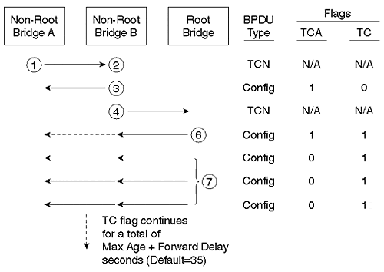
Applying these steps to the topology in Figure 6-17 (for simplicity, the steps are not shown in Figure 6-17), Cat-B and Cat-C send TCN BPDUs out their Port 1/1 (Step 1). Because the upstream bridge is also the Root Bridge, Steps 2 and 5 occur simultaneously (and allow Steps 3 and 4 to be skipped). In the next Configuration BPDU that it sends, the Root Bridge sets the TCN ACK flag to acknowledge receipt of the TCN from both downstream Catalysts. Cat-A also sets the Topology Change flag for 35 seconds (assume the default Forwarding Delay and Max Age) to cause the bridging tables to update more quickly (Step 6 and 7). All three switches receive the Topology Change flag and age out their bridging tables in 15 seconds.
Notice that shortening the aging time to 15 seconds does not flush the entire table, it just accelerates the aging process. Devices that continue to "speak" during the 15-second age-out period never leave the bridging table. However, if Host-D tries to send a frame to Host-E in 20 seconds (assume that Host-E has been silent), it is flooded to all segments by the switches because the EE-EE-EE-EE-EE-EE MAC address is no longer in any of the bridging tables. As soon as this frame reaches Host-E and Host-E responds, the switches learn the new bridge table values that are appropriate for the new topology.
Table 6-8 shows the bridge table entries for MAC address EE-EE-EE-EE-EE-EE on all three bridges after the new topology has converged and traffic has resumed.

Table 6-8. Bridge Table Value after Topology Change
Bridge Table | Port Associated with EE-EE-EE-EE-EE-EE
Cat-A | Port 1/2
Cat-B | Port 1/1
Cat-C | Port 1/2
At this point, connectivity between Host-D and Host-E is reestablished and our Doom Deathmatch can resume. Notice that the TCN BPDU reduced the failover time from 5 minutes to 50 seconds.
As previously mentioned in the "Configuration BPDUs" section, both Flag fields are stored in the same octet of a Configuration BPDU. This octet is laid out as illustrated in Figure 6-19.

Figure 6-19 Layout of Configuration BPDU Flag Fields
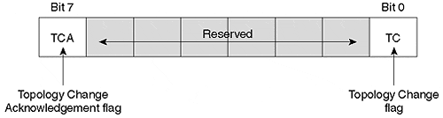
As discussed in the previous section, the TCA flag is set by the upstream bridge to tell the downstream bridge to stop sending TCN BPDUs. The TC flag is set by the Root Bridge to shorten the bridge table age-out period from 300 seconds to Forward Delay seconds.

Using Spanning Tree in Real-World Networks
Look at Figure 6-20 for a more complex topology, and see how all this STP detail adds up in the real world.

Figure 6-20 A Complex Network with All Links Shown
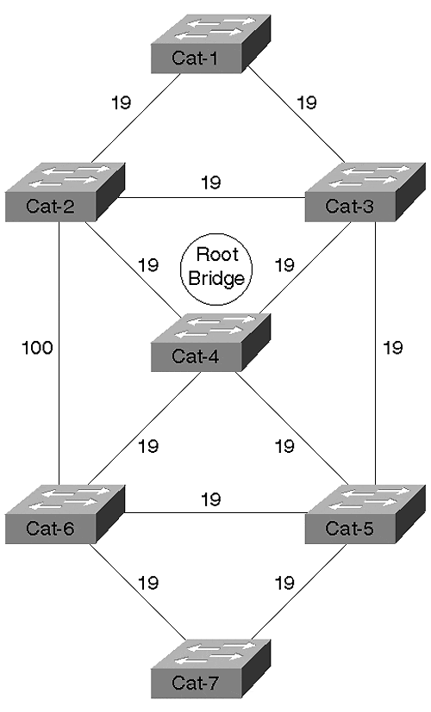
Figure 6-20 illustrates a network of seven switches connected in a highly redundant (that is, looped) configuration. Link costs are indicated—all are Fast Ethernet (cost of 19) except for the vertical link on the far left that is 10BaseT (cost of 100).
Assuming that Cat-4 wins the Root War, Figure 6-21 shows the active topology that results.

Figure 6-21 Complex Network with Central Root Bridge and Active Topology
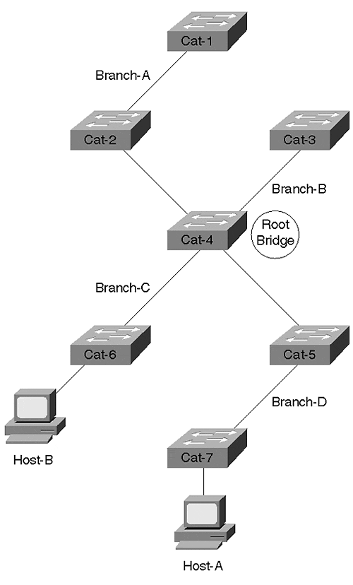
The setup in Figure 6-21 clearly illustrates the basic objective of the Spanning-Tree Protocol: make one bridge the center of the universe and then have all other bridges locate the shortest path to that location ("all roads lead to Rome"). This results in an active topology consisting of spoke-like branches that radiate out from the Root Bridge.
Notice that the Root Bridge is acting as the central switching station for all traffic between the four branches and must be capable of carrying this increased load. For example, Cat-7 and Cat-5 on Branch-D must send all traffic through the Root Bridge (Cat-4) to reach any of the other switches. In other words, don't use your slowest bridge in place of Cat-4!
Figure 6-21 also illustrates the importance of a centrally located Root Bridge. Consider the traffic between Host-A on Cat-7 and Host-B on Cat-6. When these two users want to fire up a game of Doom, the traffic must cross four bridges despite the fact that Cat-7 and Cat-6 are directly connected. Although this might seem inefficient at first, it could be much worse! For example, suppose Cat-1 happened to win the Root War as illustrated in Figure 6-22.

Figure 6-22 Complex Network with Inefficient Root Bridge and Active Topology
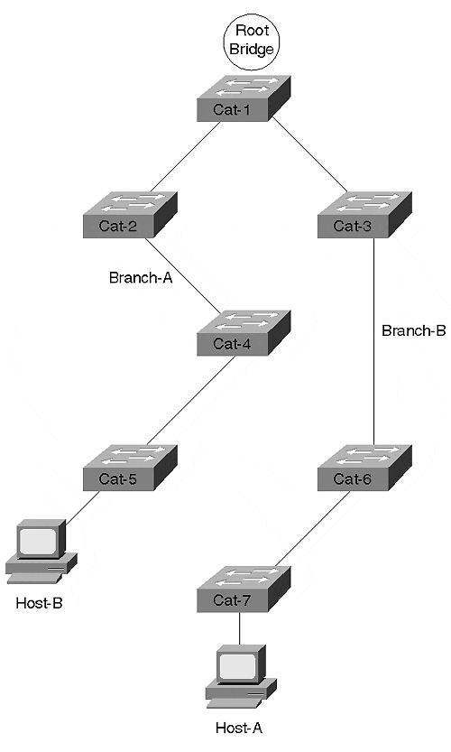
In this scenario, the network has converged into two branches with all traffic flowing through the Root Bridge. However, notice how suboptimal the flows are—Doom traffic between Host-A and Host-B must now flow through all seven bridges!
In the event that I haven't convinced you to avoid a randomly chosen Root Bridge, let me point out that the deck is stacked against you. Assume that Cat-1 is a vintage Cisco MGS or AGS router doing software bridging (Layer 2 forwarding capacity equals about 10,000 packets per second) and the remaining six devices are Catalyst 5500 or 6000 switches (Layer 2 forwarding capacity equals millions of packets per second). Without even thinking, I can guarantee you that the MGS becomes the Root Bridge every time by default!
How can I be so sure? Well, what determines who wins the Root War? The lowest BID. And as you saw earlier, BIDs are composed of two subfields: Bridge Priority and a MAC address. Because all bridges default to a Bridge Priority of 32,768, the lowest MAC address becomes the Root Bridge by default. Catalysts use MAC addresses that begin with OUIs like 00-10-FF and 00-E0-F9 (for example, MAC address 00-10-FF-9F-85-00). All Cisco MGSs use Cisco's traditional OUI of 00-00-0C (for example, MAC address 00-00-0C-58-AF-C1). 00-00-0C is about as low an OUI as you can have—there are only twelve numbers mathematically lower. Therefore, your MGS always has a lower MAC address than any Catalyst you could buy, and it always wins the Root War by default in a Cisco network (and almost any other network on the planet).
In other words, by ignoring Root Bridge placement, you can lower the throughput on your network by a factor of 1,000! Obviously, manually controlling your Root Bridge is critical to good Layer 2 performance.

Deterministic Root Bridge Placement
Based on the previous discussion, you should now agree that deterministically setting your Root Bridge is a must. In fact, you should always set more than one Root Bridge—one to act as the primary and another to act as a backup in the event the primary fails. If your bridged network is really large, you might want to even set a tertiary Root Bridge in case both the primary and the secondary fail.
This section considers how to deterministically place Root Bridges in your network. For considerations and recommendations on where you should place these devices, please consult Chapter 7.
There are two techniques available for setting Root Bridges:
- The set spantree priority command
- The set spantree root command

Manual Root Bridge Placement: set spantree priority
To force a particular bridge to win the Root War, you need to ensure that its BID is lower than all other bridges. One option might be to tweak the MAC address, but that could get ugly (trust me on this). A much simpler option is to modify the Bridge Priority. Because the high-order 16 bits of the BID consist of the Bridge Priority, lowering this number by even one (from 32,768 to 32,767) allows a bridge to always win the Root War against other bridges that are using the default value.
Bridge Priority is controlled through the set spantree priority command. The syntax for this command is:

set spantree priority priority [vlan]

Although the vlan parameter is optional, I suggest that you get in the habit of always typing it (otherwise, someday you will accidentally modify VLAN 1 when you intended to modify some other VLAN). The text revisits the vlan parameter in more detail later. For now, just assume VLAN 1 in all cases.
Tip
Almost all of the Spanning Tree set and show commands support an optional vlan parameter. If you omit this parameter, VLAN 1 is implied. Get in the habit of always explicitly entering this parameter, even if you are only interested in VLAN 1. That way you don't accidentally modify or view the wrong VLAN.

Suppose that you want to force Cat-4 to win the Root War. You could Telnet to the switch and enter:

set spantree priority 100 1

This lowers the priority to 100 for VLAN 1, causing Cat-4 to always win against other switches with the default of 32,768 (including the MGS with its lower MAC address).
But what happens if Cat-4 fails? Do you really want to fail back to the MGS? Probably not. Make Cat-2 the secondary Root Bridge by entering the following on Cat-2:

set spantree priority 200 1

As long at Cat-4 is active, Cat-2 never wins the Root War. However, as soon as Cat-4 dies, Cat-2 always takes over.
Tip
Notice that I used 100 for the primary Root Bridge and 200 for the secondary. I have found this numbering convention to work well in the real world and recommend that you adopt it. It is easy to understand and, more importantly, easy to remember. For example, if you ever look at a show command and see that your current Root Bridge has a Bridge Priority of 200, you instantly know that something has gone wrong with the primary Root Bridge. This scheme also comes in handy when the subject of load balancing is discussed later.

Using a Macro: set spantree root
Starting in version 3.X of the Catalyst 5000 NMP code, Cisco introduced a powerful new macro to automatically program Bridge Priorities and other values. The full syntax of this macro is as follows:

set spantree root [secondary] [vlan_list] [dia network_diameter] [hello hello_time]

To make a particular Catalyst the Root Bridge for VLAN 1, simply Telnet to that device and enter the following:

set spantree root 1

This causes the Catalyst to look at the Bridge Priority of the existing Root Bridge. If this value is higher than 8,192, the set spantree root macro programs the local Bridge Priority to 8,192. If the existing Root Bridge is less than 8,192, the macro sets the local bridge priority to one less than the value used by the existing Root Bridge. For example, if the existing Root Bridge is using a Bridge Priority of 100, set spantree root sets the local Bridge Priority to 99.
Note
The current documentation claims that set spantree root sets the value to 100 less than the current value if 8,192 is not low enough to win the Root War. However, I have always observed it to reduce the value only by 1.

To make another Catalyst function as a backup Root Bridge, Telnet to that device and enter the following:

set spantree root 1 secondary

This lowers the current Catalyst's Bridge Priority to 16,384. Because this value is higher than the value used by the primary, but lower than the default of 32,867, it is a simple but effect way to provide deterministic Root Bridge failover.
The dia and hello parameters can be used to automatically adjust the STP timer values according to the recommendations spelled out in the 802.1D specification. Tuning STP timers is discussed in detail in the "Fast STP Convergence" section of Chapter 7.
This might seem like a subtle point, but set spantree root is not a normal command—it is a macro that programs other commands. In other words, set spantree root never appears in a show config listing. However, the results of entering set spantree root do appear in the configuration. For example, suppose that you run the macro with set spantree root 1. Assuming that the existing Root Bridge is using a Bridge Priority higher than 8192, the macro automatically issues a set spantree priority 1 8191 command. After the set spantree priority command is written to NVRAM, there is no evidence that the macro was ever used.
However, just because set spantree root is a macro, don't let that fool you into thinking that it is "unnecessary fluff." On the contrary, using the set spantree root macro has several benefits over manually using the commands yourself:
- It can be easier to use.
- It doesn't require you to remember lots of syntax.
- If you must resort to timer tuning, set spantree root is safer than manually setting the timers because it calculates the values recommended in the 802.1D spec. See the "Fast Convergence" section of Chapter 7 for more detail on timer tuning.

All of This Per VLAN!
As if the Spanning-Tree Protocol isn't exciting enough all by itself, it turns out that everything already discussed in the chapter actually occurs once per VLAN! In other words, Cisco uses one instance of STP per VLAN. This feature is generally referred to as PVST: per VLAN Spanning Tree.
In other words, every VLAN can have a different Root Bridge and active topology. For example, VLAN 2 could look like part A of Figure 6-23, whereas VLAN 3 could look like part B.

Figure 6-23 PVST Allows You to Create Different Active Topologies for Each VLAN
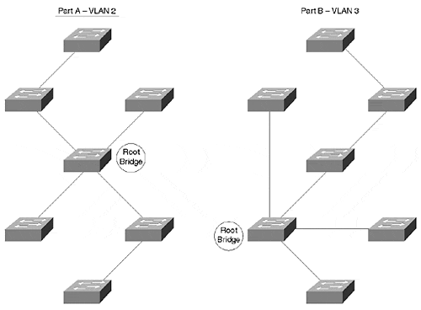
In fact, this is why there is a vlan parameter on the set spantree command that you saw in the previous section. Every VLAN could have a different set of active paths. Every VLAN could have different timer values. You get the idea.
The fact that Cisco uses one instance of STP per VLAN has two important implications:
- It can allow you to tap into many wonderful features such as load balancing and per-VLAN flows.
- It can make your life miserable (if you don't know what you are doing).
The goal here is to show you how to maximize the first point and avoid the second.
On the whole, having multiple instances of Spanning Tree gives you a phenomenal tool for controlling your network. Be aware that many vendors only use one instance of STP for all VLANs. Not only does this reduce your control, but it can lead to broken networks. For example, suppose that the single instance of Spanning Tree in VLAN 1 determines the active topology for all VLANs. However, what if you remove VLAN 5 from a link used by VLAN 1—if that link is selected as part of the active topology for all VLANs, VLAN 5 becomes partitioned. The VLAN 5 users are probably pretty upset about now.
Chapter 7 explores how to take advantage of the multiple instances of STP to accomplish advanced tasks such as STP load balancing.

Exercises
This section includes a variety of questions and hands-on lab exercises. By completing these, you can test your mastery of the material included in this chapter as well as help prepare yourself for the CCIE written and lab tests. You can find the answers to the Review Questions and the Hands-On Lab Exercises in Appendix A, "Answers to End of Chapter Exercises."

Review Questions
1: | Summarize the three-step process that STP uses to initially converge on an active topology.
2: | How many of the following items does the network shown in Figure 6-24 contain: Root Bridges, Root Ports, Designated Ports? Assume all devices are operational .  Figure 6-24 Sample Network of Four Switches and 400 Users  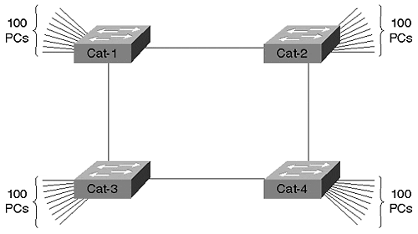
3: | When running the Spanning-Tree Protocol, every bridge port saves a copy of the best information it has heard. How do bridges decide what constitutes the best information?
4: | Why are Topology Change Notification BPDUs important? Describe the TCN process.
5: | How are Root Path Cost values calculated?
6: | Assume that you install a new bridge and it contains the lowest BID in the network. Further assume that this devices is running experimental Beta code that contains a severe memory leak and, as a result, reboots every 10 minutes. What effect does this have on the network?
7: | When using the show spantree command, why might the timer values shown on the line that begins with Root Max Age differ from the values shown on the Bridge Max Age line?
8: | Label the port types (RP=Root Port, DP=Designated Port, NDP=non-Designated Port) and the STP states (F=Forwarding, B=Blocking) in Figure 6-25. The Bridge IDs are labeled. All links are Fast Ethernet .  Figure 6-25 Sample Network  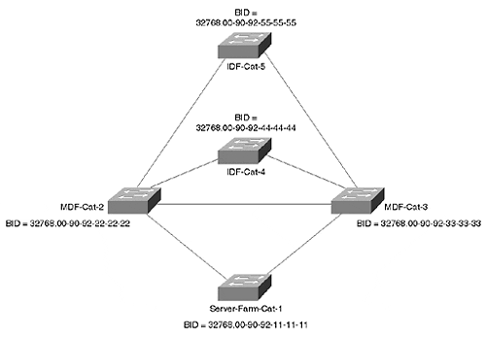
9: | What happens to the network in Figure 6-26 if Cat-4 fails?  Figure 6-26 Cat-4 Connects Two Groups of Switches  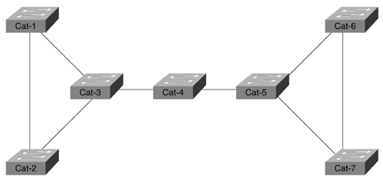

Hands-On Lab
Build a network that resembles Figure 6-27.

Figure 6-27 Hands-On Lab Diagram
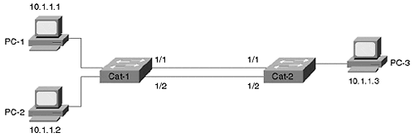
Using only VLAN 1, complete the following steps:
1: | Start a continuous ping (tip: under Microsoft Windows, use the ping -tip_address command) between PC-1 and PC-3. Break the link connecting PC-3 to Cat-2. After reconnecting the link, how long does it take for the pings to resume?
2: | Start a continuous ping between PC-1 and PC-2. As in Step 1, break the link between PC-3 and Cat-2. Does this affect the traffic between PC-1 and PC-2?
3: | Use the show spantree command on Cat-1 and Cat-2. What bridge is acting as the Root Bridge? Make a note of the state of all ports.
4: | Why is the 1/2 port on the non-Root Bridge Blocking? How did the Catalyst know to block this port?
5: | Start a continuous ping between PC-1 and PC-3. Break the 1/1 link connecting Cat-1 and Cat-2. How long before the traffic starts using the 1/2 link?
6: | Reconnect the 1/1 link from Step 2. What happens? Why?
7: | With the continuous ping from Step 3 still running, break the 1/2 link connecting Cat-1 and Cat-2. What effect does this have?

