Chapter 5. VLANs
This chapter covers the following key topics:
- What is a VLAN?—
Provides a practical and technical definition of virtual LANs.
- VLAN Types—
Describes how Layer 2, 3, and 4 switching operate under a VLAN.
- 802.1Q: VLAN Interoperability—
Describes the IEEE 802.1Q committee's effort to develop a vendor-independent method to create virtual bridged local area networks via shared VLANS (SVLs).
- Justifying the Need for VLANs—
Describes how network security, broadcast distribution, bandwidth utilization, network latency from routers, and complex access lists justify the need for configuring VLANs. This section also details the improper motivation for setting up a VLAN.
- Catalyst VLAN Configuration—
Describes how to plan for, create, and view VLAN configurations.
- Moving Users in VLANs—
Describes how VLANs simplify moving a user from one location to another.
- Protocol Filtering—
Describes how to control flooding of unneeded protocols.
When the industry started to articulate virtual LANs (VLANs) in the trade journals and the workforce, a lot of confusion arose. What exactly did they mean by VLAN? Authors had different interpretations of the new network terminology that were not always consistent with each other, much less in agreement. Vendors took varied approaches to creating VLANs which further muddled the understanding. This chapter presents definitions for VLANs as used in the Catalyst world and explains how to configure VLANs. It also discusses reasons to use and not use VLANs and attempts to clarify misinformation about them.

What Is a VLAN?
With many definitions for VLAN floating around, what exactly is it? The answer to this question can be treated in two ways because there is a technical answer and a practical answer. Technically, as set forth by IEEE, VLANs define broadcast domains in a Layer 2 network. As demonstrated in Chapter 2, "Segmenting LANs," a broadcast domain is the extent that a broadcast frame propagates through a network.
Legacy networks use router interfaces to define broadcast domain boundaries. The inherent behavior of routers prevents broadcasts from propagating through the routed interface. Hence routers automatically create broadcast domains. Layer 2 switches, on the other hand, create broadcast domains based upon the configuration of the switch. When you define the broadcast domain in the switch, you tell the switch how far it can propagate the broadcast. If the switch receives a broadcast on a port, what other ports are allowed to receive it? Should it flood the broadcast to all ports or to only some ports?
Unlike legacy network drawings, you cannot look at a switched network diagram and know where broadcast domains terminate. Figure 5-1 illustrates a legacy network where you can clearly determine the termination points for broadcast domains. They exist at each router interface. Two routers define three domains in this network. The bridge in the network extends Broadcast Domain 2, but does not create a new broadcast domain.

Figure 5-1 Broadcast Domains in a Legacy Network
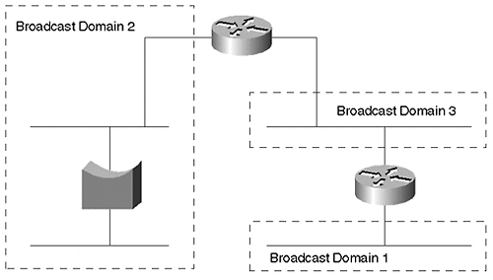
In the switched network of Figure 5-2, you cannot determine the broadcast domains by simple examination. The stations might belong to the same or multiple broadcast domains. You must examine configuration files in a VLAN environment to determine where broadcast domains terminate. Without access to configuration files, you can determine the broadcast domain extent with network analysis equipment, but it is a tedious process. How to do this is left as a review question at the end of this chapter.

Figure 5-2 Broadcast Domains in a Switched Network
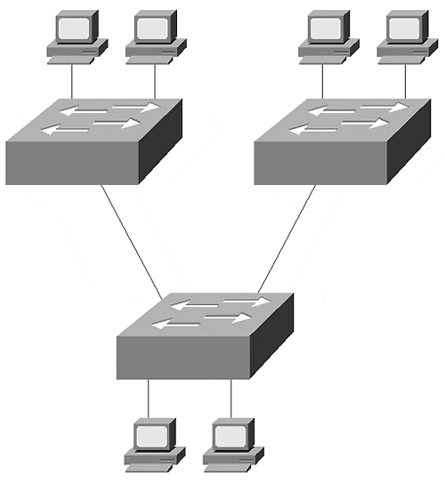
Even though you cannot easily see the broadcast domains in a switched network does not mean that they do not exist. They exist where you define and enable them. Chapter 2 presented a discussion on switches and compared them to bridges. A switch is a multi-port bridge that allows you to create multiple broadcast domains. Each broadcast domain is like a distinct virtual bridge within the switch. You can define one or many virtual bridges within the switch. Each virtual bridge you create in the switch defines a new broadcast domain (VLAN). Traffic from one VLAN cannot pass directly to another VLAN (between broadcast domains) within the switch. Layer 3 internetworking devices must interconnect the VLANs. You should not interconnect the VLANs with a bridge. Using a bridge merges the two VLANs into one giant VLAN. Rather, you must use routers or Layer 3 switches to interconnect the VLANs. Each of the four switches belong to two VLANs. A total of three broadcast domains are distributed across the switches. Figure 5-3 shows a logical representation of a switched network.

Figure 5-3 A Switched Network with Virtual Bridges
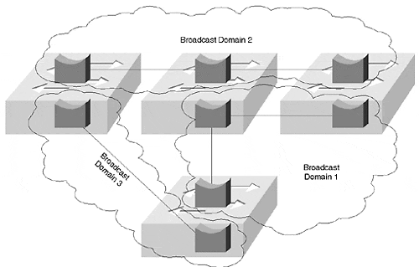
Rather than representing VLANs by designating the membership of each port, each switch has an internal representation for each virtual bridge. This is not a common way of illustrating a VLAN network, but serves to exaggerate the internal configuration of a LAN switch where each bridge within the switch corresponds to a single VLAN.

VLAN Types
The IEEE defines VLANs as a group of devices participating in the same Layer 2 domain. All devices that can communicate with each other without needing to communicate through a router (only use hubs/repeaters and bridges, real or virtual) share the broadcast domain. The Layer 2 internetworking devices move frames through the broadcast domain by examining the destination MAC address. Then, by comparing the destination address to a table, the device can determine how to forward the frame towards the destination.
Some devices use other header information to determine how to move the frame. For example, Layer 3 switches examine the destination and source IP address and forward frames between broadcast domains when needed. Traditionally, routers perform Layer 3 switching. Frames enter the router, the router chooses the best path to get to the destination, and the router then forwards the frame to the next router hop as shown in Figure 5-4. The routing protocol that you activate in the router determines the best path. A best path might be the fewest hops. Or, it might be the set of highest bandwidth segments. Or, it might be a combination of metrics. In Figure 5-4, only one choice exists to get from Station A to Station B.

Figure 5-4 Traditional Frame Flow in a Routed Network
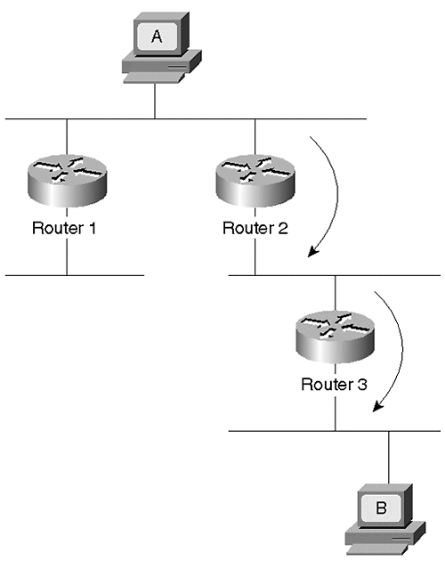
When the frame enters Router 2, the router not only determines the next hop to move the frame toward the destination, but it also performs a new Layer 2 encapsulation with a new destination/source MAC address pair, performs some Layer 3 activities such as decrementing the TTL value in an IP header, and calculates a new frame check sequence (FCS) value. Router 3 performs a similar set of actions before sending the frame to Station B. This is often called packet-by-packet switching.
The same process still occurs if you replace the shared wire segments in Figure 5-4 with a Layer 2 switched network. Figure 5-5 illustrates a similar network using Layer 2 switches and Layer 3 routers to interconnect the broadcast domains (VLANs). To get from Station A to B in the switched network, the frame must pass through three routers. Further, the frame must transit the link between Cat-C and Cat-D twice. Although this might be an exaggeration for such a small network, this can frequently happen in larger scale networks. In an extreme case, the frame can travel through the Layer 2 switched network multiple times as it passes from router to router on its way to the destination.

Figure 5-5 Traditional Frame Flow in a Switched Network
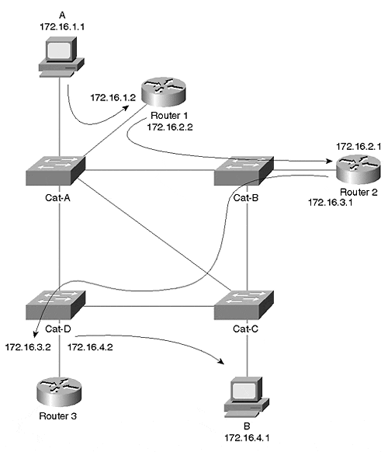
Layer 3 switching, on the other hand, circumvents the multiple entries and exits of the frame through routers. By adding a Netflow Feature Card and enabling Multilayer Switching (MLS) in a Catalyst 5000 supervisor module, a Catalyst 5000/5500 can rewrite a frame header like a router does. This gives the appearance of the frame passing through a router, yet it eliminates the need for a frame to actually pass in and out of a router interface. The Catalyst learns what to do with the frame header by watching a locally attached router. MLS is discussed in more detail in Chapter 11, "Layer 3 Switching." MLS creates a shortcut around each router as shown in Figure 5-6. When multiple routers are in the system, multiple MLS shortcuts exist between the source and destination devices. These shortcuts do not violate any Layer 3 routing rules because the NFFC does not perform any rewrites until the frames initially pass through a router. Further, when it does create the shortcut, the NFFC rewrites the frame header just as the router does.

Figure 5-6 NetFlow Shortcuts Between Routed VLANs
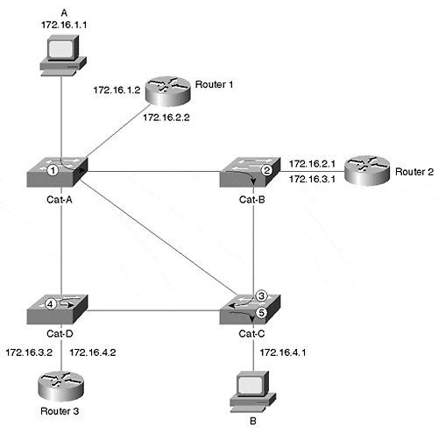
Another type of Layer 3 switching, Multiprotocol over ATM (MPOA), even eliminates the need to repeatedly pass a frame through the switched cloud. Functionally, MPOA in ATM equates to MLS in a frame network in that they both bypass routers. The routers in Figure 5-7 attach directly to an ATM cloud. Normally, when Station A wants to communicate with Station B, frames must pass in and out of the routers just as they do in the basic routed example of Figure 5-4. In Figure 5-7, the frames normally pass through the ATM cloud four times to reach Station B. However, MPOA creates a shortcut between two devices residing in different broadcast domains as shown in Figure 5-7. See Chapter 10, "Trunking with Multiprotocol Over ATM," for more details.

Figure 5-7 MPOA Shortcut to Bypass Many Routers in an ATM Network
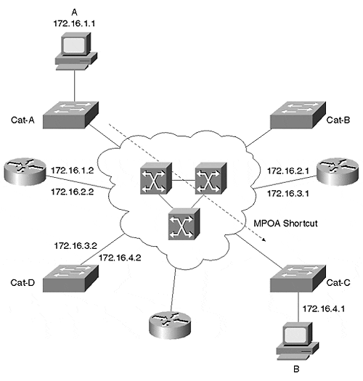
Other VLAN types use combinations of Layer 2, Layer 3, or even Layer 4 to create shortcuts in a system. Layer 4 switching creates shortcuts based upon the Layer 3 addresses and upon the Layer 4 port values. This is sometimes called application switching and provides a higher level of granularity for switching. Chapter 11 provides a more thorough discussion on this subject in the context of MLS.
Table 5-1 summarizes the various switch types found in the industry.

Table 5-1. Layered Switching Comparison
Switch Type | Switch Criteria
Layer 2 | Destination MAC address
Layer 3 | Source and destination MAC addresses and source and destination IP addresses
Layer 4 | Layer 3 criteria plus Layer 4 source and destination port values

802.1Q: VLANs and Vendor Interoperability
Because vendors took individual approaches to create VLANs, network administrators were impaired whenever multiple vendor solutions were introduced into their system. A multi-vendor VLAN must be carefully handled to deal with interoperability shortcomings. Recognizing this deficiency in the industry, IEEE commissioned the 802.1Q committee to develop a vendor-independent method to create interoperable virtual bridged local area networks.
IEEE 802.1Q describes concepts called the shared VLAN (SVL) and independent VLAN (IVL). These define how bridges store MAC addresses in their bridging tables. SVL constrains a MAC address to only one VLAN. SVL-based devices build a giant bridge table, but allow a MAC address to appear only once in the table, regardless of how many VLANs exist. For many networks, this is fine. However, this can be an undesirable constraint when devices or protocols reuse MAC addresses in different broadcast domains. For example, SUN workstations reuse a MAC address whenever two NICs are installed in the workstation. Yet each NIC attaches to a different broadcast domain and has different logical addresses. Clearly, this violates the rules of SVL networks, but not legacy networks. DecNet IV has a similar characteristic, in that MAC addresses can be reused in different broadcast domains. This too, fails in an SVL network.
Yet a third situation where SVL devices cannot work is when a router interconnects VLANs by routing some protocols and bridging others. For example, in Figure 5-8, Stations A and B support multiple protocols: TCP/IP and NetBEUI. A router in the system interconnects VLAN1 (Switch-A Ports 1 and 2) and VLAN2 (Switch-A Ports 3 and 4). The router performs routing for TCP/IP traffic and bridging for NetBEUI. (Bridging is necessary because NetBEUI is a non-routable protocol.)

Figure 5-8 An SVL Capable Switch and a Router that Routes and Bridges
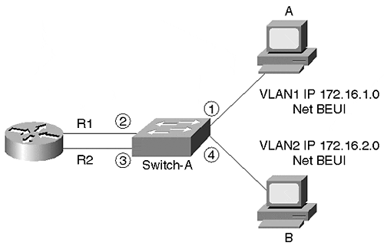
When Station A transmits an IP frame to Station B, Station A transmits a frame with the router's R1 MAC address as the destination and Station A's address as the source. The router routes the frame to Station B using the router's R2 MAC address for the source and Station B's MAC address for the destination. When Station B responds to Station A, the switch learns about Station B on Port 4 Switch-A's bridge table looks like that shown in Table 5-2, Event 1. The table shows the four ports on Switch-A (1, 2, 3, and 4) and the learned MAC addresses on each of the ports. Ports 1 and 2 belong to VLAN 1, and Ports 3 and 4 belong to VLAN 2. The MAC addresses are represented as A and B for the two workstations and R1 and R2 for the two router interfaces. Switch-A knows about Station A's MAC address on Port 1 and the router interfaces R1 and R2 MAC addresses on Ports 2 and 3, respectively. When Station A transmits a NetBEUI frame, the switch relearns Station A's MAC address on Port 1. When a router routes a frame, it replaces the source MAC address with its own MAC address. But, when the router bridges the frame out interface R2, the router does not replace the MAC address header and passes the original source MAC address through. Therefore, Switch-A now sees a frame from Station A on Port A.3. This causes the switch to believe that Station A moved. The bridge table now looks like Event 2 in Table 5-2. When Station B attempts to respond to Station A, the switch forwards the frame to router interface R2. But when the router sends the frame out interface R1, the switch does not forward the frame to Port 1. Rather, the switch filters the frame because the switch believes that Station A is on Port 3, a different VLAN.

Table 5-2. Bridging Table
VLAN | 1 |  | 2
Port | 1 | 2 | 3 | 4
Event 1 | A | R1 | R2 | B
Event 2 |  | R1 | R2,A | B
One final deficiency with 802.1Q concerns Spanning Tree. With 802.1Q, there is currently only one instance of Spanning Tree. This forces all VLANs to the same Spanning Tree topology which might not be optimal for all VLANs. The Catalyst, for example, uses multiple instances of Spanning Tree: one for each VLAN. This allows you to optimize the topology for each VLAN. Part II of this book, "Spanning Tree" provides details on the multiple instances of Spanning Tree.
The Catalyst does not use SVL tables. Rather, it uses Independent VLAN learning (IVL) which allows the same MAC address to appear in different broadcast domains. An IVL-capable device maintains independent bridge tables for each VLAN, allowing devices to reuse a MAC address in different VLANs. All of the Catalyst bridging examples in this book illustrate IVL methods.

Justifying the Need for VLANs
The previous section described the technical definition of a VLAN. This section describes practical answers. In a legacy network, administrators assign users to networks based on geography. The administrator attaches the user's workstation to the nearest network cable. If the user belongs to the engineering department and sits next to someone from the accounting department, they both belong to the same network because they attach to the same cable. This creates some interesting network issues. Discussing these issues highlights reasons for using VLANs. VLANs help to resolve many of the problems associated with legacy network designs. The sections that follow examine the five issues that warrant implementation of a VLAN.

Problem 1: Network Security
The first issue is the shared media nature of legacy networks. Whenever a station transmits in a shared network such as a legacy half-duplex 10BaseT system, all stations attached to the segment receive a copy of the frame, even if they are not the intended recipient. This does not prevent the network from functioning, but software packages to monitor network traffic are readily available and run on a number of workstation platforms. Anyone with such a package can capture passwords, sensitive e-mail (or embarrassing e-mail) and any other traffic on the network.
If the users on the network belong to the same department, this might not be disastrous, but when users from mixed departments share a segment, undesirable information captures can occur. If someone from human resources or accounting sends sensitive data such as salaries, stock options, or health records on the shared network, anyone with a network monitoring package can decode the information.
Neither of these scenarios are constrained to a single segment. These problems can occur in multisegment environments interconnected with routers. In Figure 5-9, accounting resides on two isolated segments. For users on one segment to transmit to users on the other segment, the frames must cross the engineering network. When they cross the engineering segment, they can be intercepted and misused.

Figure 5-9 Security Problems in a Legacy Network
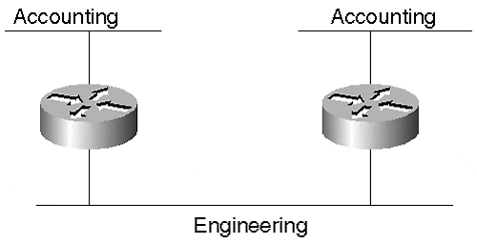
One way to eliminate the problem is to move all accounting users onto the same segment. This is not always possible because there might be space limitations preventing all accountants from sharing a common part of the building. Another reason might be due to geography. Users on one segment might be a considerable distance from users on the other segment. To move the users to a common location might mean moving the employee's household from one city to another.
A second method is to replace accounting with marketing. Who really wants to look at marketing data anyway, except for a good laugh? But accounting cannot distribute pay checks, and marketing tries to get our money. Clearly this is not a good solution.
A third approach is through the use of VLANs. VLANs enable you to place all process-related users in the same broadcast domain and isolate them from users in other broadcast domains. You can assign all accounting users to the same VLAN regardless of their physical location in the facility. You no longer have to place them in a network based upon their location. You can assign users to a VLAN based upon their function. Keep all of the accounting users on one VLAN, the marketing users on another VLAN, and engineering in yet a third.
By creating VLANs with switched network devices, you create another level of protection. Switches bridge traffic within a VLAN. When a station transmits, the frame goes to the intended destination. As long as it is a known unicast frame, the switch does not distribute the frame to all users in the VLAN (see Figure 5-10).

Figure 5-10 A Known Unicast Frame in a Switched Network
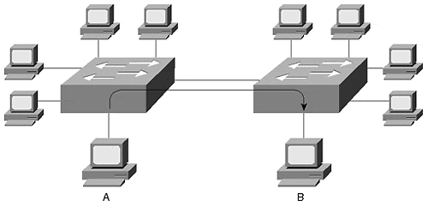
Station A in Figure 5-10 transmitted a frame to Station B attached to another Catalyst. Although the frame crosses through a Catalyst, only the destination receives a copy of the frame. The switch filters the frame from the other stations, whether they belong to a different VLAN or the same VLAN. This switch feature limits the opportunity for someone to promiscuously obtain traffic, thereby increasing the effectiveness of network security. What kind of traffic can be captured? Any traffic flooded within the VLAN is susceptible to capture. Flooded traffic includes broadcast, multicast, and unknown unicast. Note that a Catalyst feature Cisco Group Management Protocol (CGMP), if enabled, can restrict multicast flooding. This is discussed in Chapter 13, "Multicast and Broadcast Services."

Problem 2: Broadcast Distribution
Unfortunately, many, if not all, protocols create broadcasts. Some protocols create more than others. I happen to be particularly fond of Macintosh computers. Network administrators, however, despise AppleTalk due to the amount of broadcast traffic it generates. Every ten seconds, AppleTalk routers send routing updates that are broadcast frames in the network. Broadcasts go to all devices in the broadcast domain and must be processed by the receiving devices.
Other protocols share in the guilt. NetBEUI creates many broadcast frames, even when stations perform few network activities. TCP/IP stations create broadcasts for routing updates, ARP, and other processes. IPX generates broadcasts for SAP and GNS frames.
To add to the mix, many multimedia applications create broadcast and multicast frames that get distributed within a broadcast domain.
Why are broadcasts bad? Broadcasts are necessary to support protocol operations and are, therefore, overhead frames in the network. Broadcast frames rarely transport user data. (The exception might be for multimedia applications.) Because they carry no user data, they consume bandwidth in the network, reducing the effective available bandwidth for productive transfers.
Broadcasts also affect the performance of workstations. Any broadcast received by a workstation interrupts the CPU preventing it from working on user applications. As the number of broadcasts per second increases at the interface, effective CPU utilization diminishes. The actual level of degradation depends upon the applications running in the workstation, the type of network interface card and drivers, the operating system, and the workstation platform.
Tip
If broadcasts are a problem in your network, you might mitigate the effect by creating smaller broadcast domains. This was described in Chapter 2. In VLANs, this means creating additional VLANs and attaching fewer devices to each. The effectiveness of this action depends upon the source of the broadcast. If your broadcasts come from a localized server, you might simply need to isolate the server in another domain. If your broadcasts come from stations, creating multiple domains might help to reduce the number of broadcasts in each domain.

Problem 3: Bandwidth Utilization
When users attach to the same shared segment, they share the bandwidth of the segment. The more users that attach to the shared cable means less average bandwidth for each user. If the sharing becomes too great, user applications start to suffer. You start to suffer too, because users harass you for more bandwidth. VLANs, which are usually created with LAN switch equipment, can offer more bandwidth to users than is inherent in a shared network.
Each port in a Catalyst behaves like a port on a legacy bridge. Bridges filter traffic that does not need to go to segments other than the source. If a frame needs to cross the bridge, the bridge forwards the frame to the correct interface and to no others. If the bridge (switch) does not know where the destination resides, it floods the frame to all ports in the broadcast domain (VLAN).
Note
Although each port of a Catalyst behaves like a port on a bridge, there is an exception. The Catalyst family has group switch modules where ports on the module behave like a shared hub. When devices attach to ports on this module, they share bandwidth like a legacy network. Use this module when you have high density requirements, and where the devices have low bandwidth requirements, yet need connectivity to a VLAN.

In most normal situations, then, a station only sees traffic destined specifically for it. The switch filters most other background traffic in the network. This allows the workstation to have full dedicated bandwidth for sending and/or receiving frames interesting traffic.Unlike a shared hub system where only one station can transmit at a time, the switched network in Figure 5-11 allows many concurrent transmissions within a broadcast domain without directly affecting other stations inside or outside of the broadcast domain. Station pairs A/B, C/D, and E/F can all communicate with each other without affecting the other station pairs.

Figure 5-11 Concurrent Transmissions in a Catalyst
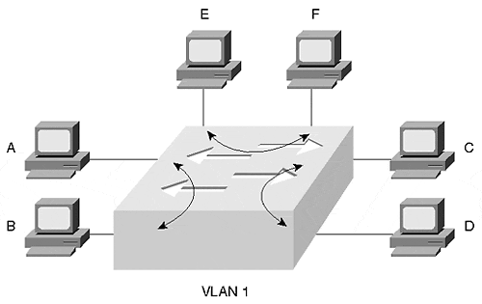

Problem 4: Network Latency from Routers
In the legacy network of Figure 5-9, accounting users on the two segments had to cross the engineering segment to transfer any data. The frames had to pass through two routers. Older software-based routers tend to be comparatively slower than other internetworking products such as a Layer 2 bridge or switch. As a frame passes through a router, the router introduces latency—the amount of time necessary to transport a frame from the ingress port to the egress port. Every router that the frame transits increases the end-to-end latency. Further, every congested segment that a frame must cross increases latency. By moving all of the accounting users into one VLAN, the need to cross through multiple routers and segments is eliminated. This reduces latency in a network that might improve performance for your users, especially if they use a send-acknowledge protocol. Send-acknowledge protocols do not send more data until an acknowledgement is received about the previous data. Network latency dramatically reduces the effective throughput for send-acknowledge protocols. If you can eliminate the need for user traffic to pass through a router by placing users in the same VLAN, you can eliminate cumulative router latency. If frames must pass through routers, enabling Layer 3 switching reduces router transit latencies, too.
VLANs help to reduce latency by reducing segment congestion. This can be a dramatic improvement if the workstations' connections originally attached to congested shared segments and the workstations' new connections all have dedicated switch ports.

Problem 5: Complex Access Lists
Cisco routers allow administrators to introduce policies controlling the flow of traffic in the network. Access lists control traffic flow and provide varied degrees of policy granularity. Through the implementation of access lists, you can prevent a specific user from communicating with another user or network, or you can prevent an entire network from accessing a user or network. You might exercise these capabilities for security reasons, or you might elect to prevent traffic from flowing through a segment to protect local bandwidth.
In any case, the management of access lists is cumbersome. You must develop the access list according to a set of rules designed by Cisco for the access list to correctly filter traffic.
In the network example of Figure 5-9, filters in the routers attached to the engineering segment can include access lists allowing the accounting traffic to pass through the engineering segment, but to never talk to any engineering devices. That does not prevent engineers from monitoring the traffic, but does prevent direct communication between the engineering and accounting devices. Accounting never sees the engineering traffic, but engineering sees all of the accounting transit traffic. (Accounting yells, "That hardly seems fair!")
VLANs can help by allowing you to keep all accounting users in one VLAN. Then their traffic does not need to pass through a router to get to peers of the VLAN. This can simplify your access list design because you can treat networks as groups with similar or equal access requirements.

Wrong Motives for Using VLANs
One common motivation for using VLANs tends to get network administrators excited about VLANs. Unfortunately, reality quickly meets enthusiasm revealing errors in motivation. The advent of VLANs led many to believe that life as a network administrator would simplify. They thought that VLANs would eliminate the need for routers, everyone could be placed in one giant flat network, and they could go home at 5:00 PM each evening like everyone else in their office. Wrong. VLANs do not eliminate Layer 3 issues. They might allow you to more easily perform some Layer 3 tasks such as developing simpler access lists. But Layer 3 routing still exists.
If anything, VLANs make networks more complex due to the introduction of the Spanning-Tree Protocol in the system and the dispersed nature of broadcast domains. Spanning Tree (discussed in Chapters 6 and 7) adds additional background traffic to your network by flooding "hello packets" (BPDUs) throughout the system every two seconds. Although hello messages do not consume significant bandwidth on segments, it does make use of a network analyzer more challenging. You might need to filter out the hello messages to find the interesting traffic that you are trying to troubleshoot. A more significant Spanning Tree element making VLANs complex is the selection of a Root Bridge. Spanning Tree participants elect a Root Bridge around which the rest of the network revolves. Depending upon the location of the Root Bridge in the network, traffic flow might not always pass through the most desirable links. Traffic might flow through less desirable links with lower bandwidth or might require more hops to reach the destination. The network administrator might need to tweak Spanning Tree default values to select a more appropriate Root Bridge. The default selection of a root bridge is not arbitrary, but is based upon the MAC address of the bridge. The bridge with the lowest MAC address becomes the Root Bridge. This means the Root Bridge selection is repeatable every time the system powers up, as long as no other bridges are introduced to the system with a lower MAC address, or other default values are changed. See Chapters 6 and 7 for more detailed information.
This discussion does not imply that you should not use VLANs. Rather, it raises the point that you need to consider not just why, but also how you plan to deploy VLANs. All networks are candidates for VLANs and switches. Your network might have one VLAN with switches, but it is still a VLAN. However, you should consider limiting the size or extent of the VLAN. As mentioned, a single VLAN extending throughout the entire network usually defies practicality and scalability. Smaller VLAN islands interconnected with Layer 3 devices typically deploy much more easily in a large scale, while allowing you to take advantage of Layer 2 VLANs within a workgroup area.

Moving Users in VLANs
VLANs reduce the problems associated with moving a user in a legacy network from one location to another. As you move a user in a legacy network, you need to consider many factors. In a VLAN, however, a number of the factors disappear. Consider the following example in Figure 5-12.

Figure 5-12 Moving a User in a Legacy Network
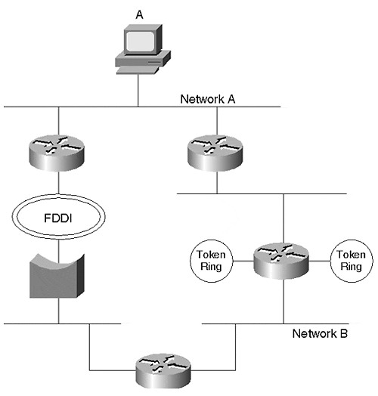
Figure 5-12 shows Station A attached to Network A in a legacy network. The user's highly educated, capable, and rational manager decides that the user needs to move to another location. As the network administrator, you inquire about the motivation for the move and learn that, "It's none of your business," which is shorthand for, "I don't have anything better to do than to reassign employee locations." Being a diligent network administrator, you quickly recognize an important task, so you set about to plan the move.

OSI Logistics for Moving Network Users
During the early 1990s, a movement was afoot to eliminate routers from the networks and create one large, flat-bridged network. These were known as end-to-end VLANs. The motivations for this type of design are considered in this section. However, as a preamble, it is important to note that experience with the end-to-end VLANs demonstrated that they do not scale well in networks and forced users to reinstate routers in the network. One of the scaling issues was with Spanning Tree. Today's design recommendations incorporate VLANs in local areas and use Layer 3 routing/switching between smaller areas. Part V of this book, "Real-World Campus Design and Implementation," discusses in more detail various approaches to VLAN deployments. Even though the end-to-end designs did not prove to be feasible, the motivations still apply in smaller areas. That is why this section covers the initial benefits of end-to-end VLANs.
What issues do you need to consider to support the move? Many issues ranging from Layer 1 through Layer 7 of the OSI model. Ignore Layers 8 (financial), 9 (political), and 10 (religious) for now because these are not officially in the OSI definition.
Table 5-3 summarizes a number of issues that should concern you.

Table 5-3. Logistics Issues in a Legacy Network
Issue | Explanation
Layer 1
Distance to network hub | The new employee location might not be close to an existing network. You might need to extend the network or even create a new one.
Media type | The user already has an adapter card installed in the workstation. Is the media compatible with the equipment at the new location? Is the new location using Category 5 cable? Fiber optic? Coax? Other?
Port availability | Are there any ports or attachment points at the new location suitable for the user?
Link speed | Can the hub or segment at the new location offer the bandwidth that the user needs?
Layer 2
Access method | Is the network at the new location of the same type as at the original location? Is the network new/old Ethernet, Fast Ethernet, Token Ring, FDDI, or other?
NIC compatibility | Is the existing NIC compatible with the new network hardware? If you have to change the NIC, are the new drivers compatible with the upper layers?
Layer 3
Logical address | You might need to assign a new protocol address to the user at the new location.
Default gateway | The user's workstation might need to be reconfigured to point to a different gateway.
Firewalls/access lists | By moving the user, you might need to modify router access lists and firewall configurations to allow the user to reach the resources that support his functions.
Higher Layers
Available bandwidth to resources | Layer 1 issues listed link speed. This is for the local link. But the user's resources might be located on another segment forcing the traffic to cross other segments. Do the transit segments have enough bandwidth to support the user's applications?
You must deal with all of these issues when you move users in a legacy network environment. Layer 1 and Layer 2 issues can create some undesirable situations like forcing you to change a user from Ethernet to Token Ring because the new location uses that access method. This should cause you to worry about compatibility with the user's upper layer protocols. If you need to attach to a different network type, you need to change the workstation's NIC and associated drivers. You might think that the drivers are compatible with the upper layers, but you might discover at 5:00 PM on a Friday evening that they are not.
Maybe you need to use fiber optics to reach from the new location to a hub because the distance is too long. Or, you might use fiber because the cable runs through an electrically noisy environment.
Possibly, new switches or hubs need to be installed to support the relocated user because all of the other interfaces might be occupied. If you install a new repeater/hub, make sure that you do not exceed the collision domain extent. If you install a new switch, you need to configure the correct VLAN setting and any other appropriate parameters.
Although all layers create headaches at one time or another for network administrators, Layer 3 creates irksome migraines. Layer 3 issues are even more complex, because they frequently involve changes in equipment configuration files. When you move the user, he might attach to an entirely different logical network than where he was originally. This creates a large set of potential actions on your part. For example, because the user now attaches to a different network, you need to modify his host address. Some of this pain is lessened through the use of Dynamic Host Configuration Protocol (DHCP) to automatically acquire an IP address. This works even when moving a user from one VLAN to another.
Even more annoying, you might need to modify any policy-based devices to allow the new address to reach the same services as prior to the move. For example, you might need to modify access lists in routers to enable the station's frames to transit the network to reach a file server. Remember that routers evaluate access lists from the top of the list to the bottom and stop whenever a match occurs. This means that you need to be sure to place the new entry in the correct location in the access list so that it is correctly evaluated. If any firewalls exist between the station and its resources, you need to ensure that the firewall's settings permit access to all desired resources.
Yet another item you must consider involves a combination of higher and lower layers. What bandwidth does the user's applications require? Can the network provide the same bandwidth for the paths that the frames must now transit? If not, you might have some serious network redesign in front of you.

Deploying VLANs to Eliminate Broadcast Domain Issues
Now consider a similar network designed with Catalysts rather than a legacy design. By using Catalysts as in Figure 5-13, you can deploy VLANs to distribute and constrain broadcast domains. When deploying VLANs, some items in Table 5-3 become irrelevant when moving a user from one location to another in the network.

Figure 5-13 A Switched Version of the Legacy Network of Figure 5-12
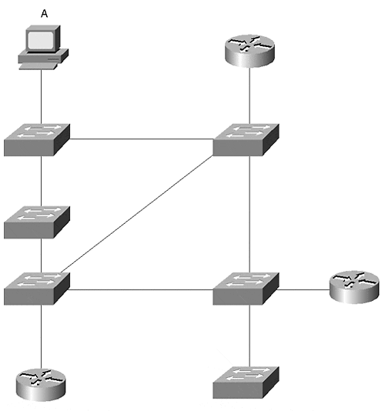
VLANs do not eliminate Layer 1 or Layer 2 issues. You still need to worry about port availability, media and access types, and the distance from the station to the switch.
You still need to worry about higher layer issues such as bandwidth to resources. The switched network cannot implicitly guarantee bandwidth. It does, however, offer you flexible alternatives to install more bandwidth between switches without redesigning a whole network infrastructure. For example, you can install more links between Catalysts, or you can move to higher speed links. (Inter-Catalyst connection options are reviewed in Chapter 8, "Trunking Technologies and Applications." ) Upgrading to a higher speed link does not force you to install a new access method. You can upgrade from a 10 Mbps to a Fast Ethernet or Gigabit Ethernet solution fairly easily and transparently to users. Obviously, similar solutions are available in routers too, but you might not be able to obtain the port density that you want to service many stations.
VLANs do not directly help mitigate lower layer or higher layer difficulties in a legacy LAN. Other than for the possibility of user stations experiencing more bandwidth with switched VLAN equipment, why use VLANs? Here is the good news: in a VLAN environment, Layer 3 issues no longer need to be a concern as they were in legacy network designs. When moving the user in Figure 5-13, you can configure the switch port at the new location to belong to the same VLAN as at the old location. This allows the user to remain in the same broadcast domain. Because the user belongs to the same broadcast domain, the routers and firewalls view the user as belonging to the same network even though a new physical location is involved. This eliminates the need to perform any Layer 3 tasks such as changing host addresses for the new location and leaves access list and firewall configurations intact.
The VLAN approach just described is sometimes called end-to-end VLANs, or VLAN everywhere or the distributed VLAN design method. It has the clear advantage of allowing you to keep a user in the same broadcast domain regardless of the physical location. As good as it seems to take this approach, it does have disadvantages. (Alas, nothing is ever as good as it seems.) Issues arise whenever the network grows in extent. As you add more Catalysts to the system, you add more bridges which increases the Spanning Tree topology complexity. This was mentioned in the previous section.

Deploying Layer 3 Distribution for Network Access Management and Load Distribution
In contrast, another approach to deploying VLANs potentially simplifies Spanning Tree issues. Some network designers use a Layer 3 approach in the system for distribution and backbone layers and use Layer 2 devices for access layers. Figure 5-14 shows such a network concept. In this system, the network design uses Layer 2 switches to the desktop and Layer 3 switches, such as the Catalyst 8500 and Catalyst 6000 series, for the distribution and backbone segments.

Figure 5-14 Layer 3 Design in a Switched Network
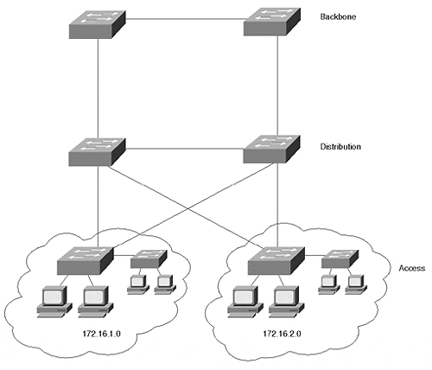
Part V of this book describes VLAN design philosophies. One approach, the Layer 3 distribution design, minimizes the Spanning Tree extent and topology because the Spanning Tree is constrained to the pockets of access devices. Access pockets can be placed on floors as in Figure 5-15. Each floor has its own access network. Users on the floor share the access network regardless of their community of interest. Engineering and accounting might share the VLAN. If necessary, the access network can be divided into a couple of VLANs to provide additional isolation between users or departments. Further, it enables load balancing, which is not easily obtainable in a Layer 2 design. These advantages lead many network engineers to avoid the end-to-end VLAN approach in favor of the Layer 3 design approach.

Figure 5-15 Layer 3 Design Approach Applied to a Facility
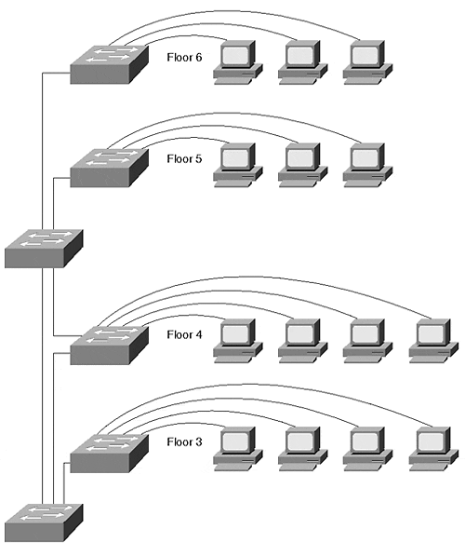
Historically, network approaches swayed from Layer 2 to Layer 3 back to Layer 2 and now back to Layer 3. The earliest networks were by default Layer 2. At some point in history, someone realized that they didn't scale very well, and they wanted to connect Layer 2 segments together. So routers were invented. Soon, the whole world deployed routers. But because routers were slow, designers started to look at high-performance bridges to interconnect the networks on a large scale. This was the advent of the Layer 2 switching products during the late 1980s to early 1990s. Until recently, Layer 2 switching plans dominated new network designs. Then came the realization that large scale Layer 2 networks created other problems, and router speeds have increased dramatically since the early 1990s. Engineers reexamined Layer 3 approaches for the backbone and distribution networks and now tend to consider Layer 3 designs a more desirable approach. It can, however, restore the disadvantages of Layer 3 complexities in a legacy network if poorly implemented.

Catalyst VLAN Configuration
Some VLAN components assign stations to VLANs based upon MAC addresses. The Catalyst, on the other hand, associates ports to a VLAN. Any device attached to the port belongs to the VLAN describing the switch interface. Even if a shared hub attaches to the port, all stations on the hub belong to the same VLAN. This is called a port-centric approach to VLANs. To configure VLANs in a Catalyst, you must first plan the VLAN membership and then assign ports to the correct VLAN. Planning VLAN membership involves knowing what Layer 3 networks should belong to the VLAN, what inter-VLAN connectivity you require, and where the VLAN will be distributed. Are you going to use end-to-end VLANs or use a Layer 3 approach to deploy your networks? After you proceed through the planning stages, you are ready to create the VLANs.

Planning VLANs
Before you enable new VLANs, make sure that you know what you really want to do and how your actions can affect other VLANs or stations already present in your system. The planning at this stage can primarily focus around Layer 3 issues. What networks need to be supported in the VLAN? Is there more than one protocol that you want in the VLAN? Because each VLAN corresponds to a broadcast domain, you can support multiple protocols in the VLAN. However, you should only have one network for each protocol in the VLAN.
A multiswitch system like that shown in Figure 5-16 can have several VLANs.

Figure 5-16 A Typical VLAN Network Address Deployment
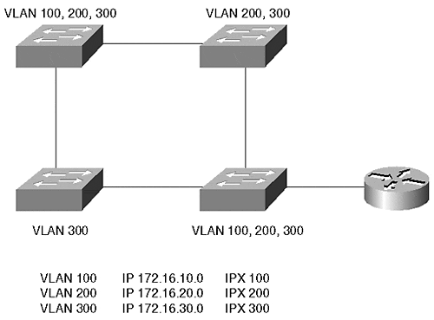
Each VLAN in Figure 5-16 supports multiple protocols. For the networks to communicate with each other, they must pass through a router. The router on a stick in Figure 5-16 interconnects several networks together. Example 5-1 shows a configuration file for this router.

Example 5-1 Router on a Stick Configuration File
interface fastethernet 2/0.1 ip address 172.16.10.1 255.255.255.0 ipx network 100 encapsulation isl 100 interface fastethernet 2/0.2 ip address 172.16.20.1 255.255.255.0 ipx network 200 encapsulation isl 200 interface fastethernet 2/0.3 ip address 172.16.30.1 255.255.255.0 encapsulation isl 300
Example 5-1 sets up a trunk between a device and the router. Trunks and Inter-Switch Link (ISL) encapsulation are discussed in more detail in Chapter 8. Trunks allow traffic from more than one VLAN to communicate over one physical link. The encapsulation isl command in Example 5-1 instructs the router to use ISL trunking to communicate with the broadcast domain for each subinterface. Note that the router configuration uses subinterfaces. Normally, in a router, you assign a single address per protocol on an interface. However, when you want to use a single physical interface in a way that, to the routing protocols, appears as multiple interfaces, you can use subinterfaces—for example, when creating a trunk between a Catalyst and a router, as in Example 5-1. The router needs to identify a separate broadcast domain for each VLAN on the trunk.
Cisco routers use a concept of subinterfaces to spoof the router into thinking that a physical interface is actually more than one physical interface. Each subinterface identifies a new broadcast domain on the physical interface and can belong to its own IP network, even though they all actually belong to the same major interface. The router configured in Example 5-1 uses three subinterfaces making the router think that the one physical interface (the major interface) interface fastethernet 2/0 is actually three physical interfaces, and therefore, three broadcast domains. Each belongs to a different IP subnet. You can recognize a subinterface on a Cisco router because the major interface designator has a .x after it. For example, subinterface 3 is identified in Example 5-1 as int fastethernet 2/0.3 where .3 designates the specific subinterface for the major interface.
The subinterface concept arises again when configuring LANE and MPOA on routers and on the Catalyst ATM modules.
In Example 5-1, which network is isolated from the others? IPX network 300 is isolated because the router does not have this network defined on any of its interfaces.
At times, a physical network configuration can confuse you. A common question we hear in class or consulting situations is, "Can I do this with a VLAN?" Frequently, an answer can be devised by representing the VLANs in a logical configuration. Figure 5-16 shows a physical network; Figure 5-17 shows the same network, but redrawn to show the logical connectivity. The drawing replaces each VLAN with a wire representation labeled with the networks assigned to the VLAN. This more conventional representation helps when trying to design and deploy a VLAN, because it places networks and components into their logical relationship.

Figure 5-17 A Logical Representation of Figure 5-16
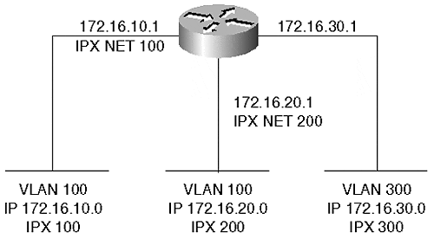
Figure 5-18 shows another network configuration where two VLANs carry the same IP network. Nothing prevents this configuration and it is valid. It is not, however, recommended for most networks. This configuration represents the same subnet on two logical wires.

Figure 5-18 Overlapping IP Networks
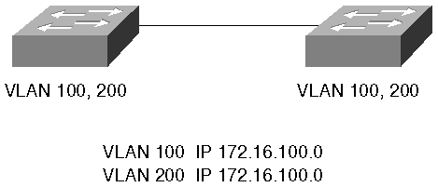
The network could be redrawn as in Figure 5-19 where clearly there are two isolated broadcast domains. As long as you do not attempt to interconnect them with a router, this configuration is completely valid. Why can they not be connected with a router? Because this forces a router to have two interfaces that belong to the same IP subnetwork. The router does not let you do this.

Figure 5-19 Logical Representation of Figure 5-18
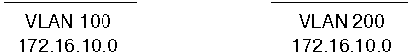
The logical connectivity drawing loses information regarding physical interconnectivity which is important for bandwidth planning. For example, Figure 5-19 might lead you to believe that all devices in VLAN 100 have full bandwidth available between all components. You might also believe the same regarding VLAN 200. However, the physical representation of Figure 5-18 makes it clear that the two VLANs share a link between the switches. This must be a shared bandwidth link which is not obvious from the logical representation.
Tip
Use the logical representation to plan and troubleshoot Layer 3 issues and use the physical drawings to determine Layer 2-related issues.

Creating VLANs
Creating a VLAN involves the following steps:
Step 1. Assign the Catalyst to a VTP domain
Step 2. Create the VLAN
Step 3. Associate ports to a VLAN
To facilitate creation, deletion, and management of VLANs in Catalysts, Cisco developed a protocol called VLAN Trunking Protocol (VTP). Chapter 12, "VLAN Trunking Protocol," covers VTP in more detail. However, a brief introduction is necessary here. You can divide a large Catalyst network into VTP management domains to ease some configuration and management tasks. Management domains are loosely analogous to autonomous systems in a routed network where a group of devices share some common attributes. Catalysts share VLAN information with each other within a VTP domain. A Catalyst must belong to a VTP domain before you can create a VLAN. You cannot create a VLAN on any Catalyst. The Catalyst must be configured in either the server or transparent mode to create the VLAN. By default, the Catalyst operates in the server mode. These modes and the command details to set them are described in Chapter 12.
You can configure a Catalyst's VTP domain membership with the set vtp domain name command. Each domain is uniquely identified by a text string. Note that the name is case sensitive. Therefore, a domain name of Cisco is not the same as cisco. Other rules about VTP domains that you need to consider are also detailed in Chapter 12.
Whenever you create or delete a VLAN, VTP transmits the VLAN status to the other Catalysts in the VTP domain. If the receiving Catalyst in the VTP domain is configured as a server or client, it uses this information to automatically modify its VLAN list. This saves you the task of repeating the command to create the same VLAN in all participating Catalysts within the domain. Create the VLAN in one Catalyst, and all Catalysts in the domain automatically learn about the new VLAN. The exception to the rule occurs if the receiving Catalyst is in transparent mode. In this case, the receiving Catalyst ignores the VTP. Transparent Catalysts only use locally configured information.
After the Catalyst belongs to a named VTP domain, you can create a VLAN. Use the set vlan command to create a VLAN in a Catalyst.
Example 5-2 shows three attempts to create VLAN 2. Note that in the second attempt the Catalyst fails to create the VLAN as indicated in the bolded line of the output. It fails because the Catalyst was not assigned to a VTP management domain. Only after the Catalyst is assigned to a VTP domain is Catalyst able to create the VLAN. What is the domain name that the Catalyst belongs to? The Catalyst belongs to the VTP domain wally.

Example 5-2 set vlan Screen Example
Console> (enable) set vlan 2 willitwork Usage: set vlan <vlan_num> [name <name>] [type <type>] [state <state>] [said <said>] [mtu <mtu>] [ring <ring_number>] [bridge <bridge_number>] [parent <vlan_num>] [mode <bridge_mode>] [stp <stp_type>] [translation <vlan_num>] [backupcrf <off|on>] [aremaxhop <hopcount>] [stemaxhop <hopcount>] (name = 1..32 characters, state = (active, suspend) type = (ethernet, fddi, fddinet, trcrf, trbrf) said = 1..4294967294, mtu = 576..18190, ring_number = 0x1..0xfff bridge_number = 0x1..0xf, parent = 2..1005, mode = (srt, srb) stp = (ieee, ibm, auto), translation = 1..1005 hopcount = 1..13) Console> (enable) set vlan 2 name willitwork Cannot add/modify VLANs on a VTP server without a domain name. Console> (enable) Console> (enable) set vtp domain wally VTP domain wally modified Console> (enable) set vlan 2 willitwork Vlan 2 configuration successful Console> (enable)
Note that the usage information indicates that the minimum input necessary to create a VLAN is the VLAN number. Optionally, you can specify a VLAN name, type, and other parameters. Many of the other parameters configure the Catalyst for Token Ring or FDDI VLANs. If you do not specify a VLAN name, the Catalyst assigns the name VLAN#. If you do not specify a VLAN type, the Catalyst assumes that you are configuring an Ethernet VLAN. Assigning a name does not change the performance of the Catalyst or VLAN. If used well, it enables you to document the VLAN by reminding yourself what the VLAN is for. Use meaningful names to document the VLAN. This helps you with troubleshooting and configuration tasks.
After you create a VLAN, you can assign ports to the VLAN. Assigning ports to a VLAN uses the same command as for creating the VLAN. Example 5-3 shows an attempt to assign a block of ports to VLAN 2. Unfortunately, the command is entered incorrectly the first time. What is wrong with the command? The set vlan command fails in the first case because the range specifies a non-existent interface on the Supervisor module. 1/8 indicates the eighth port on the Supervisor.

Example 5-3 Assigning Ports to a VLAN
Console> (enable) set vlan 2 2/1-1/8 Usage: set vlan <vlan_num> <mod/ports…> (An example of mod/ports is 1/1,2/1-12,3/1-2,4/1-12) Console> (enable) set vlan 2 2/1-2/8 VLAN 2 modified. VLAN 1 modified. VLAN Mod/Ports ---- ----------------------- 2 2/1-8 Console> (enable)
After the port designation is corrected, the Catalyst successfully reassigns the block of ports to VLAN 2. When designating ports, remember that you can assign a block by using hyphens and commas. Do not insert any spaces, though, between the ports on the line. This causes the Catalyst to parse the command leaving you with only some of the ports assigned into the VLAN.
Note
In many instances where administrators install Catalysts, legacy hubs already exist. You might have network areas where stations do not need the dedicated bandwidth of a switch port and can easily share bandwidth with other devices. To provide more bandwidth, you can elect to not attach as many devices as were originally attached, and then attach the hub to a Catalyst interface. Be sure to remember, though, that all of the devices on that hub belong to the same Layer 2 VLAN because they all ultimately attach to the same Catalyst port.

Deleting VLANs
You can remove VLANs from the management domain using the clear vlan vlan_number command. For example, if you want to remove VLAN 5 from your VTP management domain, you can type the command clear vlan 5 on a Catalyst configured as a VTP server. You cannot delete VLANs from a VTP client Catalyst. If the Catalyst is configured in transparent mode, you can delete the VLAN. However, the VLAN is removed only from the one Catalyst and is not deleted throughout the management domain. All VLAN creations and deletions are only locally significant on a transparent Catalyst.
When you attempt to delete the VLAN, the Catalyst warns you that all ports belonging to the VLAN in the management domain will move into a disabled state. If you have 50 devices as members of the VLAN when you delete it, all 50 stations become isolated because their local Catalyst port becomes disabled. If you recreate the VLAN, the ports become active again because the Catalyst remembers what VLAN you want the port to belong to. If the VLAN exists, the ports become active. If the VLAN does not exist, the ports become inactive. This could be catastrophic if you accidentally eliminate a VLAN that still has active users on it.
Also, realize that if you have a VTP management domain where you have most of your Catalysts configured as VTP servers and clients with a few Catalysts configured in transparent mode, you can inadvertently cause another situation when you delete a VLAN in the transparent device when the VLAN exists throughout the management domain. For example, suppose you have three Catalysts in a row with Cat-A configured in server mode, Cat-B configured in transparent mode, and Cat-C configured in client or server mode. Each Catalyst has a member of VLAN 10, so you create the VLAN on Cat-B, and you create it on Cat-A (Cat-C acquires the VLAN information from Cat-A as a result of VTP). From a Spanning Tree point of view, you have one Spanning Tree domain, and therefore, one Spanning Tree Root Bridge. But suppose that you decide you no longer need VLAN 10 on Cat-B, because there are no longer members of the VLAN. So, you delete the VLAN with the clear vlan 10 command. From a VLAN point of view, this is perfectly acceptable. However, from a Spanning Tree point of view, you now created two Spanning Tree domains. Because Cat-B no longer participates in the VLAN, it no longer contributes to the Spanning Tree for that VLAN. Therefore, Cat-A and Cat-C each become a Root Bridge for VLAN 10 in each of their Spanning Tree domains.
Although Spanning Tree reconverges as a result of the apparent topology change, users in VLAN 10 cannot communicate with each other until the Spanning Tree topology finally places ports into the forwarding state.
Tip
When deleting VLANs from a management domain, whether it is on a Catalyst configured in server or transparent mode, be sure that you consider how you can affect the network. You have the possibility of isolating a lot of users and of disrupting Spanning Tree in a network.

Viewing VLAN Configurations
Of course, you want to examine your VLAN configurations at one time or another. Example 5-4 shows a Catalyst output for the show vlan command.

Example 5-4 show vlan Command and Output
Console> (enable) show vlan VLAN Name Status Mod/Ports, Vlans ---- -------------------------------- --------- ---------------------------- 1 default active 1/1-2 2/9-24 2 willitwork active 2/1-8 1002 fddi-default active 1003 token-ring-default active 1004 fddinet-default active 1005 trnet-default active VLAN Type SAID MTU Parent RingNo BrdgNo Stp BrdgMode Trans1 Trans2 ---- ----- ---------- ----- ------ ------ ------ ---- -------- ------ ------ 1 enet 100001 1500 - - - - - 0 0 2 enet 100002 1500 - - - - - 0 0 1002 fddi 101002 1500 - 0x0 - - - 0 0 1003 trcrf 101003 1500 0 0x0 - - - 0 0 1004 fdnet 101004 1500 - - 0x0 ieee - 0 0 1005 trbrf 101005 1500 - - 0x0 ibm - 0 0 VLAN AREHops STEHops Backup CRF ---- ------- ------- ---------- 1003 7 7 off Console> (enable)
VLAN 2, created in the previous section, is highlighted in the output of Example 5-4. The show vlan output is divided into three portions. The first portion shows the VLAN number, name, status, and ports assigned to the VLAN. This provides a quick evaluation of the condition of a VLAN within the Catalyst. The second portion displays the VLAN type and other parameters relevant to the VLAN—for example, the MTU size. The other columns display information for Token Ring and FDDI VLANs. The third portion of the output displays further information for source-routed VLANs.
Note that there are several VLANs present in the output. All of the entries in the display, except for VLAN 2, show default VLANs which are always present in the Catalyst. These default VLANs cannot be removed from the Catalyst. When you first power a new Catalyst, all Ethernet interfaces belong to VLAN 1. Also, the Supervisor module sc0 or sl0 interface belongs to this VLAN by default. If you interconnect several Catalysts, each populated with Ethernet modules and with only default configurations, all of the Catalyst interfaces belong to the same VLAN. You have one giant broadcast domain.

VMPS and Dynamic VLANs: Advanced Administration
Normally, when you configure a VLAN, you must perform three steps:
Step 1. Ensure that the Catalyst belongs to a VTP domain
Step 2. Create a VLAN
Step 3. Assign ports to the VLAN
The first two steps globally affect Catalysts. When you create a VLAN, VTP announces the addition or deletion of the VLAN throughout the VTP domain. Assigning ports to a VLAN, however, is a local event. VTP does not announce what ports belong to which VLAN. You must log in to the Catalyst where you want to assign ports. After you assign the port to a VLAN, any device attached to the port belongs to the assigned VLAN. (The exception to this is the port security feature that allows one and only one MAC address on the port to belong to the VLAN.) When you attach a station to a port on the Catalyst, you need to ensure that the port belongs to the correct VLAN. Unfortunately, you might not always have access to the CLI to make a change. Or, you might have users who frequently relocate within their facilities environment. But you do not want them to bother you every time they relocate a station, especially when it happens after midnight or during a weekend.
Cisco built a feature into the Catalyst to facilitate dynamic port configurations. The dynamic VLAN feature automatically configures a port to a VLAN based upon the MAC address of the device attached to the port as shown in the following sequence:
Step 1. When you attach a device to the port and the device transmits a frame, the Catalyst learns the source MAC address.
Step 2. The Catalyst then interrogates a VLAN membership policy server (VMPS). The VMPS server has a database of MAC addresses and the authorized VLAN for each MAC address.
Step 3. The VMPS responds to the client Catalyst with the authorized VLAN.
Step 4. The VMPS client Catalyst configures the port to the correct VLAN based upon the information received from the VMPS.
The bulk of your work as the network administrator is to initially build the database. After you build the database, you (or your users) do not have to statically configure a Catalyst every time that a device moves from one port to another.
This feature also provides a level of security because the user's MAC address for the device must be in a database before the Catalyst assigns the port to a VLAN. If the MAC address is not in the database, the Catalyst can refuse the connection or assign the user to a default VLAN.
Three components enable a dynamic VLAN environment. First, you must have a TFTP server. The VMPS database resides as a text file on the TFTP server. The second component, the VMPS server, reads the database from the TFTP server and locally remembers all of the data. Dynamic VLAN clients interrogate the VMPS whenever a device attaches to a port on the Catalyst. You can configure up to two backup VMPS servers. The third component, the VMPS client, communicates with the VMPS server using UDP transport and a socket value of 1589. This is a well known protocol value registered with the Internet Assigned Numbers Authority (IANA) as VQP (VMPS Query Protocol).
Figure 5-20 illustrates the relationship between the components. Cat-A serves as the primary VMPS server, with two other Catalysts also enabled as backup VMPS servers. The section on configuring the VMPS client details how to identify primary and backup VMPS servers. The VMPS server (Cat-A) accesses the TFTP server when you initially enable the VMPS server, or whenever you manually force the VMPS to download a new configuration table. The VMPS server must have an IP address and it might need a default route to the TFTP server for the VMPS server to initialize. The VMPS server needs a default route if the VMPS and TFTP servers reside on different subnets/VLANs.

Figure 5-20 Dynamic VLAN Architecture
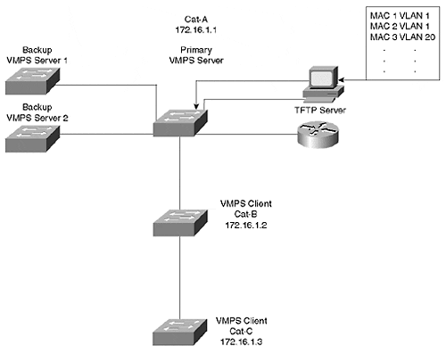
Cat-B and Cat-C are each configured as VMPS clients and get port-to-VLAN authorizations from the VMPS server. Therefore, they need to be able to communicate with the VMPS server.
The following list outlines the steps for configuring dynamic VLANs:
Step 1. Build the VLAN database and load into a TFTP server.
Step 2. Configure the VMPS server IP address.
Step 3. On the VMPS server, enter the IP address of the TFTP server.
Step 4. Enable the VMPS server.
Step 5. Configure VMPS clients with an IP address.
Step 6. On the VMPS clients, configure the IP address of the VMPS server.
Step 7. Identify dynamic ports on clients.
The sections that follow provide more detail on this seven-step sequence for configuring dynamic VLANs.

Building the VMPS Database for TFTP Download
The bulk of your configuration activity resides in building the VMPS database, a simple text file. The VMPS server downloads the text file database and uses it to determine whether devices are authorized to join a VLAN. Example 5-5 shows a representative database. The database divides into three portions. The first part modifies global parameters for the VMPS system. The second part defines the MAC address and the authorized VLAN for the address. The third part defines other policies to restrict VLANs to specific ports or groups of ports.

Example 5-5 VLAN Database Example
!PART 1: GLOBAL SETTINGS !vmps domain <domain-name> ! The VMPS domain must be defined. !vmps mode { open | secure } ! The default mode is open. !vmps fallback <vlan-name> !vmps no-domain-req { allow | deny } ! ! The default value is allow. ! The VMPS domain name MUST MATCH the VTP domain name. vmps domain testvtp vmps mode open vmps fallback default vmps no-domain-req deny ! ! !PART 2: MAC ADDRESS DATABASE !MAC Addresses ! vmps-mac-addrs ! ! address <addr> vlan-name <vlan_name> ! address 0060.0893.dbc1 vlan-name Engineering address 0060.08aa.5279 vlan-name --NONE-- address 0060.08b6.49fb vlan-name Engineering ! !PART 3: OTHER POLICIES !Port Groups ! !vmps-port-group <group-name> ! device <device-id> { port <port-name> | all-ports } vmps-port-group restrictengineering device 172.16.1.2 port 3/1 device 172.16.1.2 port 3/2 device 172.16.1.3 port 4/1 device 172.16.1.3 port 4/3 device 172.16.1.3 port 4/5 ! ! ! !VLAN groups ! USE THIS TO ASSOCIATE A GROUP OF VLANs TOGETHER. THE DATABASE TREATS ! ALL OF THE VLANs AS A SINGLE GROUP. ! !vmps-vlan-group <group-name> ! vlan-name <vlan-name> ! ! ! !VLAN port Policies ! !vmps-port-policies {vlan-name <vlan_name> | vlan-group <group-name> } ! { port-group <group-name> | device <device-id> port <port-name> } vmps-port-policies vlan-name port-group restrictengineering !

VMPS Database Global Settings
In the global configuration portion of the database (Part 1 in Example 5-5), you configure the VMPS domain name, the security mode, the fallback VLAN, and the policy regarding VMPS and VTP domain name mismatches.
The VMPS domain name must match the VTP domain name for the VMPS server to respond to a VMPS client. You can force the VMPS server to accept requests from VMPS clients with a domain name mismatch by setting the parameter vmps no-domain-req allow in the database.
The database entry vmps mode { open | secure } defines what action to take if the VMPS server does not have an entry for a MAC address. The open mode means that, if there is no entry for the MAC address, assign the port to the fallback VLAN. If you do not define a fallback, the port remains unassigned. If you set the mode to secure, the VMPS server instructs the VMPS client to shut down the interface instead of leaving it unassigned. An unassigned port can continue to try to assign a port through repeated requests. A shutdown port stays that way until you enable it.
The fallback VLAN is like a miscellaneous VLAN. If the database does not have an entry for the MAC address, the VMPS server assigns the device to the fallback VLAN, if one is configured.

VMPS Database VLAN Authorizations
The heart of the database is found here in the middle portion (Part 2 of Example 5-5). This defines the MAC address-to-VLAN association. Each device that you want to dynamically assign needs to have an entry in the database indicating its MAC address and the authorized VLAN. If the host attaches to a dynamic port, the Catalyst refers to the database for the VLAN assignment. Note that the VLAN assignment is by name, not by VLAN number. Also note a reserved VLAN name, --NONE--. This VLAN explicitly denies a MAC address from any dynamic VLAN port. Use this to ensure that certain devices never work when attached to a dynamic port. You can achieve a similar result by setting the security mode to enabled and not defining a fallback VLAN. But that affects all devices not in the database, not just a specific MAC address.
You can elect to enable these services for security reasons. For example, you might have specific devices that you never want to gain access through dynamic ports, in which case you can use the mapping to NONE option. This prevents the device from even joining the fallback VLAN. On the other hand, you might not want any station that is not in the database to dynamically join any VLAN. In this case, you should enable the security mode. This saves you from having to explicitly identify every excluded device.

VMPS Database Group Policies
Through the third part of the VMPS database (Part 3 in Example 5-5), you can restrict VLANS to specific ports on the VMPS client. Suppose, for example, that you want to ensure that hosts in the engineering VLAN only get authorized when they attach to Ports 3/1 and 3/2 on Cat-B, and Ports 4/1,3,5 on Cat-C in Figure 5-20. If the host attaches to any other dynamic port, do not authorize the port configuration, even if the MAC address is in the database. You can configure this in the database as shown in the third part of Example 5-5. Note that the database depends upon the IP address to specify the VMPS client and the policies regarding it.

Configuring the VMPS Server
You should complete the TFTP file configuration before you enable the VMPS server. You can have up to three VMPS servers, the active and two backups. When you enable the server, it attempts to download the database from the TFTP server. If it fails to download the database, the Catalyst does not enable the VMPS server function.
Two commands configure the VMPS server—set vmps tftpserver ip_addr [filename] and set vmps state enable. The first command points the VMPS server to the TFTP server and optionally specifies the database filename. If you do not specify a filename, the VMPS tries the filename vmps-config-database.1. Use the command set vmps tftpserver ip_addr [filename] to inform the VMPS server of the TFTP server's IP address and the VMPS database filename to request.
After you configure the TFTP server information, you can enable the VMPS server with the command set vmps state enable. At this point, the VMPS server attempts to download the VMPS database from the TFTP server.
If at some point after you enable the server you modify the VMPS database on the TFTP server, you can force the VMPS server to acquire the new database with the command download vmps.
You can check the status of the VMPS server with the command show vmps. This command reports all of the current configuration information for the server, as shown in Example 5-6.

Example 5-6 show vmps Output
Console> show vmps VMPS Server Status: ------------------- Management Domain: Accounting State: enbabled Operational Status: active TFTP Server: 144.254.10.33 TFTP File: myvmpsdatabase.db Fallback VLAN: miscbucket Secure Mode: open VMPS No Domain Req: allow VMPS Client Status: --------------------- VMPS VQP Version: 1 Reconfirm Interval: 20 min Server Retry Count: 3 VMPS domain server: 172.16.1.1 No dynamic ports configured. Console>
The show vmps command works for both the VMPS server and client. The top half of the display shows the server configuration information, and the bottom half displays client values. If you have trouble getting the VMPS server operational, use this command to view a summary of the parameters. In particular, check that the VMPS domain name matches the VTP domain name. State is either enabled or disabled. You should see enabled if you entered the set vmps state enable command. Check the operational status. This displays either active, inactive, or downloading. The downloading status implies that the VMPS server is retrieving the VMPS database from the TFTP server. The inactive status means that the VMPS server tried to get the database, but failed and became inactive. Finally, check the database filename and ensure that the Catalyst can reach the server, that the file exists, and that it is a VMPS file.
Cisco has two optional tools for the VMPS database—the User Registration Tool (URT) and the User Tracker for Cisco Works for Switched Internetworks (CWSI). The tools help with the creation of the database and allow you to place the VMPS server in a non-Catalyst device. The sections that follow provide additional information on these two tools.

URT
Cisco's User Registration Tool (URT) allows you to have a VLAN membership database built based upon a user's Windows/NT login information rather than based upon a MAC address. You can only use URT with Windows 95/98 and Windows NT 4 clients running Microsoft Networking (NetBios or Client for Microsoft Networks) running over TCP/IP using the Dynamic Host Control Protocol (DHCP). URT does not support other operating systems or network layer protocols. You must manually load a URT client package on the NT 4 clients/servers so it can interact with the URT server. However, Windows 95/98 clients automatically install the URT client service from their NT domain controller.
URT sets up an NT 4 database and behaves like a VMPS server. You still need to enable Catalysts as VMPS clients pointing to the NT server with the URT database.
Managing the URT server requires CWSI 2.1 as it interacts with the CWSI 2.1 ANI server to define workstation relationships to VLANs.

User Tracker for CWSI
User Tracker simplifies the task of building the TFTP server database. With Cisco Works for Switched Internetworks (CWSI), you can use the User Tracker function to build the database. User Tracker keeps track of individual stations in your network. Through a series of screens, you can use the information gleaned by User Tracker to automatically add entries to the VMPS database on your TFTP server. This eliminates the need for you to manually type entries in the database eliminating typographical errors in the database.

Configuring the VMPS Client
The VMPS client configuration includes steps to inform the client of the IP address of the VMPS server and to set ports to dynamic mode. By default, ports are in static mode which means that you must manually configure the VLAN membership. Setting the port to dynamic means that the Catalyst automatically configures the port VLAN membership based upon the response of the VMPS server.
Use the command set vmps server ip_addr [primary] to inform the client about the VMPS server IP address. You can specify up to three VMPS servers in the configuration file. One server functions as the primary server, the other two as backups.
To configure ports as dynamic, use the command set port membership mod_num/port_num dynamic. You cannot make a trunk port a dynamic port. You must first turn off trunking before you set port membership to dynamic. Nor can you set a secure port to dynamic. If you have port security enabled, you must disable it before you set it to dynamic. After you enter the set port membership command, the Catalyst attempts to communicate with the VMPS server using VQP when the attached device initially transmits. If the client successfully communicates with the server, the server responds in one of four ways:
- Assigns the port to an authorized VLAN
- Assigns the port to a fallback VLAN
- Denies access
- Disables the port
If the VMPS server finds an entry for the MAC address in the VMPS database, the server responds with the authorized VLAN for that device. The VMPS client enables the port and configures the port to the correct VLAN. If the VMPS server does not find the MAC address in the database, it assigns the device to the fallback VLAN if you set one up in the database. If you do not have a fallback specified, the VMPS server responds with instructions to deny access or shut down the interface, depending upon the VMPS security setting. Deny access differs from shutdown in that deny allows devices to try again (the behavior if the security option is disabled), whereas shutdown literally shuts down the port and prevents any further attempts to dynamically assign the port (the default behavior if the security option is enabled).
You can have multiple hosts on the dynamic port; however, all hosts must be authorized for the same VLAN, and you cannot have more than 50 hosts on the port.
Note that a Catalyst does not initiate a VQP to the server until the device attached to the port transmits. When the local Catalyst sees the source MAC address, it can generate a request to the VMPS server. If you use the show port command, you can determine what VLAN a port is assigned to. Dynamic ports have a VLAN nomenclature of dyn- as shown in Example 5-7.

Example 5-7 Displaying Dynamic Ports
Console> show port Port Name Status Vlan Level Duplex Speed Type 1/1 connect dyn-3 normal full 100 100 BASE-TX 1/2 connect trunk normal half 100 100 BASE-TX 2/1 connect trunk normal full 155 OC3 MMF ATM 3/1 connect dyn- normal half 10 10 BASE-T 3/2 connect dyn-5 normal half 10 10 BASE-T 3/3 connect dyn-5 normal half 10 10 BASE-T Console> (enable)
Note the entry for Port 1/1. It has a dynamic VLAN assignment. But the highlighted Port 3/1 is a dynamic port without a VLAN assignment. The Catalyst does not forward any frames from the host attached to this port. When you first attach a host to the port, the Catalyst does not know the source MAC address and automatically configures the port in this mode.
After the host transmits and the VMPS client receives a valid response from the VMPS server, the VMPS client Catalyst enables the interface in the correct VLAN. If the client sits idle for awhile causing the bridge aging timer to expire for the entry, the Catalyst returns the port to an unassigned state. The VMPS client issues a new query to the VMPS server when the host transmits again.
Confirm the VMPS client configuration with the show vmps command as was shown in Example 5-6. The bottom half of this output shows the client settings. The reconfirm interval defines how often the client interrogates the VMPS server to see if a policy changed for locally attached hosts. In Example 5-6, the interval is for every 20 minutes. The Server Retry Count, in this case three, specifies how many times the VMPS client should try to reach the VMPS server. If it fails to receive a response from the server after three attempts, the client attempts to reach one of the backup servers. Finally, the output shows how the IP address of the VMPS server the client is attempting to use, 172.16.1.1.

Protocol Filtering
A switch forwards traffic within a broadcast domain based upon the destination MAC address. The switch filters, forwards, or floods the frame depending upon whether or not the switch knows about the destination in its address table. The switch normally does not look at any Layer 3 information (or Layer 2 protocol type) to decide how to treat the frame. (MLS and MPOA are exceptions). Refer to Figure 5-21 for another example of the Catalyst blocking traffic based upon the protocol.

Figure 5-21 Protocol Filtering
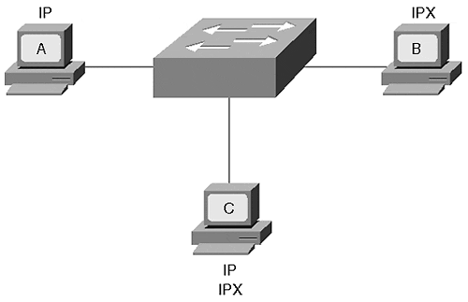
If Station A in Figure 5-21 sends a frame to Station B, the switch forwards the frame, even if Station B does not share the same Layer 3 protocol as Station A. This is an unusual situation. Suppose, however, that the VLAN contains stations with a mix of protocols in use. Some stations use IP, some use IPX, and others might even have a mix of protocols. If a switch needs to flood an IP frame, it floods it out all ports in the VLAN, even if the attached station does not support the frame's protocol. This is the nature of a broadcast domain.
A Catalyst 5000 equipped with a NetFlow Feature Card and a Supervisor III engine, as well as many other Catalysts, can override this behavior with protocol filtering. Protocol filtering works on Ethernet, Fast Ethernet, or Gigabit Ethernet non-trunking interfaces. Protocol filtering prevents the Catalyst from flooding frames from a protocol if there are no stations on the destination port that use that protocol. For example, if you have a VLAN with a mix of IP and IPX protocols, any flooded traffic appears on all ports in the VLAN. Protocol filtering prevents the Catalyst from flooding traffic from a protocol if the destination port does not use that protocol. The Catalyst listens for active protocols on an interface. Only when it sees an active protocol does it flood traffic from that protocol. In Figure 5-21, there is a mix of protocols in the VLAN. Some of the stations in the network support only one protocol, either IP or IPX. Some of the stations support both. The Catalyst learns that Station A uses IP, Station B uses IPX, and Station C uses both by examining the Layer 2 protocol type value. When Station A creates an IP broadcast, Station B does not see the frame, only Station C. Likewise, if Station B creates a frame for the switch to flood, the frame does not appear on Station A's interface because this is an IP-only interface.
The Catalyst enables and disables protocols in groups. They are the following:
- IP
- IPX
- AppleTalk, DECnet, and Vines
- All others

Review Questions
This section includes a variety of questions on the topic of campus design implementation. By completing these, you can test your mastery of the material included in this chapter as well as help prepare yourself for the CCIE written test.
1: | Early in this chapter, it was mentioned that you can determine the extent of a broadcast domain in a switched network without configuration files. How do you do it?
2: | Two Catalysts interconnect stations as shown in Figure 5-22. Station A cannot communicate with Station B. Why not? Example 5-8 provides additional information for the system.  Figure 5-22 Figure for Review Question 2  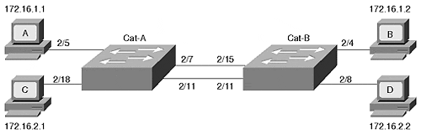  Example 5-8 Cat-A and Cat-B Configurations  Cat-A > (enable) show vlan VLAN Name Status Mod/Ports, Vlans ---- -------------------------------- --------- ---------------------------- 1 default active 1/1-2 2/1-8 2 vlan2 active 2/9-24 1002 fddi-default active 1003 token-ring-default active 1004 fddinet-default active 1005 trnet-default active Cat-B> (enable) show vlan VLAN Name Status Mod/Ports, Vlans ---- -------------------------------- --------- ---------------------------- 1 default active 1/1-2 2/9-24 2 vlan2 active 2/1-8 1002 fddi-default active 1003 token-ring-default active 1004 fddinet-default active 1005 trnet-default active
3: | Again referring to Figure 5-22 and Example 5-8, can Station C communicate with Station D?
4: | Are there any Spanning Tree issues in Figure 5-22?
5: | Draw a logical representation of Figure 5-22 of the way the network actually exists as opposed to what was probably intended.
6: | Is there ever a time when you would bridge between VLANs?
7: | List the three components of dynamic VLANs using VMPS.

