



Computer Communications 27 (2004) 1220–1228

www.elsevier.com/locate/comcom

Abstract

Protection performance components in MPLS networks

Eusebi Calle*, Joseґ L. Marzo, Anna Urra

Broadband Comm. and Distributed Systems, Institut d’Informa`tica i Aplicacions (IIiA), Universitat de Girona, 17071 Girona, Spain

In this paper, we present a new methodology for evaluating fault recovery performance of some existing mechanisms, which considers the
establishment of quality of service network paths with protection. In order to evaluate the level of protection of a network, different
components, such as protection parameters (packet loss and restoration time), or network parameters and constraints (link failure probability
and network load), are analyzed. A formulation to calculate the inﬂuence of each component in the establishment of protected paths is
discussed in multiprotocol label switching (MPLS) networks. Several experiments are presented to support this formulation. Moreover, an
analysis of the relationship between these protection components and different trafﬁc classes is also introduced and justiﬁed.
q 2004 Elsevier B.V. All rights reserved.
Keywords: Multiprotocol label switching; Fault recovery; Network performance

1. Introduction

New network technology enables increasingly higher
volumes of information. As networks grow, offering
better quality of service (QoS), the consequences of a
failure become more pronounced. Network reliability is
seen as a key requirement for the new trafﬁc engineered
networks [12].
In this paper, MPLS technology is used to evaluate our
approach. MPLS allows network packet encapsulation at
ingress points (ingress nodes) by labeling and routing/for-
warding packets along a label switched path (LSP).
However, they can also be easily applied in those network
technologies that implement the concept of virtual paths.
Network reliability can be provided through different
fault management mechanisms applied at different network
levels and time scales. MPLS provides a fast restoration
method for fault recovery. MPLS fault restoration mechan-
isms usually use backup LSP establishment: trafﬁc can be
redirected to these backups in case of failure. Several
methods deﬁning ‘fast restoration’ MPLS frameworks have
been proposed in different RFCs and surveys [1 – 3].
Several schemes [4 – 8] have proposed routing MPLS
LSPs so that certain QoS parameters are guaranteed. These
proposals use MPLS capabilities to develop an on-line

* Corresponding author.
E-mail addresses: eusebi@eia.udg.es (E. Calle), marzo@eia.udg.es
(J.L. Marzo), aurra@eia.udg.es (A. Urra).
0140-3664/$ - see front matter q 2004 Elsevier B.V. All rights reserved.
doi:10.1016/j.comcom.2004.02.025

routing mechanism that provides better performance, e.g.
reducing the LSP establishment rejection rate.
However, these schemes do not take into consideration
other aspects, such as network failure probability, or the
quality of protection parameters, such as packet loss or
restoration time, which is important in high-speed networks.
These aspects are addressed in this paper, along with an
analysis certain trafﬁc services that have higher resilience
requirements, which means fast, suitable recovery mechan-
isms need to be created.
In Section 2 main MPLS protection methods are
reviewed. A description and formulation of different
network and QoS components and their relationship with
the network protection is introduced in Section 3. Finally,
different experiments are carried out to support previous
section formulation and demonstrate the advantages of this
new methodology.

2. Protection in MPLS networks

In this section a brief review of the mechanisms involved
in the development of a backup protection method is
provided. The particular protection architecture of MPLS is
used to describe them. There follows a discussion of the
advantages and disadvantages of the various backup
methods.
Protection methods begin with fault identiﬁcation and
end with link recovery. There is a chain of events, which

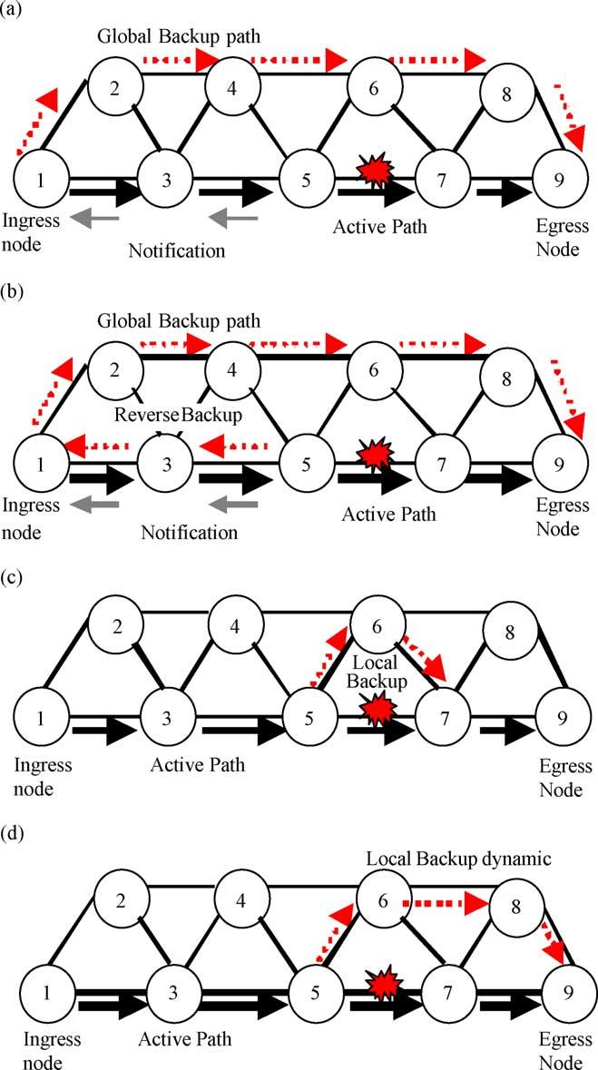

E. Calle et al. / Computer Communications 27 (2004) 1220–1228

involves various components. First, a method for selecting
the working and protection paths is needed. If a QoS must be
achieved, a QoS routing method should be used [4 – 8]. The
next step involves mechanisms for fault detection and
notiﬁcation: these convey information (about the occurrence
of a fault) to the network entity responsible for taking the
appropriate corrective action, for example, transmitting a
fault indication signal (FIS). Finally, a switchover mechan-
ism is needed to redirect trafﬁc from the working path to the
backup path.
In order to provide certain protection features, two new
sorts of nodes are necessary: a node responsible for the
switchover function once the failure is identiﬁed and a node
where the working and backup paths are merged. In MPLS,
these two nodes are deﬁned as path source label switch
router (PSL) and path merge label switch router (PML),
respectively [1].

2.1. Backup path set up methods

2.1.1. Global backup path
In this model (see Fig. 1(a)), an ingress node is
responsible for path restoration when the FIS arrives. This
requires an alternative, unconnected backup path for each
working path. The ingress node is where the protection
process is initiated, irrespective of the failure location along
the working path.
The advantage of this method is that only one backup
path per working path needs to be set up. Furthermore, it is a
centralized protection method, which means that only one
LSR has to be provided with PSL functions. On the other
hand, this method has a high cost (in terms of time) as the
FIS is sent back to the ingress node. Furthermore, it implies
higher packet losses during the switchover time.

1221

2.1.2. Reverse backup path
The main feature of this method is that it reverses trafﬁc
close to the point of failure, back to the source switch
(ingress node) of the path being protected, via a reverse
backup LSP (see Fig. 1(b)). As soon as a failure is detected,
the LSR at the ingress of the failed link reroutes incoming
trafﬁc to the backup LSP sending it in the opposite direction,
back to the ingress node. Haskin proposes pre-establishing
the reverse backup path [14], making use of the same nodes
of the working path, thus simplifying the signaling process.
This method is especially suitable for avoiding packet
loss of sensitive trafﬁc. Another advantage is the simpliﬁed
fault indication, since the reverse backup transmits the FIS
to the ingress node and the recovery trafﬁc path at the same
time. One of the disadvantages is poor resource utilization.
Two backups per protected domain are needed. Another
drawback, which it shares with the global repair model, is
the time taken to send back the fault indication to the ingress
node.

Fig. 1. Main fault management schemes: (a) global backup, (b) reverse
backup, (c) and (d) local backup.
2.1.3. Local backup path
In this method, restoration begins at a point much closer
to the fault (see Fig. 1(c) and (d)). It is a local method and
does not necessarily involve the ingress node. The main
advantage is that it offers a faster restoration time than the
global repair model, as well as a signiﬁcant reduction in the
packet loss.
On the other hand, every node requiring protection has to
be provided with a switchover function (PSL). A PML
needs to be provided too. Another drawback is the
maintenance and creation of multiple backups (one per
protected domain). This can lead to low resource utilization
and increased complexity. An intermediate solution estab-
lishes local backups only for segments with high reliability
requirements.
In dynamic environments local backups are used in a
different manner. The PSL node usually selects a new

1222

E. Calle et al. / Computer Communications 27 (2004) 1220–1228

alternative (disjoint) route from this node to the egress
nodes. This case is shown in Fig. 1(d).

2.2. Resource reservation and backup setup

Setting up a backup path can be done on a pre-established
or on-demand basis. The resource allocation can be reserved
or not reserved (it is normally expressed in terms of
bandwidth) [3]. Backup setup concerns the initiation of the
recovery path setup. In the pre-established case, a recovery
path is established prior to the link failure, whereas for the
on-demand methods, the recovery path is established after
the failure.
Resource allocation is pre-established if network
resources are allocated before the failure. A backup path
can be established with no (speciﬁc) bandwidth allocated.
When the working and backup paths are selected, in order to
pre-establish and pre-reserve resources, a signaling protocol
should be used. In MPLS, an LSP is created distributing the
appropriate labels over each LSR node and reserving the
requested resources. Currently, there are two possible
signaling protocols with QoS support: CR-LDP and
TE-RSVP [12]. These schemes make it possible to set up
several QoS parameters and implement resource reservation
in order to achieve the required QoS level.

2.3. Shared backups

Some working paths can share the same backup path.
The resource reservation and the routing methods must take
this into account. These mechanisms can save a large
amount of resources by maintaining the same level of
protection for single failures. The information about the
aggregate shared bandwidth can be distributed to nodes for
performing route computation [8]. If such information is not
available, sharing backups is not possible. In optical
scenarios, where protection is applied with simultaneous
transmissions on both paths (the working and the backup
paths), sharing backups is not possible. In these schemes,
the receiver (PML node in MPLS networks) selects the data
ﬂow from the path with the stronger carrier signal.

2.4. Characterization of the protection methods

Table 1 shows a taxonomy of the main protection
methods. Each method is classiﬁed according to the elements

Table 1
Backup path methods taxonomy
Backup methods
Reserved or shared resource allocation

described above for creating a backup path. A new notation to
identify each method is also proposed in this table. For
instance a pre-established global backup path with reserved
resources is identiﬁed as PRG (pre-established backup path,
reserved resource allocation, and global). For simplicity,
shared and reserved resource methods are not distinguished
in the table. This notation is used in the following sections.

2.5. Related work

In classical QoS routing schemes, such as Widest Shortest
Path (WSP) [4], QoS is achieved by maximizing the resource
utilization. Other parameters, for describing the network state,
trafﬁc classes or network parameters are not considered in
these schemes. Moreover, they do not consider path protection
as an important aspect in offering QoS.
Other recent schemes [4 – 8] develop more complex and
effective routing methods. In these schemes global backup
paths are commonly used to support protection. The main
objective of these schemes is to offer a protection routing
method which maximizes the resource consumption and
minimizes the path request rejection ratio. However, only
one protection scheme is considered and network par-
ameters, such as link failure probability or trafﬁc classes, are
not considered.
There are few schemes that propose alternative protec-
tion methods for achieving a more accurate and suitable
protection scheme. Global and local methods are the major
mechanisms employed. Proposals that make use of several
schemes involve developing a necessary, but not sufﬁcient,
recovery time (RT) and packet loss (PL) analysis, in order to
select the most suitable method.
Another important aspect is the classiﬁcation of the
trafﬁc to be carried by the selected paths. New multiservice
networks involve a separate treatment of each service in
order to achieve the required QoS. There are some QoS
routing proposals that take this aspect into account in their
objectives, such as Ref. [5]. However, these schemes do not
take full advantage of these techniques in developing a
protection method. A previous work of ours, [13,14],
introduces a methodology to select the most suitable backup
method, taking into account several protection components.
In Ref. [3] we discussed the main factors involved in
protection and their relationship with Diffserv trafﬁc classes.

No reserved resource allocation

Pre-established backup path setup Global (PRG) Reverse (PRR) Local (PRL) Global (PNRG) Reverse (PNRR) Local (PNRL)

On-demand backup path setup
Global (ORG) Reverse (ORR) Local (ORL) Global (ONRG) Reverse (ONRR) Local (ONRL)

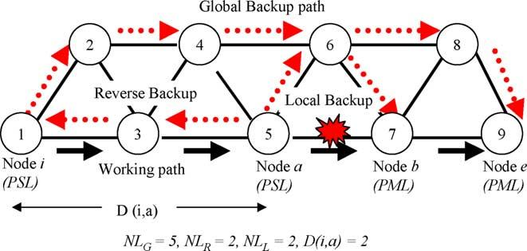

E. Calle et al. / Computer Communications 27 (2004) 1220–1228

1223

3. Protection components

In this section, a formulation of the main protection
components and constraints is proposed and justiﬁed by
different experiments. First of all, an analysis of the
protection parameters (packet loss and restoration time)
and resource consumption is provided. This is followed by
an analysis of different network parameters and their
inﬂuence with respect to the network protection mechan-
isms, and in particular, link failure probability and network
load. Finally, the relationship between different trafﬁc
classes and protection methods is presented. The differ-
entiated services (DS) implementation is used to formalize
the trafﬁc classes.

3.1. QoS and protection constraints: restoration time
and packet loss

3.1.1. Restoration time
Restoration time (RT) depends on the chain of events
involved in the recovery procedures described in Section 2.
Basically, there are four components that affect RT.
The Detection time (DT) of the failure which we can
ignore when comparing the methods since it affects all the
methods equally (DT ј 0), the notiﬁcation time (NT)
during which the node responsible for taking the switchover
actions is notiﬁed of the failure, and the time taken to switch
the trafﬁc from the working path to the backup path,
switchover time (ST). In addition, if the fault management
method is dynamic (or on-demand), i.e. the backup path is
not pre-established, then a rerouting time (RrT) to route and
signal the backup path once the failure is detected must be
added to the RT formulation.
The largest component of this formulation is the
notiﬁcation time, because it is responsible for most of the
packet loss ratio. The Notiﬁcation Time is directly affected
by the distance Dрi; aЮ between the node where the failure is
identiﬁed (see node a in Fig. 2) and the node responsible for
taking the switchover actions (node i; in the global and
reverse backup methods). In local backup, of course, the
node which detects the failure is itself responsible for
the switchover procedure, so the distance is not relevant
in this method. Other factors affecting the notiﬁcation time
are the link delay (LD), or the latency in the propagation of

Fig. 2. Illustrative example.

the packets along the links, the node processing delay
(NPD) and the buffer processing delay (BPD) (i.e. the time
that the packets are enqueued in the node buffers). The sum
of the LD, BPD and the NPD is the propagation time (PT).
To sum up, the restoration time, RT, is made up of the
following components:
RT ј DT ю NT ю RrT ю ST р1Ю
where DT, detection time; RrT, rerouting time; ST,
switchover time; NT, notiﬁcation time and NT is obtained
by the following formulation
NT ј Dрi; aЮ·PT р2Ю
where D is the distance Dрi; aЮ (see Fig. 2). Distance
between the node previous to the failed link (point a) and the
ingress node (point i) and PT, propagation time:
PT ј NPD ю LD ю BPD р3Ю
In Table 2, we propose a range of different levels of
protection requirements that can be established according to
the desired restoration time. For many methods, 50 ms is the
threshold for establishing fast protection mechanisms.
However, we suggest going beyond this limitation by
proposing new levels for experimental purposes.

3.1.2. Packet loss
Packet loss (PL) occurs during the process between the
failure occurrence to the failure is notiﬁed to the PSL node.
So, the PL depends on the restoration time (RT), especially
the notiﬁcation and the rerouting time components (in the
case of a dynamic or on-demand fault management method)
and on the current rate рRЮ of the trafﬁc in the affected LSP.
The product of distance and rate provides an upper limit for
packet loss
PL ј RT·R ю LP р4Ю
where LP is the lost packets in the link failure; R is the rate:
allocated bandwidth (bits/s).

3.2. Resource consumption formulation

The Resource consumption (RC) is evaluated depending
on the repair method used. For simplicity, we propose the
utilization of the allocated bandwidth as the metric.
Therefore, RC can simply be evaluated by computing the
number of links on the path and the allocated bandwidth on

Table 2
Protection levels vs restoration time
Protection requirements Restoration time (RT)

Very low .1 min
Low 200 ms – 1 min
Medium 50 ms – 200 ms
High 20 ms – 50 ms
Very high ,20 ms

1224

each link.

E. Calle et al. / Computer Communications 27 (2004) 1220–1228

probability. However, we present a formulation and some
analytical results which show how previous knowledge of

RC ј NL·RB
р5Ю
this probability inﬂuences the choice of the protection

where RB is the reserved bandwidth and NL is the number
of links on the working path.
The general formulations above have to be adapted to the
different backup path methods described in Section 2. The
resource consumption for the global method, (RC_{G}),
depends on the number of links in the backup path (NL_{G}).
The resource consumption for the reverse repair method,
(RC_{R}), is the sum of the RC_{G}plus the resources required for
the reverse path (NL_{R}). The resource consumption for the
local repair method (RC_{L}) depends on the reserved
bandwidth and the number of links NL_{L}. In the case of
local backup, it should be noted that more than one local
backup could be created to protect several links in the
working path. Hence, the RC for the different methods is
evaluated thus:
RC_{G}ј NL_{G}·RB р6Ю
mechanisms.
We propose the following approximation [14] to
establish the link failure probability of an speciﬁc
LSP(LSP_FP)
X
LSP_FP ј LFP_{i}р9Ю
iј1

where k is the number of links of the LSP
LFP_{i}p 1 ; i
where LFP_{i}is the link failure probability for each link рiЮ of
the LSP.
Failure probabilities can be a decision component when
the routing algorithm offers more than one equivalent path.
A resource consumption reduction can be also achieved if
only local backups are used to protect those links with high

RC_{R}ј RC_{G}ю NL_{R}·RB
RC_{L}ј NL_{L}·RB
р7Ю
р8Ю
failure probabilities respect to other protection methods
(global or reverse backups).

where RC_{G}, RC_{R}, RC_{L}are resource consumptions (global,
reverse and local, respectively) NL_{G}, NL_{R}, NL_{L}are number
of links (global, reverse and local, respectively).
A particular case is when, using the Haskin mechanism
[14], resource consumption is RC_{G}ю NL_{w}·RB (where NL_{W}
is the number of links in the working path).
Selecting protection methods with bandwidth allocation
implies a combination of different methods (local, global or
reverse) in order to achieve the requested protection level
with balanced resource consumption cost.

3.3. Network constraints: link failure probability
and network load

Selecting the most suitable protection method depends
on physical network parameters and network status
parameters. The ﬁrst set of parameters are concerned with
how the physical network technology affects the occurrence
of a network link failure, i.e. link failure probability. The
second concerns the current state of the network, i.e.
network load.
In this section, the relationship between these parameters
and the protection methods is analyzed.

3.3.1. Link failure probability
Currently, several wire technologies (twister pairs,
coaxial cable, radio links, optical ﬁber, etc.) coexist in a
network. Some of these links may present different link
failure probabilities. It is difﬁcult to establish an exact value
for this probability, but an approximate value can be
obtained by analyzing different statistics or network
provider experience. In this paper, we do not address the
various methods for evaluating a value for link failure
3.3.2. Network load
Network load should also be taken into consideration in
the development of new QoS and protected paths. In a
dynamic scenario, the network conditions, in terms of
network load should be considered before selecting a
protection method.
Effective protection methods imply the utilization of pre-
established and pre-allocated protection methods. However,
excessive resource consumption involves using no pre-
allocated schemes. The network status, in terms of network
load is crucial in evaluating the performance of these
methods.
In high network-load scenarios, recovery time and packet
loss are increased. Some delays (such the BPD) are longer
and the failure indication signals are delayed, especially if
the network does not support priority packets.

3.4. Protection with different classes of trafﬁc

Another aspect of expanding QoS routing performance is
the use of the trafﬁc – proﬁle concept to characterize the
probability and/or the sensibility of a class of trafﬁc—in the
case of failure. In this way, the routing algorithm can act in
different ways depending on the trafﬁc class.
Let us consider a DS scenario where four class-types are
deﬁned according to the DS draft from the IETF [10]. An
expedited forwarding (EF) class is deﬁned to transport real-
time trafﬁc, two assured forwarding (AF1 and AF2) classes
are used by trafﬁc with two different ﬂavors for losses and,
as usual, a best effort (BE) class for trafﬁc with no QoS
requirements.
There are several proposed methods, such as Ref. [9],
that attempt to relate what the QoS parameters of each DS

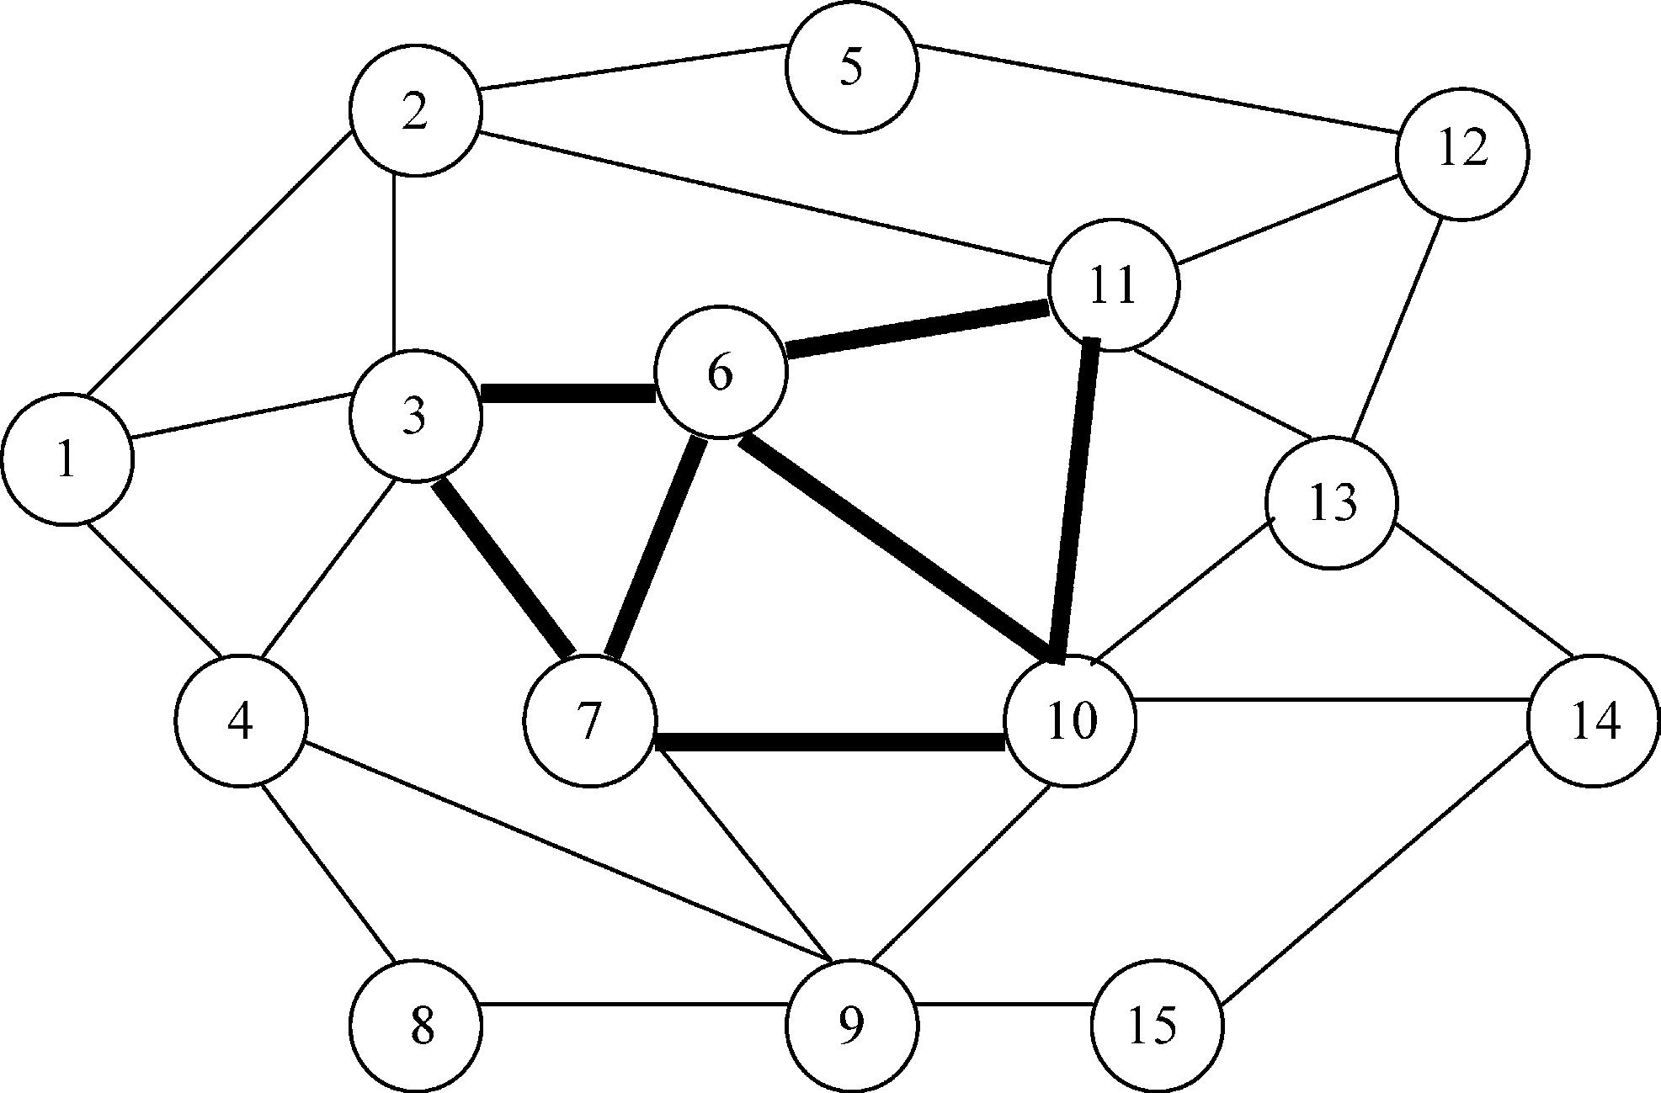

Table 3
DiffServ and protection methods
Protection performance components

E. Calle et al. / Computer Communications 27 (2004) 1220–1228

DS trafﬁc classes

1225

Restoration time
Packet loss
Resources
Failure probability
Protection mechanisms priority (acronyms in Table 1)
ю

2

EF

Fast
Low
Medium
Low

PRL

AF1

Fast
Low/medium
Medium
Low

PRG/PRR/PRL

AF2

Medium
Medium
Medium/low
Medium

PRL
PNRG/PNRR/PNRL
ORG/ORR/ORL

BE

None
None
None
None

ONRG/ONRR/ONRL

trafﬁc class are. However, there are very few proposals that
relate what the protection parameters are in relation to each
trafﬁc class. In this section, we propose a more suitable
protection strategy, which takes into account the trafﬁc
class. Protection parameters (PL and RT) and the resource
consumption (RC) are weighted with relation to each trafﬁc
class.
Table 3 shows the proposed protection strategies
according to the QoS requirements. They are sorted
according to priority. Pre-established reserved local (PRL)
recovery protection is assigned to EF due to the
restoration time constraint, which should be short for
real time trafﬁc. As very low losses are required for AF1,
the pre-established reserved methods are chosen. The
protection domain for AF2 can be pre-established or on-
demand and the bandwidth allocation can be reserved or
un-reserved depending on link reliability. BE trafﬁc does
not require pre-established methods or reserved resources.
Backup path setup (pre-established or on-demand),
resource allocation (reserved or not reserved) are
protection parameters deﬁned in [10].
In the pre-established case, a recovery path is
established prior to the link failure, whereas for the on-
demand backup path setup the recovery path is
established after the failure. The pre-established scheme
for setup is obviously faster, and therefore it is proposed
for EF and AF1 trafﬁc classes. Resource allocation
indicates if network resources (normally bandwidth) are
already allocated to the backup path before the failure
(pre-established) or after the failure (having noted that
the backup path can be established with no speciﬁc
bandwidth allocated). Another aspect to consider, when
deﬁning a more detailed resource reservation strategy, is
the method used to allocate bandwidth to LSPs. These
are equivalent-bandwidth allocated (same amount as the
working path) or limited-bandwidth allocated (less
bandwidth than the working path). For EF and AF1,
equivalent bandwidth is allocated so no signiﬁcant QoS
degradation is expected.

4. Experimental results

In order to test this formulation, we carried out different
experiments using the ns-2 [11] MNS2.0 (MPLS module)
for ns2.8. This module has been modiﬁed to enhance certain
features, such as providing background trafﬁc (variable bit
rate (VBR)) in scenarios with different network load. We
also tried out all protection methods described in Table 1.
For these experiments we used the same topology,
(shown in Fig. 3). The capacity of the links is 12 and 48
(bold lines) units. But these capacities are scaled by 10, in
order to experiment with thousand of LSPs. Each link is bi-
directional (i.e. it acts like two unidirectional links of half of
that capacity). There are 15 nodes and 28 links. In the
simulation experiments, LSP requests arrived randomly, at
the same average rate for all ingress – egress node pairs. The
main objective of this experiment was to determine the
behavior of various protections schemes in a dynamic
scenario. LSPs arrive between each ingress – egress pair
according to a Poisson process with an average rate l; and
the holding times are exponentially distributed with a mean
value of 1=m: In this set of experiments, l=m ј 150:

Fig. 3. Network topology.

1226

E. Calle et al. / Computer Communications 27 (2004) 1220–1228

Ten independent trials were calculated over a window of
10,000 LSP set-up requests. Fifty percent of these requests
were protected trafﬁc (PT). The remaining 50% is not

Table 5
Inﬂuence of failure notiﬁcation distances рDрi; aЮЮ and the propagation time
(PT)

protected trafﬁc (NPT), conducted simply by a WSP routing
algorithm. Trafﬁc is modeled using constant bit rate (CBR)
Link
delay
Failure notiﬁcation distance

trafﬁc, there is also a variable bit rate (VBR) background
trafﬁc. Link failure probabilities are assigned randomly for
(ms) Dрi; aЮ ј 2 Dрi; aЮ ј 3 Dрi; aЮ ј 4
Dрi; aЮ ј 0

each trial between 0 and 5 Ј 10²4. The allocated bandwidth
RT PL RT PL RT
PL RT PL

for LSPs is uniformly distributed to 1, 2 or 3 bandwidth
units; the same bandwidth is allocated for backup paths.
20 ms 40.2 10 60.4 14 80.7 24 0.2 2
10 ms 20.2 5 30.4 8 40.54 12 0.2 1
8 ms 16.2 4 24.4 6 32.5 9 0.2 1

4.1. Experiments to evaluate PL and RT formulation
2 ms
4.2 1 6.4 2 8.54 3 0.2 0.1

In Table 4, the inﬂuence of the distance is shown. Results
represent the average of packet loss and restoration times
(milliseconds) of 10 trials. In order to develop the RT
formulation, this distance D(i,a) is deﬁned as the number of
hops between the node which detects the failure, (node a;
see Fig. 2), and the node responsible for the switchover
(node i). In this ﬁrst set of experiments, failures are triggered
in different links (with LFP ј 5 Ј 10²4) and failure
notiﬁcation distances 0, 2, 3, 4. Failures are recovered
using global backup methods. The analysis of the distance is
a crucial aspect when selecting the protection method. A
distance equal to zero means that a local method is chosen;
otherwise, the global or the inverse method can be selected.
The results reveal that the RT is directly proportional to the
distance. Table 4 also gives the different trafﬁc rates,
showing how it inﬂuences packet loss (PL), according to
formula (4).
Note that when the trafﬁc rate is high, (for instance, 0.002
packets/s, see Table 4), the notiﬁcation distance may
dramatically affect the restoration time (RT for Dрi; aЮ ј 4
is twice what it is for Dрi; aЮ ј 2). The same case occurs for
packet loss. There are 62 packets lost for Dрi; aЮ ј 4
compared to 26 packets lost in the case of Dрi; aЮ ј 2:
In Table 5, different link delays are analyzed in order to
evaluate their inﬂuence on PL and RT when the propagation
time varies (see formulas (2) and (3)). The results
also reveal that the link delay is the most relevant parameter
for both PL and RT, when the notiﬁcation distances are
large.

Table 4
Inﬂuence of failure notiﬁcation distances рDрi; aЮЮ and trafﬁc rates рRЮ in
packet loss (PL) and restoration time (RT)
Trafﬁc Failure notiﬁcation distance

Note, that in the case of having the same trafﬁc rate (Table
5) and large notiﬁcation distances (for instance Dрi; aЮ ј 4)
the propagation time between all links is a crucial aspect.
When the link delay increases from 2 to 20 ms, the restoration
time is almost 100% worse. The same performance occurs for
packet loss. There are 24 packets lost (for link delay of 20 ms)
compared to three packets in the case of 2 ms.

4.2. Network load

Table 6 shows the signiﬁcance of the method selected
regarding the RT : In this case, a more realistic network,
where background trafﬁc is introduced to simulate this
scenario, shows that Global and Reverse backup methods
with no resource reservation behave similarly, with regard
to the RT: The distance and the background trafﬁc affect
both methods equally. Furthermore, RT values for Global
and Reverse methods are very similar (see Table 6), but not
identical. For instance for a network load of 40%, the RT for
the global methods is 31.32, while for the reverse method it
is 31.67 ms. This is due to the fact that they use different
routes to send the Fault Indication Signal (FIS), although the
distance to the ingress node is the same in both cases.
Consequently, it is important that the routing method
applied should take into account the inﬂuence of the
network load, in particular when the backup method does
not reserve resources. Another conclusion is that a more
loaded network can negatively affect restoration time

Table 6
Inﬂuence of the network load in protection methods with no resource
reservation

rate
(packets/s) Dрi; aЮ ј 2 Dрi; aЮ ј 3 Dрi; aЮ ј 4
Dрi; aЮ ј 0
Network
load
Pre-established non-reserved resources protection methods

Global Reverse Local

RT PL RT PL RT
PL RT PL
(PNRG)
(PNRR)
(PNRL)

0.02
0.01

20.2 2 30.4 3 40.54 6 0.2 1.0
20.2 5 30.4 8 40.54 12 0.2 1
RT
PL
RT
PL
RT
PL

0.008 20.2 6 30.4 9 40.54 15 0.2 1.2
0.004 20.2 13 30.4 18 40.54 30 0.2 2.3
0.002 20.2 26 30.4 36 40.54 62 0.2 5
0%
25%
40%
30.4
30.54
31.32
7
8
8
30.61
30.98
31.67
1.0
1
1
0.37
0.37
0.37
0
1
1

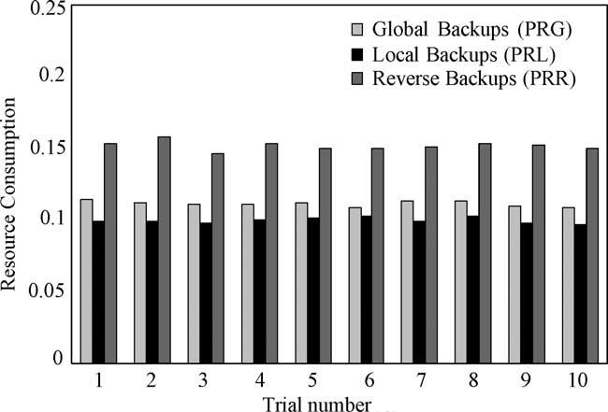
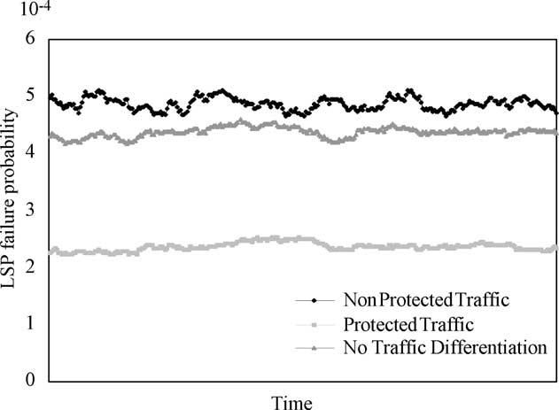
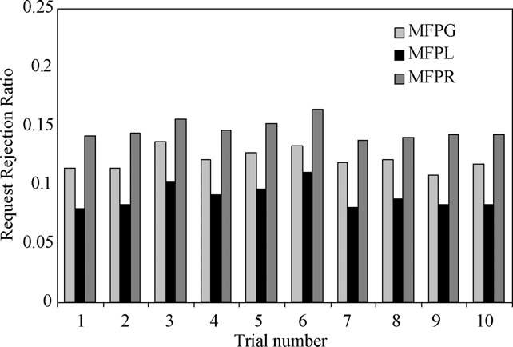

E. Calle et al. / Computer Communications 27 (2004) 1220–1228

(i.e. increase it), whenever resources are not reserved,
except in the case of using local backup paths.
In a similar way, the network load directly affects packet
loss in the case of using fault management methods with no
allocated resources.

4.3. Resource consumption

Fig. 4 shows the percentage of resources used by the
three pre-established, pre-allocated protection methods
PRG, PRR, and PRL. As expected, the results show that
reverse backups consume more resources and local backups
obtain the lowest percentage. However, in this case, only
20% of the network links are protected. If the network Fig. 5. Failure probability analysis.
protection percentage increases, locals backups may con-

1227

sume more resources than global or reverse backups. It is
notable that there is a strong relationship between the local
backup resource consumption and the number of links to be
protected. The results also show that reverse backups always
use more resources than global backups. However, in each
trial there is a different proportion between them. This is due
to the fact the establishment reverse backups begins on the
last node to be protected, minimizing the resource
consumption when this node is near the ingress node (see
formula (7)).

4.4. Failure probability

Fig. 5 shows the enhancement of the network protection
level in terms of link failure probability. In this case, trafﬁc
with different protection requirements is separated. Paths for
protected trafﬁc are chosen with the minimum LSP_FP: The
results show that trafﬁc with no protection accumulates
large LSP_FP (i.e. 5 Ј 10²4). On the other hand, protected
trafﬁc gets low LSP_FP values. If the minimization of the
LSP_FPs is not considered, in the result is an accumulation
of large values for all trafﬁc (about 4 Ј 10²4_{).}

Fig. 4. Resource consumption analysis.
4.5. Enhancing routing algorithms in multiservice scenarios

In this section, we present the inﬂuence of each protection
component independently. In multiservice networks, major
routing algorithms should use only some of these com-
ponents in order to design suitable protection mechanisms.
Therefore, each trafﬁc class should be dealt with by an
algorithm that considers the aspects reviewed in Table 3.
However, these new routing algorithms should not alter
classical QoS routing algorithms objectives: minimizing
resource consumption and optimizing the request rejection
ratio.
We analyzed the request rejection ratio of certain
algorithms based on the well-known widest shortest path
(WSP). They were enhanced by adding a new objective:
minimizing the failure probability, hence, the path with
minimum LSP_FP is chosen. We refer to them as minimum
failure probability (MFP) routing algorithms. Three new
methods are evaluated: global (MFPG), local (MFPL) and
reverse (MFPR) backups, according to the strategies
presented in Section 2. Backup paths are pre-established
and pre-allocated to overcome the network load effect.
Fig. 6 shows the request rejection ratio for each method.
The results were evaluated when 20% of the network links

Fig. 6. Request rejection ration analysis.

1228

E. Calle et al. / Computer Communications 27 (2004) 1220–1228

were protected. In this case the request rejection ratio
ranged from 8%, where there was no backup creation, to
15% in the case of using only reverse backups.

5. Conclusions

In this paper, we have presented several performance
components used to evaluate the degree of protection
offered by current QoS routing algorithms. We have
introduced a methodology to deﬁne the crucial components
in the creation of QoS and protection mechanisms.
A formalization for each QoS protection component has
been presented. Results have shown that by taking into
account the link fault probability better protection degrees
can be achieved, while maintaining similar resource
consumption. In some cases, such resource consumption
can be also improved applying only local protection to those
links with high failure probabilities. Network load is a
crucial aspect to consider when selecting the backup
method. Simulation results show that in a low load case it
is unnecessary to allocate bandwidth; however, when the
network load increases, such reservation should be done to
ensure the expected restoration time. Another interesting
conclusion is that the fault notiﬁcation distance (as deﬁned
in this work) is the most relevant and conﬁgurable
component when restoration time is critical.
When different classes of services, with different
protection requirements, are needed, routing methods
should add the suitable protection components to their
computations. Results have shown that by combining some
of these protection components in the design of the QoS
routing algorithms, high protection levels can be achieved
maintaining acceptable request rejection values.
Network operators and Internet service providers can use
this methodology to evaluate the performance of their
networks from the point of view of protection. Moreover,
this proposal and the formalization therein will enable
network providers to analyze the level of protection their
network has, and ﬁnd the most suitable strategies in terms of
their protection requirements.

Acknowledgements

This work has been partially supported by the Spanish
Ministry Science and Technology (TIC2003-05567).

References

[1] V. Sharma, B.M. Crane, S. Makam, K. Owens, C. Huang, F.
Hellstrand, J. Weil, L. Andersson, B. Jamoussi, B. Cain, S. Civanlar,
A. Chiu, Framework for MPLS-Based Recovery, RFC3469 (2003)
February.
[2] C. Huang, V. Sharma, K. Owens, S. Makam, Building reliable MPLS
Networks using a path protection mechanism, IEEE Communications
Magazine (2002) March.
[3] J.L. Marzo, E. Calle, C. Scoglio, T. Anjali, QoS On-Line Routing and
MPLS Multilevel Protection: a Survey, IEEE Communications
Magazine (2003) October.
[4] R. Guerin, D. Williams, A. Orda, QoS Routing Mechanisms and
OSPF Extensions, In proceedings IEEE Globecom, 1997.
[5] S. Subhash, M. Waldvogel, P. Warkhede. Proﬁle-Based Routing: a
New Framework for MPLS Trafﬁc Engineering, Proceedings of
QofIS’01.
[6] Q. Ma, P. Steenkiste, On Path Selection for Trafﬁc with Bandwidth
Guarantees, Proceedings of IEEE Conference of Network Protocols
(1997).
[7] M. Kodialam, T.V. Lakshman, Minimum Interference Routing with
Applications to MPLS Trafﬁc Engineering, Proceedings of IEEE
Infocom (2000).
[8] M. Kodialam, T.V. Lakshman, Dynamic Routing of Locally
Restorable Bandwidth Guaranteed Tunnels using Aggregated Link
Usage Information, Proceedings of IEEE Infocom (2001).
[9] Autenrieth, A. KirstaЁdter, Engineering End-to-End IP Resilience
using resilience-differentiated QoS, IEEE Communications Magazine
(January 2002).
[10] F. Le Facheur, et al., Requirements for support of Diff-Serv-aware
MPLS trafﬁc engineering, RFC3270 (May 2002).
[11] UCB/LBL/VINT Network Simulator—ns (version 2), http://www.isi.
edu/nsnam/ns/.
[12] D. Awduche, et al., Requirements for Trafﬁc Engineering Over
MPLS, Sep (1999) RFC2702.
[13] J.L. Marzo, E. Calle, C. Scoglio, T. Anjali, Adding QoS Protection in
Order to Enhance MPLS QoS Routing, Proceedings of ICC (2003).
[14] Eusebi Calle, Jose L Marzo, Anna Urra, Pere Vila`, Enhancing MPLS
QoS routing algorithms by using the Network Protection Degree
paradigm, Proceedings of Globecom (2003).

