


Computer Communications 26 (2003) 376–387

On the complexity of QoS routing

P. Van Mieghem, F.A. Kuipers*

www.elsevier.com/locate/comcom

Abstract

Information Technology and Systems, Delft University of Technology, P.O. Box 5031, 2600 GA Delft, The Netherlands
Received 12 May 2002; accepted 14 May 2002

We present SAMCRA, an exact QoS routing algorithm that guarantees to ﬁnd a feasible path if such a path exists. Because SAMCRA is an
exact algorithm, its complexity also characterizes that of QoS routing in general. The complexity of SAMCRA is simulated in speciﬁc classes
of graphs. Since the complexity of an algorithm involves a scaling of relevant parameters, the second part of this paper analyses how routing
with multiple independent link weights affects the hopcount distribution. Both the complexity and the hopcount analysis indicate that for a
special class of networks, QoS routing exhibits features similar to single-parameter routing. These results suggest that there may exist classes
of graphs in which QoS routing is not NP-complete.
q 2002 Elsevier Science B.V. All rights reserved.
Keywords: QoS routing; Trafﬁc engineering; Complexity; Hopcount

1. QoS routing in perspective

After almost 5 years since the appearance of our ‘Aspects
of QoS routing’ [20], a brief update seems desirable because
more understanding has been gained since then although
basically little on the concepts has been changed. Our
starting point here is the complementarity between routing
algorithm and routing protocol. We quote from Ref. [20]

Network routing essentially consists of two identities, the
routing algorithm and the routing protocol. The routing
algorithm assumes a temporarily static or frozen view of
the network topology. [· · ·] The routing protocol, on the
other hand, provides each node in the network topology
with a consistent view of that topology at some
moment…

If this duality is acceptable, it says that capturing the
dynamics of the topology and the link weights is taken care
of by the routing protocol. Once the graph where each link is
speciﬁed by a QoS link weight vector with as components
for example delay, cell/packet loss, available bandwidth,
monetary cost, etc.… is offered by the routing protocol to a
node, a local QoS routing algorithm is applied to determine
in that graph a path from A to B subject to a QoS constraint

* Corresponding author.
E-mail addresses: f.a.kuipers@its.tudelft.nl (F.A. Kuipers),
p.vanmieghem@its.tudelft.nl (P. Van Mieghem).

vector. If an effective QoS routing protocol exists together
with a QoS routing algorithm, we argue intuitively that the
load in the network will be distributed automatically by QoS
routing (both protocol and algorithm) and will tend closely
to an optimally load-balanced network. Thus, under these
assumptions, many of the current goals in trafﬁc engineering
(ietf-tewg) would be achieved as a natural spin-off of QoS
routing. We believe that this potential additionally under-
lines the importance of QoS routing.
Relatively many papers have been devoted to QoS
routing algorithms, but very few to the QoS routing protocol
[2,3], which seems to indicate that the latter poses
considerably more difﬁculty than the former as solutions
are (very) rare. Undoubtedly, the difﬁculty lies in the QoS
routing protocol and less in the QoS routing algorithm. Even
stronger as commented below, we claim that the ‘QoS
routing algorithm’-part of the dual problem is nearly
entirely solved. Although a promising QoS routing protocol
in the connection oriented world (PNNI in ATM) has been
standardized, the complex parts (apart from the routing
algorithm) have been left over as ‘vendor speciﬁc parts’, in
particular, the topology and link weight vector update
strategy. As a side remark and an argument why these
difﬁcult issues have been treated in a step motherly fashion,
many operators are reluctant to outsource the control of their
network to ‘intelligent’ QoS routing software.
A corresponding protocol in the connectionless world
(Internet) is not available due to a number of reasons.

0140-3664/03/$ - see front matter q 2002 Elsevier Science B.V. All rights reserved.
PII: S 0 1 4 0 - 3 6 6 4 ( 0 2 ) 0 0 1 5 6 - 1

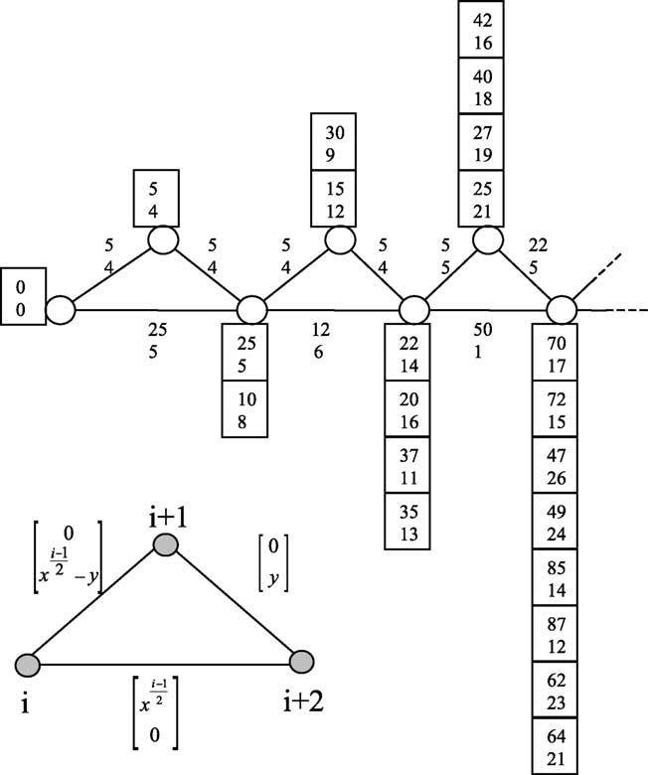
P. Van Mieghem, F.A. Kuipers / Computer Communications 26 (2003) 376–387

First, the Internet suffers from a routing legacy. Whereas the
intradomain link state protocols (e.g. OSPF) could be
upgraded relatively easy if, as in PNNI, a consistent
topology and link weight vector update strategy existed,
the situation for the interdomain routing protocols (e.g.
BGP-4 and updates) is more problematic. Mainly the
chaotic and unstandardized way in which peering agree-
ments are signed makes current end-to-end (QoS) routing
opaque and inefﬁcient. Recent measurements [7] of the end-
to-end delay show that the length of the end-to-end path can
be several times (even an order of magnitude) longer than
the shortest possible distance. Further, the average number
of hops in the Internet [19] is about 15 while telephony
operates with only half that number. Hence, there is room
for improvements on the interdomain level! However, even
if the interdomain routing would have been solved, the
connectionless or hop-by-hop paradigm in Internet implies
that QoS routing needs an exact algorithm (and concepts of
active networking) as proved in Ref. [21].
The need for an exact routing algorithm brings us
from the protocol to the algorithm, which is the focal
point of this paper. The difﬁculty does not lie in the
existence of an exact QoS algorithm—we have proposed
SAMCRA (Section 2)—but in its complexity. For some

377

time already, it is known [12,23] that QoS routing with
additive link weights is an NP-complete problem¹which
is interpreted, in practice, as unfeasible. Hence, only
approximations (heuristics) with polynomial time com-
plexity of the QoS algorithm are considered feasible.
This point of view resulted in the publication of a wealth
of heuristics [17], each of them claiming some attractive
features over the others. Thus, these heuristics introduced
a blurring factor in the already complex ﬁeld of QoS
routing because, as we claim here, their need or
existence is argued as superﬂuous. Indeed, after about
5 years of extensive simulations on a huge number of
graphs (of a particular class), we have never observed
tendencies towards NP-complete behavior [11,21]. Goal
of this paper is to provide some arguments why we
believe that, for a large class of graphs (and most likely
also realistic networks), the QoS routing problem is not
NP-complete. Unfortunately, so far, for that class of
graphs we are unable to prove that SAMCRA (or
equivalent QoS routing since SAMCRA is exact²) is
not NP-complete.

1 A problem is NP-complete if it cannot be solved in polynomial time.
This means that the number of elementary computations or complexity C
grows faster than any polynomial function if the problem parameters
increase. Mathematically, let be a the basic problem parameter of problem
P. Problem P is said to be NP-complete if, for 1 . 0; C_{P}ј Oрexpр1aЮЮ as
a ! 1 for any algorithm thatsolves problem P. If at least one algorithm is
known, for which C_{P}ј Oрa¹Ю for some 1; then P is not NP-complete or is a
polynomial problem. More details can be found in Garey and Johnson [12].
2_{In}Ref. [21], it has been proved that SAMCRA is exact. However, it has
not been shown that SAMCRA is the most efﬁcient algorithm possible.
Therefore, the complexity derived from SAMCRA is strictly speaking an
upper-bound for the complexity of QoS routing.
Fig. 1. An example of a ‘chain’ topology that, when continued for large N
(dotted lines), illustrates the NP-completeness of QoS routing. The basic
ingredients for NP-completeness in this example are both the special
topology structure that regularly (in the i ю 2 nodes) forces paths to
coincide and the link weight structure that is correlated over the entire
chain.

Proving or disproving NP-completeness is known to be
notoriously difﬁcult. The fact that QoS routing is, in general,
NP-complete follows from Fig. 1: if the chain topology is
continued according to the triangular structure (bottom left),
at each node i, the path vector or sum of the link weight
vectors from left on up to node i (that are not dominated,
explained below) grows as a power of 2. This example
learns two basic features. First, NP-completeness involves a
scaling of the relevant parameters. For example, if the
number of added nodes N in the chain topology increases
without bound, the number of entries (non-dominated path
vectors) to make a QoS routing decision grows as Oр2^{N}=2_{Ю}:
Second, the cause of NP-completeness lies hidden in the
special structure of the topology and, perhaps more
important, in the speciﬁcs of the link weight vector. The
latter is seen to be correlated over the path from A (left node)
to B (node at the right). The proof that QoS routing is NP-
complete in Ref. [23] heavily relies on the correlation of the
link weight vectors. Furthermore, it sufﬁces to show that
there exists one case (a speciﬁc topology and link weight
structure) in which QoS routing is NP-complete to catalogue
QoS routing as a whole as an NP-complete problem. Both
the chain topology and the correlated link weight vectors are
unlikely to occur in realistic networks and this article

378

P. Van Mieghem, F.A. Kuipers / Computer Communications 26 (2003) 376–387

suggests that QoS routing in realistic networks may not be
NP-complete. In other words, the QoS routing problem
conﬁned to a particular class of networks (topology and link
weight structure) may not be NP-complete. We know that
there are classes of graphs that are polynomially solvable.
For example, QoS routing for the class of graphs where all
nodes have degree 2 can always be solved in polynomial
time irrespective of the link weight structure. Another
‘polynomially solvable’ case is the class of graphs where all
link weight vectors are identical. In summary, the difﬁculty
remains in determining the full (or at least a large) set of
classes for which QoS routing is not NP-complete and this
article is a ﬁrst, tiny step towards this goal.
After a brief presentation of SAMCRA [21], an exact
Self-Adaptive Multiple Constraints Routing Algorithm, in
Section 2, the complexity is studied through simulations.

2.1. The concepts behind SAMCRA

SAMCRA is the successor of TAMCRA, a Tunable
Accuracy Multiple Constraints Routing Algorithm [10,11].
As opposed to TAMCRA, SAMCRA guarantees to ﬁnd a
path within the constraints, provided such a path exists.
Furthermore, SAMCRA only allocates queue-space (mem-
ory) when truly needed, whereas in TAMCRA the allocated
queue-space is predeﬁned. The major performance criterion
for SAMCRA, namely the running-time/complexity, will be
discussed in Section 2.2. Similar to TAMCRA, SAMCRA is
based on three fundamental concepts:
(1) A non-linear measure for the path length. Motivated
by the geometry of the constraints surface in m-dimensional
space, we deﬁned the length of a path P as follows [11]:
w_{i}рPЮ

The results show that for certain classes of graphs, the
complexity of QoS routing does not seem to point towards a
lрPЮ ј max
1#i#m
L_{i}
р1Ю

NP-complete behavior. The scaling (limit of N to inﬁnity)
cannot be simulated. Therefore, the second part (Section 4)
of this paper analyses the hopcount of the shortest path in
multiple dimensions. This section is an extension to
previous work on the hopcount in the Internet [20]. The
analytic results indicate that, for the class of random graphs
with uniformly distributed link weight components, further
denoted as the RGU class, the hopcount in multiple
dimensions behaves as a single dimension routing problem
with modiﬁed link weight distribution. Hence, the combi-
nation of both results hints (unfortunately does not prove)
that, for a large class of graphs, the QoS routing problem is
not NP-complete.

2. SAMCRA: a self-adaptive multiple constraints
routing algorithm

A network topology is denoted by GрN; EЮ; where N is
the set of nodes and E is the set of links. With a slight abuse
of notation we will also denote by N and E, respectively, the
number of nodes and the number of links. A network
supporting QoS consists of link weight vectors with m non-
negative QoS measures (w_{i}рeЮ; i ј 1; …; m; e [ E) as
components. The QoS measure of a path can either be
additive in which case it is the sum of the QoS measures
along the path (such as delay, jitter, the logarithm of 1 minus
the probability of packet loss, cost of a link, etc.) or it can be
the minimum(maximum) of the QoS measures along the
path (typically, available bandwidth and policy ﬂags).
Min(max) QoS measures are treated by omitting all links
(and possibly disconnected nodes) which do not satisfy the
requested min(max) QoS constraints. We call this topology
ﬁltering. Additive QoS measures cause more difﬁculties: the
multiple constrained path (MCP) problem, deﬁned as
ﬁnding a path subject to more than one additive constraint
(L_{i}), is known to be NP-complete [12,23] and hence
considered as intractable for large networks.
where w_{i}рPЮ ј^{P}e[P^{w}i^{р}eЮ:
The deﬁnition of the path length has to be non-linear in
order to guarantee that a retrieved path lies within the
constraints, i.e. lрPЮ # 1: A solution to the MCP problem is
a path whose link weights are all within the constraints,
w_{i}рPЮ # L_{i}; for all i ј 1; …; m: SAMCRA can also be
applied to solve multiple constrained optimization pro-
blems, e.g. delay-constrained least-cost routing. Depending
on the speciﬁcs of a constrained optimization problem,
SAMCRA can be used with different length functions,
provided they obey the criteria for length in vector algebra.
Examples of length functions different from Eq. (1) are
given in Ref. [21]. In Refs. [13,15], TAMCRA-based
algorithms with speciﬁc length functions are proposed and
evaluated. By using the length function (Eq. (1)), all QoS
measures are considered as equally important. An important
corollary of a non-linear path length as Eq. (1) is that the
subsections of shortest paths in multiple dimensions are not
necessarily shortest paths. This suggests to consider in the
computation more paths than only the shortest one, leading
us naturally to the k-shortest path approach.
(2) The k-shortest path approach. The k-shortest path
algorithm [8] is essentially Dijkstra’s algorithm that does
not stop when the destination is reached, but continues until
the destination has been reached k times. If k is not
restricted, the k-shortest path algorithm returns all possible
paths between A and B. The k-shortest path approach is
applied to the intermediate nodes i on the path from source
node s to destination node d, where we keep track of
multiple sub-paths from s to i. Not all sub-paths are stored,
but an efﬁcient distinction based on non-dominance is made.
(3) The principle of non-dominated paths [14]. A (sub)-
path Q is dominated by a (sub)-path P if w_{i}рPЮ # w_{i}рQЮ for
i ј 1; …; m; with an inequality for at least one link weight
component i. SAMCRA only considers non-dominated
(sub)-paths. The principle of non-dominance enables an
efﬁcient reduction in the search-space (all paths between the
source and destination) without compromising the solution.

P. Van Mieghem, F.A. Kuipers / Computer Communications 26 (2003) 376–387

379

2.2. The complexity of SAMCRA

2.2.1. Worst-case complexity
In the graph GрN; EЮ; the queue in SAMCRA can never
contain more than kN path lengths, where k denotes the
number of non-dominated paths (within the constraints) that
are stored in the queue of a node. Because SAMCRA self-
adaptively allocates the queue-size at each node, k may
differ per node. When using a Fibonacci (or relaxed) heap to
structure the queues [9], selecting the minimum path length
among kN different path lengths takes at most a calculation
time of the order of logрkNЮ: As each node can at most be
selected k times from the queue, the extract_min function
(explained in Ref. [9]) in line 6 of SAMCRA’s meta-code
(Appendix B) takes OрkN logрkNЮ at most. The for-loop
starting on line 11 is invoked at most k times from each side
of each link in the graph. Calculating the length takes OрmЮ
when there are m metrics in the graph while verifying path
dominance takes OрkmЮ at most. Adding or replacing a path
length in the queue takes O (1). Adding the contributions
yields a worst-case complexity CSAMCRA with k ј k_{max}of

average-case complexity was ﬁrst advocated by Levin
[18]. We will now give a calculation that suggests that the
average and even amortized³complexity of SAMCRA is
polynomial in time for ﬁxed m and all weights w_{i}
independent random variables.

Lemma 1. The expected number of non-dominated vectors
in a set of T i.i.d. vectors in m dimensions is upper bounded
by рln T Ю^{m}21:

A proof of Lemma 1 can be found by adopting a similar
approach as presented by Barndorff-Nielsen and Sobel [4]
or by Bentley et al. [5]. To gain some insight into the
number of non-dominated paths in a graph, we will assume
that the path-vectors are i.i.d. vectors. When we apply
Lemma 1 to the complexity of SAMCRA, we see that, in the
worst-case, SAMCRA examines T ј beрN 2 2Ю!c paths,
leading us to an expected number of non-dominated paths
between the source and destination in the worst-case of

рln TЮ^{m}21_{ј р}lnрbeрN 2 2Ю!cЮЮ^{m}21

CSAMCRA^{ј}OрkN logрkNЮ ю k²mEЮ
р2Ю
# р1 ю рN 2 2ЮlnрN 2 2ЮЮ^{m}21

where k_{max}is an upper-bound on the number of non-
dominated paths in GрN; EЮ: A precise expression for k is
difﬁcult to ﬁnd. However, two upper-bounds can be
determined. The ﬁrst upper-bound k_{max}for k,
k_{max}ј beрN 2 2Ю!c
is an upper-bound on the total number of paths between a
source and destination in GрN; EЮ [22].
If the constraints (or link weight components) have a
ﬁnite granularity, a second upper-bound applies,
Y

Hence, the amortized complexity of SAMCRA is given by
Eq. (2) with k ј рln T Ю^{m}21_{ј р}lnрbeрN 2 2Ю!cЮЮ^{m}21; which is
polynomial in N for ﬁxed m.
In the limit m ! 1 and for w_{j}independent random
variables, all paths in GрN; EЮ are non-dominated, which
leads to the following Lemma (proved in Ref. [21]).

Lemma 2. If the m components of the link weight vectors
are independent random variables and the constraints L_{j}
are such that 0 # w_{j}=L_{j}# 1; then any path with K hops has
precisely a length (as deﬁned by Eq. (1)) equal to K in the

k_{max}ј
iј1
L_{i}
р3Ю
limit m ! 1:

max рL_{j}Ю
j
where the constraints L_{i}are expressed as an integer number
of a basic metric unit. For instance, if the ﬁnest granularity
for time measurements is 1 ms, then the constraint value for,
e.g. end-to-end delay is expressed in an integer number
times 1 ms. This bound (Eq. (3)) has been published earlier
in Ref. [11] but ﬁrst proved here in Appendix A.
Clearly, for a single constraint (m ј 1 and k ј 1), the
complexity (Eq. (2)) reduces to that of Dijkstra’s algorithm.
As mentioned above, for multiple (additive) metrics the
worst-case complexity of SAMCRA is NP-complete. The
NP-complete behavior also follows from Eq. (2) and the two
expressions for k_{max}:

2.2.2. Average-case complexity
Although there exist many problems that are NP-
complete, the average-case complexity might not be
intractable, suggesting that such an algorithm could
have a good performance in practice. The theory of
This means that for m ! 1 it sufﬁces to calculate the
minimum hop path, irrespective of the link weight
distribution of the m independent components. Since the
minimum hop problem is an instance of a single metric
shortest path problem, it has polynomial complexity. Of
course, this limit case m ! 1 mainly has theoretically
value. In realistic QoS routing, only a few link weights are
expected to occur. The number m of QoS link weights is a
design choice for the QoS routing protocol.
In summary, if the link weights are independent random
variables, there are two properties reducing the search-space
(the number of paths to be examined) of SAMCRA. For m
small the concept of non-dominance is very powerful,
resulting in the presence of only a small number of non-
dominated paths between two points in a graph. At the other
extreme, for m large, the values L_{j}of the constraints cause

3 Amortized analysis differs from average-case analysis in that
probability is not involved; an amortized analysis guarantees the average
performance of each operation in the worst-case [9].

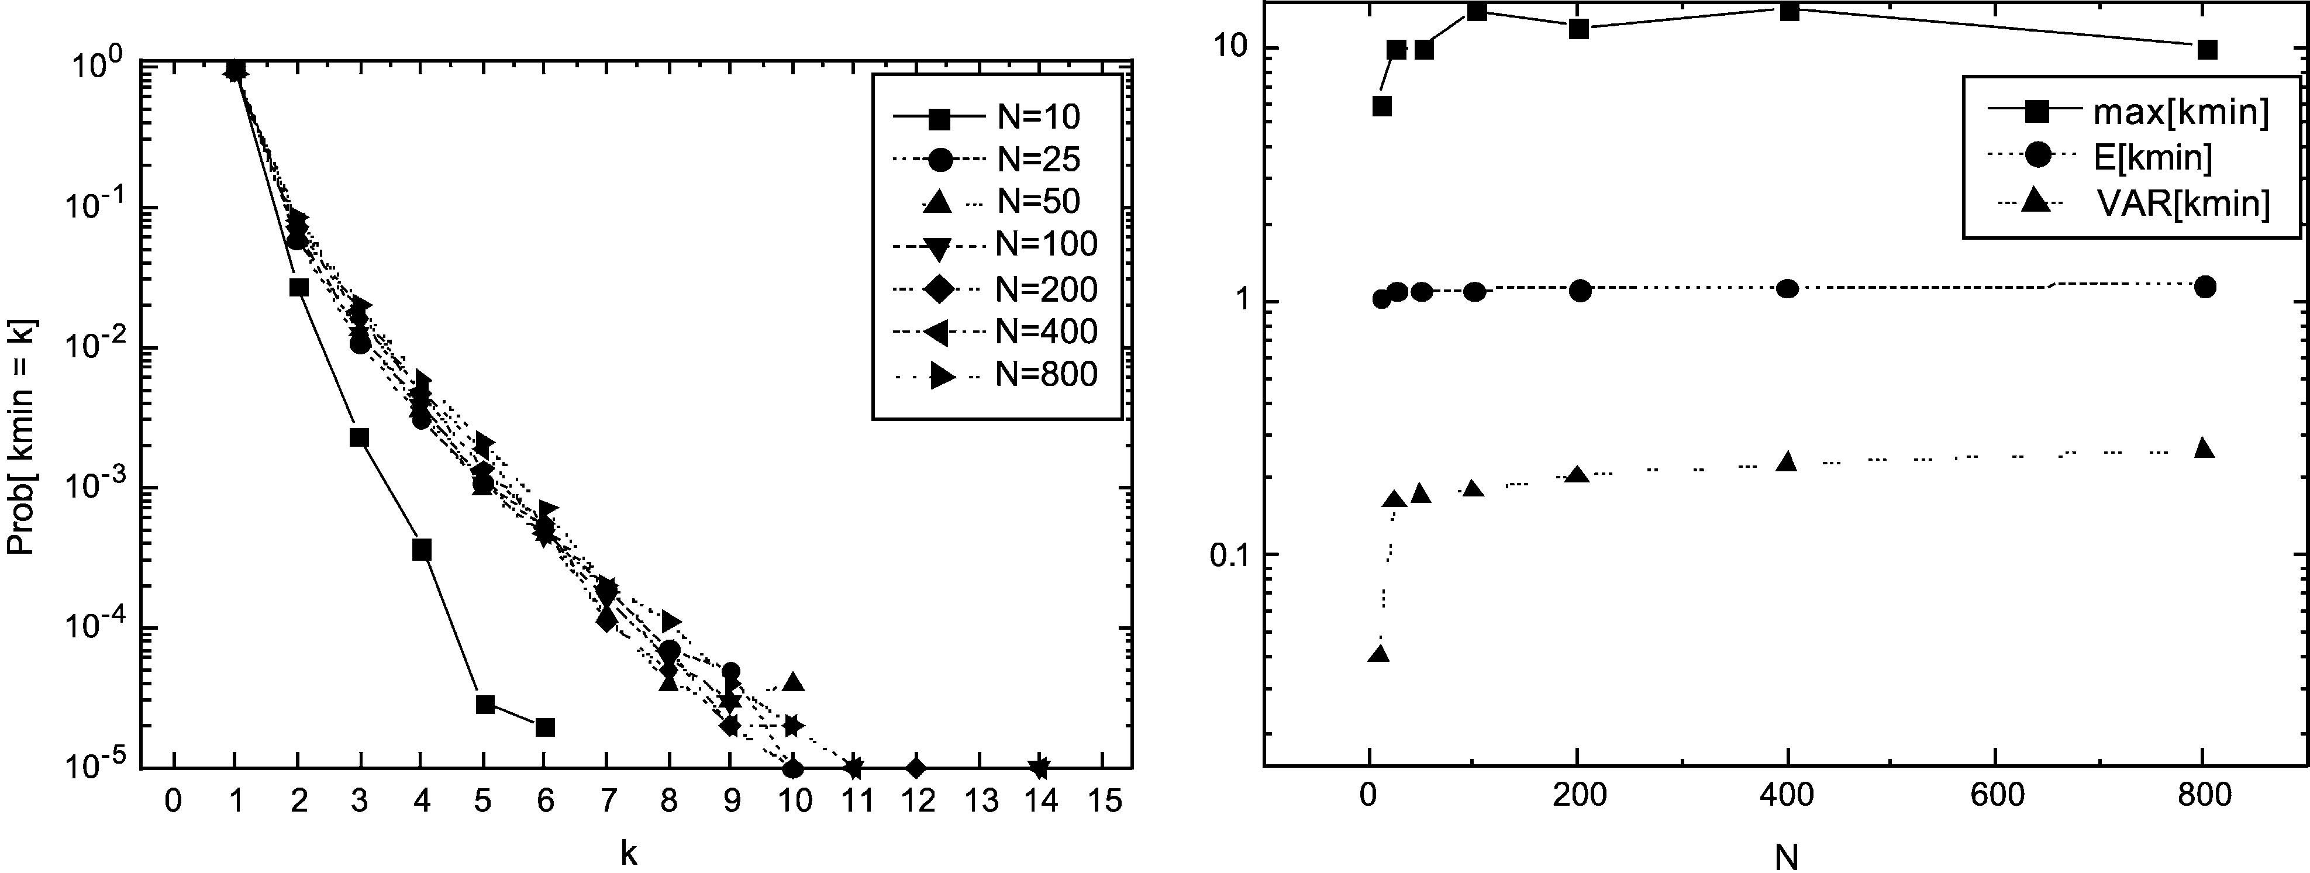
380

P. Van Mieghem, F.A. Kuipers / Computer Communications 26 (2003) 376–387

the largest search-space reduction, because only a few paths
between the source and destination lie within the con-
straints. Even if the constraints are chosen inﬁnitely large,
SAMCRA may lower them in the course of the computation
(by means of endvalue, line 25/26 meta-code) without
affecting the solution.
The two properties complement each other, resulting in
an overall good average performance of SAMCRA. The
simulation results of Section 3 indicate that the average
complexity of SAMCRA is OрN log N ю mEЮ which
follows from Eq. (2) with EЅk < 1; for the class G_{p}рNЮ of
random graphs [6], with independent uniformly distributed
link weights, further denoted by RGU.

3. Simulation results on complexity

3.1. The class RGU

The simulations were performed on random graphs of the
type G_{p}рNЮ [6]. The expected link density p also equals the
probability that there is a link between two nodes. The m
components of the link weight vector, w_{i}рeЮ; are indepen-
dent uniformly distributed random variables in the range
[0,1].
SAMCRA searches for the shortest path within the
constraints instead of just any path obeying the constraints.
Since all link weights are in the range [0,1], the highest
possible weight of a loop-free path w_{i}рPЮ is N 2 1: By
choosing all the constraints equal to N, all possible (loop-
free) paths between the source and destination will be able
to satisfy these constraints. When the goal is to ﬁnd the
shortest path within a set of constrained paths, choosing the
constraints large and hence increasing the amount of paths
that need to be evaluated, will increase the complexity of
ﬁnding the shortest path. Hence, we are simulating a worst-
case scenario by choosing the constraints equal to N.

For each simulation run, we used SAMCRA to
compute the shortest path between a source node (labeled
1) and destination node (labeled N ) for a large number
(minimum of 10⁵) of random graphs of the type G_{p}рNЮ:
For each computation we stored the hopcount and
minimum queue-size (k_{min}) needed to ﬁnd the shortest
path within the constraints. If TAMCRA had used that
particular k_{min}under the same conditions, it would have
found the same shortest path as SAMCRA did, but if a
smaller value had been used TAMCRA would not have
found the shortest path.
For all simulations in this section, we have computed the
95% conﬁdence intervals, which were all less than 0.52% of
the mean. Furthermore, we have validated our simulations
with the chain topology of Fig. 1. These simulations
conﬁrmed that, once the constraints are large enough, k_{min}
grows exponentially (as Oр2^{N}=2_{Ю}) with N. Moreover, if for
the same topology w_{i}рeЮ ј w_{i}рe^{p}Ю; for i ј 1; …; m; ;e; e^{p}[
E or if w_{i}рeЮ ј wрeЮ; for i ј 1; …; m; e [ E; then we found
that k_{min}ј 1: This shows that the link weight structure is
very important.
We will start by presenting the simulation results for
m ј 2: Fig. 2 gives the minimum queue-size (k_{min})
needed to ﬁnd the shortest path within the constraints.
Fig. 2 also gives the statistics corresponding to the
results for k_{min}:
Fig. 2 shows that an increase of N does not result in an
exponential increase in k_{min}: The expectation EЅk remains
close to 1 and hardly increases with N. If we extrapolate
these results to N ! 1; Fig. 2 suggests that for the class of
random graphs G_{p}рNЮ with 2 independent uniformly
distributed link weights, the average complexity of
SAMCRA is approximately OрN log N ю 2EЮ:
Figs. 3 and 4 show a similar behavior (EЅk < 1). The
only difference is that the worst-case values (maxЅk )
have slightly increased with m, as a result of the
increased expected number of non-dominated paths.

Fig. 2. Results for k_{min}with m ј 2:

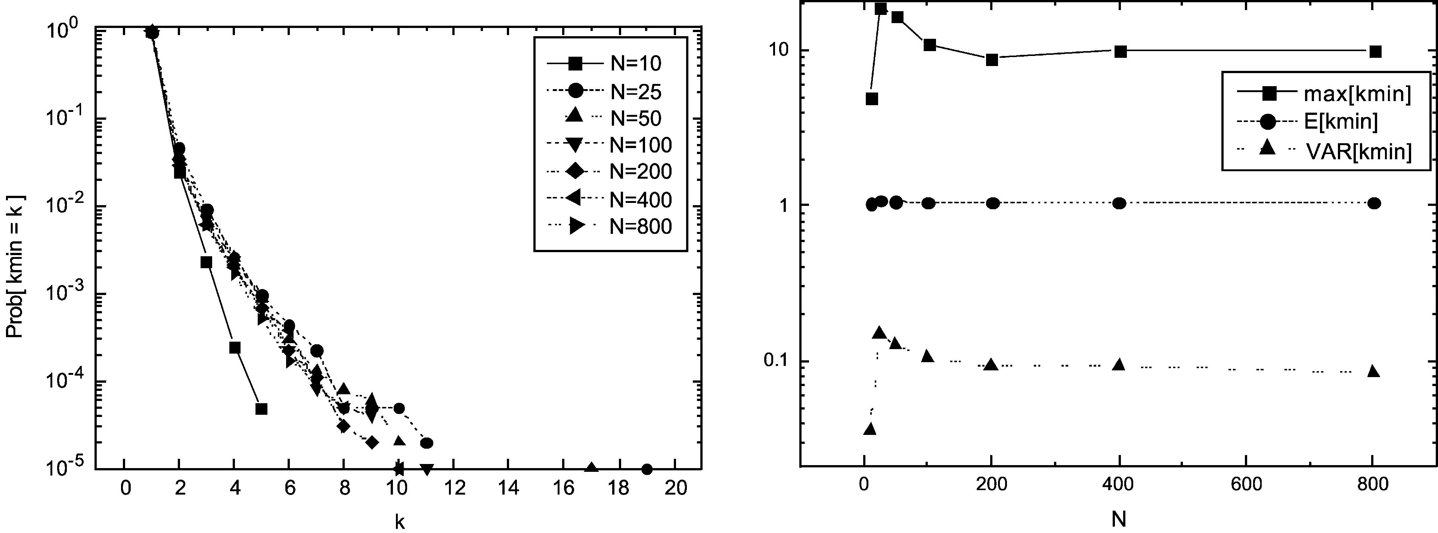
P. Van Mieghem, F.A. Kuipers / Computer Communications 26 (2003) 376–387

Fig. 3. Results for k_{min}with m ј 4:

381

However, since EЅk stays close to one, the simulation
results suggest that the two search-space-reducing con-
cepts, dominance and constraint values, are so strong that
the average complexity of SAMCRA is not signiﬁcantly
inﬂuenced by the number of metrics m. The behavior of
k_{min}as a function of the number of constraints m is
illustrated in Fig. 5.
In the previous paragraph we indicated that there are two
concepts reducing the search-space of SAMCRA. For small
m the dominant factor is the non-dominance property,
whereas for m ! 1 the constraint values are more
dominant. Because these properties are most effective in a
certain range of m’s, we expect the worst-case behavior to
occur with an m that is neither small nor large. Fig. 5 shows
the k-distribution for different values of m. The best
performance is achieved with m ј 2 and the worst
performance is for m around 8. However, as Fig. 4
illustrates, EЅk for m ј 8 is still approximately 1, leading
us to believe that for the class of random graphs G_{p}рNЮ with
independent uniformly distributed weights, the average
complexity of SAMCRA is approximately OрN log
N ю mEЮ for every m.
Our last simulation concerns the granularity of the
constraints (or link weights). When the granularity is ﬁnite,
an upper-bound, in terms of the constraints, on the number
of non-dominated paths can be found (Eq. (3)). The ﬁner the
granularity, the larger this upper-bound. Fig. 6 conﬁrms this
behavior (for N ј 20 and p ј 0:2). In practice the
constraints (or link weights) have a ﬁnite granularity,
which according to Fig. 6 will positively inﬂuence the
running-time of SAMCRA.
Because SAMCRA solves the MCP problem exactly, and
since the simulations suggest that SAMCRA’s average
complexity is polynomial for G_{p}рNЮ with independent
uniformly distributed link weights, the MCP problem for
that class RGU seems, on average, solvable in polynomial
time. The observation that EЅk < 1 indicates that, for the
sizes N considered, routing in multiple dimensions is
analogous to routing in a single dimension (m ј 1).

3.2. A two-dimensional lattice

Contrary to the class of RGU graphs, this
section is devoted to extremely regular graphs, namely

Fig. 4. Results for k_{min}with m ј 8:

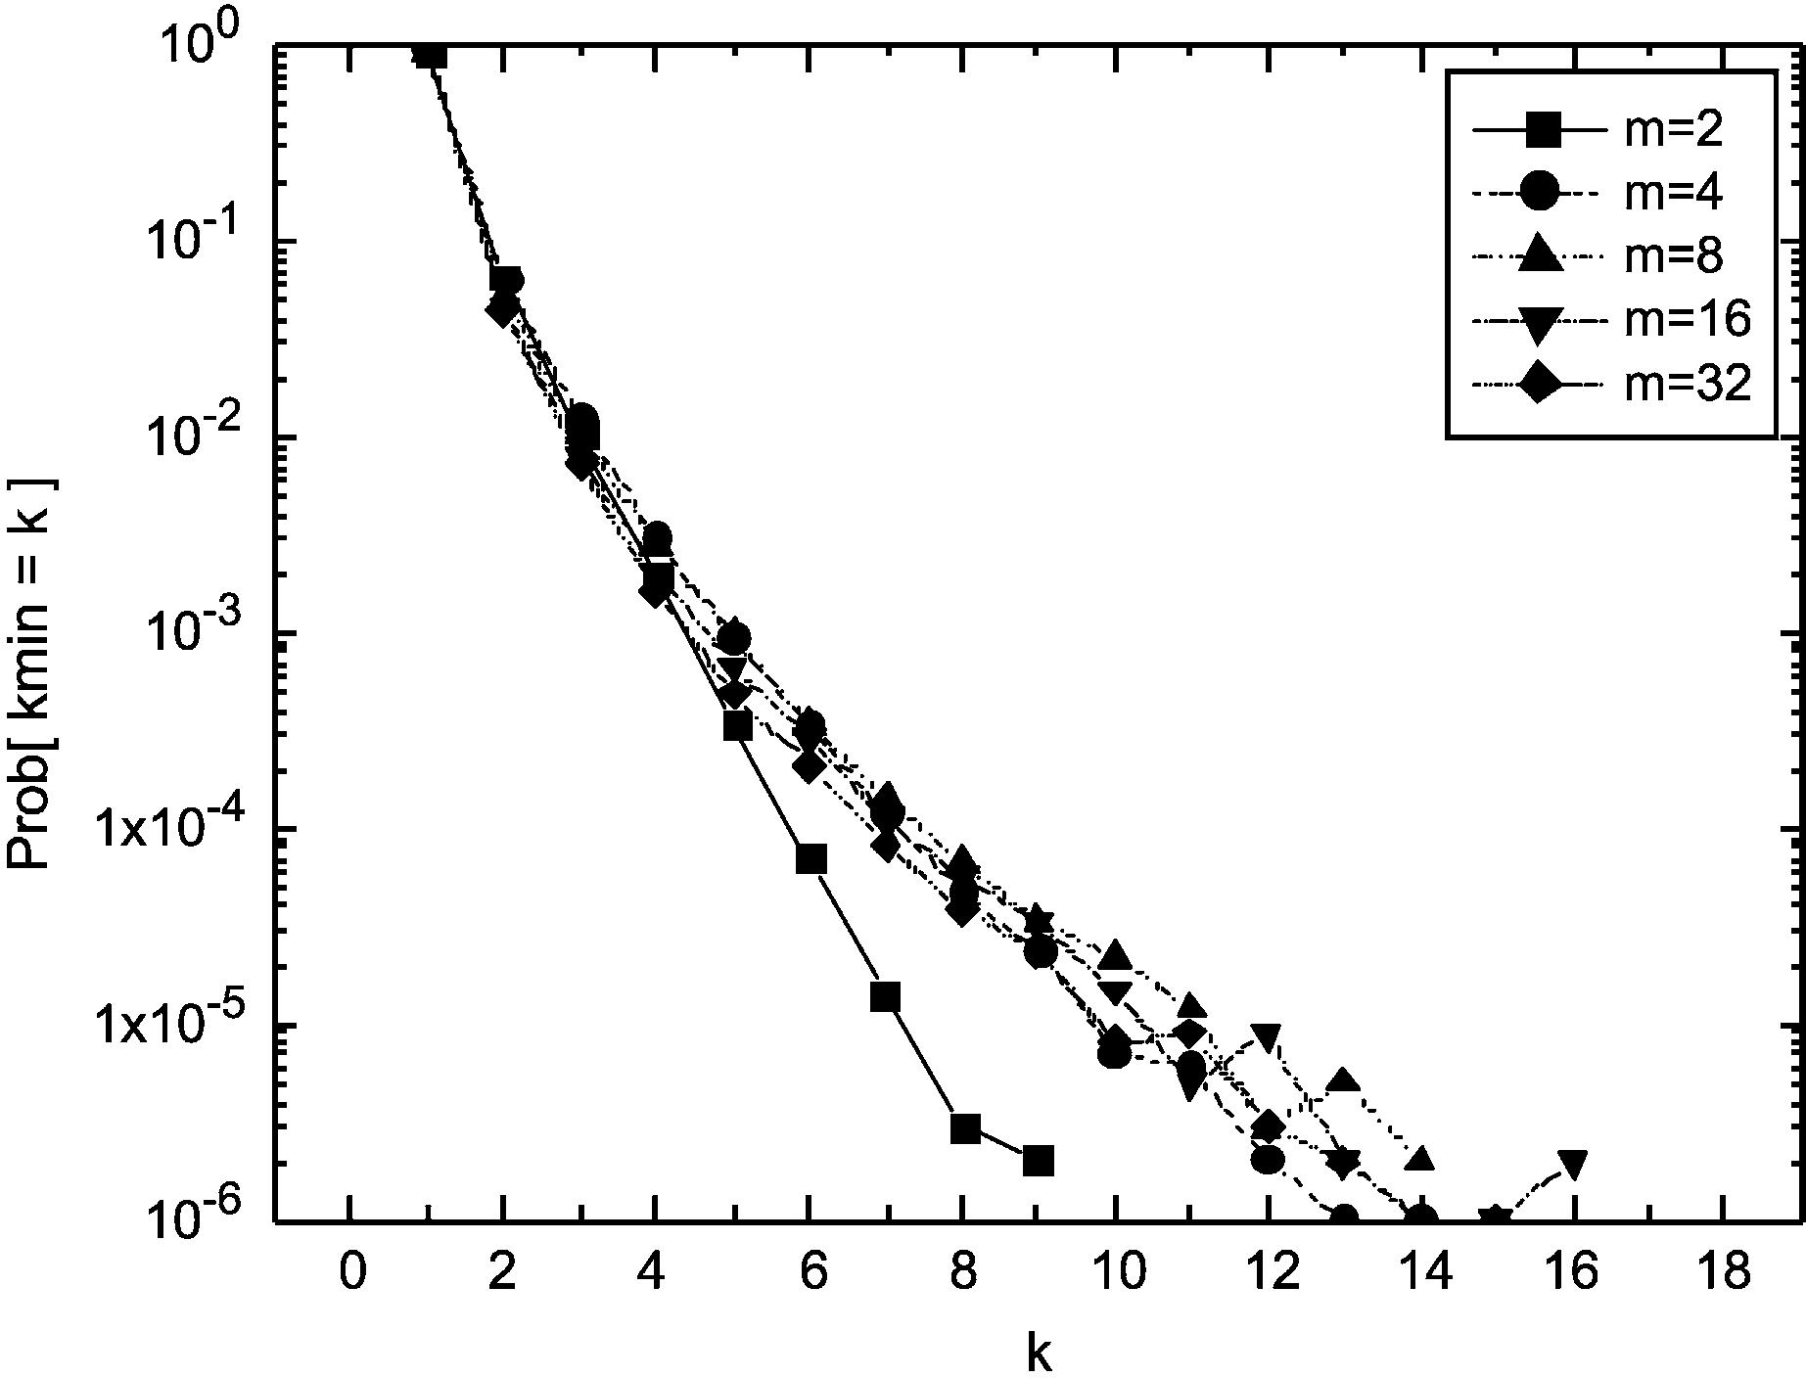
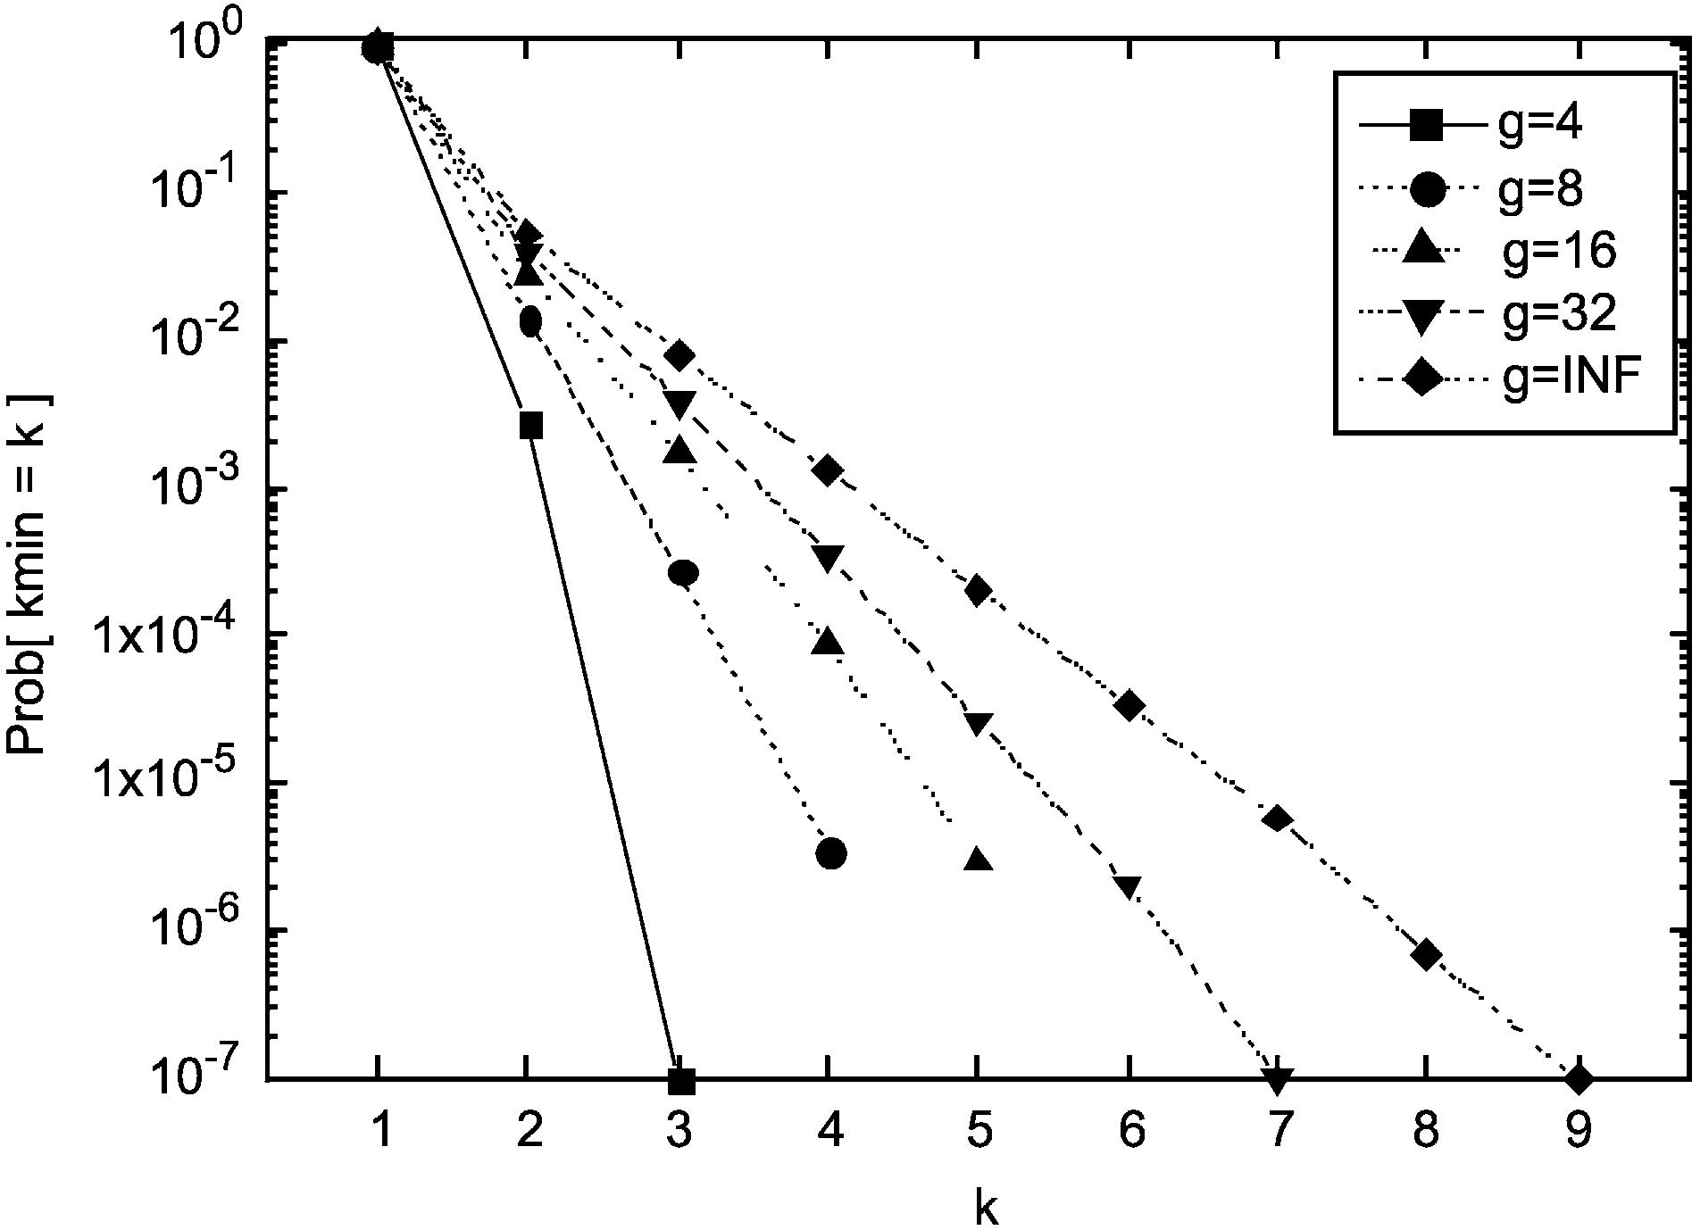
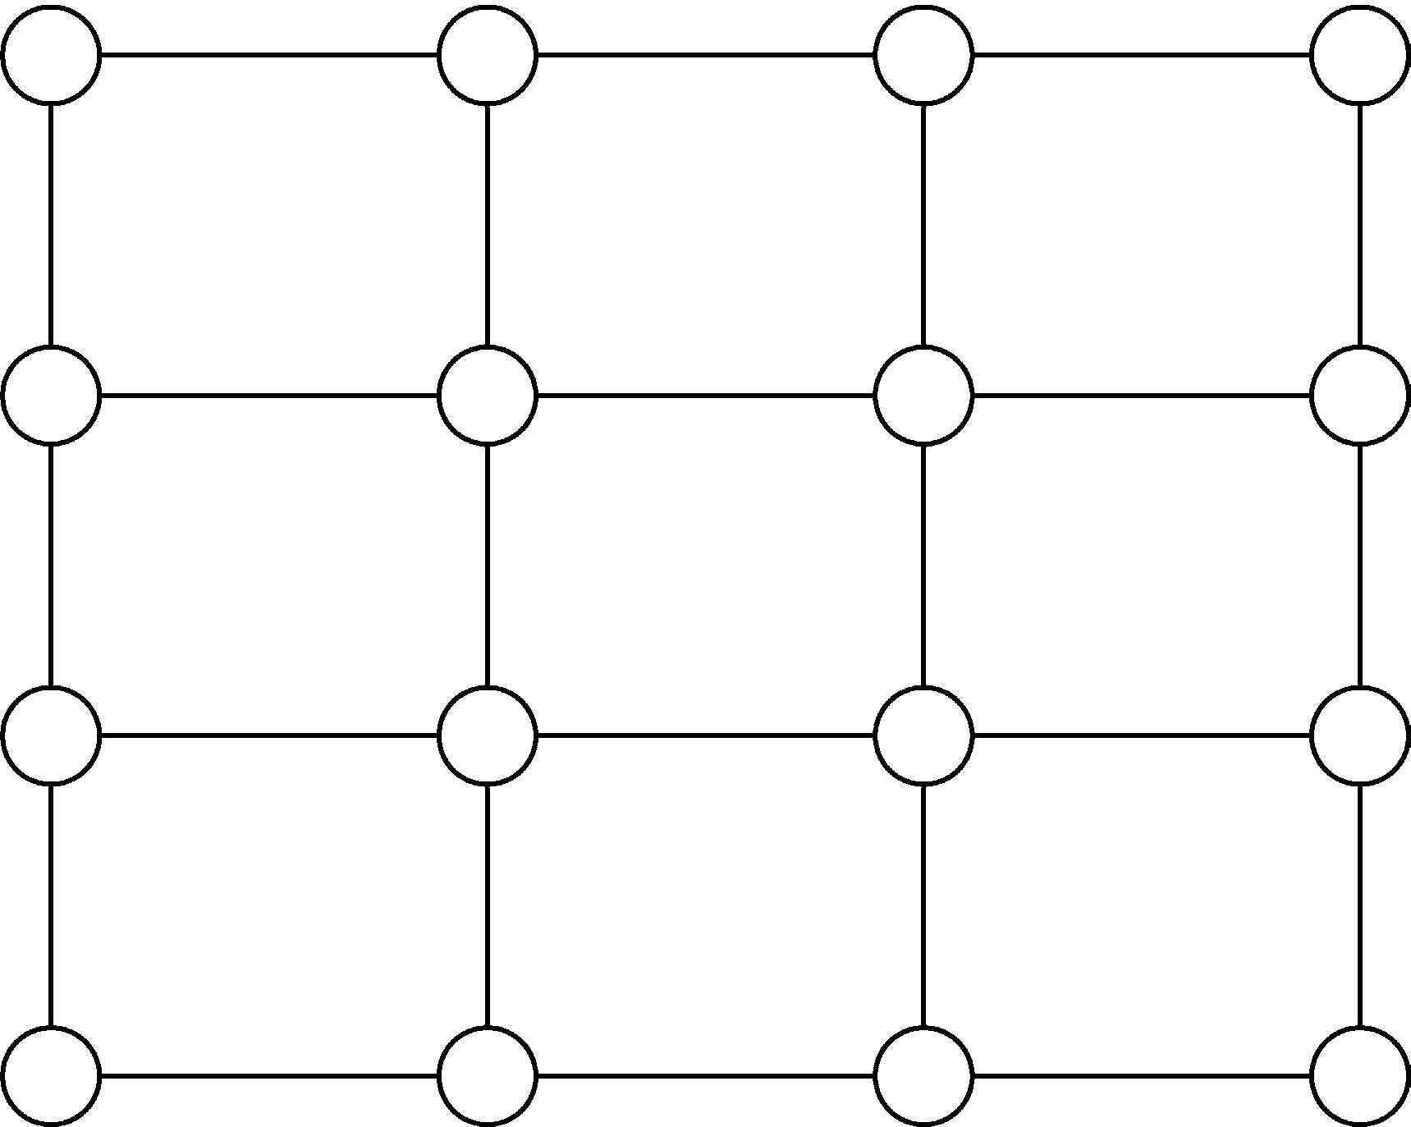
382

P. Van Mieghem, F.A. Kuipers / Computer Communications 26 (2003) 376–387

Fig. 5. P.d.f. of k_{min}; N ј 20:

two-dimensional lattices. The regular structure of Fig. 1
has inspired us to investigate the complexity of SAMCRA
in lattices. The m components of the link weight vector,
w_{i}рeЮ; remain independent uniformly distributed random
variables. We refer to the class of two-dimensional lattices
with uniformly distributed link weight vectors as 2LGU.
Fig. 7 gives an example of a two-dimensional lattice
consisting of 16 nodes: every internal node has degree 4
while nodes on the boundary have degree 3 and the 4
corner nodes have degree 2.
For our simulations we only generated square-shaped

Fig. 7. A two-dimensional lattice of 16 nodes.

maxрk_{min}Ю increases only linearly with N (in the range up
to 625 nodes). Hence, if this linear tendency can be
extrapolated to large N, we would be able to conclude that
also the class 2LGU does not cause SAMCRA’s
complexity to be NP-complete.
Fig. 9 shows the behavior of k_{min}as function of the
dimension m (at a ﬁxed size N ј 25). Up to m ј 32; the
statistics for k_{min}increase with m. For the class RGU
displayed in Fig. 5, a similar increase of k_{min}up to m ј 8
is observed, but k_{min}decreases afterwards. This decrease
is due to the constraint values, that are chosen ‘inﬁnitely’

lattices. Since the sides of this square consist of ﬃﬃﬃ_{N}nodes,
large but are reduced in the course of the path

Nﬃﬃﬃ must be an integer number. The source node is chosen in
the upper left corner and the destination node in the right
lower corner. This location of source and destination is
expected to lead to worst-case behavior for SAMCRA
because it yields the longest hop-count path. All simulations
were performed on 10⁵graphs in the class 2LGU.
Fig. 8 displays the probability distribution of k_{min}with
the most important statistical parameters. As expected,
Fig. 8 illustrates that k_{min}indeed increases faster than for
the class RGU with same size N. Fig. 8 also shows that

Fig. 6. k_{min}for different granularity.
computation to the path weight vector of an already
discovered path that obeys the constraints (see Appendix
B line 25 and 26 in SAMCRA’s meta code). The
minimum number of hops between the source and
destination is on average larger in the class 2LGU than
in the class RGU. As a result the constraint values are
reduced at a later point in the path computation and
therefore we do not see a decrease in Fig. 9 as soon as we
did in Fig. 5. In reality the constraint values will not be
chosen inﬁnitely large, leading to a smaller search-space
and consequently smaller complexity.

4. The expected hopcount EЅh_{N}for the random graph
G_{p}рNЮ

Only the class RGU is considered here. Each link is
speciﬁed by a weight vector with m independent
components possessing the same distribution function
F_{w}рxЮ ј PrЅw # x ј xª1_{Ѕ}0;1^{р}xЮ ю 1_{р}1;1Ю^{р}xЮ; a . 0 р4Ю
For this network topology, the expected hopcount EЅh_{N}or
the average number of traversed routers along a path
between two arbitrarily chosen nodes in the network will be
computed. The behavior of the expected hopcount EЅh_{N}in
multiple dimension QoS routing will be related to the single
metric case (m ј 1). That case m ј 1 has been treated

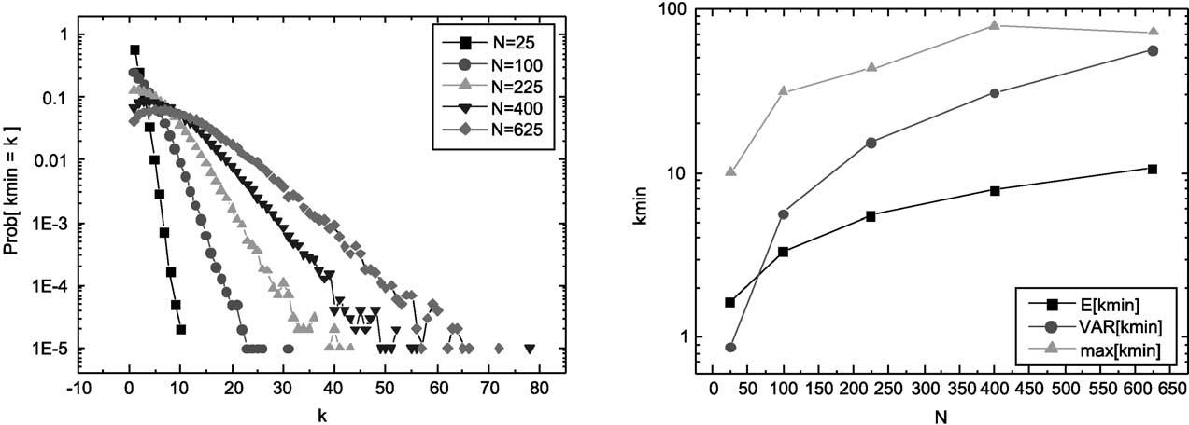
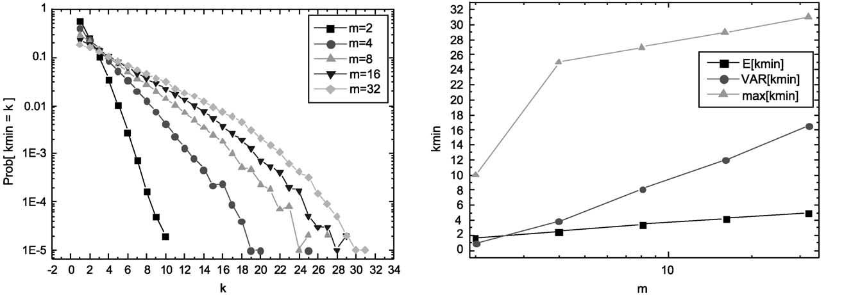
P. Van Mieghem, F.A. Kuipers / Computer Communications 26 (2003) 376–387

Fig. 8. Results for k_{min}with m ј 2 as a function of the number of nodes N.

383

previously in Ref. [19], where it has been shown, under
quite general assumptions, that
ln N
EЅh_{N},

and where F_{w}1p_{ј}F_{w}: By induction it follows from (link
weights), that for z # 0;
zak_{р}aGрaЮЮ^{k}
F_{w}kp_{р}zЮ ,

varЅh_{N},
a
ln N
a²
Gрak ю 1Ю
In multiple (m ) dimensions, SAMCRA’s deﬁnition of the
path length (Eq. (1)) requires the maximum link weight of

Lemma 2 shows that for m ! 1 in the class RGU, the
shortest path is the one with minimal hopcount. Thus the
derivation for a single weight metric in Ref. [19] for G_{p}рNЮ
with all link weights 1 is also valid for m ! 1: The ﬁrst
order (asymptotic) calculus as presented in Ref. [19] will be
extended to m $ 2 for large N. In that paper, the estimate
the individual components w_{N}рgЮ ј max_{i}ј1;…;m^{Ѕ}w_{i}рgЮ
along some path g: Since we have assumed that the
individual links weight components are i.i.d random
variables, and hence PrЅw_{N}# z ј рPrЅw_{i}# zЮ^{m}; this
implies for m-dimensions that
" #_{m}

PrЅh_{N}ј k; w_{N}# z . N^{k}21_{p}k_{F}k_{w}p_{р}zЮ
has been proved, where the distribution function F^{k}w^{p}рzЮ is
the probability that a sum of k independent random variables
each with d.f. F_{w}is at most z and is given by the k-fold
F_{w}kp_{р}zЮ ,

such that
zak_{р}aGрaЮЮ^{k}
Gрak ю 1Ю

"

zak_{р}aGрaЮЮ^{k}

#_{m}

convolution
р_{z}
PrЅh_{N}ј k; w_{N}# z . N^{k}21_{p}k
Gрak ю 1Ю

F_{w}kp_{р}zЮ ј

0
F^{р}w^{k}21Юp_{р}z 2 yЮf_{w}рyЮdy;
k $ 2
We will further conﬁne to the case a ј 1; i.e. each link
weight component is uniformly distributed over [0,1] as in

Fig. 9. Results for k_{min}with N ј 25 for different dimensions m.

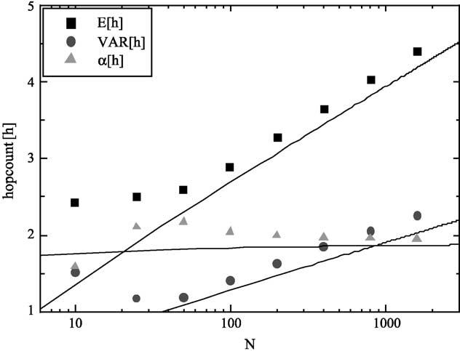
384

the class RGU

P. Van Mieghem, F.A. Kuipers / Computer Communications 26 (2003) 376–387

or
A⁰

PrЅh_{N}ј k; w_{N}# z .
1 рNpz^{m}Ю^{k}
N рk!Ю^{m}
р5Ю
EЅh_{N}, y¹=m_{ю}y
m^{р}yЮ
A_{m}рyЮ
р13Ю

For a typical value of z, the probabilities in Eq. (5) should
Using Eq. (12) in Eq. (13), we arrive at

sum to 1
EЅh_{N}, y¹=m₂
1

2
1 2
1
m
р14Ю

1 ј
1
X 1_{р}Npz^{m}Ю^{k}
where y is a solution of V_{m}рyЮ , N: As shown in Ref. [16],

N
kј1
рk!Юm
the solution y is

At last, for a typical value of z, PrЅw_{N}# z is close to unity
resulting in

y ,
ln N
m
m
ю^{ln}N
m
m21

PrЅh_{N}ј k; w_{N}# z . PrЅh_{N}ј k
Ј¹рm 2 1Юlnрln NЮ ю Q ю Oрlnрln NЮln^{m}22_{N}Ю:

Let us denote with y ј Npz^{m};
2
Introduced into Eq. (14), the average hopcount follows as

S_{m}рyЮ ј
X 1
kј0
y^{k}
рk!Ю^{m}
р6Ю

EЅh_{N},
ln N_{ю}1
m 2

1 2
1
m

lnрln NЮ ю
ln m
2m
р

2
1
2

subject to
N ю 1 ј S_{m}рyЮ

р7Ю
1 2
1
m
ln
m
2p
ю 1 ю O^{ln}ln NЮ
ln N
р15Ю

Hence, the typical value y of the end-to-end link weight that
obeys Eq. (7) is independent on the link density p for large
N. Also the average hopcount and the variance can be
written in function of S_{m}рyЮ as
y
This formula indicates that, to a ﬁrst order, m ј a: The
simulations (Figs. 10 and 11) show that, for higher values of
m, the expectation of the hopcount tends slower to the
asymptotic EЅh_{N}-regime given by Eq. (15).
For the computation of the variance, we conﬁne
ourselves to the case m ј 2; for which

EЅh_{N} ј
N
S0
myЮ
р8Ю
X

varЅh_{N} ј
1
N
"
y²S⁰⁰m^{р}yЮ ю yS⁰m^{р}yЮ 2
y2
N
рS⁰m^{р}yЮЮ²
#
р9Ю
V₂рyЮ ј

kј0
y^{k}=рk!Ю²ј I₀р2^{p}ﬃ_{y}Ю

We will ﬁrst compute good order approximations for EЅh_{N}
in the general case and only varЅh_{N}and the ratio a ј
EЅh_{N}=varЅh_{N}in case m ј 2: Let us further concentrate on
X
where I₀рzЮ denotes the modiﬁed Bessel function of order
zero [1, Section 9.6]. The variance of the hopcount from Eq.
(9) with
d2_{I}0^{р}2^{p}ﬃ_{y}Ю_{ј}I₀р₂pﬃ_{y}Ю₂I₁р2^{p}ﬃ_{y}Ю
S⁰⁰m^{р}yЮ ј

V_{m}рyЮ ј

kј0
y^{k}
рk!Ю^{m}
р10Ю
dy²
y
y^{p}ﬃ_{y}

Clearly, V_{m}рyЮ ј lim_{N}!1 S_{m}рyЮ: It is shown in Ref. [16,
Appendix] that

V_{m}рyЮ , A_{m}рyЮexpЅmy¹=m
with
р2pЮ^{р}12mЮ=2
р11Ю

A_{m}рyЮ ј
p_{m}ﬃﬃﬃ y²1=2р12р1=mЮЮ
р12Ю

After taking the logarithmic derivative of Eq. (11), we
obtain
A⁰

V⁰m^{р}yЮ , V_{m}рyЮ
m^{р}yЮ
A_{m}рyЮ
ю y^{р}1=mЮ21

In view of Eq. (7), y is a solution of V_{m}рyЮ , N; such that the
average (Eq. (8)) becomes

Fig. 10. The average EЅhN;2;the variance varЅhN;2 and the ratio a ј

EЅh_{N},
y
N
V⁰m^{р}yЮ ,
V_{m}рyЮ
N
y
A⁰m^{р}yЮ
A_{m}рyЮ
ю y¹=m
EЅhN;2⁼varЅhN;2 of the shortest path found by SAMCRA, as a function of
the size of the random graph N with two link metrices (m ј 2). The full
lines are the theoretical asymptotics.

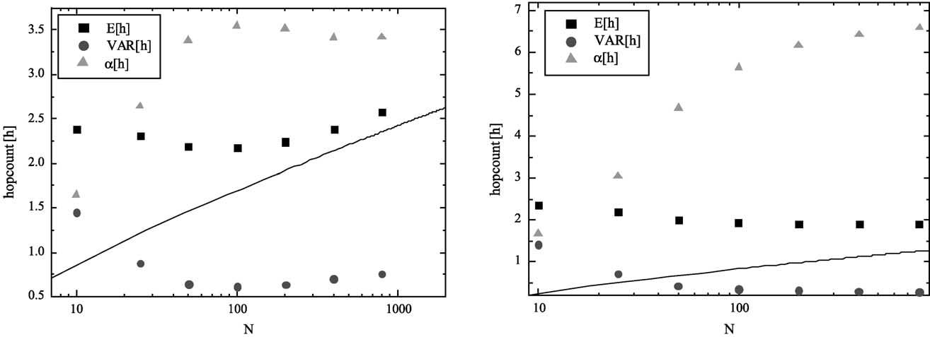

pﬃ

P. Van Mieghem, F.A. Kuipers / Computer Communications 26 (2003) 376–387

Fig. 11. Hopcount statistics for m ј 4 (left) and m ј 8 (right).

385

varЅh_{N};2,
y
N
I₀р2^{p}ﬃ_{y}Ю 2
y_{I}1^{р}2^{p}ﬃ_{y}Ю ю EЅh_{N};2²рEЅh_{N};2^{Ю}2
N
m ј 2 dimensions scales with N in a similar fashion as the
same quantities in G_{p}рNЮ with a single link weight, but
polynomially distributed with F_{w}Ѕw # x ј x²:

, y 2 рEЅh_{N};2^{Ю}2
At this point, we must take the difference between I₀рxЮ and
I₁рxЮ into account otherwise we end up with varЅh_{N}, 0:
For large x
ex
I₀рxЮ , pﬃﬃﬃﬃ₂px¹ю₈1_{x}ю Oрx²2_{Ю}
and
ex
I₁рxЮ , pﬃﬃﬃﬃ₂px¹2₈3_{x}ю Oрx²2_{Ю}
such that
1
I₁рxЮ , I₀рxЮ 1 2 ю Oрx²2_{Ю}
In summary, the asymptotic analysis reveals that, for the
class RGU, the hopcount in m dimensions behaves similarly
as in the random graph G_{p}рNЮ in m ј 1 dimension with
polynomially distributed link weights speciﬁed via Eq. (4)
where the polynomial degree a is precisely equal to the
dimension m. This result, independent of the simulations of
the complexity of SAMCRA, suggests a transformation of
shortest path properties in multiple dimensions to the single
parameter routing case, especially when the link weight
components are independent. As argued in Ref. [19], the
dependence of the hopcount on a particular topology is less
sensitive than on the link weight structure, which this
analysis supports.

EЅh_{N};2,

y
N
2x
I₁р2^{p}ﬃ_{y}Ю p¹ﬃ_{y}
р
2^{p}ﬃ_{y}Ю
5. Conclusions

Since constrained-based routing is an essential building
block for a future QoS-aware network architecture, we have

,^{I}0
p_{y}ﬃ₂1_{ю}Oрy²1_{Ю}
proposed a multiple constraints, exact routing algorithm

N
р
р
4
called SAMCRA. Although the worst-case complexity is

Thus
,^{ln}NЮ_{ю}ln lnрNЮЮ
2 4
2
1_{ю}O¹
4 lnрNЮ

!
р16Ю
NP-complete (which is inherent to the fact that the multiple
constraints problem is NP-complete), when the link weight
vectors are i.i.d. vectors the average complexity in the
worst-case is polynomial. A large amount of simulations on

varЅh_{N};2,y 2^{p}ﬃ_{y}2¹
2
ј
p_{y}ﬃ
2
1
ю O p¹ﬃ
р17Ю
random graphs with independent link weight components

and

a ј

EЅh_{N};2
4

, 2 2¹
2

р
16
seem to suggest that the worst-case complexity is poly-
nomial for this class of graphs and that the average-case
complexity is similar to the complexity in the single
parameter case. Simulations on a different class of graphs,

varЅh_{N};2
p₂ﬃ
, 2 2₄pﬃﬃﬃﬃﬃﬃ_{ln}N^{ю}O
4^{p ю}ﬃ_{y}O
1
lnрNЮ
y²1_{Ю}
namely the regular two-dimensional lattice graphs with
uniformly distributed link weights display, as expected, a
higher computational complexity. However, also these
simulations suggest a polynomial complexity in the worst

This corresponds well with the simulations shown in Fig. 9.
In addition, the average and variance of the hopcount for
case. For the considered classes, the MCP problem thus
seems tractable.

386

P. Van Mieghem, F.A. Kuipers / Computer Communications 26 (2003) 376–387

The second part of this paper was devoted the study of
the hopcount in multiple dimensions as in QoS-aware
networks. For random graphs of the class RGU, a general
formula for the expected hopcount in m dimensions has
been derived and only extended to the variance varЅh_{N}as
well in m ј 2 dimensions, in order to compute the variance
and the ratio of the expected hopcount and its variance. To
ﬁrst order, with the network size N q m large enough, the
expected hopcount behaves asymptotically similar as the
expected hopcount in m ј 1 dimension with a polynomial

Theorem 1. The number of non-dominated paths within the
constraints cannot exceed Eq. (3).

Proof. Without loss of generality we assume that L₁#
L₂# · · · # L_{m}such that Eq. (3) reduces to k_{max}ј^{Q}m_{i}ј²1¹L_{i}:
First, if m ј 1; there is only one shortest and non-dominated
(according to Ad deﬁnition 1) path possible within the
constraint L₁: This case reduces to single parameter shortest
path routing with k_{max}ј 1:
For m $ 2; the maximum number of distinct paths⁴is
Q_{m}

distribution function (xª1_{Ѕ}0;1^{р}xЮ ю 1_{р}1;1Ю^{р}xЮ) and polynomial
degree a ј m:
Both the complexity analysis and the hopcount compu-
tation suggests that for special classes of networks, among
which random graphs of the class RGU in m dimensions, the
QoS routing problem exhibits features similar to the one
dimensional (single parameter) case. The complexity
analysis suggested this correspondence for small N, whereas
the asymptotic analysis for the hopcount revealed the
connection for N ! 1: We showed that there are indeed
classes of graphs for which the MCP problem is not NP-
iј1^{L}i:Two paths P₁and P₂do not dominate each other if,
for at least two different link weight components 1 # a –
b # m holds that w_{a}рP₁Ю , w_{a}рP₂Ю and w_{b}рP₁Ю . w_{b}рP₂Ю:
This deﬁnition implies that, for any couple of non-
dominated paths P₁and P₂; at least two components of
the m-dimensional vector ~рP₁Ю must be different from
~рP₂Ю: Equivalently, if we consider a (m 2 1)-dimensional
subvector ~ by discarding the jth component in ~ ; at least
one component of ~рP₁Ю must differ from ~рP₂Ю: The
Q | maximum number of different subvectors~equals  m
Q_{m}iј1;i–j^{L}i:If j – m such that L_{j}, L_{m}; within the

complete. The problem is to determine the full set of classes
of graphs which posses a polynomial, rather than non-
polynomial worst case complexity. Further, what is the
inﬂuence of the correlation structure between the link
weight components because Lemma 1 and the simulations
suggest that independence of these link weight components
seems to destroy NP-completeness. Moreover, we notice
that the proof presented in Ref. [23] strongly relies on the
choice of the link weights. At last, if our claims about
the NP-completeness would be correct, how large is then the
class of networks that really lead to an NP-complete
behavior of the MCP problem? In view of the large amount
of simulations performed over several years by now, it
seems that this last class fortunately must be small, which
suggests that, in practice, the QoS-routing problems may
turn out to be feasible.

Appendix A. Proof of Eq. (3) for k_{max}

Recall that all weight components have a ﬁnite
granularity, which implies that they are expressed in an
integer number times a basic unit.

Deﬁnition 1. Non-dominance. A path P is called non-
dominated if there does not exist a path P^{p}for which
w_{i}рP^{p}Ю # w_{i}рPЮ; ;i and ’j : w_{j}рP^{p}Ю , w_{j}рPЮ:

Ad deﬁnition 1. If there are two or more different paths
between the same pair of nodes that have an identical weight
vector, only one of these paths sufﬁces. In the sequel we will
therefore extend Deﬁnition 1 to denote one path out of the
set of equal weight vector paths as being non-dominated and
regard the others as dominated paths.
iј1;i–j^{L}i possibilities, there are paths for which only the
jth and/or mth component differ while all the other
components are equal. In order for these paths not to
dominate each other, the jth and mth component must satisfy
the condition that if w_{m}рP₁Ю . w_{m}рP₂Ю; then w_{j}рP₁Ю ,
w_{j}рP₂Ю or vice versa. For the mth component, there are L_{m}
different paths for which w_{m}рP₁Ю ј L_{m}. w_{m}рP₂Ю ј L_{m}2
1 . · · · . w_{m}рP_{L}m^{Ю ј}1: Since L_{j}, L_{m}; there are only L_{j}
paths for which w_{j}рP₁Ю ј 1 , w_{j}рP₂Ю ј 2 , · · · ,
w_{j}рP_{L}j^{Ю ј}L_{j}: Therefore, there are paths P₁and P₂for
which w_{m}рP₁Ю . w_{m}рP₂Ю; but w_{j}рP₁Ю ј w_{j}рP₂Ю: Hence, only
L_{j}instead of L_{m}non-dominated paths are possible, leading
to a total of L_{j}=L_{m}Q_{m}iј1;i–j^{L}i^{ј}Q_{m}iј²1¹L_{i}non-dominated
paths. This proofs the upper-bound k_{max}ј^{Q}m_{i}ј²1¹L_{i}: A
Corollary 1. Eq. (3) is strict.
Proof. Without loss of generality assume that L₁# L₂#
· · · # L_{m}: We will show that there exist sequences
{L₁; L₂; …; L_{m}} for which the bound (Eq. (3)) is achieved.
If for each pair of paths P_{i}; P_{j}the mth link weight compo-
nent obey

X 1
w_{m}рP_{i}Ю $ w_{m}рP_{j}Ю ю рw_{k}рP_{j}Ю 2 w_{k}рP_{i}ЮЮ рA1Ю
kј1

then Eq. (3) is a strict, attainable bound.
Formula (A1) is found by recursively applying the
following prerequisite recalling that the smallest difference
between two weight components is one unit. If for two paths
P₁; P₂applies that w_{j}рP₁Ю 2 w_{j}рP₂Ю ј 1 (in units of the jth
weight component) for only one j of the ﬁrst m 2 1 metrics
and w_{i}рP₁Ю 2 w_{i}рP₂Ю ј 0 for the other 1 # i – j # m 2 1;

4 Two paths are called distinct if their path weight vectors are not
identical.

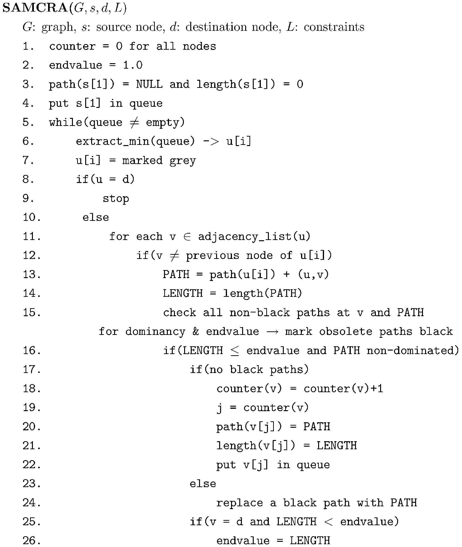
P. Van Mieghem, F.A. Kuipers / Computer Communications 26 (2003) 376–387

then for non-dominance to apply, the mth weight com- References
ponents must satisfy w_{m}рP₁Ю 2 w_{m}рP₂Ю # 21: If Eq. (A1) is

387

not obeyed, then w_{m}рP₁Ю . w_{m}рP₂Ю 2 1; i.e. w_{i}рP₁Ю $
w_{i}рP₂Ю for i ј 1; …; m and according to the deﬁnition of
non-dominance P₁is then dominated by P₂:
The largest possible difference between two path vectors
provides us with a lower-bound on L_{m};
X 1
L_{m}$ 1 ю рL_{i}2 1Ю
iј1
When this bound is not satisﬁed, then the number of non-
dominated paths within the constraints is smaller than
Eq. (3). A

For example, in m ј 5 dimensions, with L₁ј 1; L₂ј 2;
L₃ј 3; L₄ј 3; L₅ј 6 р$ 1 ю 1 ю 2 ю 2Ю; all 18 non-
dominated vectors are
[1] M. Abramowitz, I.A. Stegun (Eds.), Handbook of Mathematical
Functions, With Formulas, Graphs, and Mathematical Tables, Hand-
book of Mathematical Functions, With Formulas, Graphs, and
Mathematical Tables, June, Dover, New York, 1974, ISBN:
0486612724.
[2] G. Apostolopoulos, D. Williams, S. Kamat, R. Guerin, A. Orda, T.
Przygienda, QoS Routing Mechanisms and OSPF Extensions, RFC
2676, August, 1999.
[3] The ATM Forum, Private Network-to-Network Interface Speciﬁca-
tion Version 1.0 (PNNI 1.0), af-pnni-0055.000, March 1996.
[4] O. Barndorff-Nielsen, M. Sobel, On the distribution of the number of
admissible points in a vector random sample, Theory of Probability
and its Applications 11 (2) (1966).
[5] J.L. Bentley, H.T. Kung, M. Schkolnick, C.D. Thompson, On the
average number of maxima in a set of vectors and applications,
Journal of ACM 25 (4) (1978) 536 – 543.
[6] B. Bollobas, Random Graphs, Academic Press, London, 1985.
[7] C.J. Bovy, H.T. Mertodimedjo, G. Hooghiemstra, H. Uijterwaal,
P. Van Mieghem, Analysis of end-to-end delay measurements in
Internet. Proceedings of Passive and Active Measurement (PAM

1
1
1
1
6
1
1
1
2
5
1
1
1
3
4
1
1
2
1
5
1
1
2
2
4
1
1
2
3
3
1
1
3
1
4
1
1
3
2
3
1
1
3
3
2
1
2
1
1
5
1
2
1
2
4
1
2
1
3
3
1
2
2
1
4
1
2
2
2
3
1
2
2
3
2
1
2
3
1
3
1
2
3
2
2
1
2
3
3
1
2002) Fort Collins USA March 25 – 27, pp. 26 – 33.
[8] E.I. Chong, S. Maddila, S. Morley, On ﬁnding single-source single-
destination k shortest paths, Journal of Computing and Information
(1995) 40 – 47. special issue ICCI’95.
[9] T.H. Cormen, C.E. Leiserson, R.L. Rivest, Introduction to Algor-
ithms, The MIT Press, Cambridge, 2000.
[10] H. De Neve, P. Van Mieghem, A Multiple Quality of Service Routing
Algorithm for PNNI, IEEE ATM Workshop, Fairfax, May 26 – 29,
1998, pp. 324 – 328.
[11] H. De Neve, P. Van Mieghem, TAMCRA: a tunable accuracy
multiple constraints routing algorithm, Computer Communications 23
(2000) 667 – 679.

Appendix B. SAMCRA’s meta-code

For a detailed explanation of this meta-code, we refer to
Ref. [21].
[12] M.R. Garey, D.S. Johnson, Computers and Intractability: a Guide to
the Theory of NP-Completeness, Freeman, San Francisco, 1979.
[13] L. Guo, I. Matta, Search Space Reduction in QoS Routing,
Proceedings of the 19th International Conference on Distributed
Computing Systems, vol. 3, 1999, pp. 142 – 149.
[14] M.I. Henig, The shortest path problem with two objective functions,
European Journal of Operational Research 25 (1985) 281 – 291.
[15] K. Korkmaz, M. Krunz, Multi-constrained optimal path selection,
IEEE INFOCOM (2001).
[16] F.A. Kuipers, P. Van Mieghem, QoS Routing: average complexity and
hopcount in m dimensions, in: M. Smirnov, J. Crowcroft, J. Roberts, F.
Boavida (Eds.), Proceedings of Second International Workshop on
Quality of Future Internet Services, QofIS 2001,Coimbra, Portugal,
September 24 – 26, Springer, Berlin, 2001, pp. 110 – 126.
[17] F.A. Kuipers, T. Korkmaz, M. Krunz, P. Van Mieghem, Overview of
constraint-based path selection algorithms for QoS Routing, IEEE
Communications Magazine, December 2002.
[18] L.A. Levin, Average case complete problems, SIAM Journal of
Computer 15 (1) (1986) 285 – 286.
[19] P. Van Mieghem, G. Hooghiemstra, R. van der Hofstad, A Scaling
Law for the Hopcount in Internet, Delft University of Technology,
Report 2000125, 2000, http://wwwtvs.et.tudelft.nl/people/piet/
telconference.html.
[20] P. Van Mieghem, H. De Neve, Aspects of quality of service routing,
SPIE’98, November 1 – 6, Boston, USA, 3529A-05, 1998.
[21] P. Van Mieghem, H. De Neve, F.A. Kuipers, Hop-by-Hop quality of
service routing, Computer Networks 37 (3 – 4) (2001) 407 – 423.
[22] P. Van Mieghem, Paths in the simple random graph and the Waxman
graph, Probability in the Engineering and Informational Sciences
(PEIS) 15 (2001) 535 – 555.
[23] Z. Wang, J. Crowcroft, QoS routing for supporting multimedia
applications, IEEE JSAC 14 (7) (1996) 1188 – 1234.

