



Microprocessors and Microsystems 28 (2004) 439–445

www.elsevier.com/locate/micpro

Abstract

Loop detection in MPLS for wireless sensor networks^{q}

Vasu Jollyª, Naoto Kimuraª, Shahram Latiﬁª, Pradip K Srimani^{b,}*
aDepartment of Electrical Engineering, University of Nevada, Las Vegas, NV, USA
bDepartment of Computer Science, University of Clemson, 401 Edwards, Clemson, SC 29634, USA
Received 28 August 2003; revised 26 February 2004; accepted 1 March 2004
Available online 26 March 2004

Very few technologies illustrate the fast rate of technological innovations more than wireless sensor networks. Sensor networks offer a
virtual path capability to carry differentiated services efﬁciently across the wireless backbone. In this paper, we provide a new efﬁcient
strategy for loop detection in Multi-protocol Label Switching (MPLS) for wireless networks—MPLS is a novel wireless networking topology
that can be used to provide differentiated service, trafﬁc engineering and quality of service in wireless networks.
q 2004 Elsevier B.V. All rights reserved.
Keywords: Sensor networks; Power aware protocols; DPM; SPM; Loop detection; Multi-protocol label switching

1. Loops in wireless sensor networks and MPLS

The astronomical growth of the Internet communication
offers a serious challenge for network planners in terms of
heavy user trafﬁc. The Internet core is continuously being
expanded to meet growing bandwidth demands. The growth
in bandwidth demand hinders core providers’ ability to add
infrastructure. Besides issues of resource constraints,
another concern is to signiﬁcantly transport bytes over the
backbone to provide an efﬁcient class of service for the
diverse requirements of the users, such as multimedia
applications. To manage the above addressed issue, there is
a need to either increase the bandwidth of existing circuits
or the capacity of the core routers apart from adding more
core routers. In general, network providers need to be
concerned about scalability issues, which can escalate the
ability to expand the network in all the dimensions. Multi-
protocol Label Switching (MPLS) based on Label switching
offers an ability to build highly scalable networks. The
greatest strength of MPLS is its coexistence with IP trafﬁc
and its reuse of IP routing protocols. It encapsulates the
dexterity of routing with the performance of switching
providing relevance to networks with a pure IP architecture

q
Last authors work was partially supported by an NSF award ANI-
0218495.
* Corresponding author. Tel.: ю 1-864-656-7552; fax: ю 1-864-656-0145.
E-mail address: srimani@cs.clemson.edu (P.K. Srimani).
0141-9331/$ - see front matter q 2004 Elsevier B.V. All rights reserved.
doi:10.1016/j.micpro.2004.03.011

as well as those with IP and ATM or combination of other
Layer 2 technologies.
MPLS [1,3,4,6] is rapidly emerging as an Internet
Engineering Task Force (IETF), standard intended to
enhance the speed, scalability and service providing
capabilities in the Internet. MPLS uses the technique of
packet forwarding based on labels, to enable the implemen-
tation of a simpler high-performance packet-forwarding
engine. This also de-couples packet forwarding from routing,
facilitating to provide varied routing services independent of
the packet forwarding paradigm. The evolution of this
technology in relation to other existing technologies is
tracked. In MPLS, a small ﬁxed format label is encapsulated
within each data packet on its entry into the MPLS network.
In router networks, the label is a separate, 32-bit header. In
ATM networks, the label is placed into the Virtual Path
Identiﬁer/Virtual Channel Identiﬁer cell header [7 – 10].
In the MPLS core, Label switched Routers (LSRs) read
only the label, not the network layer packet header. Labels
have only local signiﬁcance between two devices that are
involved in communication. At each hop across the
network, the routing of the data packet is based on the
value of the incoming label and eventually issued to an
outwards interface with a new label value. The path that data
traverses through a network is deﬁned by the transition in
label values, as the label is swapped at each LSR. Since the
mapping between labels is constant at each LSR, the path is
determined by the initial label value. Such a path is called

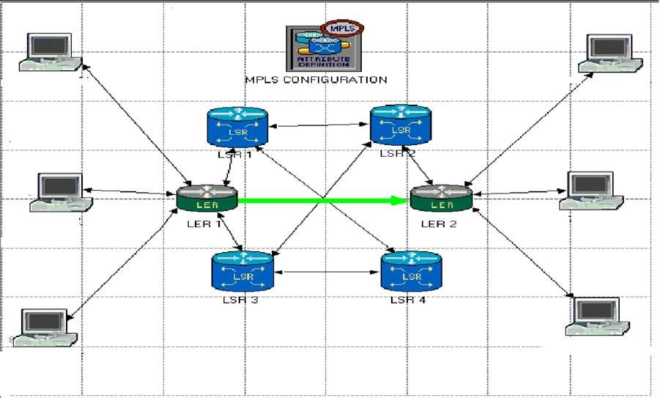

440

V. Jolly et al. / Microprocessors and Microsystems 28 (2004) 439–445

a Label Switched Path (LSP). At the ingress to an MPLS
network, each packet is examined to determine which LSP it
should use and hence what label to assign to it. Here, the IP
packets are classiﬁed based on the information carried in the
IP header of the packets and the local routing information
maintained by the LSR and a label is assigned to them. The
labels are then distributed to the neighboring LSRs, and
further associates and distributes till the egress LSR is
reached. Each LSR uses the label to forward the packet. At
each LSR the outgoing label replaces the incoming label and
the data packet is switched to the next LSR. The process of
switching the label is known as Label Swapping. The set of
all packets that are forwarded in the same way is known as a
Forwarding Equivalence Class (FEC). One or more FECs
may be mapped to a single LSP. Classiﬁcation and ﬁltering
of the information packet happen only once, at the ingress
edge. At the egress edge (output routers), labels are stripped
and packets are forwarded to their ﬁnal destination.
Fig. 1 depicts two data ﬂows from workstation 2 to
workstation 5. LSP is shown connecting LER1 and LER 2.
LER 1 is the ingress point into the MPLS network for data
from workstations 1 – 3, respectively. A packet enters the
ingress Edge LSR (LER 1) where it is processed to
determine which Layer 3 services it requires, such as QoS
and bandwidth management. Based on routing and policy
requirements, the Edge LSR selects and applies a label to
the packet header and forwards the packet. Thus, LER 1
determines the FEC for each packet, deduces the LSP to use
and adds a label to the packet. LER 1 then forwards the
packet on the appropriate interface for the LSP.
LSR 1 is an intermediate LSR in the MPLS network. It
simply takes each labeled packet it receives and reads the
label on each packet, replaces it with a new one as listed in
the table, uses the pairing {incoming interface, label value}
to decide the pairing {outgoing interface, label value} with
which to forward the packet and ﬁnally forwards the packet.
This action is repeated at all LSRs, till the time it reaches

LER 2.The incoming label and corresponding outgoing
labels are stored in a table, known as the forwarding table.
The swapping of label value and forwarding of the packet
can be performed in hardware. This allows MPLS networks
to be built on existing label switching hardware such as
ATM and Frame Relay. LER 2 acts as egress LSRs from the
MPLS network. These LSRs perform the same lookup as the
intermediate LSRs, but the {outgoing interface, label value}
pair marks the packet as exiting the LSP. The egress Edge
LSR (LER 2) strips the label, reads the packet header, and
forwards it to its ﬁnal destination using layer 3 routing. So,
if LER 1 identiﬁes all packets for ws-5 and appropriately
labels them they will be successfully forwarded through the
network. In MPLS, data transmission occurs on label-
switched paths (LSPs). LSPs are a sequence of labels at each
and every node along the path from the source to the
destination. LSPs are established either prior to data
transmission (control-driven) or upon detection of a certain
ﬂow of data (data-driven). The labels, which are underlying
protocol-speciﬁc identiﬁers, are distributed using label
distribution protocol or RSVP or piggybacked on routing
protocols like border gateway protocol and OSPF. Each data
packet encapsulates and carries the labels during their
journey from source to destination. High-speed switching of
data is possible because the ﬁxed-length labels are inserted
at the very beginning of the packet or cell and can be used by
hardware to switch packets quickly between links.
The issue of transient loops for large router networks is
currently addressed with utmost importance in MPLS
environment. The asynchronous behavior of LSRs and
Link failures in the chain of routers or hubs, sometimes
causes control path to jump into an oblivious loop behavior,
which results in an establishment of a LSP along the routing
loop, until it breaks of itself. Control packet needs to be
discarded once this behavior is detected or halted to be re-
routed from an alternate path. In MPLS scenario, since the
labels are distributed and the path for the data packets is set

Fig. 1. Workstations communicating under MPLS environment.

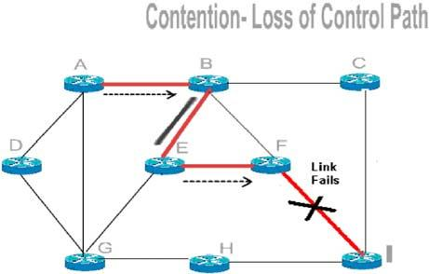
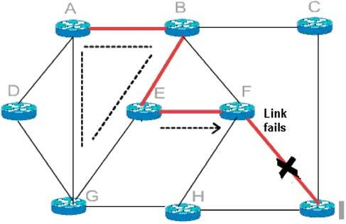

V. Jolly et al. / Microprocessors and Microsystems 28 (2004) 439–445

beforehand, the loop formation occurs at the control path.
Discussion of these issues forms a large part of the
Framework document at MPLS Work Group. Ohba [2]
addressed the problem of Loop Detection and stressed the
need to eradicate loop formation in MPLS networks.
Pertinent information about forwarding data packets needs
to be established by each node, within a network. A network
performance can remarkably degrade due to existence of an
undesirable loop. The occurrence of loop formation in
MPLS is generally a less frequent phenomenon, but needs to

441

be dealt with a higher order of precision to avoid abrupt data
losses. The loop avoidance mechanism should not be too
complex to devour the router’s computational power by
gulping the router’s memory. Rather, it should be simple
and effective.
Currently two loop prevention algorithms have been
proposed to the IETF [2], which is path-vector/diffusion
algorithm and colored thread algorithm. The mechanism for
the loop detection and prevention establishes running a
thread hop-by-hop before the labels are distributed inside
a MPLS cloud. With the passage of the each next hop, a
distributed procedure is executed within the thread mech-
anism. The present work in this paper is a brief overview of
the existing loop prevention mechanism, besides using the
global variables, instead of IP addresses for comparative
smaller network cloud. The existing loop prevention scheme
is briefed which ensures loop detection and loop mitigation
Furthermore, a suggestion of assigning the labels, while
rewinding the thread has been given, which could
substantially reduce the LSP set up time and add to the
efﬁcient thread mechanism.

2. Loop formation in MPLS

The loop formation within the nodes or routers is an
unfavorable phenomenon. With the ﬂow of data packets,
each node needs to be updated and synchronized, according
to any of the existing routing algorithm, such as shortest
path between nodes or less congested path backbone. The
inconsistency in refreshing the routing information causes
loops to get formed and data packets to move within the
loop without reaching the destination. If loop formation is
not controlled, it leads to control packet looping, where
packets used for establishing a LSP continue to be
forwarded along the routing loop until the routing loop
breaks either by itself or explicitly. Fig. 2 shows a network
with multiple paths existing from a source (S) to a
destination (D) at any given time. We use a shortest Path
algorithm, considering the distance from LSR A (source) to
LSR I (destination). In MPLS, a control path is generated
before the actual data can be transmitted. In this control
path, the task of label assignment and label distribution is
accomplished. Considering the output of this algorithm, the
path A – B – E – F – I from LSR A to LSR I is the shortest one.
This particular structure can be extended to any generalized
Fig. 2. Simple loop formation.
case in the cluster of networks, as the weight between any
two nodes is the major factor in resolving the actual shortest
path. At this point, it should be noted that the data ﬂow has
not yet taken place; it is just the label assignment, which
gets initiated. Theoretically, all the router nodes should get
refreshed simultaneously and in synchronization with real
time. Assuming that a link between LSR-F and LSR-I fails,
some data packets destined for LSR-I have already departed
from node A to F. Node F would have to send back the
control packets and has to reroute it from a different path,
which should be the shortest of all available paths. Now
LSR-F takes another short path: F – E – B – A – G – H – I.
However, LSR-B may still stick to the previous shortest
path, without knowing the failure between LSR-F and
LSR-I. In this case, LSR-B continues to send control packets
towards LSR-E and LSR-F. On the other hand, LSR E tends
to send the control packets towards LSR-B. Thus a loop gets
formed between LSR-B and LSR-E, resulting in a loss of the
control path. Though this loop occurrence is rare and
transient, it has to be removed for an efﬁcient set-up of a
label path and later the data path, which results in an
efﬁcient ﬂow of data. Furthermore, without any loop
avoidance algorithm installed, it should be noted that as
the loop gets larger and more complex, it takes more time
for the system to trace it manually and to come out of the
loop. Fig. 3 reveals a complex loop formation for the
previous network, which has the shortest control path from
LSR-A (S) to LSR-I (D): A – B – E – F – I.
If a link between LSR-F and LSR-I fails, some of the data
packets destined for LSR-I have already departed from node
A to F. In this case, the LSR’s A, B, E and F have been
refreshed and understand the failure of link F-I.
The rerouting takes place from F – E – B – A – G – H – I.

Fig. 3. Complex loop formation.

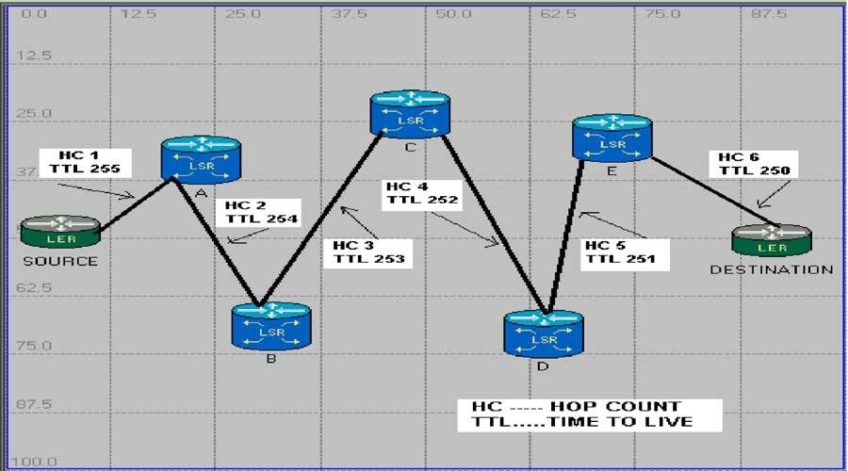

442

V. Jolly et al. / Microprocessors and Microsystems 28 (2004) 439–445

Furthermore, we assume that LSR G is not refreshed at this
time, and in its information database {LSR-G’s}, the most
optimal path from G – I is G – E – F – I. As soon as the
rerouting takes place, the control path follows F – E – B – A –
G and towards E – F – I, which results in the formation of a
complex loop G – E – B – A.

2.1. Colored thread algorithm

RFC 3063 [5] addressing Colored Thread algorithm is
categorized as an experimental standard and currently is
the part of research and experimental effort. In this
section, a mechanism for generating a thread is explained
and the basic thread actions are explained [5,6]. The
examples showing the launch and the end of threads have
been explained in the following subsections. The import-
ance of thread mechanism is addressed and its relevance
to the current loop prevention scheme is discussed in
detail.

2.2. Thread attributes

A thread is a sequence of messages used to set up an
LSP, in the ‘ordered downstream-on-demand’ (ingress-
initiated ordered control) style. There are three attributes
related to threads. They may be encoded into a single
thread object as.

2.3. Thread color

The sole purpose of assigning a color to respective
threads is to assign a unique entity to the path control
message. Since the color has to be unique in time and space,
thus ensuring the interface between the LSRs to be unique.
When the thread is allowed to pass through LSRs, these
unique colors will be assigned to each interface and the
results be stored and maintained by the nodes. It should be

noted that a thread be called transparent, when all the ﬁelds
in it, are zeroes and is reserved for stalling of thread.

COLOR ј IP ADDRESS ю UNIQUE IDENTIFIER

A 16 bit unique number is selected on the random basis,
and is allowed to be incremented by a ﬁxed interval, thus by
enabling color to be unique and ensuring that while working
with independent nodes, the same color does not get
repeated. In this method, the initial event identiﬁer is either
selected at random or assigned to be larger than the largest
event identiﬁer used on the previous system incarnation.

2.4. Thread TTL

A Time to Live (TTL) ﬁeld is added to a thread whenever
a node creates a path control message This TTL ﬁeld,
decreases with one bit of each hop. To prevent the
unnecessary looping actions in a network, the message
should not be forwarded when, TTL reaches 0. The TTL is
set by the sender to the maximum time the thread is allowed
to be in the network. If the thread is in the Internet system
longer than the TTL, then the thread must be destroyed. The
ﬁeld must be decremented by one. The time is measured in
units of seconds (i.e. the value one means 1 s). Thus, the
maximum TTL is 255 s or 4.25 min (Fig. 4).

2.5. Thread hop count

Thread hop count is the ﬁeld, which starts from a
minimum value (say 1), from the ingress node, and keeps on
increasing uniformly (by one), with each hop change When
the ingress node assigns a hop count of one to its
downstream link, it stores this value and jump to the next
LSR, and it happens for all the LSRs in the network. When a
loop is found, a special hop count value ј (0XFF) is
assigned, which should be larger than 256 (corresponding
decrementing TTL value). When the same colored thread is
received on multiple incoming links, or the same thread

Fig. 4. Hop count and time to live.

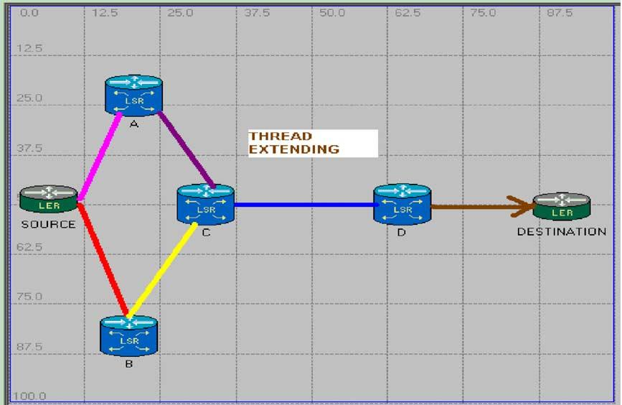

V. Jolly et al. / Microprocessors and Microsystems 28 (2004) 439–445

color was assigned to the node again, it is said that the thread 2.7. Thread merging
forms a loop. A network manager can judge whether it

443

assigned the received thread color by checking the IP
address part of the received thread color.3.5. A thread is said
to form a loop when the thread of same color is received on
an incoming link of the router. A thread creator can detect it,
by checking the IP address ﬁeld of the LSR. The basic
thread actions to prevent LSP loops include ‘thread
extending’, ‘thread rewinding’, ‘thread withdrawing’,
‘thread merging’, and ‘thread stalling’.

2.6. Thread extending

Extension of thread plays a pivotal role in color thread
algorithm [2] Before setting up a LSP and assigning the
respective labels to each LSR, a thread, needs to be
extended from the source node to the destination node. The
thread creation starts from the ingress node and ends at the
egress node. Each respective node from source until
destination creates a thread, assigns color and extends it
downstream. The color and the hop count of each thread,
becomes the color and hop count of the outgoing link. In
other words, for the ingress node, the hop count is set to be
one; the TTL ﬁeld is set to be its maximum value, 256. The
color assigned to the thread is the concatenation of the
ingress node’s IP address and a unique identiﬁer ﬁeld. It
should be noted here with utmost importance that every time
a node receives a thread and extends it downstream, it may
or may not change color of the thread. While extending a
thread, the node will change the color of thread, if the next
node is a new node and has not been assigned with any
color. This thread extends with the changing color. Color of
thread will not be changed if the next hop has already been
assigned a color in the network for a particular LSP set up
(Fig. 5).
Thread merging is merging of two or more threads to a
single outgoing link When LSR ‘L’ receives a colored
thread, and the outgoing thread from LSR ‘L’ is colored,
merging occurs. In this case LSR’L’ merges the incoming
thread, thus ensuring no message is send downstream.
Merging also takes place, if a link has more number of
incoming threads.
For a thread to be merged on LSR’L’, the following
conditions should hold true: (a) LSR’L’ should not be an
egress node, (b) outgoing Link of LSR’L’ should be colored,
(c) the hop count for outgoing thread for LSR L should be at
least one greater than the hop count of the incoming thread
to LSR L, and (d) incoming thread to Link ’L’ should be
colored.

2.8. Thread stalling, rewinding and withdrawing

When a colored thread is received, if the thread forms a
loop, the received thread color and hop count are stored on
the receiving link without being extended This is the special
case of thread merging applied only for threads forming a
loop and referred to as the ‘thread stalling’, and the
incoming link storing the stalled thread is called
‘stalled incoming link’. A distinction is made between
stalled incoming links and unstalled incoming links.
When a loop-free condition is satisﬁed and the thread
reaches the desired node (destination), an acknowledgement
needs to be passed towards the node, where the thread was
initially generated. It follows exactly the same path extend
the thread in reverse direction and thus it is called rewinding
the extended thread. Fig. 3 shows an example of thread
rewinding (Fig. 6).
While rewinding, all the parameters are set to be null. In
other words, the color of all the threads is made transparent.

Fig. 5. Thread extending.

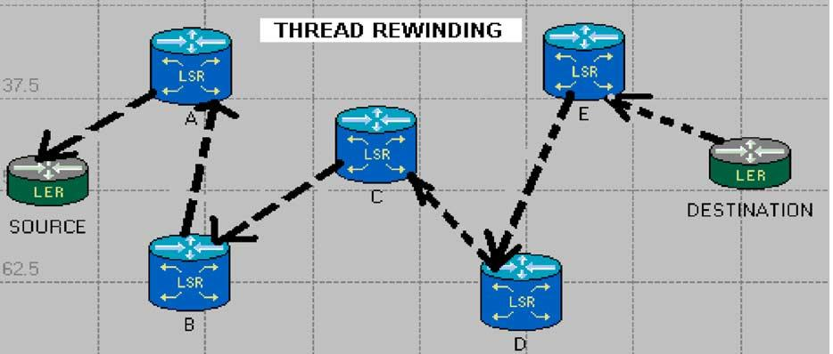

444

V. Jolly et al. / Microprocessors and Microsystems 28 (2004) 439–445

Fig. 6. Thread rewinding.

Furthermore it ensures that the network is ready to be
assigned with labels to set up a loop free LSP.
It is possible for a node to tear down a path. A node tears
down the portion of the path downstream of itself by
sending teardown messages to its next hop. This process is
known as the ‘thread withdrawing’.

2.9. Loop free condition

The loop-free condition in an MPLS network is: (a) a
colored thread is received by the egress node, OR (b) all of
the following conditions hold: A colored thread is received
by the destination node, Destination node’s outgoing link is
transparent, AND Destination node’s outgoing link hop
count is at least one greater than the hop count of the newly
received thread.
When a node rewinds a thread, which was received on a
particular link, it changes the color of that link to
transparent. If there is a link from node M to node N, and
M has extended a colored thread to N over that link, and M
determines (by receiving a message from N) that N has
rewound that thread, and then M sets the color of its
outgoing link to transparent. M then continues rewinding
the thread, and in addition, rewinds any other incoming
thread, which had been merged with the thread being
rewound, including stalled threads. Each node can start label
switching after the thread colors in all incoming and
outgoing links becomes transparent. Note that transparent
threads are threads which have already been rewound;
hence, there is no such thing as rewinding a transparent
thread.

3. Label space

Uniqueness of label is a fuzzy issue A single VPN label
may be carried across an entire network, whereas the local
label works as a physical next-hop marker. If a standard IP
based router can decide internally, where a packet needs to
be sent in order to reach a destination, then that router only
has to have one address for every router to reach it.

Per interface, labels are unique per interface, which means
each interface of an LSR has its own label space. Thus,
different interfaces of an LSR can use exactly the same
label for different bindings. Labels in the interface label
space are unique per interface; the same labels can exist in
another interface label space while platform labels are
unique over the entire router. Platform label space is also
referred to as ’global allocation pool’. Most implemen-
tations use interface label space because label assignment is
a local thing and it does not matter if the same labels exist in
different interface label spaces. Platform labels become
important in fast reroute link protection where the labels
need to be unique on the entire platform (because the label
pushed over the back up link needs to be different from the
label pushed on the primary link). Labels are always
between 1 and 1048575.

4. Applicability of algorithm

The Extended Colored threads Algorithm is applicable
for smaller networks such as Intranet subsystems for a huge
organization. Instead of IP addresses we used in the colored
thread algorithm, we can use global unique variables. RFC
3036 [6] suggests, that when there is no loop detected in a
network, the threads are rewound to the point of creation
and as they are rewound, the labels are assigned. This
proposal goes along with using less memory space within
router. By using the unique label, we are just using 2²⁰bits
for generating color, instead of 2³²bits for IP address. With
this all, the known routers within the Intranet have already
been assigned a global variable, and since labels are already
assigned after loop detection, there is no need to assign it
after the algorithm. This clearly means that if the number рnЮ
of routers is in use for setting up the LSP, then we are
reducing the total memory usage of the LSR’s by the factor
of ‘n’ thus substantially improving the efﬁciency of Intranet
structure. The algorithm has the following logical steps: (1)
per Platform Labels are assigned within the network to each
router; (2) each router knows, about each and every router
within the network; (3) a shortest path or the desired label

V. Jolly et al. / Microprocessors and Microsystems 28 (2004) 439–445

445

path is generated; (4) threads are extended; (5) colors are
assigned (color of thread will be unique within a particular
cloud); (6) loop free condition is achieved; (7) when thread
reaches the destination, it is rewound and While rewinding,
Label ﬂag is made ‘high’ (Label ﬂag ‘high’ indicates that
Label has been assigned, while the thread is rewound); and
(8) LSP is set up.
The proposed algorithm performs an efﬁcient way to
reduce the memory usage of an individual router by
handling fewer bits. Furthermore, the time taken to assign
labels for setting up the LSP is saved by assigning labels,
while rewinding threads. This work can be extended in
several directions. First, this algorithm selects a single
shortest path for the router to initiate the thread. Extensions
to this algorithm may take into account extensive node
failures, multiple links or multiple node failure, or the
computation of several backup paths to improve the
pliability of the routing path. Second, Implementation of
this algorithm on an FPGA chip, can be accomplished and
then have a sequence selected for the algorithm to use on
requirement basis, e.g. colored thread algorithm or extended
color thread algorithm. In addition, it needs to be
determined, if the techniques developed for this algorithm
for MPLS network gets its place in the Internet besides
Intranet with as less memory usage as possible ﬁnally, the
main extension to this work includes an implementation in

commercial routers and deployment in large-scale networks
for MPLS routing and trafﬁc engineering.

References

[1] I.F. Akyildiz, W. Su, Y. Sankarasubramaniam, E. Cayirci, A survey
on sensor networks, IEEE Communications Magazine 40 (8) (2002)
102 – 114.
[2] K. Scott, N. Bambos, Routing and channel assignment for low power
transmission in PCS, Universal Personal Communications (1996).
[3] V. Jolly, S. Latiﬁ, Towards an efﬁcient loop prevention mechanism,
The 2003 International Conference on Parallel and Distributed
Processing Techniques and Applications, PDPTA (2003).
[4] Development platform for self-organizing wireless sensor networks,
Proceedings SPIE, Unattended Ground Sensor Technologies and
Applications 3713, 257 – 268.
[5] Y. Ohba, Y. Katsube, E. Rosen, P. Doolan, MPLS Loop Prevention
Mechanism, IETF Networking Group, RFC 3063 (February 2001).
[6] Y. Ohba, Issues on loop prevention in MPLS networks, IEEE
Communications Magazine 37 (12) (December 1999) 64 – 68.
[7] E. Rosen, A. Viswanathan, R. Callon, Multiprotocol label switching
architecture, IETF Networking Group, RFC 3031 (January 2001).
[8] Paul Brittain Adrian Farrel, MPLS Trafﬁc Engineering: a choice of
signaling protocols, Data connection, white paper, 2000.
[9] J. Moy, Applicability Statement for OSPF Protocol overview, IETF
Networking Group, RFC 1370 (April 1998).
[10] A. Forcina, A. Luvison, F. Perardi, A strategy for ATM introduction
into public networks communications, SUPERCOMM/ICC ’90.
Conference Record 4 (1990) 1596 – 1601.

