


Computer Communications 26 (2003) 603–610

www.elsevier.com/locate/comcom

Lambda GLSP setup with QoS requirements in optical Internet

SuKyoung Lee^{a,}*, David Grifﬁtha, Joo-Seok Song^{b}
aNational Institute of Standards and Technology, 100 Bureau Drive, Stop 8920, Gaithersburg, MD 20899, USA
bDepartment of Computer Science, Yonsei University, Seoul, South Korea
Received 17 July 2001; revised 27 May 2002; accepted 18 June 2002

Abstract
GMPLS is currently being speciﬁed as the control plane for next generation optical networks. While one merit of GMPLS is that network
operators are able to control the trafﬁc of Internet Protocol (IP) and thus offer performance superior to that of traditional Internet Gateway
Protocols (IGP), it has been a challenge to develop an efﬁcient Trafﬁc Engineering (TE) technique to satisfy the different trafﬁc requirements
of end-users in GMPLS domain. Several TE techniques have been thought of by creating a set of Generalized Label Switched Paths (GLSPs)
in the optical network.
In this paper we present a technique for establishing GLSP in optical Internet, that supports Quality of Service (QoS) considering the trafﬁc
ﬂows with delay QoS requirements. This approach accounts for the processing delay at the network layer that may be encountered in optical
nodes that terminate lightpaths and perform some types of trafﬁc grooming. Additionally, we extend the QoS routing framework by deﬁning
additional extensions that can be used in conjunction with Shared Risk Group (SRG) identiﬁers to reserve backup paths that do not share
network resources with the working paths that they are protecting. We provide some simulation results to demonstrate the effectiveness of
our routing algorithms.
q 2002 Elsevier Science B.V. All rights reserved.
Keywords: GLSP; Optical Internet; TE; Backup path

1. Introduction

Recent years have seen a growing need to support
applications that require a high Quality of Service (QoS) on
networks that use the Internet Protocol (IP), voice trafﬁc
being a classic example. The response to this need has been
the development of a range of tools, such as Integrated
Services (IntServ) and Differentiated Services (DiffServ), to
support various levels of QoS. In addition, it is now possible
to implement Trafﬁc Engineering (TE) in IP networks using
tools such as Multi-Protocol Label Switching (MPLS) [1].
Using TE extensions to OSPF in combination with MPLS, it
is possible to route connections across the network in order
to optimize network utilization, avoid islands of stranded
bandwidth, and balance load. The rapid growth in data
trafﬁc currently being experienced is fueled by the Internet,
posing new challenges for transport network providers. To
meet the bandwidth demand of the Internet, it is natural to
use optical technologies with Wavelength Division Multi-
plexing (WDM) to offer the capability of building very large

* Corresponding author.
E-mail address: sukyoung@antd.nist.gov (S.K. Lee).

wide area networks with throughput of the order of terabits
per second.
Recently, with the advent of new trafﬁc engineering
protocols like MPLS, there has been considerable activity
in several standards groups to integrate MPLS and WDM
networking technologies into a uniﬁed structure for
optical Internet [2]. This extended version of MPLS
that is so-called GMPLS will allow many carriers to
deploy optical Internets where lambdas (wavelengths) are
treated as very low-level point-to-point links for the
transmission of packets between high performance
routers. In this optical Internet, optical switches translate
label assignments into corresponding wavelength assign-
ments and setup GLSP using local control interfaces to
switch devices. Subsequent to GLSP setup, no explicit
label lookup/processing operations are performed by
Optical Labeling Switched Routers (O-LSRs).
One of the beneﬁts of GMPLS is that it supports TE
by allowing the node at the network ingress to specify
the route that a GLSP will take by using Explicit
Routing (ER). An explicit route is speciﬁed by the
ingress as a sequence of hops that must be used to reach
the egress, which is different from the hop-by-hop

0140-3664/03/$ - see front matter q 2002 Elsevier Science B.V. All rights reserved.
PII: S 0 1 4 0 - 3 6 6 4 ( 0 2 ) 0 0 1 8 4 - 6

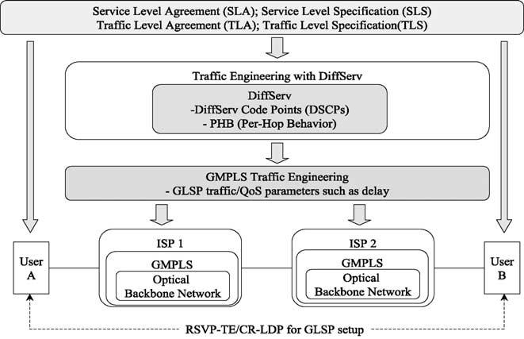
604

S.K. Lee et al. / Computer Communications 26 (2003) 603–610

routing, that is usually associated with packet-switch
capable networks. ER features can also be used to
facilitate QoS support for multiple class of services in
GMPLS networks (e.g. DiffServ). There have been
several efforts directed towards using QoS information
to make routing decisions, but their focus is different
from ours. A method for supporting QoS using the
IETF’s Open Shortest Path First (OSPF) routing protocol
can be found in Ref. [4]. This approach advertises
available bandwidth and delay metrics in OSPF Link
State Advertisements (LSAs), but does not use the delay
metric in computing paths. Some centralized routing
schemes have been proposed, notably that in Ref. [4],
which seek to ﬁnd the transiting path whose delay is less
than a prescribed limit and whose bandwidth is greater
than a speciﬁed lower bound. That approach uses
Dijkstra’s algorithm to ﬁnd a suitable path but does not
speciﬁcally account for delays at layer 3 or for relative
throughput, as our algorithm does.
Routing to support QoS requirements could be also
applied to optical networks [5]. QoS routing selects a path
ofﬂine for each ﬂow or connection to satisfy diverse
performance requirements and optimize resource usage.
Even though network resource is still available, uneven
distribution of trafﬁc prevents from meeting QoS con-
straints, that is, leads to worse delay performance in terms of
delay QoS. In this case, TE arranges trafﬁc ﬂows so that
congestion caused by uneven network utilization can be
avoided.
In this paper, we propose a mechanism to provide better
delay performance and improve network utilization in the
optical network. We do this by using a linear programming
approach that seeks to minimize the total path delay,
including delay introduced by packet processing at layers
above optical. While other researchers, speciﬁcally [6], have
introduced linear programs that account for the bottleneck
effect at layer 3, their approach seeks to maximize total
network throughput, while ours is focused on meeting QoS
requirements.
The optimization routine that we are proposing will
take path delay, including queueing delay at layer 3, into
account. In optical Internet using lambda labeling,
processing at layer 3 would constitute a signiﬁcant
bottleneck whose impact we wish to minimize. In
transparent optical networks where it is possible to
create lightpath connections between every pair of edge
routers, this is not an issue. But in large networks with
thousands of devices at the edge, creating a virtual
topology that is a full mesh is impractical. Thus, we can
expect that intermediate nodes with layer 3 functionality
will exist in a lambda labeling network (most likely at
the edges of optical subnetworks in the core). Thus it
would be useful to account for the impact of layer 3
processing when the ingress computes the explicit route.
The layer 3 processing overhead at intermediate nodes is
accounted for in the proposed path set-up algorithm.

The rest of paper is structured as follows. In Section 2 we
introduce the background. We describe our algorithm in
Section 3 where an integer linear program (ILP) based
solution is used. In Section 4 we present simulation results,
and ﬁnally in Section 5 conclusion is drawn.

2. Background

Core optical network consists of the Optical Cross-
Connects (OXCs) and ﬁber links interconnecting OXCs.
Each OXC can route an input wavelength to an output
wavelength. These OXCs, in most of the cases, can preclude
the electronic processing, and thus a optical connection can
be established between edge nodes. In lambda labeling
network, GMPLS control plane is attached onto OXC
devices and treats them as GMPLS nodes, hereafter called
as O-LSR nodes, allowing GMPLS signaling to compute
and set up Generalized Label Switched Paths (GLSPs)
between O-LSR nodes in a similar way as MPLS LSPs.
O-LSRs can be viewed as a combination of a router and
an OXC. The router component is responsible for all the
layer 3 functions such as addressing, routing, and global
topology discovery. It is also responsible for optimizing
network performance, which can be carried out via TE with
QoS support, management of optical resources (i.e.
wavelength assignment in coordination with the optical
channel sublayer), and restoration. That is, the most
important advantage of GMPLS turns out to be its ability
to do TE of IP networks although it was originally devised
with other goals such as faster forwarding of IP datagrams.
Even if GMPLS is very useful as protocols for establishing
trafﬁc engineered paths through optical Internet, many
researchers have recently begun working on the mechan-
isms of computing these paths [7]. Therefore, the objective
of this paper is to formulate the TE problems in
mathematical form to motivate more work towards the
consideration of multiple QoS classes. As can be seen in

Fig. 1. Trafﬁc engineering with QoS requirements.

S.K. Lee et al. / Computer Communications 26 (2003) 603–610

605

Fig. 1, the wavelengths can be assigned to the GLSPs in
accordance with QoS class [5]. GMPLS would be applicable
to DiffServ based networks as the growing trend is to use
DiffServ in the edge O-LSRs and lightpaths in the core. In
this paper, ingress O-LSRs determine the GLSPs that IP
trafﬁc ﬂows will be routed through, in terms of the QoS
requirements such as the maximum acceptable delay.
Additionally, this path computation based on delay
requirement can be also applied to establishing a backup
path with reservations every time a primary path is
established across the network. Seeing the objective of TE
in terms of priorities, although we consider only a single
level of priority for delay QoS in this paper, the proposed
approach naturally can extend to multiple priority levels. As
a consequence, the performance of the QoS service classes
is oblivious to the presence of the delay-sensitive trafﬁc.
Reliable network operation is another important aspect
of TE. Failure recovery scenarios must be designed to
ensure continuity of service following network impair-
ments. Therefore, the operational capability must exist to
reroute trafﬁc through the remnant capacity when failures
occur. While this rerouting procedure should make more
effective use of the residual post-failure capacity, it
should establish a backup GLSP to still satisfy the QoS
requirement even after the trafﬁc is recovered onto the
backup path.
As a signaling protocol to support the QoS, there are two
methods in GMPLS. One uses TE extensions to the
Resource Reservation Protocol (RSVP-TE) [8,9] and the
other one utilizes extensions to the Label Distribution
Protocol (LDP) called Constraint-based Routing LDP (CR-
LDP) [8,10]. IETF have been developing both signaling
protocols. Either RSVP-TE or CR-LDP can be used

That is, Interior Gateway Protocol (IGP), such as OSPF
with extensions for optical and TE attributes will allow
nodes to exchange information about optical network
topology, resource availability, and even policy
information.
Let G ј (N,L) describe the given network with node
set N ј n₁; n₂; …; n_{l}N^{l}and link set L ј l₁; l₂; …; l_{l}L^{l};
where lNl and lLl denote the cardinalities of the node
set and the link set, respectively. A link will be referred
to by the ordered node pair it connects, (n₁, n₂). Let
D ј {D_{ij}} be the distance matrix from node i to node j
that means a propagation delay from node i to node jрi –
jЮ: Let K ј k₁; k₂; …; k_{l}K^{l}be the set of trafﬁc demands
belonging to a speciﬁc service class between a pair of
edge O-LSRs. Typically there are several QoS service
classes, each having characteristic speciﬁcations, such as
delay. Here, we assume that the service class belongs
to delay-sensitive class, since the algorithm focuses on
delay QoS. Each trafﬁc demand k [ K is deﬁned by the
ordered triple (I_{k}, E_{k}, 1_{k}), where I_{k}is the ingress OXC,
E_{k}is the egress OXC, and 1_{k}is the maximum edge-to-
edge delay that is allowed for request k. For trafﬁc ﬂow,
We deﬁne l^{I}k^{E}k to be the average ﬂow associated with
the kth trafﬁc demand belonging to the delay-sensitive
class requesting CR-GLSP set-up. These demands are
assumed to arrive one at a time. Like l^{I}k^{E}k ; l^{IE}ij denotes
the trafﬁc from ingress I to egress E that ﬂows over an
intermediate virtual link (i,j ).
The unknown variables that need to be determined based
on optimizing a certain objective function and satisfying a
set of constraints are the following. These binary valued
variables indicate a set of virtual connectivities:
(

allowing a GLSP to be explicitly speciﬁed across the
optical core (Fig. 1) since both signaling protocols were also
recently extended to support GMPLS.
v_{ij}ј
1 if the virtual topology has a direct fiber link рi; jЮ;
0 otherwise
р1Ю

3. GLSP set-up algorithm

The main problem of the proposed algorithm is to
establish a GLSP that meets the delay requirement (We call
this GLSP as CR-GLSP: Constraint-based Routed GLSP).
The algorithm routes the GLSPs over the topology, and
assigns wavelengths optimally to the various lightpaths.
This assignment problem very likely belongs to the class of
NP-hard problems [11], since its sub-problem, the static
lightpath establishment has been shown to be NP-hard in
Ref. [12]. Therefore, it is righteous to formulate the problem
as an ILP.
We consider a connected network with N OXCs and L
directed links such as ﬁbers. Each ﬁber carries a certain
number of wavelengths. A subset of these nodes is
assumed to be edge O-LSRs between which lightpaths
can be set up. We are given all the information on the
virtual topology and status through a link state protocol.
where i; j ј 1; 2; …;_{l}Nl; i – j: If the TE function per-
forms CR-GLSP setup online when a new CR-GLSP
request arrives after a virtual topology is determined
initially, these variables would assume the role of
constants via virtual topology matrix. On the other
hand, in case that the virtual topology is being formally
modeled over the physical topology ofﬂine, the TE tool
should compute the variables to overlay the virtual
GLSPs. Thus, the online TE tool could be used to solve,
in real time, problems such as the QoS based routing and
rerouting of GLSPs.
When the network manager gets a request for a new
CR-GLSP with a certain QoS requirement, it should
determine whether this CR-GLSP can be routed to meet
the QoS. The decision variables assume a binary value
and denote which virtual link the GLSP select in the
network. In mathematical form,
(₁if the CR-GLSP has a lightpath on link рi; jЮ
e_{ij}ј р2Ю
0 otherwise

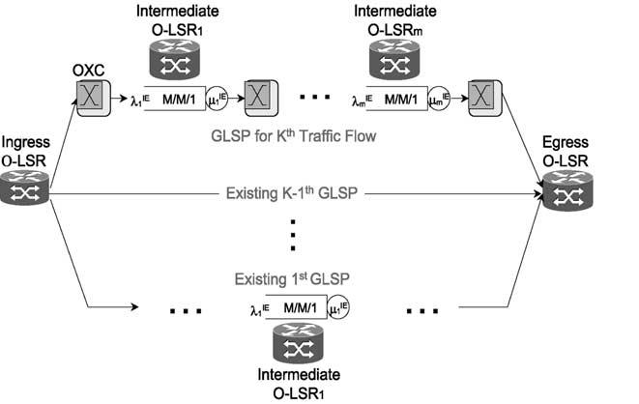
606

S.K. Lee et al. / Computer Communications 26 (2003) 603–610

where i; j ј 1; 2; …;_{l}Nl and i – j: That is, e_{ij}indicates
whether the CR-GLSP is routed over the virtual link
from node i to node j as in Ref. [13].
x_{i}indicates the layer 3 routing capability of the node as
follows:
(

if there is no virtual link connecting them. Additionally,
we can incorporate the layer 3 port throughput into
constraint (7). When the trafﬁc ﬂowing through a link is
going forward an intermediate O-LSR, the trafﬁc demand
should not be larger than the sum of the maximum
throughput supported by IP router port:

x_{i}ј
0 if node i has no layer 3 processing
1 otherwise
р3Ю
l_{ij}# W_{ij}C{1 ю рa 2 1ЮQ_{j}};
р10Ю

The set of variables has to satisfy the following constraints.
X X
where a # 1 denotes the maximum layer 3 port
throughput, expressed as a fraction of the optical layer

j
v_{ij}# T_{i};
i
v_{ij}# R_{j}for all i; j:
р4Ю
throughput.
A packet traversing the CR-GLSP experiences an end-to-

where T_{i}and R_{j}are the number of transmitters and receivers,
respectively, at node i and j (i, j [ N ).
X
l_{ij}ј v_{ij}l^{IE}ij^{ю}e_{ij}l^{I}k^{E}k for all i; j: р5Ю
I;E
8
end delay of^{P}i;j^{e}ij^{l}I_{ij}k^{E}k_{D}ij^{ю}dnode;where dnode denotes the
total waiting time at all nodes over the CR-GLSP. The
dominant delay in light to moderately loaded high bandwidth
optical networks is known as the propagation delay, which is
uniquely determined by the length of the optical path over the
physical WDM network. However, since wavelengths and

X_{l}I_{ij}k^{E}k₂X_{l}I_{ji}k^{E}k ј
j j

l_{ij}# W_{ij}C;
>>< l^{I}k^{E}k ; i ј I_{k}
2l^{I}k^{E}k ; i ј E_{k}
>>:
0; otherwise:

р6Ю

р7Ю
ﬁbers are ﬁnite, a lightpath is not always established between
each source and destination IP routers. Moreover, if trafﬁc
grooming is available in some nodes, it is not always
necessary to deploy a direct lightpath between two nodes to
carry trafﬁc between them. Instead, the trafﬁc demand
between two nodes may be carried by multiple lightpaths

where C is the capacity of each wavelength on a ﬁber and
W_{ij}denotes the number of wavelengths per link in the virtual
topology between the nodes i and j for all i and j.
l^{I}ij^{k}E_{k}ј e_{ij}l^{I}k^{E}k : р8Ю
among some intermediate nodes without direct lightpath
deployment between the two (end) nodes. Consequently, IP
packets are forwarded to the destination by multi-hop IP
routing. By this routing, layer 3 processing may still be a
bottleneck of a network. Thus, dnode is deﬁned to be the

e_{ij}# v_{ij}:
р9Ю
waiting and processing time at O-LSRs, since these nodes are
the likely bottleneck points on any CR-GLSP. The delay

Constraint (4) ensures that we can set up only single
lightpath per port at each node. Constraints (5) and (6)
are related to the trafﬁc ﬂow on virtual link for all i and
j. When the new trafﬁc demand is routed, the deﬁnition
of the total trafﬁc over link (i, j ), l_{ij}is expressed in
constraint (5). Constraint (6) assures that the ﬂow of
trafﬁc is conserved at each node. Although splitting is
used for load balancing purposes by routing demands
over multiple GLSPs at the ingress point, it is not
permissible for the routing algorithm to always split
trafﬁc in an arbitrary manner since the trafﬁc being
routed may be inherently unsplittable. In this paper, the
trafﬁc ﬂow l^{I}k^{E}k will not bifurcate either at any point in
the network from the fact that the proposed TE algorithm
is trying to route a CR-GLSP request explicitly to meet
the QoS. Thus, constraint (6) is brought in so the trafﬁc
ﬂowing into an OXC to be tantamount to that ﬂowing
out of the OXC for any OXC other than the ingress and
egress O-LSRs. In terms of the constraints, the link
capacity should not be exceeded with the addition of the
new CR-GLSP along its path through the network that is
presented in constraint (7). Constraint (8) speciﬁes that if
the link (i, j ) does not exist on the CR-GLSP, no trafﬁc
can be routed on that link. Finally, constraint (9) keeps
the new CR-GLSP from being set up between two nodes
increases with the number of hops and the expected
processing delay at the intermediate nodes, since there can
be an arbitrary number of intermediate O-LSRs on the GLSP.
we deﬁne l^{IE}m to be the aggregate input rate to the mth
рm ј 1; 2; …; MЮ O-LSR. Under the independence
assumption on interarrivals we can model the delay
experienced at layer 3 using an M/M/1 queueing model.
Fig. 2 depicts the operation of such an optical Internet.
Given that m^{IE}m be the service rate in each intermediate
node, we can get the average layer 3 processing delay

Fig. 2. Delay with layer 3 processing.

seen by the trafﬁc ﬂow as

S.K. Lee et al. / Computer Communications 26 (2003) 603–610

Step 2: if there is any GLSP to minimize Eq. (13)
then go to Step 4;

607

t ј
X
mј1
r | IE  m
р1 2 r^{IE}m^{Ю}l^{IE}m;
р11Ю
else if the request is negotiable
then relax 1_{k}and go to Step 2;
else go to Step 3;

where r^{IE}m^{ј}l^{IE}m⁼m^{IE}m is the utilization. Using the local
connectivity and processing rate variables, the above
Eq. (11) becomes
Step 3: Block this GLSP request and go to Step 5;
Step 4: Provision resources for the GLSP and update
network state;

t ј
X

i;j
e_{ij}Q_{j}
m_{j}2 р^{P}‘^{l}‘j^{ю}l^{I}k^{E}k Ю:

р12Ю
Step 5: End;

To satisfy the requirements of diverse routing, rerouting
and restoration as well as TE, ER is necessary for

Thus, for the kth trafﬁc ﬂow belonging to DS class, the
objective function for delay can be written as
X
f рe_{ij}Ю ј р e_{ij}l^{I}k^{E}k D_{ij}Ю ю t; р13Ю
i;j
In Eq. (13), the second term t will be zero if there is no
layer 3 processing at any point on the GLSP. The
objective function, Eq. (13), should be minimized in
order to support the delay QoS requirement of the kth
ﬂow belonging to the delay-sensitive class. If the
minimum value of Eq. (13) does not satisfy the delay
QoS requirement, the values computed from the mini-
mization would not be applied to the variable e_{ij}.
On top of the constraints in Eqs. (4) – (9), an additional
two constraints should be deﬁned, that are related to QoS
and layer 3 processing rate. One constraint for tolerable QoS
can be deﬁned as
constructing lightpaths. The route on which a new lightpath
is to be established is speciﬁed by an object contained in the
GLSP setup message. This route is typically be chosen by
the ingress O-LSR, but it could be determined by a higher
level network management system. The route may be
speciﬁed either as a series of routers/OXCs, or in terms of
the speciﬁc links used. Therefore, the above mechanism
performs the calculation of primary and restoration light-
path routes on-line as the individual requests arrive. These
lightpaths could be computed all at once by doing an ofﬂine
calculation that accounts for all the pending requests.
Because the network loading varies over time, the
consideration of the optimal route selection could require
the reconﬁguration of established lightpath routes, as
described in Ref. [3]. Although frequent lightpath reroutings
may not be acceptable, a limited number of lightpath
reroutings could improve the network state, supporting the

0 # f рe_{ij}Ю # 1_{k}:
р14Ю
requested QoS of the future trafﬁc while maintaining the
QoS of the trafﬁc that the network is already supporting. In

The other one for layer 3 processing rate can be expressed as
m_{j}$ v_{ij}X_{l}IE_{ij}ю e_{ij}Q_{j}l^{I}k^{E}k for all I; E: р15Ю
i
It is generally known that the multicommodity network ﬂow
problem with integer constraints is NP-hard [11]. Thus the k
disjoint route problem which is NP-hard in Ref. [11] can be
dealt with the same as that the k distinct egress node pairs
ﬁnd k mutually link-disjoint routes.
Whenever a new trafﬁc ﬂow belonging to delay-sensitive
class requests explicitly routed GLSP, the virtual lightpath
will be conﬁgured and the network state will be updated.
Unless it is possible to support the GLSP with the desired
QoS, the request can be blocked or renegotiated and
attempted again. Alternatively, the network manager can
preempt the minimum number of lower priority ﬂows that
will allow the GLSP to be set up. The procedure for the kth
request, which does not account for preemption, proceeds as
follows:

Step 0: Obtain the parameters associated with the kth
setup request
Step 1: if a transmitter or a receiver is not available at I_{k}
or E_{k}
then go to Step 3;
the initial conﬁguration stage where there is no conﬁgured
virtual topology, the appropriate virtual lightpath could be
found by repeating the above procedure. This procedure is
applied to the trafﬁc that has the most stringent delay limit
among all initial trafﬁc demands of delay-sensitive service
class at all egress O-LSRs being done so to the trafﬁc with
the next highest QoS requirement, in turn. Like setting up
usual GLSP, the virtual topology would be conﬁgured for
the trafﬁc demand of delay-sensitive service class at each
egress OXC by minimizing the objective function of delay.
By ﬁnding the values of all the elements of the set {l^{IE}ij}; we
can obtain a full set of routing assignments for all the trafﬁc
in the optical network.
Failure of LSPs due to link failures is detected via
GMPLS signaling protocol (e.g. CR-LDP or RSVP-TE)
information by the edge routers. They can request a
rerouting of the LSPs after the link-state database has
been updated by routing protocols or by other means. (An
alternative, not studied in the paper, is to setup a disjoint
path backup GLSP so that failures can be accommodated by
changing the FEC to GLSP mapping at the ingress routers.)
Let S be the set of Shared Risk Link Groups (SRLGs)
associated with elements of the network. A single link or
node may belong to more than one SRLG. Deﬁne S_{ij}to
be the set of SRLG identiﬁers associated with the link

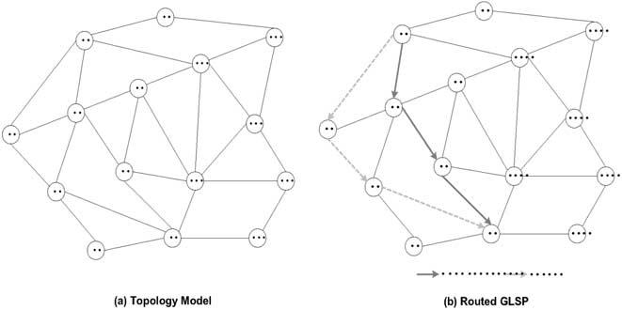
608

S.K. Lee et al. / Computer Communications 26 (2003) 603–610

(i, j ) and deﬁne S_{n}to the set of all Shared Risk Group
(SRG) identiﬁers associated with node n. Then the full
set of SRG identiﬁers for the network is just the union of
all these sets: S ј р^{S}n[N^{S}n^{Ю}S_{р}S‘[L^{S}‘^{Ю}: In order to set
up a M:N protection group with QoS constraints that
generally routes M backup paths that are node disjoint
from N primary paths, we can proceed in the following
way. Let K ј {k_{i}}^{K}iј1 be the set of requests for working
paths in the protection group. For the ﬁrst working path
k₁, we can use the algorithm that we have described
above since there is no SRLG/SRG constraint. The
SRLG/SRG identiﬁers associated with the working path
are accumulated in the set S(k₁). In order to compute a
backup path for this working path, which will have the
same source and destination nodes I_{k}1^{and}E_{k}1 and the
same delay and bandwidth QoS requirements 1_{k}1 and
B_{k}1, we can do several things. One possibility is to
execute the Shortest Path First (SPF) algorithm described
in Ref. [4], with some modiﬁcations. Like Eq. (11), let
t_{n}ј^{X}r^{IE}n

Fig. 3. Network model.
results of the proposed algorithm and compare it to the well-
known SPF algorithm using a set of simulations. We have
run our algorithm several times using GMPLS Lightwave
Agile Switching Simulator (GLASS) which was developed
by NIST to evaluate control algorithms in integrated
MPLS/optical networks [14], and calculated average
blocking probability and average end-to-end delay. That
is, the performance is analyzed in terms of the number of

I;E
р1 2 r^{IE}n^{Ю}l^{IE}n
rejected CR-GLSP requests and delay.

be the average layer 3 processing delay at node n due to
all the existing trafﬁc ﬂows that are passing through the
node. Whenever a ﬂow is added, modiﬁed, or deleted,
{t_{n}}_{n}[N should be updated. Recall that we deﬁned D_{ij}to
be the propagation delay on the link from Node i to
Node j. Deﬁne B_{ij}to be the available bandwidth on the
link from i to j.

Step 1: If B_{ij}, B_{k}1, set D_{ij}ј 1.
Step 2: If S_{ij}[ S(k₁), set D_{ij}ј 1.
Step 3: (Backup path initialization.) Set P ј {I_{k}}; m ј I_{k}:
In the ﬁrst place, we describe a simulation environment
used to validate our algorithm in providing service
requested by delay-sensitive class. The simulation tests
were carried out on a model of the network shown in
Fig. 3(a), which has also been used in Ref. [15]. In this
topology model, a maximum of four wavelengths are
available for use in each link and the capacity is 10 Gbps.
The propagation delay D_{ij}is assumed to be 0.05 ms for all
links (i, j ), and the maximum tolerable delay limit of every
GLSP request from delay-sensitive trafﬁc is 0.5 ms. For this
topology, we consider in this paper two network models:

1
1

Let f рPЮ ј t_{I}k be the total delay on the backup path.
one model where the values of the x_{j}are assumed to be 1 for

1
Step 4: Determine the node n^{p}with the lowest delay cost
with respect to node m, which satisﬁes
min_{n}[N;n P^{Ѕ}D_{m};n^{ю}t_{n}:
Step 5: Add n^{p}to P. f рPЮ ј f рPЮ ю D_{m};n^{p}ю t_{n}p:
Step 6: If f рPЮ . 1_{k}1;no backup path satisfying the desired
QoS requirements can be found.
If n^{p}ј E_{k}1, the algorithm has executed successfully.
Step 7: Set m ј n^{p}and go to Step 4.

If it is not possible to ﬁnd a backup path with the desired
QoS characteristics, the algorithm could be run again with
relaxed values for the maximum delay or minimum
bandwidth, although this could result in a degradation of
performance in the event of a failure on the primary path, even
if the ﬂow is successfully switched over to the backup path.

4. Performance evaluation from simulation

Some simulation experiments have been conducted in
order to study the performance of the proposed CR-GLSP
routing algorithm. In this section, we present the simulation
all the edge nodes and the other one where the network layer
processing overhead is placed on the nodes 5, 8, 9, 12 and
14. Every GLSP request arrives at all edge nodes, according
to a Poisson process with mean arrival rate, l_{r}of 200, 1000,
1500, and 2000 in each experiment, respectively. Like in
Ref. [16], the arrival rates of trafﬁc for the different source
and destination pair were chosen from a uniformly
distributed random variable in the interval [1, l^{IE}]. The
value of l^{IE}was selected as 2.5 Gbps in this simulation
experiment. 10% of total trafﬁc ﬂows belongs to delay-
sensitive service class. We assume that the time between
GLSP set-up and teardown is exponentially distributed with
a mean of 1 min. When a GLSP set-up request arrives at an
ingress node, the destination is chosen randomly among all
the edge nodes except the ingress with the set-up request.
All the simulations were run till 5000 GLSP set-up requests
were generated and each simulation was repeated 10 times
to get the average blocking rate and the average delay
measured during the simulation.
The average blocking performance versus the GLSP set-
up requests is shown in Fig. 4 where graph (a) and (b) is the
performance of overall trafﬁc and that of delay sensitive

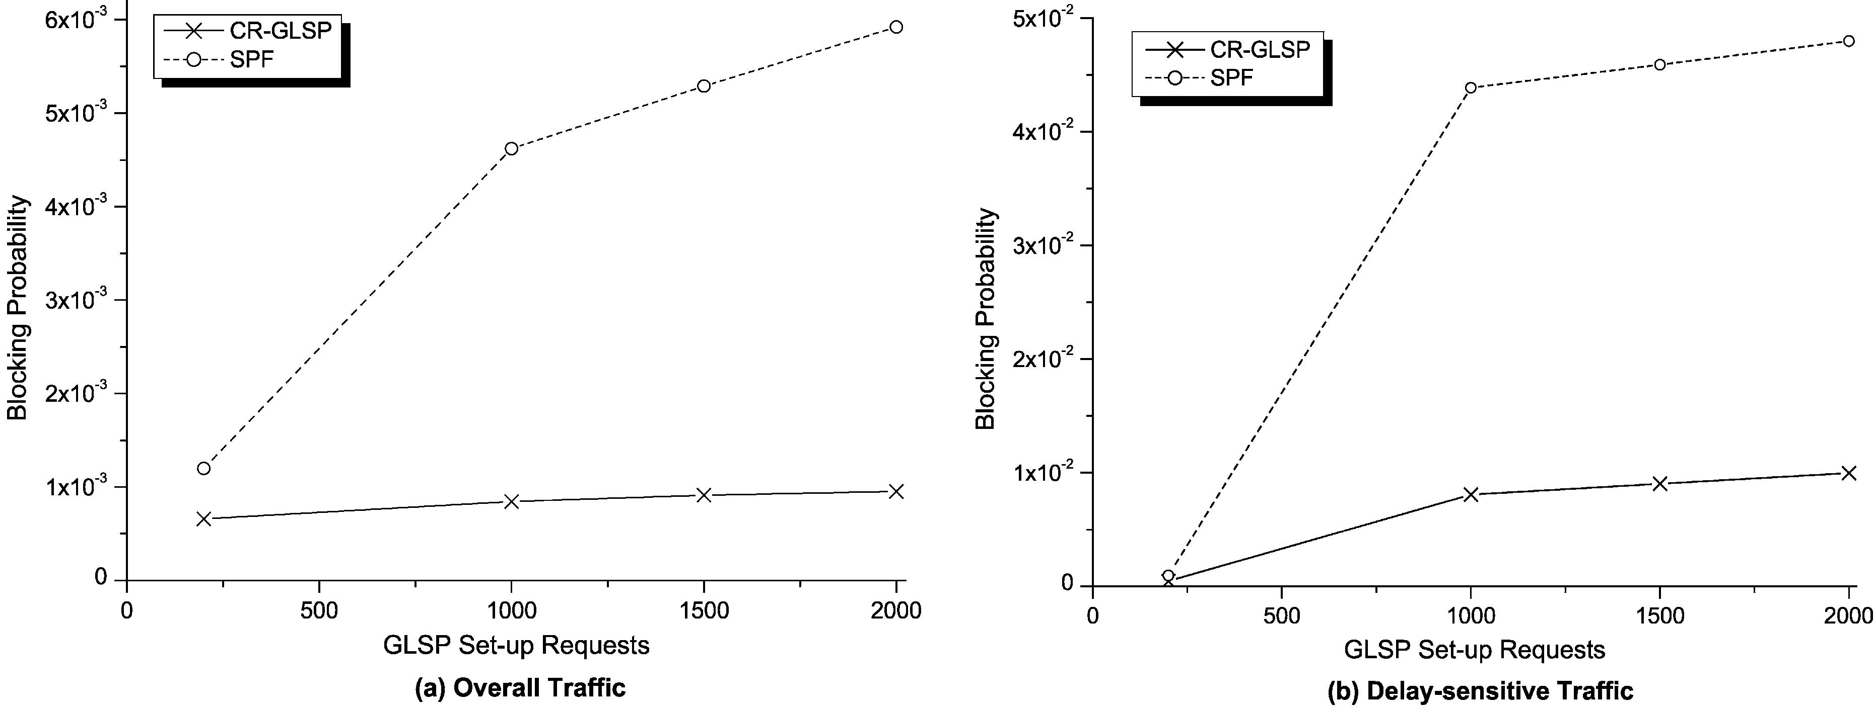
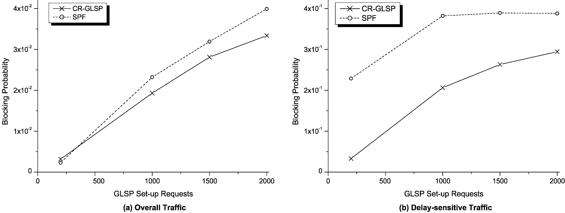
S.K. Lee et al. / Computer Communications 26 (2003) 603–610

Fig. 4. Blocking probability for model 1.

609

trafﬁc, respectively. Fig. 5 also shows the average blocking
performance from the other set of simulations where the
location of intermediate O-LSRs is changed, i.e. the layer 3
processing is at nodes 5, 8, 9, 12 and 14. The average
blocking rate increases at the increasing of the GLSP set-up
requests. Moreover, the gain due to the consideration of
network layer processing is evident from these graphs.
Therefore, we ﬁnd that the proposed CR-GLSP algorithm
performed better with respect to the blocking rate, which
means that the CR-GLSP algorithm utilizes network
resources more efﬁciently. This improvement is realized
due to the fact that although CR-GLSP algorithm would not
be able to ﬁnd the available bandwidth over the path with
the minimum delay, it tries to utilize the path with the next
minimum delay keeping the tolerable delay.
Without performance degradation in blocking rate, we
obtain the better performance in terms of average end-to-
end delay. The average delay associated with both
algorithms is presented in Table 1 measured during the
overall simulation time for the two topology models where

model 1 performs layer 3 processing at all the edge nodes
and the model 2 does so at only the 5 nodes listed above.
From Table 1, it can be observed that the average delay
increases at the increasing of the GLSP set-up requests since
the more GLSPs are requested to be established, the more
the trafﬁc ﬂows into the network. Despite the increasing of
the average delay, the average delay of the CR-GLSP
algorithm is still smaller than that of SPF algorithm. This is
due to the fact that the CR-GLSP algorithm incorporates
network layer processing delay into routing decision. It
resulted from this incorporation that the CR-GLSP algor-
ithm chose different path from that in SPF algorithm
between source node 2 and destination node 9. As can be
seen in Fig. 3(b), the SPF algorithm routed the GLSP over
the route 2 ! 1 ! 4 ! 9 while the CR-GLSP algorithm
selected the route 2 ! 3 ! 7 ! 9.
Therefore, it is known that our formulation in CR-GLSP
is applicable to ER of backup GLSP as well as working
GLSP in large IP over WDM networks with QoS
constraints.

Fig. 5. Blocking probability for model 2.

610

Table 1

S.K. Lee et al. / Computer Communications 26 (2003) 603–610

QoS. At that time, it is worth noting multiple service

Delay performance (Unit: ms: 1/l_{r}; GLSP requests)
categories whose level of restoration is different.

1/l_{r}

Model 1
200
1000
1500
2000
Model 2
200
1000
1500
2000

5. Conclusion
CR-GLSP algorithm

0.266
0.292
0.321
0.343

0.215
0.228
0.257
0.275
SPF algorithm

0.424
0.477
0.499
0.521

0.371
0.417
0.421
0.429

References

[1] E. Rosen, A. Viswanathan, R. Callon, Multiprotocol Label Switching
Architecture, RFC 3031, January, 2001.
[2] A. Banerjee, J. Drakes, J.P. Lang, B. Turner, K. Kompella, Y.
Rekhter, Generalized multiprotocol label switching: an overview of
routing and management enhancements, IEEE Commun. Mag.
January (2001).
[3] G. Apostolopoulos, D. Williams, S. Kamat, R. Guerin, A. Orda, T.
Przygienda, QoS Routing Mechanisms and OSPF Extensions, RFC
2676, August, 1999.
[4] Z. Wang, J. Crowcroft, “Quality-of-Service Routing for Supporting
Multimedia Applications”, IEEE JSAC 14 (7) (1996).
[5] N. Golmie, T.D. Ndousse, D. Su, A differentiated optical services
model for WDM networks, IEEE Commun. Mag. 38 (2) (2000).
[6] H. Harai, F. Kubota, H. Nakazato, Design of reconﬁgurable lightpaths

The success of next generation IP over WDM networking
depends on the ability to offer and support QoS to
customers. It is clear that network layer processing cannot
be neglected for designing TE algorithms as well as for this.
In this paper, we formulated an optimization problem for
constraint-based routing to support the QoS requested by
delay-sensitive trafﬁc in optical Internet. The CR-GLSP
algorithm described in this paper is based on the idea that
trafﬁc ﬂows encounter the delay resulting from layer 3
processing at subnetwork edge nodes. The algorithm uses
the current state of the network to determine the delay
associated with each possible path, and then chooses the
path with the minimum total delay. The simulation results
showed that the proposed algorithm improves the delay
performance as well as the probability of successful GLSP
establishment in comparison to SPF algorithm, which do not
take the network layer processing into account. In the
simulation test, GLASS tool was used as a simulation tool
that was developed by NIST for optical Internet. The
presented algorithm can also be used for establishing
backup path with delay constraint and we described how
to apply to protection.
The future study is network survivability which is also
treated as an important issue recently. We are designing a
several efﬁcient restoration algorithms that ensure its
survivability in optical Internet while we sustain the delay
in IP over WDM networks, IEICE Trans. Commun. E83-B (10)
(2000).
[7] D. Awduche, J. Malcolm, J. Agogbua, M. O’Dell, J. McManus,
Requirements for Trafﬁc Engineering over MPLS, RFC 2702,
September, 1999.
[8] Data Connection Computer Technology, MPLS Trafﬁc Engineering:
A Choice of Signaling Protocols, http://www.dataconnection.com/
download/crldprsvp.pdf.
[9] P. Ashwood, A. Banerjee, L. Berger, G. Bernstein, J. Drake, Y. Fan,
K. Kompella, J.P. Lang, F. Liaw, E. Mannie, P. Pan, B. Rajagopalan,
Y. Rekhter, D. Saha, V. Sharma, G. Swallow, Z.B. Tang, Generalized
MPLS Signaling-RSVP-TE Extensions, Work on Progress, draft-ietf-
mpls-generalized-rsvp-te-04.txt, July, 2001.
[10] P. Ashwood, A. Banerjee, L. Berger, G. Bernstein, J. Drake, Y. Fan,
D. Fedyk, K. Kompella, E. Mannie, J.P. Lang, B. Rajagopalan, Y.
Rekhter, V. Sharma, G. Swallow, Z.B. Tang, Generalized MPLS
Signaling-CR-LDP Extensions, Work on Progress, draft-ietf-mpls-
generalized-cr-ldp-04.txt, July, 2001.
[11] M. Garey, D. Johnson, Computers and Intractability, W.H. Freeman,
New York, 1979.
[12] I. Chlamtac, A. Ganz, G. Karmi, Lightpath communications: an
approach to high bandwidth optical WANs, IEEE Trans. Commun. 40
(7) (1992).
[13] R. Ramaswami, K.N. Sivarajan, Optical Networks: a Practical
Perspective, Morgan Kaufmann, Los altos, CA, 1998.
[14] NIST, http://www.antd.nist.gov/proj/asia/glass/.
[15] K. Kar, M. Kodialam, T.V. Lakshman, Minimum interference routing
of bandwidth guaranteed tunnels with MPLS trafﬁc engineering
applications, IEEE JSAC 18 (12) (2000).
[16] I. Widjaja, A.I. Elwalid, Study of GMPLS Lightpath Setup over
Lambda-Router Networks, ICC’02, May, 2002.

