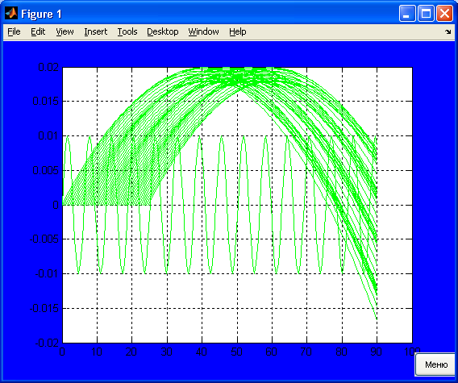
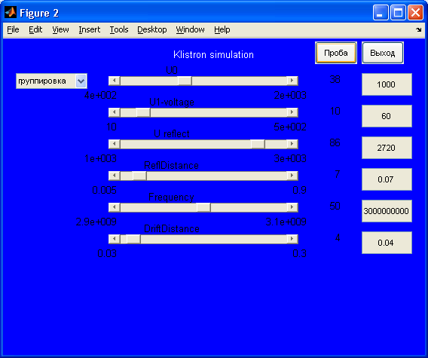
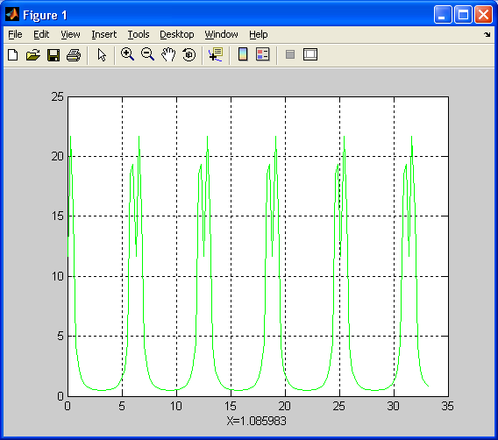
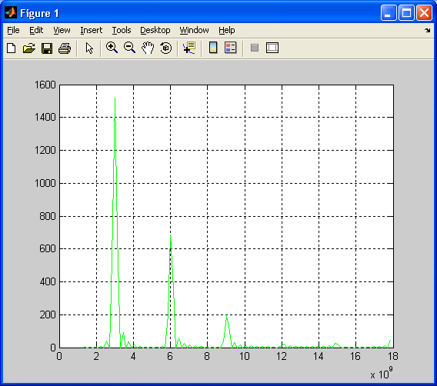
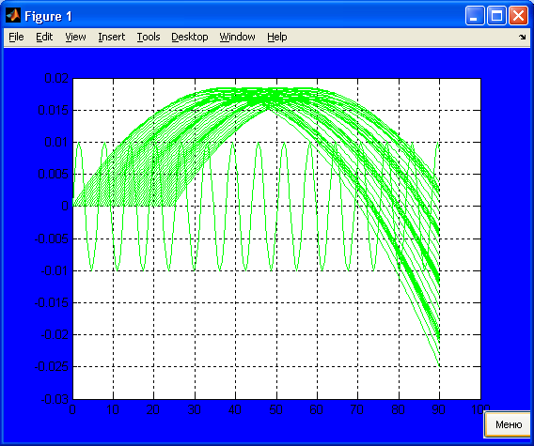

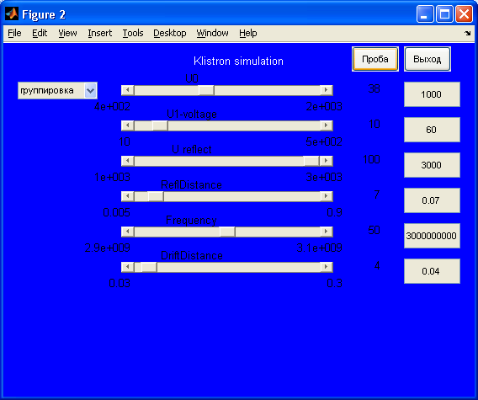
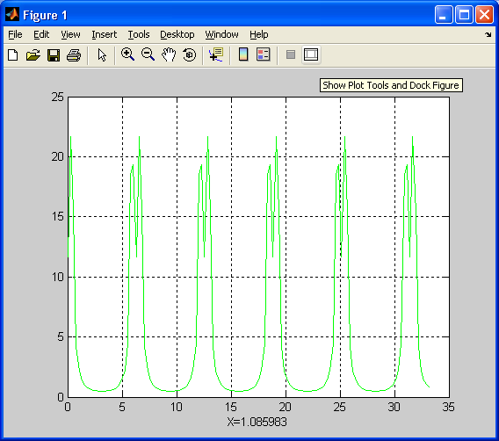
Пролетный клистрон
Traject
function traject(u0, u1, teta, omega, N, ns, nf, aRf)
n=N;
fi= 0.01: pi/6 : n*pi;
nse=1; if nf>(n-1), nf=(n-1); end;
ve=sqrt(2*1.6*10^(-19)*u0/(9.1*10^(-31)));
m1=sin(0.5*teta)/(0.5*teta);
hold off;
plot(fi(ns:nf),0.01*sin(fi(ns:nf)),'g-');
hold on
for i = 1:48
v(i)=ve*(1+m1*u1/(2*u0)*sin(fi(i)));
for j = 1:(n-1)
z(j)=v(i).*((fi(j)/omega)-(fi(i)/omega));
end;
if ns>i, nse=ns; else nse=i;end;
plot(fi(nse:nf),z(nse:nf),'g-');
end;

grid on;
hold off;
Groppir
clear; clf
n=288;
u0=1000; u1=60; f=3e+9; omega=2*pi*f;
teta=pi/2;
uRf=2000; sRf=0.05;
aRf = 1.6*10^-19*u0/(sRf*9.1*10^-31)
ns=1; nf=ns+172;
figure(gcf);
traject(u0, u1, teta, omega, n, ns, nf, aRf);

