grouppir

clear; clf
n=288;
u0=1000; u1=60; f=3e+9; omega=2*pi*f;
teta=pi/2;
uRf=2000; sRf=0.05;
aRf= 1.6e-19*u1/(sRf*9.1e-31);
ns=1; nf=ns+172;
figure(gcf);
traject(u0, u1, teta, omega, N, ns, nf, aRf);

traject

function traject(u0, u1, teta, omega, N, ns, nf, aRf)
n=N;
fi= 0.01 : pi/6 : n*pi;
nse=1; if nf>(n-1), nf=(n-1); end;
ve=sqrt(2*(u0*1.6e-19/9.1e-31));
m1=sin(0.5*teta)/(0.5*teta);

hold off;
plot(fi(ns:nf),0.01*sin(fi(ns:nf)),'g-');

hold on
for i = 1:48
v(i)=ve*(1+m1*u1/(2*u0)*sin(fi(i)));
for j = 1:(n-1)
z(j)=v(i).*(fi(j)/omega-fi(i)/omega)-(0.5)*aRf*(fi(j)/omega-fi(i)/omega)^2;
end;
if ns>i, nse=ns; else nse=i;end;
plot(fi(nse:nf),z(nse:nf),'g-');
end;

grid on;
hold off;

klystron

%Prepared by R.A.Garaev for UHF labs
n=288;
u0min=400; u0max=2000; u0=1000;
u1min=10; u1max=500; u1=60;
Fmin=2.9e+9; Fmax=3.1e+9;Fr=3e+9; omega=2*pi*Fr;
DrifDmin=0.03; DrifDmax=0.30; DrifD=0.04;
teta=pi/2;
uRfmin=1000; uRfmax=3000; uRf=2000;
sRfmin=0.005; sRfmax=0.9; sRf=0.07;
aRf=((uRf+u0) / sRf) * 1.6e-19 / 9.1e-31;
ns=1; nf=ns+172;

fi= 0.01: pi/12 : 20*pi;

% --------------------------------
windG1=figure; figure(windG1); %Там графики
set(windG1,'Color',[ 0 0 1]);
traject(u0, u1, teta, omega, n, ns, nf, aRf);

% --------------------------------
Change_button = uicontrol('Style','Pushbutton','Units','normalized',...
'Position',[.91 .01 .1 .07],...
'Callback','figure(windM1)','String','Меню'); %Кнопка выхода в меню%

% --------------------------------
windM1=figure; %Там меню с органами управления
figure(windM1); % Окно с будущим меню на передний план

ctl_ini; %Инициализация
captionM = 'Klistron simulation';

% --------------------------------
Ctrl1='on'; captnPar1 ='U0';
popup1Val =1; popup1Opts='группировка|ток I2|гармоники';
Slider1Min=u0min; Slider1Max=u0max; Slider1Val=u0;

% --------------------------------
Ctrl2='on'; captnPar2 ='U1-voltage';
Slider2Min=u1min; Slider2Max=u1max; Slider2Val=u1;

% --------------------------------
Ctrl3='on'; captnPar3 ='U reflect';
Slider3Min=uRfmin; Slider3Max=uRfmax; Slider3Val=uRf;

% --------------------------------
Ctrl4='on'; captnPar4 ='ReflDistance';
Slider4Min=sRfmin; Slider4Max=sRfmax; Slider4Val=sRf;

% --------------------------------
Ctrl5='on'; captnPar5 ='Frequency';
Slider5Min=Fmin; Slider5Max=Fmax; Slider5Val=Fr;

% --------------------------------
Ctrl6='on'; captnPar6 ='DriftDistance';
Slider6Min=DrifDmin; Slider6Max=DrifDmax; Slider6Val=DrifD;

% --------------------------------
%Ctrl7='on'; captnPar7 ='U0';
%Slider7Min=u0min; Slider7Max=u0max; Slider7Val=u0;

% --------------------------------
%Ctrl8='on'; captnPar8 ='U0';
%Slider8Min=u0min; Slider8Max=u0max; Slider8Val=u0;

% --------------------------------
UActionCheck=['uo= Edit1Val; u1= Edit2Val;'...
'uRf= Edit3Val; sRf= Edit4Val;'...
'Fr= Edit5Val; DrifD=Edit6Val;'...
'figure(windG1);'...
'if popup1Val==1,'...
'aRf=((uo+uRf) / sRf) * 1.6e-19 / 9.1e-31;'...
'traject(u0, u1, teta, 2*pi*Fr, n, ns, nf, aRf);'...
'end;'...
'if popup1Val~=1,'...
've=sqrt(2.*1.6e-19 .*u0 ./9.1e-31);'...
'X=2*pi*Fr*DrifD*sin(teta/2)/(teta/2)*u1/2/u0/ve;'...
'I2=abs(1./(1-X * cos(phi))); hold off;'...
'end;'...
'if popup1Val==2,'...
'plot(phi(1:128),I2(1:128),''g-'');hold on;grid on;'...
'xlabel(sprintf(''X=%f'',X));'...
'end;'...
'if popup1Val==3,'...
'Y=fft(I2,480); Pyy=Y.*conj(Y)/480;'...
'f=Fr*24/480*(0:240);'...
'plot(f(10:120),Pyy(10:120),''g-''), grid on;'...
'end;'...
];

% =================================
ctlgra00; % В окно - меню органов управления

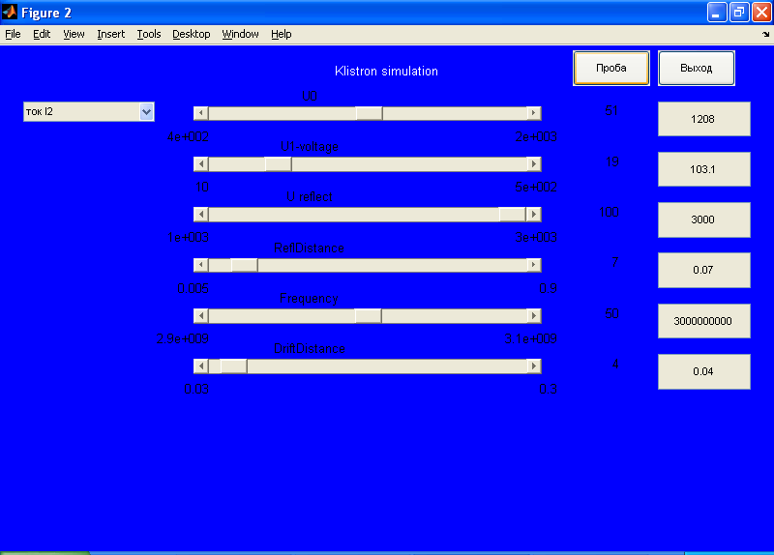

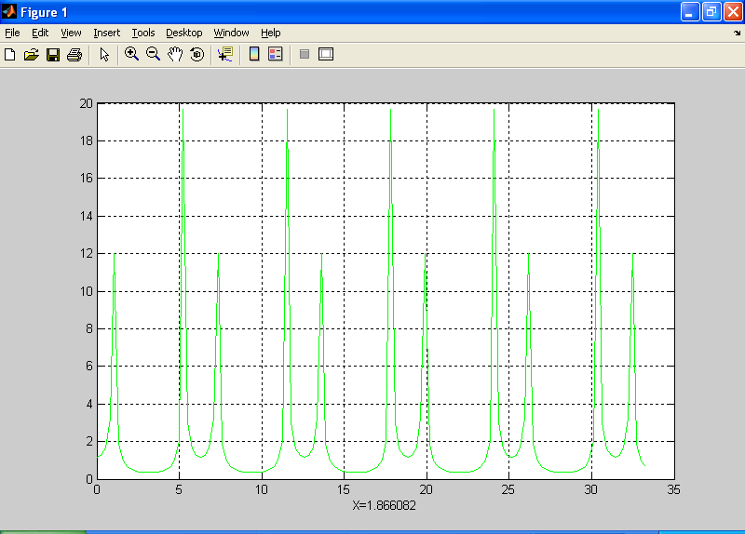

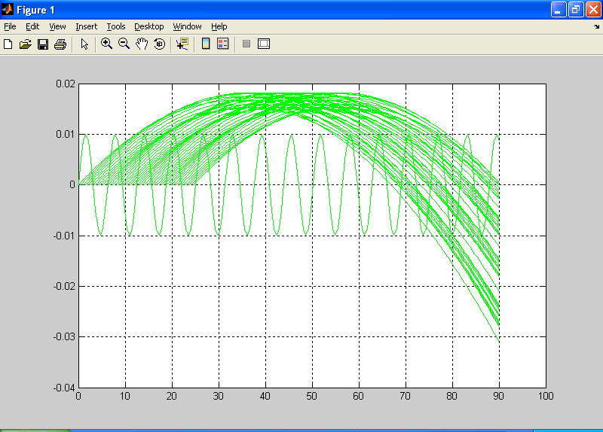

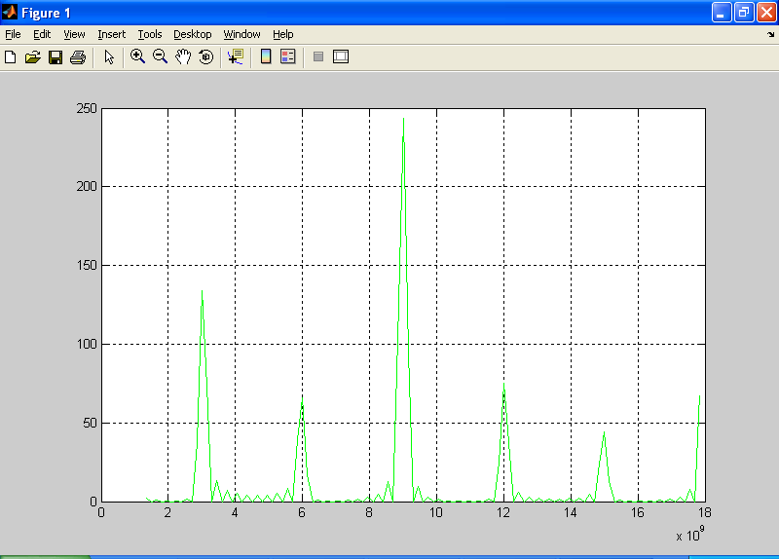

Для пролЁтного клистрона

function traject(u0, u1, teta, omega, N, ns, nf, aRf)
n=N;
fi= 0.01 : pi/6 : n*pi;
nse=1; if nf>(n-1), nf=(n-1); end;
ve=sqrt(2*(u0*1.6e-19/9.1e-31));
m1=sin(0.5*teta)/(0.5*teta);

hold off;
plot(fi(ns:nf),0.01*sin(fi(ns:nf)),'g-');

hold on
for i = 1:48
v(i)=ve*(1+m1*u1/(2*u0)*sin(fi(i)));
for j = 1:(n-1)
z(j)=v(i).*(fi(j)/omega-fi(i)/omega);
end;
if ns>i, nse=ns; else nse=i;end;
plot(fi(nse:nf),z(nse:nf),'g-');
end;

grid on;
hold off;

