INFORMATIONS ABOUT the AUTHORS

Kusimov Salavat Tagirivich, 1942 of birth, engineering doctor, professor, rector of the Ufa state air technical university.  Area of scientific interests: optics, processing of signals.  The working address: 450000, Bashkortostan republics, Ufa, K.Marx street, 12, house 1, ph.: + 7-3472-22-22-15.  The home address: 450025, Ufa, Frunze street, house 5, apartment 19, ph.: + 7-3472-51-65-85, Kusimov@rb.ru | 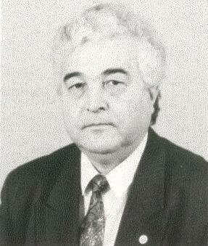

Sultanov Albert Hanovich, 1950 of birth, in 1973 were ended by Novosibirsk electrotechnical institute, in 1996 has protected a professor engineering doctoral thesis, head of chair “Telecommunication systems” of the Ufa state air technical university, teacher.  Area of scientific interests: semiconducting and antenna engineering, optics, communication.  The working address: 450000, Bashkortostan republics, Ufa, K.Marx street, 12, house 6, ph./fax: + 7-3472-23-06-89,  E-mail: tks@ugatu.ac.ru .  The home address: 450005, Ufa, Mingazeva street, house 158/1, apartment 704 | 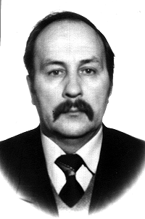

Usmanov Ramil Gafurovich, 1953 of birth, director «Energo-connect» of Open Joint-Stock Company «Bashkirenergo». Area of scientific interests: fiber-optical communication, multi-channel digital systems of transfer.  The working address: 450000, Bashkortostan republics, Ufa, K.Marx street, 30, ph.: + 7-3472-79-70-90,  E-mail: esv@bashkirenergo.ru .  The home address: 450005, Ufa | 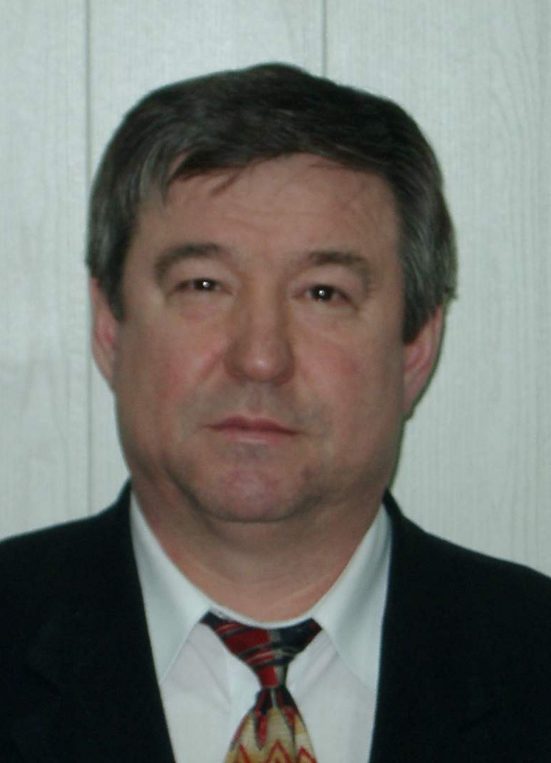

Sharifgaliev Irek Adhamovich, 1967 of birth, in 1990 has ended Moscow height technical university by Bauman. General director of Closed Joint-Stock Company «Energospeznaladka», Ufa.  Area of scientific interests: opto-electronics fiber-optical communication, electronic equipment of communication, processing of signals.  The working address: 450000, Bashkortostan republics, Ufa, Bakalinskay street, 68/6, ph.: + 7-3472-79-71-54,  E-mail: sia@bashnet.ru .  The home address: 450054, Ufa, Russian street, house 41, apartment 100 | 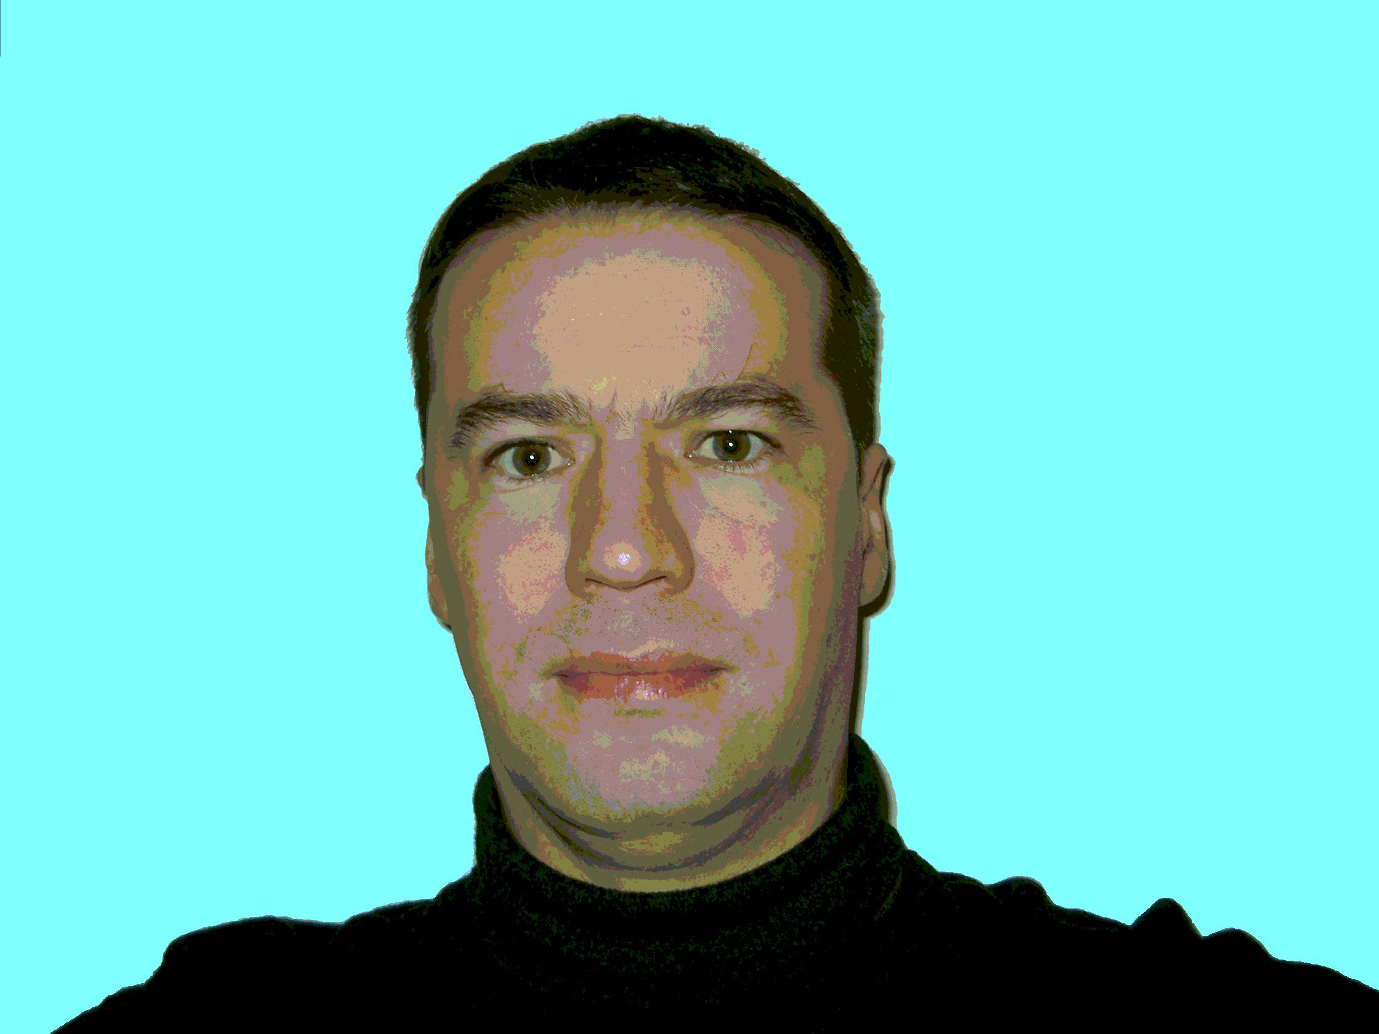

Vinogradova Irina Leonidovna, 1970 of birth, in 1992 has ended Ufa state air technical university, in 2000 has protected a candidate engineering thesis, teacher.  Area of scientific interests: optics, fiber-optical communication, theory of signals processing, quantum electronics engineering.  The working address: 450000, Bashkortostan republics, Ufa, K.Marx street, 12, house 6, ph./fax: + 7-3472-22-43-84,  E-mail: tks@ugatu.ac.ru .  The home address: 450054, Ufa, October Prospectus street, house 56, apartment 49, ph.: + 7-3472-37-22-77 | 