МИНИСТЕРСТВО ОБРАЗОВАНИЯ РОССИЙСКОЙ ФЕДЕРАЦИИ

УФИМСКИЙ ГОСУДАРСТВЕННЫЙ АВИАЦИОННЫЙ
ТЕХНИЧЕСКИЙ УНИВЕРСИТЕТ

Кафедра ТОЭ

Расчетно-графическая работа №2
«Анализ электрических цепей переменного тока»

Выполнил: студент гр. БМС-208
Сагдатов М.А.
Проверил: Чечулина И. Е.

Уфа 2005

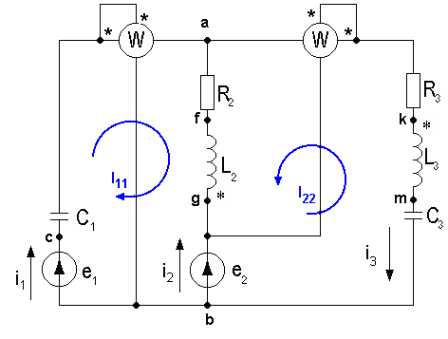

ν = 50Гц
ω = 314Гц
$$\begin{aligned}X_{C1}=\frac{1}{{ωC}_{1}}=\frac{1}{\text{314}∗\text{45}∗{\text{10}}^{−6}}=\text{70},\text{77} \text{Ом} \\ X_{C3}=\frac{1}{{ωC}_{3}}=\frac{1}{\text{314}∗\text{46}∗{\text{10}}^{−6}}=\text{69},\text{23} \text{Ом}\end{aligned}$$
Х_{L2} = ωL₂ = 13,816 Ом
Х_{L3} = ωL₃ = 5,966 Ом
$\begin{aligned}{\overset{˙}{E}}_{1}=\text{228}e^{j\text{42}}=\text{169},\text{437}+j\text{152},\text{562} B \\ {\overset{˙}{E}}_{2}=\text{42}e^{j\text{213}}=−\text{35},\text{224}−j\text{22},\text{8748} B\end{aligned}$

- МЕТОД КОНТУРНЫХ ТОКОВ.

$$\begin{aligned}\left\{{\overset{˙}{I}}_{\text{11}}{\underline{Z}}_{\text{11}}+{\overset{˙}{I}}_{\text{22}}{\underline{Z}}_{\text{12}}={\overset{˙}{E}}_{\text{11}} | \right.\end{aligned}$$

$$\begin{aligned}\left\{(−{\text{jX}}_{C1}+R_{2}+{\text{jX}}_{L2}){\overset{˙}{I}}_{\text{11}}+(R_{2}+{\text{jX}}_{L2}){\overset{˙}{I}}_{\text{22}}={\overset{˙}{E}}_{1}−{\overset{˙}{E}}_{2} | \right.\end{aligned}$$

$$\begin{aligned}Z_{\text{11}}=R_{2}+j(X_{L2}−X_{C1})=\text{52}−j\text{56},\text{954} \text{Ом} \\ Z_{\text{22}}=R_{2}+R_{3}+j(X_{L2}+X_{L3}−X_{C3})=\text{123}−j\text{49},\text{448} \text{Ом} \\ Z_{\text{12}}=Z_{\text{21}}=R_{2}+{\text{jX}}_{L2}=\text{52}+j\text{13},\text{816} \text{Ом} \\ \\ {\overset{˙}{E}}_{\text{11}}={\overset{˙}{E}}_{1}−{\overset{˙}{E}}_{2}=\text{204},\text{661}+j\text{175},\text{4368} B \\ {\overset{˙}{E}}_{\text{22}}=−{\overset{˙}{E}}_{2}=\text{35},\text{224}+j\text{22},\text{8748} B \\ \\ \begin{matrix}\text{Re}→ & \text{52} & \text{52} & \text{204},\text{661} \\ \begin{aligned}\text{Im}→ \\ \end{aligned} & \begin{aligned}−\text{56},\text{954} \\ \end{aligned} & \begin{aligned}\text{13},\text{816} \\ \end{aligned} & \begin{aligned}\text{175},\text{4368} \\ \end{aligned} \\ \text{Re}→ & \text{52} & \text{123} & \text{35},\text{224} \\ \text{Im}→ & \text{13},\text{816} & −\text{49},\text{448} & \text{22},\text{8748}\end{matrix} \begin{matrix}{\overset{˙}{I}}_{\text{11}}=−0,\text{5983}+j2,\text{9937} A \\ {\overset{˙}{I}}_{\text{22}}=1,\text{1041}−j0,\text{56856} A\end{matrix} \\ \\ {\overset{˙}{I}}_{1}={\overset{˙}{I}}_{\text{11}}=−0,\text{5983}+j2,\text{9937}=3,\text{05}e^{j\text{101},3} A \\ {\overset{˙}{I}}_{2}=−{\overset{˙}{I}}_{\text{11}}−{\overset{˙}{I}}_{\text{22}}=−0,\text{5058}−j2,\text{425}=2,\text{477}e^{j\text{258},\text{22}} A \\ {\overset{˙}{I}}_{3}=−{\overset{˙}{I}}_{\text{22}}=−1,\text{1041}+j0,\text{56856}=1,\text{24}e^{j\text{152},\text{75}}\end{aligned}$$
$$\begin{aligned}i_{1}(t)=4,\text{31}\text{sin}(ωt+\text{101},3) \\ i_{2}(t)=3,5\text{sin}(ωt+\text{258},\text{22}) \\ i_{3}(t)=1,\text{75}\text{sin}(ωt+\text{152},\text{75})\end{aligned}$$

ПОКАЗАНИЕ ВАТТМЕТРОВ.
Показания 1 ваттметра: $W_{1}=\text{Re}({\overset{˙}{U}}_{\text{ab}}\overset{}{I_{1}})$

Показания 2 ваттметра: $W_{2}=\text{Re}(({\overset{˙}{U}}_{\text{ab}}−{\overset{˙}{E}}_{2})\overset{}{I_{3}})$

${\overset{˙}{U}}_{\text{ab}}={\overset{˙}{I}}_{3}(R_{3}+j(X_{L3}−X_{C3}))=1,\text{246}e^{j\text{152},\text{75}}∗\text{95},\text{096}e^{−j\text{41},\text{702}}=\text{117},\text{9196}e^{j\text{111},\text{048}} B$$\begin{aligned}W_{1}=\text{Re}({\overset{˙}{U}}_{\text{ab}}\overset{}{I_{1}})=\text{Re}(\text{117},\text{9196}e^{j\text{111},\text{048}}∗3,\text{05}e^{j\text{258},\text{698}})=\text{Re}(\text{359},\text{655}e)= \\ \text{Re}(\text{355},\text{35}+j\text{60},\text{88})=\text{355},\text{35} \text{Вт}\end{aligned}$
$$W_{2}=\text{Re}(({\overset{˙}{U}}_{\text{ab}}−{\overset{˙}{E}}_{2})\overset{}{I_{3}})=\text{Re}((−7,\text{206}+j\text{133},\text{09})(−1,\text{1041}−j0,\text{56856}))=\text{83},6 \text{Вт}$$

БАЛАНС АКТИВНЫХ И РЕАКТИВНЫХ МОЩНОСТЕЙ.

$${\begin{aligned}{\tilde{S}}_{\text{ист}}={\tilde{S}}_{\text{пр}} \\ {\tilde{S}}_{\text{ист}}={\tilde{S}}_{J}+{\tilde{S}}_{E}\text{ \{}\tilde{S}\end{aligned}}_{J}=0{\tilde{S}}_{\text{ист}}={\tilde{S}}_{E}=\overset{}{I_{1}}{\overset{˙}{E}}_{1}+\overset{}{I_{2}}{\overset{˙}{E}}_{2}=\text{355},\text{35}−j\text{598},\text{518}+\text{73},\text{29}−j\text{73},\text{.}\text{848}=\text{428},\text{64}−j\text{672},\text{364} \text{Вт}{\tilde{S}}_{\text{пр}}=P_{\text{ПР}}+{\text{jQ}}_{\text{ПР}}P_{\text{ПР}}=I_{2}^{2}R_{2}+I_{3}^{2}R_{3}=2,{\text{477}}^{2}∗\text{52}+1,{\text{24}}^{2}∗\text{71}=\text{428},\text{22} \text{Вт}Q_{\text{ПР}}=−X_{C1}I_{1}^{2}+X_{L2}I_{2}^{2}+I_{3}^{2}(X_{L3}−X_{C3})=−\text{670},\text{845} \text{Вт}{\tilde{S}}_{\text{пр}}=\text{428},\text{22}−j\text{670},\text{845} \text{Bт}{\tilde{S}}_{\text{ист}}≈{\tilde{S}}_{\text{пр}}$$
Баланс активных и реактивных мощностей соблюдается

ТОПОГРАФИЧЕСКАЯ ДИАГРАММА НАПРЯЖЕНИЙ И ВЕКТОРНАЯ ДИАГРАММА ТОКОВ

$$\begin{aligned}{\overset{˙}{I}}_{1}=−0,\text{5983}+j2,\text{9937} A \\ {\overset{˙}{I}}_{2}=−0,\text{5058}−j2,\text{425} A \\ {\overset{˙}{I}}_{3}=−1,\text{1041}+j0,\text{56856}\end{aligned}$$
$$\begin{aligned}{\overset{˙}{ϕ}}_{b}=0 \\ {\overset{˙}{ϕ}}_{c}={\overset{˙}{E}}_{1}=\text{169},\text{437}+j\text{152},\text{562} B \\ {\overset{˙}{ϕ}}_{a}={\overset{˙}{I}}_{1}{\text{jX}}_{C1}+{\overset{˙}{ϕ}}_{c}=−\text{42},\text{423}+j\text{110},\text{22} B \\ {\overset{˙}{ϕ}}_{f}=R_{2}{\overset{˙}{I}}_{2}+{\overset{˙}{ϕ}}_{a}=−\text{68},\text{723}−j\text{15},\text{88} B \\ {\overset{˙}{ϕ}}_{g}={\overset{˙}{I}}_{2}{\text{jX}}_{L2}+{\overset{˙}{ϕ}}_{f}=−\text{35},\text{223}−j\text{22},\text{87} B \\ {\overset{˙}{ϕ}}_{m}=−{\overset{˙}{I}}_{3}{\text{jX}}_{C3}=\text{39},\text{36}+j\text{76},\text{44} B \\ {\overset{˙}{ϕ}}_{k}={\overset{˙}{I}}_{3}{\text{jX}}_{L3}+{\overset{˙}{ϕ}}_{m}=\text{35},\text{97}+j\text{69},\text{85} B\end{aligned}$$

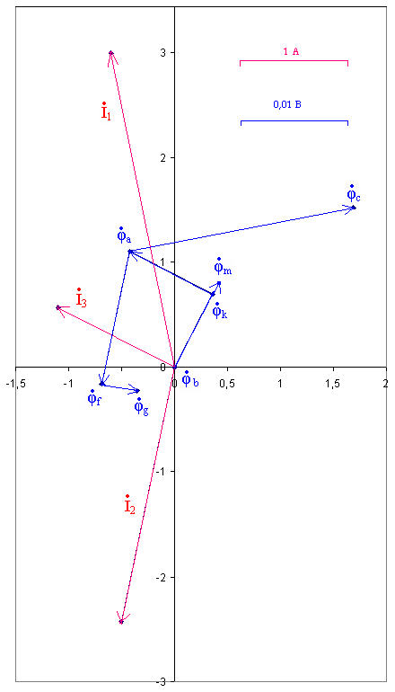

УРАВНЕНИЕ КИРХГОФА В ОБЩЕМ ВИДЕ В ДИФФЕРЕНЦИАЛЬНЫХ И КОМПЛЕКСНЫХ ФОРМАХ.

$$\begin{aligned}\left\{i_{1}+i_{2}−i_{3}=0 | \right.\left\{\frac{1}{C_{1}}\int{i_{1}\text{dt}−i_{2}R_{2}−L_{2}\frac{{\text{di}}_{2}}{\text{dt}}−M_{\text{23}}\frac{{\text{di}}_{3}}{\text{dt}}=e_{1}−e_{2}} | \right.\end{aligned}$$

$$\begin{aligned}\left\{{\overset{˙}{I}}_{1}+{\overset{˙}{I}}_{2}−{\overset{˙}{I}}_{3}=0 | \right.\left\{−{\overset{˙}{I}}_{1}j\frac{1}{{ωC}_{1}}−{\overset{˙}{I}}_{2}R_{2}−{\overset{˙}{I}}_{2}{jωL}_{2}−{\overset{˙}{I}}_{3}{jωM}_{\text{23}}={\overset{˙}{E}}_{1}−{\overset{˙}{E}}_{2} | \right.\end{aligned}$$

