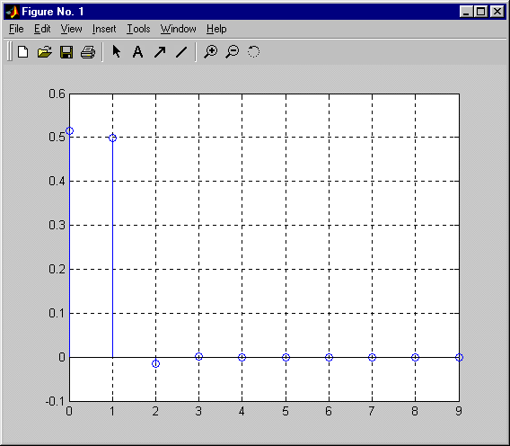
b=[1 1]
a=[1.9391 0.0609]
h=impz(b,a,10)
stem(0:length(h)-1,h),grid

b =

1 1

a =

1.9391 0.0609

h =

0.5157
0.4995
-0.0157
0.0005
-0.0000
0.0000
-0.0000
0.0000
-0.0000
0.0000

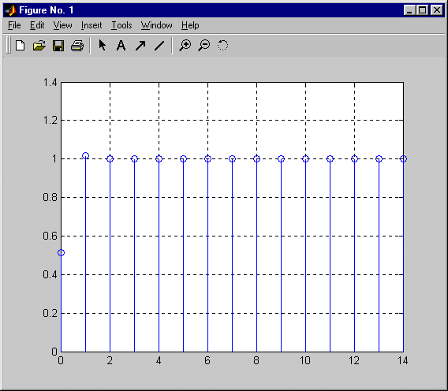
x=ones(1,15)
y=filter(b,a,x)
stem(0:length(y)-1,y),grid

x =

Columns 1 through 8

1 1 1 1 1 1 1 1

Columns 9 through 15

1 1 1 1 1 1 1

y =

Columns 1 through 5

0.5157 1.0152 0.9995 1.0000 1.0000

Columns 6 through 10

1.0000 1.0000 1.0000 1.0000 1.0000

Columns 11 through 15

1.0000 1.0000 1.0000 1.0000 1.0000
2.3
n=0:32
x=sin(2*pi*0.125*n)+sin(2*pi*0.25*n)
y=filter(b,a,x)
figure(1),stem(0:length(x)-1,x),grid
figure(2),stem(0:length(y)-1,y),grid

n =

Columns 1 through 8

0 1 2 3 4 5 6 7

Columns 9 through 16

8 9 10 11 12 13 14 15

Columns 17 through 24

16 17 18 19 20 21 22 23

Columns 25 through 32

24 25 26 27 28 29 30 31

Column 33

32

x =

Columns 1 through 5

0 1.7071 1.0000 -0.2929 -0.0000

Columns 6 through 10

0.2929 -1.0000 -1.7071 -0.0000 1.7071

Columns 11 through 15

1.0000 -0.2929 -0.0000 0.2929 -1.0000

Columns 16 through 20

-1.7071 -0.0000 1.7071 1.0000 -0.2929

Columns 21 through 25

-0.0000 0.2929 -1.0000 -1.7071 -0.0000

Columns 26 through 30

1.7071 1.0000 -0.2929 -0.0000 0.2929

Columns 31 through 33

-1.0000 -1.7071 -0.0000

y =

Columns 1 through 5

0 0.8804 1.3684 0.3217 -0.1611

Columns 6 through 10

0.1561 -0.3696 -1.3845 -0.8369 0.9066

Columns 11 through 15

1.3676 0.3217 -0.1611 0.1561 -0.3696

Columns 16 through 20

-1.3845 -0.8369 0.9066 1.3676 0.3217

Columns 21 through 25

-0.1611 0.1561 -0.3696 -1.3845 -0.8369

Columns 26 through 30

0.9066 1.3676 0.3217 -0.1611 0.1561

Columns 31 through 33

-0.3696 -1.3845 -0.8369
vxodnoi
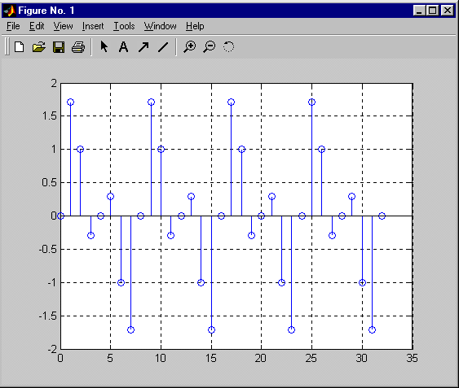
vixodnoi
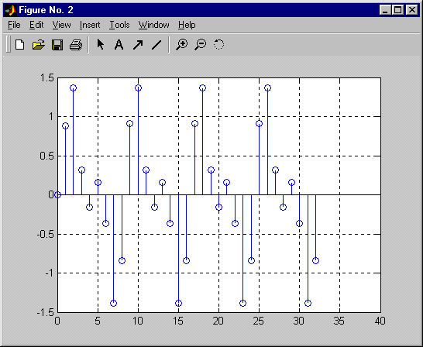
2.3.2
прямоугольные импульсы
x=[0 0 0 0 1 1 1 1 0 0 0 0 1 1 1 1 0 0 0 0 1 1 1 1 0 0 0 0 1 1 1 1]
y=filter(b,a,x)
figure(1),stem(0:length(x)-1,x),grid
figure(2),stem(0:length(y)-1,y),grid

x =

Columns 1 through 8

0 0 0 0 1 1 1 1

Columns 9 through 16

0 0 0 0 1 1 1 1

Columns 17 through 24

0 0 0 0 1 1 1 1

Columns 25 through 32

0 0 0 0 1 1 1 1

y =

Columns 1 through 5

0 0 0 0 0.5157

Columns 6 through 10

1.0152 0.9995 1.0000 0.4843 -0.0152

Columns 11 through 15

0.0005 -0.0000 0.5157 1.0152 0.9995

Columns 16 through 20

1.0000 0.4843 -0.0152 0.0005 -0.0000

Columns 21 through 25

0.5157 1.0152 0.9995 1.0000 0.4843

Columns 26 through 30

-0.0152 0.0005 -0.0000 0.5157 1.0152

Columns 31 through 32

  - 1.0000

входной
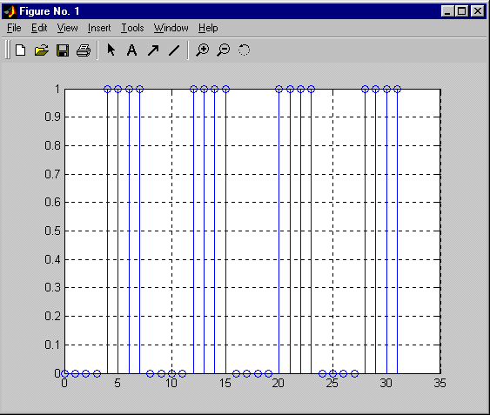
выходной
