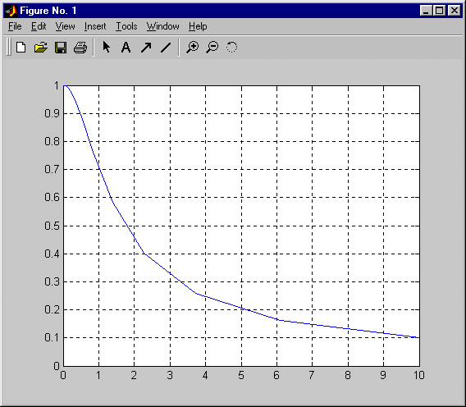

b=[1]
a=[1 1]
[h,w]=freqs(b,a,15)
plot(w,abs(h)), grid
w'
abs(h)'

h =

0.9999 - 0.0100i
0.9997 - 0.0164i
0.9993 - 0.0268i
0.9981 - 0.0439i
0.9948 - 0.0716i
0.9863 - 0.1163i
0.9641 - 0.1861i
0.9091 - 0.2875i
0.7885 - 0.4084i
0.5815 - 0.4933i
0.3412 - 0.4741i
0.1618 - 0.3683i
0.0671 - 0.2503i
0.0261 - 0.1595i
0.0099 - 0.0990i

w =

0.0100
0.0164
0.0268
0.0439
0.0720
0.1179
0.1931
0.3162
0.5179
0.8483
1.3895
2.2758
3.7276
6.1054
10.0000
ans =

Columns 1 through 6

0 0.2094 0.4189 0.6283 0.8378 1.0472

Columns 7 through 12

1.2566 1.4661 1.6755 1.8850 2.0944 2.3038

Columns 13 through 15

2.5133 2.7227 2.9322

ans =

Columns 1 through 6

0.5000 0.5028 0.5112 0.5257 0.5473 0.5774

Columns 7 through 12

0.6180 0.6728 0.7472 0.8507 1.0000 1.2293

Columns 13 through 15

1.6180 2.4049 4.7834
b=[1 1]
a=[1.9391 0.0609]
[h,w]=freqz(b,a,15)
plot(w/2/pi,abs(h)),grid
(w/2/pi)'
abs(h)'

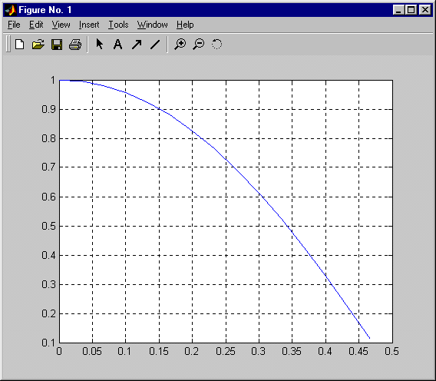

h =

1.0000
0.9904 - 0.0978i
0.9617 - 0.1920i
0.9148 - 0.2791i
0.8512 - 0.3559i
0.7728 - 0.4190i
0.6823 - 0.4656i
0.5831 - 0.4930i
0.4790 - 0.4996i
0.3744 - 0.4840i
0.2743 - 0.4462i
0.1835 - 0.3871i
0.1069 - 0.3090i
0.0487 - 0.2153i
0.0124 - 0.1105i

w =

0
0.2094
0.4189
0.6283
0.8378
1.0472
1.2566
1.4661
1.6755
1.8850
2.0944
2.3038
2.5133
2.7227
2.9322

w

ans =

Columns 1 through 6

0 0.0333 0.0667 0.1000 0.1333 0.1667

Columns 7 through 12

0.2000 0.2333 0.2667 0.3000 0.3333 0.3667

Columns 13 through 15

0.4000 0.4333 0.4667

ans =

Columns 1 through 6

1.0000 0.9952 0.9807 0.9565 0.9226 0.8791

Columns 7 through 12

0.8260 0.7636 0.6921 0.6119 0.5237 0.4284

Columns 13 through 15

0.3270 0.2208 0.1112

